Savitribai Phule Pune University

Remote Internship - High Level Design
on
Multimodal Academic Performance Prediction System using Text, Tabular and Behavioral Data

By
Manasi Narkhede(DS24M11)

Guided by:
Mr. Rithik Raj Vaishya

Table of Contents
1. Introduction 3
1.1 Scope of the Document 3
1.2 Intended Audience 3
1.3 System Overview 3
2. System Design 4
2.1 Application Design 4
2.2 Process Flow 5
2.3 Information Flow 5
2.4 Component Design 5
2.5 Key Design Considerations 6
2.6 API Catalogue 6
3. Data Design 8
3.1 Data Model 8
3.2 Data Access Mechanism 8
3.3 Data Retention Policies 8
3.4 Data Migration 8
4. Interfaces 9
5. State and Session Management 10
6. Caching 11
7. Non-Functional Requirements 12
7.1 Security Aspects 12
7.2 Performance Aspects 12
8. References 13

1. Introduction

1.1 Scope of the Document
This High Level Design (HLD) document provides an architectural overview of the Multimodal Academic Performance Prediction System. It describes the system's major components, their interactions, data flows, and the technology decisions that shape the overall architecture. This document is intended to serve as a blueprint for development and a reference for stakeholders reviewing the system's design.

1.2 Intended Audience
This document is intended for project supervisors, academic evaluators, software architects, development team members, and quality assurance personnel who need to understand the high-level architecture and design rationale of the system.

1.3 System Overview
The system is a full-stack web application that predicts student academic risk using a multimodal machine learning pipeline. It ingests three types of data — tabular academic records, behavioral engagement logs, and free-text student submissions — processes them through dedicated preprocessing pipelines, generates unimodal predictions using XGBoost, LSTM, and Transformer models respectively, and fuses these predictions through an XGBoost meta-learner ensemble. Predictions are accompanied by SHAP-based explainability and natural language summaries.

2. System Design

2.1 Application Design
The application follows a client-server architecture with three major layers:
Presentation Layer: A React 19 single-page application built with Vite and TypeScript. It uses Zustand for client-side state management, TanStack React Query for server state and caching, and Recharts for data visualization. The frontend communicates with the backend exclusively through RESTful API calls with JWT bearer token authentication.
Application Layer: A FastAPI-based Python backend providing asynchronous REST endpoints. It handles authentication (JWT with bcrypt password hashing), request validation (Pydantic), rate limiting (SlowAPI), structured logging, and ML model inference. The backend uses SQLAlchemy with asyncpg for non-blocking database operations.
Data Layer: PostgreSQL 15 serves as the primary relational database storing users, students, cohorts, and prediction history. Pre-trained ML model artifacts (.pt and .json files) are stored on the filesystem. MLflow is used for experiment tracking and model versioning.
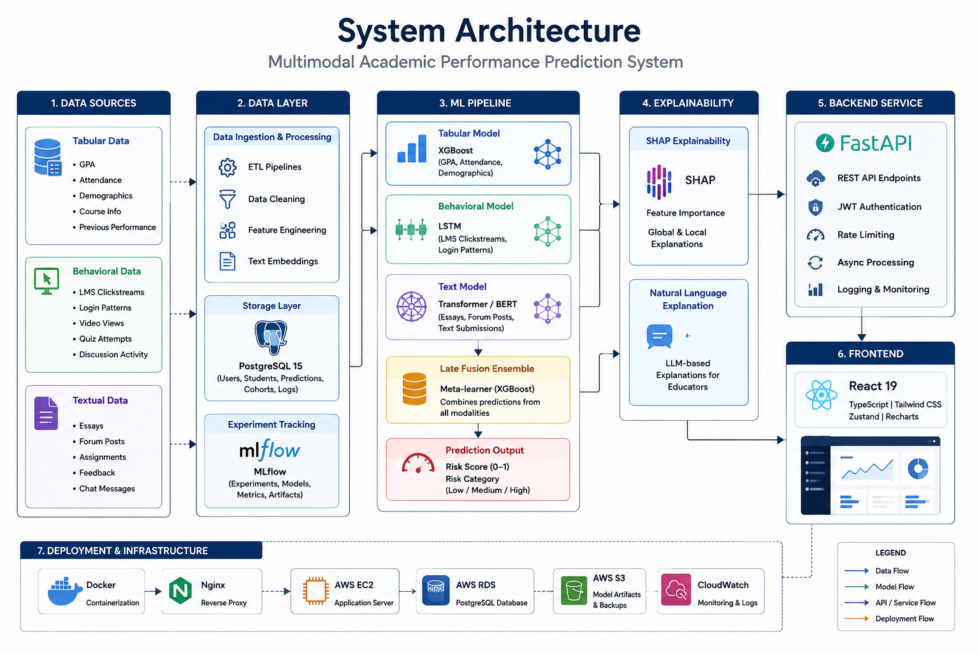
Figure 1: High-Level System Architecture

2.2 Process Flow
The core prediction flow proceeds as follows:
1. User authenticates via POST /auth/login and receives a JWT access token.
2. User navigates to the cohort dashboard, which fetches cohort data via GET /cohort/{id}.
3. User selects a student and triggers a prediction via POST /predict.
4. The PredictionService loads three unimodal model predictors (lazy initialization).
5. Student features are retrieved from preprocessed NumPy arrays using an in-memory cache.
6. Each unimodal model produces a risk probability independently.
7. The FusionPredictor combines the three probabilities through the XGBoost meta-learner.
8. The ExplainabilityService generates SHAP values and an NLG narrative summary.
9. The prediction is persisted to the predictions table and returned to the frontend.
10. The frontend displays the risk level, SHAP feature attributions, and explanation.

2.3 Information Flow
Data flows through the system in a unidirectional pipeline:
Raw Data (CSV files) → Preprocessing Pipelines → Feature Arrays (NumPy .npy) → Unimodal Models → Probability Scores → Fusion Ensemble → Fused Risk Score → SHAP Explainer → NLG Summarizer → API Response → React Frontend.
Authentication tokens flow from the backend to the frontend and are stored in the Zustand auth store. Each subsequent API request includes the JWT in the Authorization header.

2.4 Component Design
Table 1: Component Design
Component | Technology | Responsibility
Frontend SPA | React 19 + Vite + TypeScript | User interface, routing, state management
API Gateway / Proxy | Nginx | SSL termination, static file serving, reverse proxy
REST API | FastAPI (Python 3.11) | Request handling, auth, validation, rate limiting
Auth Module | python-jose + passlib | JWT token creation/validation, password hashing
Tabular Model | XGBoost | Risk prediction from academic features
Behavioral Model | PyTorch LSTM | Risk prediction from engagement sequences
Text Model | PyTorch (DistilBERT embeddings) | Risk prediction from text embeddings
Fusion Ensemble | XGBoost meta-learner | Combine unimodal predictions
Explainability | SHAP + NLG Summarizer | Feature attribution and narrative generation
Database | PostgreSQL 15 + SQLAlchemy | Persistent storage for users, students, predictions
Experiment Tracking | MLflow | Model versioning and metrics logging
Caching | In-memory (Python dict) | Embedding and prediction caching

2.5 Key Design Considerations
Late Fusion Strategy: The system uses late fusion (decision-level fusion) rather than early or intermediate fusion. Each modality produces an independent probability, and these are combined by the meta-learner. This design provides graceful degradation — if one modality's data is missing, the system imputes with population means.
Lazy Model Loading: ML models are loaded on first request rather than at startup. This reduces memory usage and startup time in development, while production caching ensures models are only loaded once.
Async-First Architecture: The entire backend is built on async Python (asyncio), using asyncpg for database operations and FastAPI's native async support for request handling.
Multi-Stage Docker Builds: Both frontend and backend Dockerfiles use multi-stage builds to minimize production image sizes and reduce the attack surface.

2.6 API Catalogue
Table 2: API Catalogue
Method | Endpoint | Auth | Description
GET | /health | No | Health check and system status
POST | /auth/login | No | Authenticate and receive JWT token
POST | /auth/register | No | Register a new user account
POST | /predictions/predict | Yes | Get risk prediction for a student
GET | /cohort/{id} | Yes | Get cohort summary and risk distribution
GET | /models | Yes | List available ML models and metrics
GET | /protected | Yes | Test authenticated access
GET | /stub/cohort/{id} | No (dev) | Mock cohort data for frontend development
POST | /stub/predict | No (dev) | Mock prediction for frontend development
GET | /stub/models | No (dev) | Mock model metadata for frontend development

3. Data Design

3.1 Data Model
The relational database uses four core tables managed by SQLAlchemy ORM with Alembic migrations:
Table 3: Data Model
Table | Key Columns | Relationships
users | id (PK), email (UNIQUE), hashed_password, role, created_at | One-to-many → predictions
students | id (PK), name, cohort_id (FK), demographics (JSON), created_at | Many-to-one → cohorts, One-to-many → predictions
cohorts | id (PK), name, created_at | One-to-many → students
predictions | id (PK), student_id (FK), user_id (FK), at_risk_probability, risk_level, explanation_text, text_score, tabular_score, behavioral_score, created_at | Many-to-one → students, Many-to-one → users

3.2 Data Access Mechanism
Database access uses SQLAlchemy's async session factory with connection pooling (pool_size=10, max_overflow=20, pool_recycle=3600). Sessions are managed via FastAPI's dependency injection system using an async context manager (get_db). All queries use SQLAlchemy's select() construct for type-safe, composable queries.

3.3 Data Retention Policies
All prediction records are retained indefinitely for audit and analysis purposes. User passwords are hashed with bcrypt and never stored in plaintext. Student demographic data is stored as encrypted JSON. Session tokens expire after the configured JWT_ACCESS_TOKEN_EXPIRE_MINUTES (default: 30 minutes).

3.4 Data Migration
Database schema migrations are managed by Alembic. Migration scripts are version-controlled in the backend/alembic/versions/ directory. The production deployment script runs 'alembic upgrade head' automatically before starting the application server.

4. Interfaces
The system exposes a RESTful HTTP/JSON API as the sole interface between frontend and backend. CORS is configured to allow requests only from the FRONTEND_URL origin. The API uses Pydantic models for request/response serialization and validation. All authenticated endpoints require a Bearer JWT token in the Authorization header.

5. State and Session Management
Frontend state management uses Zustand stores: authStore (JWT token, user info, login/logout actions) and uiStore (theme, sidebar state). Server state is managed through TanStack React Query with automatic caching, refetching, and garbage collection. Backend sessions are stateless (JWT-based), with no server-side session storage.

6. Caching
The backend implements an in-memory LRU cache for student embeddings (text, tabular, behavioral features). The cache uses a dictionary with composite keys (student_id × feature_type) and provides thread-safe get/set operations. NumPy feature arrays are loaded once and cached in a module-level dictionary. The frontend uses React Query's built-in cache with configurable stale time.

7. Non-Functional Requirements

7.1 Security Aspects
• JWT-based stateless authentication with HS256 signing and configurable expiry.
• Passwords hashed with bcrypt (passlib) — never stored in plaintext.
• CORS restricted to configured frontend origin(s).
• Non-root Docker containers with dedicated appuser.
• Nginx security headers: HSTS, X-Frame-Options, X-Content-Type-Options, Referrer-Policy.
• SSL/TLS termination at Nginx with Let's Encrypt certificates.
• Rate limiting on prediction endpoints (10 requests/minute per IP).
• Input validation via Pydantic models on all API endpoints.
• Environment variables for all secrets (never hardcoded).

7.2 Performance Aspects
• Async I/O throughout the backend (asyncpg, FastAPI async endpoints).
• Connection pooling with pool_size=10 and max_overflow=20.
• In-memory embedding cache to avoid repeated disk I/O.
• Lazy model loading to reduce startup time.
• Gzip compression enabled in Nginx.
• Multi-stage Docker builds for minimal production image sizes.
• Backend memory limit of 3GB enforced via Docker Compose.

8. References
[1] Baltrušaitis, T., Ahuja, C., & Morency, L.-P. (2019). Multimodal Machine Learning: A Survey and Taxonomy. Foundations and Trends® in Computer Graphics and Vision.
[2] Zadeh, A., Chen, M., Poria, S., Cambria, E., & Morency, L.-P. (2017). Tensor Fusion Network for Multimodal Sentiment Analysis. ACL Workshop.
[3] Vaswani, A., et al. (2017). Attention Is All You Need. NeurIPS.
[4] Devlin, J., Chang, M.-W., Lee, K., & Toutanova, K. (2019). BERT: Pre-training of Deep Bidirectional Transformers for Language Understanding. NAACL.
[5] Chen, T., & Guestrin, C. (2016). XGBoost: A Scalable Tree Boosting System. KDD.
[6] Lundberg, S. M., & Lee, S.-I. (2017). A Unified Approach to Interpreting Model Predictions (SHAP). NIPS Workshop.
[7] Ribeiro, M. T., Singh, S., & Guestrin, C. (2016). "Why Should I Trust You?" Explaining the Predictions of Any Classifier (LIME). KDD.
[8] Zhou, Z.-H. (2012). Ensemble Methods: Foundations and Algorithms. Chapman & Hall/CRC.
[9] Baker, R. S. J. d., & Inventado, P. S. (2014). Educational Data Mining and Learning Analytics. Springer.
[10] Romero, C., & Ventura, S. (2010). Educational Data Mining: A Review of the State of the Art. IEEE Transactions on SMC.
[11] Kuhn, M., & Johnson, K. (2013). Applied Predictive Modeling. Springer.
[12] Goodfellow, I., Bengio, Y., & Courville, A. (2016). Deep Learning. MIT Press.
[13] Poria, S., Cambria, E., Bajpai, R., & Hussain, A. (2017). A Review of Affective Computing. IEEE Trans. Affective Computing.
[14] Lundberg, S. M., et al. (2020). From Local Explanations to Global Understanding with Explainable AI for Trees. Nature Machine Intelligence.

