Savitribai Phule Pune University

Remote Internship - Synopsis
on
Multimodal Academic Performance Prediction System using Text, Tabular and Behavioral Data

By
Manasi Narkhede(DS24M11)

Guided by:
Mr. Rithik Raj Vaishya

Table of Contents
1. Introduction 3
2. Problem Statement 4
3. Objectives 5
4. Scope 6
5. Methodology 7
6. Technology Stack 8
7. System Architecture 9
8. Expected Outcomes 10
9. References 11

1. Introduction
The Multimodal Academic Performance Prediction System is an end-to-end machine learning platform designed to identify students at risk of academic underperformance by analyzing multiple data modalities simultaneously. Traditional early-warning systems in education typically rely on a single data source, such as grades or attendance records. This project takes a fundamentally different approach by combining three distinct data modalities — tabular academic records, behavioral engagement logs from learning management systems, and free-text student submissions — into a unified risk prediction with explainable AI.
The system addresses a critical need in modern education: the ability to proactively identify struggling students before they reach a point of academic crisis. By leveraging multimodal machine learning, the system captures signals that any single modality would miss, providing educators with a comprehensive and nuanced view of each student's academic trajectory.

2. Problem Statement
Educational institutions face a persistent challenge in identifying at-risk students early enough for effective intervention. Current approaches suffer from several key limitations:
• Single-modality systems miss important signals — a student may have acceptable grades but exhibit declining behavioral engagement patterns that precede academic failure.
• Manual identification by faculty is subjective, inconsistent, and does not scale to large cohorts.
• Existing predictive models often operate as 'black boxes' without providing actionable explanations for their predictions, reducing trust and adoption by educators.
• Most systems lack the ability to handle missing data gracefully — if one data source is unavailable for a student, the system cannot produce any prediction.
This project aims to solve these problems by building a multimodal fusion system that combines tabular, behavioral, and textual data sources with a meta-learner ensemble, provides SHAP-based explainability with natural language summaries, and handles missing modalities through population mean imputation.

3. Objectives
The primary objectives of this project are:
1. Design and implement three unimodal machine learning models — XGBoost for tabular data, LSTM for behavioral sequences, and a Transformer-based classifier for text embeddings.
2. Build a late fusion ensemble that combines the three unimodal predictions using an XGBoost meta-learner to produce a unified risk probability.
3. Implement SHAP-based explainability with a Natural Language Generation (NLG) summarizer that translates feature attributions into human-readable explanations.
4. Develop a full-stack web application with a React frontend and FastAPI backend, featuring a cohort dashboard, student risk table, and explanation modal.
5. Containerize the application with Docker and provide production deployment scripts for AWS EC2/RDS.
6. Ensure ethical AI practices including fairness evaluation, transparency, and human-in-the-loop design.

4. Scope
The scope of this project encompasses the complete software development lifecycle from data generation and preprocessing through model training, API development, frontend implementation, and production deployment. The system processes three types of student data:
Table 1: Scope of model
Data Modality | Source | ML Model | Features
Tabular | Academic records (CSV) | XGBoost (Gradient Boosting) | GPA, attendance, demographics, scores
Behavioral | LMS clickstreams (CSV) | LSTM (PyTorch) | Login patterns, time-on-task, click sequences
Textual | Essays, forum posts (CSV) | Transformer (DistilBERT) | 768-dim embeddings from student writing

The system is designed for deployment in educational institutions and includes features for JWT-based authentication, rate limiting, structured logging, in-memory caching, and database-backed prediction history.

5. Methodology
The development methodology follows an iterative, agile approach with the following phases:
Phase 1 — Data Pipeline: Generate synthetic student data using controlled distributions, preprocess each modality (scaling, encoding, tokenization, sequence padding), and produce train/validation/test splits.
Phase 2 — Unimodal Model Training: Train the XGBoost tabular model with class-weighted binary:logistic objective, the 2-layer LSTM behavioral model with BCEWithLogitsLoss, and the DistilBERT-based text classifier on frozen 768-dimensional embeddings.
Phase 3 — Fusion Ensemble: Align predictions from all three models by student_id, train an XGBoost meta-learner on the concatenated probability vector, and evaluate improvement over the best single modality.
Phase 4 — Explainability: Integrate SHAP TreeExplainer for the tabular model and build an NLG summarizer that translates SHAP values into natural language explanations.
Phase 5 — Full-Stack Application: Build FastAPI REST API with async SQLAlchemy, React frontend with Zustand state management and Recharts visualizations.
Phase 6 — Deployment & Monitoring: Containerize with Docker, configure Nginx reverse proxy with SSL, and deploy to AWS EC2 with RDS PostgreSQL.

6. Technology Stack
Table 2: Technology Stack
Category | Technology | Purpose
Backend | Python 3.11, FastAPI | Async REST API framework
Backend | SQLAlchemy + asyncpg | Async ORM & PostgreSQL driver
Backend | Alembic | Database schema migrations
ML Models | XGBoost | Tabular gradient boosting classifier
ML Models | PyTorch (LSTM) | Behavioral sequence model
ML Models | HuggingFace Transformers | Text embedding (DistilBERT)
ML Models | SHAP | Model explainability
ML Models | MLflow | Experiment tracking
Frontend | React 19, TypeScript | UI framework
Frontend | Vite 7 | Build tool & dev server
Frontend | Tailwind CSS | Utility-first styling
Frontend | Zustand | Lightweight state management
Frontend | TanStack React Query | Server state & data fetching
Frontend | Recharts | Data visualization
Database | PostgreSQL 15 | Relational database
Infrastructure | Docker, Docker Compose | Containerization
Infrastructure | Nginx | Reverse proxy & SSL termination
Infrastructure | AWS EC2 / RDS | Cloud hosting
Testing | pytest, Vitest | Backend & frontend testing

7. System Architecture
The system follows a three-tier architecture with a React SPA frontend communicating with a FastAPI backend through RESTful APIs, backed by a PostgreSQL database. The ML pipeline runs within the backend, loading pre-trained model artifacts at startup.
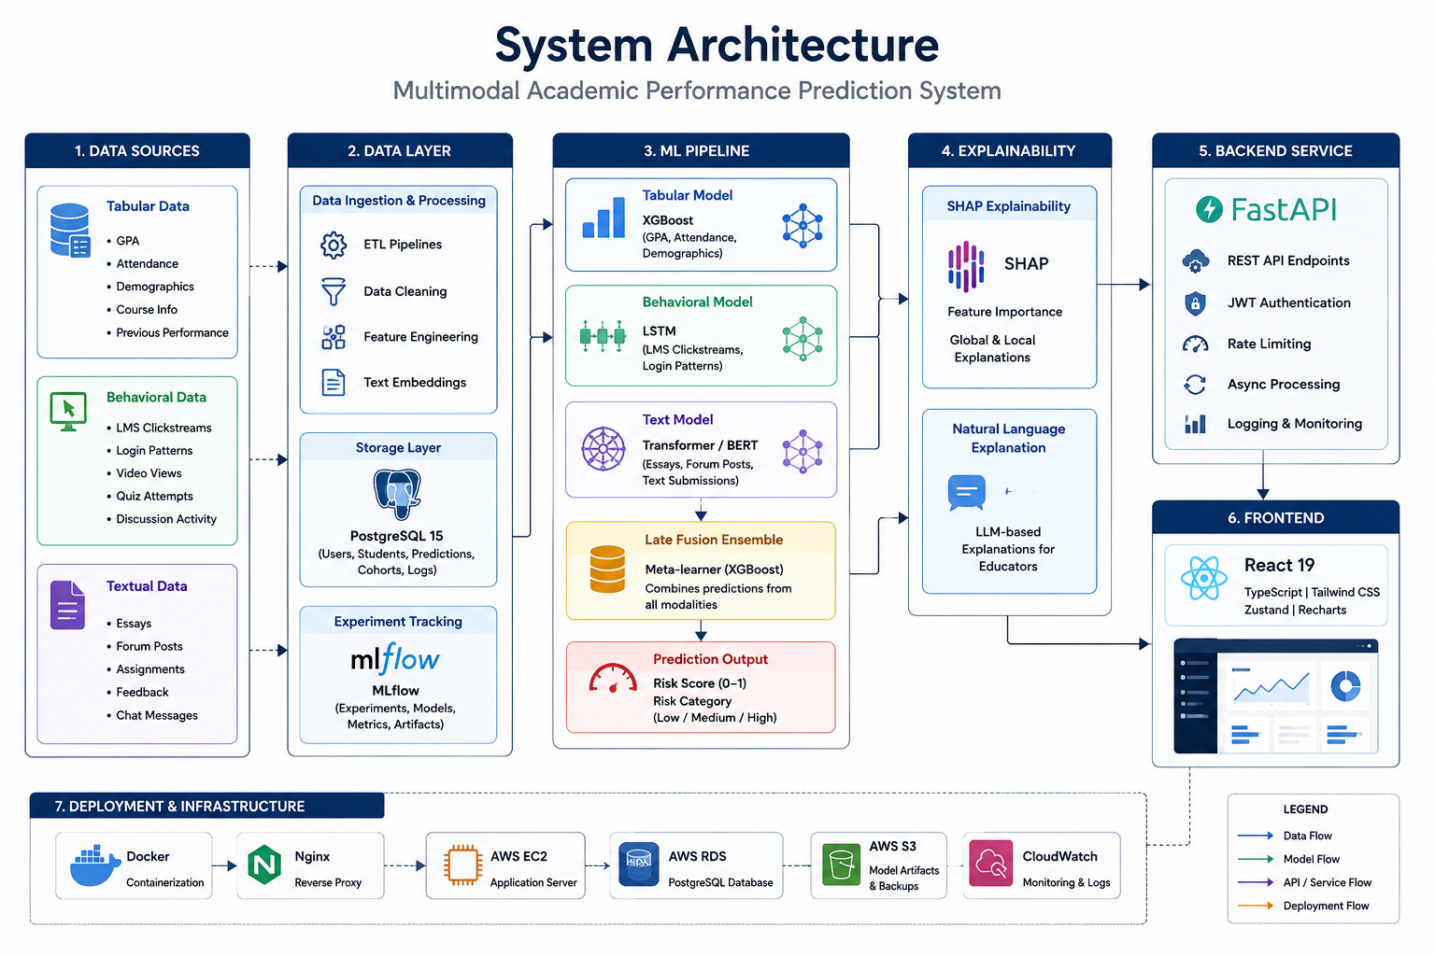
Figure 1: System Architecture Diagram

8. Expected Outcomes
1. A trained multimodal ensemble achieving higher F1 score than any single unimodal model.
2. Explainable predictions with SHAP values and natural language summaries for each student.
3. A production-ready web application with login, cohort dashboard, risk table, and explanation modal.
4. Docker-based deployment pipeline with automated database seeding and migrations.
5. Comprehensive test suite with 17 backend test files covering models, API, and services.

9. References
[1] Baltrušaitis, T., Ahuja, C., & Morency, L.-P. (2019). Multimodal Machine Learning: A Survey and Taxonomy. Foundations and Trends® in Computer Graphics and Vision.
[2] Zadeh, A., Chen, M., Poria, S., Cambria, E., & Morency, L.-P. (2017). Tensor Fusion Network for Multimodal Sentiment Analysis. ACL Workshop.
[3] Vaswani, A., et al. (2017). Attention Is All You Need. NeurIPS.
[4] Devlin, J., Chang, M.-W., Lee, K., & Toutanova, K. (2019). BERT: Pre-training of Deep Bidirectional Transformers for Language Understanding. NAACL.
[5] Chen, T., & Guestrin, C. (2016). XGBoost: A Scalable Tree Boosting System. KDD.
[6] Lundberg, S. M., & Lee, S.-I. (2017). A Unified Approach to Interpreting Model Predictions (SHAP). NIPS Workshop.
[7] Ribeiro, M. T., Singh, S., & Guestrin, C. (2016). "Why Should I Trust You?" Explaining the Predictions of Any Classifier (LIME). KDD.
[8] Zhou, Z.-H. (2012). Ensemble Methods: Foundations and Algorithms. Chapman & Hall/CRC.
[9] Baker, R. S. J. d., & Inventado, P. S. (2014). Educational Data Mining and Learning Analytics. Springer.
[10] Romero, C., & Ventura, S. (2010). Educational Data Mining: A Review of the State of the Art. IEEE Transactions on SMC.
[11] Kuhn, M., & Johnson, K. (2013). Applied Predictive Modeling. Springer.
[12] Goodfellow, I., Bengio, Y., & Courville, A. (2016). Deep Learning. MIT Press.
[13] Poria, S., Cambria, E., Bajpai, R., & Hussain, A. (2017). A Review of Affective Computing. IEEE Trans. Affective Computing.
[14] Lundberg, S. M., et al. (2020). From Local Explanations to Global Understanding with Explainable AI for Trees. Nature Machine Intelligence.

