**Assignment –5 Relational and Logical Operators.**

1. Write a query that will give you all orders for more than Rs. 1,000.

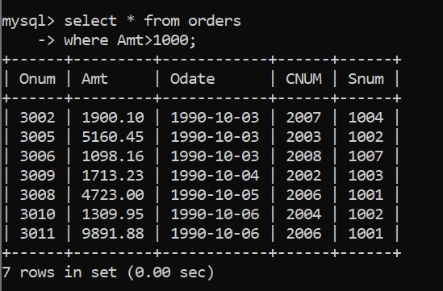

1. Write a query that will give you the names and cities of all salespeople in London with a commission above .10.

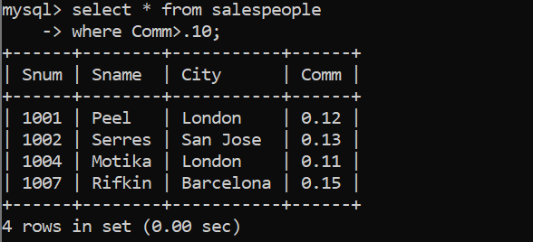

1. Write a query on the Customers table whose output will exclude all customers with a rating <= 100, unless they are located in Rome.

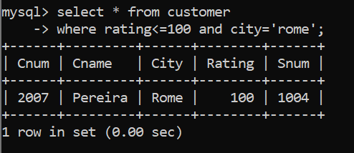

1. What will be the output from the following query? Select * from Orders where (amt < 1000 OR NOT (odate = ‘1990-10-03’ AND cnum > 2003));

ERROR!

1. What will be the output of the following query? Select * from Orders where NOT ((odate = ‘1990-10-03’ OR snum >1006) AND amt >= 1500);

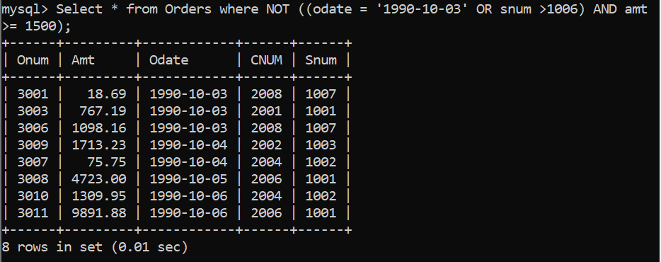

6) What is a simpler way to write this query? Select snum, sname, city, comm From Salespeople where (comm > .12 OR comm <.14);

