**Bansilal Ramnath Agarwal Charitable Trust’s**

**Vishwakarma Institute of Technology, Pune-37  *(An autonomous institute of Savitribai Phule Pune University)***



**Title : To study modeling methodologies and identify their applicability to various categories of projects.**

|  |  |
| --- | --- |
| **Year** | **Third** |
| **Branch** | **AI & DS** |
| **Division** | **AI-A** |
| **Batch** | **3** |
| **PRN** | **12320092** |
| **Roll no.** | **81** |
| **Name** | **Pandit Manasi Dilip** |
| **Subject** | **Software Design and Methodologies** |

**1. Waterfall Model**

* **Description**:  
  The Waterfall Model is a traditional linear and sequential software development approach where each phase is completed fully before the next phase begins. The process follows a strict progression through requirements gathering, system design, implementation (coding), testing, deployment, and maintenance. Each phase has specific deliverables, and no phase overlaps with another. It is best suited for projects with fixed and well-documented requirements.

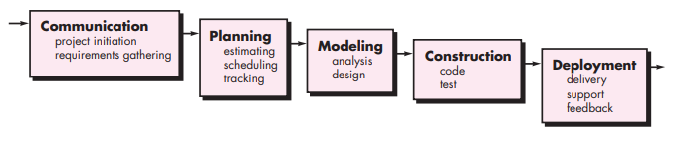

* **Advantages**:
  + Simple to use and understand due to its linear nature.
  + Clear documentation ensures everyone involved understands the system.
  + Each phase has well-defined milestones, making progress measurable.
  + Works effectively for small projects with well-understood requirements.
* **Limitations**:
  + Highly inflexible to changes once a phase is completed.
  + Errors discovered later in the process are costly to fix.
  + Limited customer feedback during development as the product is delivered at the end.
  + Poor fit for dynamic, evolving requirements.
* **Real-World Example**:  
  Developing a payroll system where the business requirements, tax rules, and calculations are clearly defined and unlikely to change.

**2. V-Model (Verification and Validation Model)**

* **Description**:  
  The V-Model extends the Waterfall Model by emphasizing verification and validation at each stage of development. Each development phase (e.g., requirements, design, coding) has a corresponding testing phase (e.g., user acceptance testing, system testing, unit testing). This ensures errors are identified as early as possible and guarantees a high-quality product.

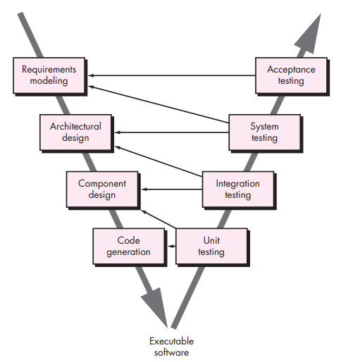

* **Advantages**:
  + Focuses on testing and validation at every stage, ensuring a quality product.
  + Errors are detected early, reducing overall project costs.
  + Ideal for safety-critical systems that require extensive verification (e.g., medical, aviation).
* **Limitations**:
  + Inflexible and requires detailed requirements upfront.
  + Not suited for projects where frequent requirement changes are expected.
  + Higher documentation overhead compared to the Waterfall Model.
* **Real-World Example**:  
  Used in the development of medical device software where adherence to regulatory standards and validation is critical.

**3. Incremental Model**

* **Description**:  
  The Incremental Model divides the system into small, manageable modules that are developed and delivered incrementally. Each module is fully functional and integrates seamlessly into the overall system. Feedback from early increments is used to improve subsequent ones. It’s well-suited for projects requiring early delivery of basic functionality.

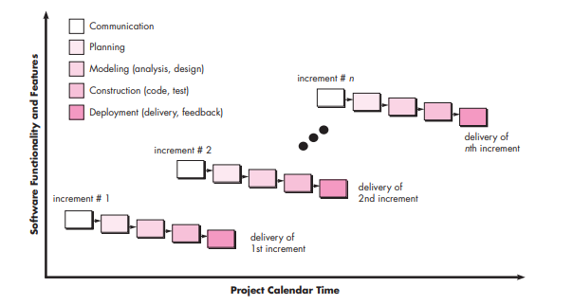

* **Advantages**:
  + Delivers functional software early in the development cycle.
  + Easier to test and debug smaller modules.
  + Flexible, allowing changes to requirements in later increments.
  + Reduces risks by delivering and evaluating portions of the system early.
* **Limitations**:
  + Requires careful planning to ensure modules integrate smoothly.
  + May increase complexity if modules are not properly aligned.
  + Not ideal for projects where full system functionality is needed immediately.
* **Real-World Example**:  
  Developing an e-commerce platform, where core functionalities like user registration, product catalog, and payment gateway are delivered incrementally.

**5. Iterative Model**

* **Description**:  
  The Iterative Model begins with implementing a small, basic subset of the system’s requirements. This subset is then improved upon through repeated cycles (iterations). Each iteration builds upon the previous one until the complete system is developed. It’s well-suited for projects where requirements are uncertain or likely to evolve over time.

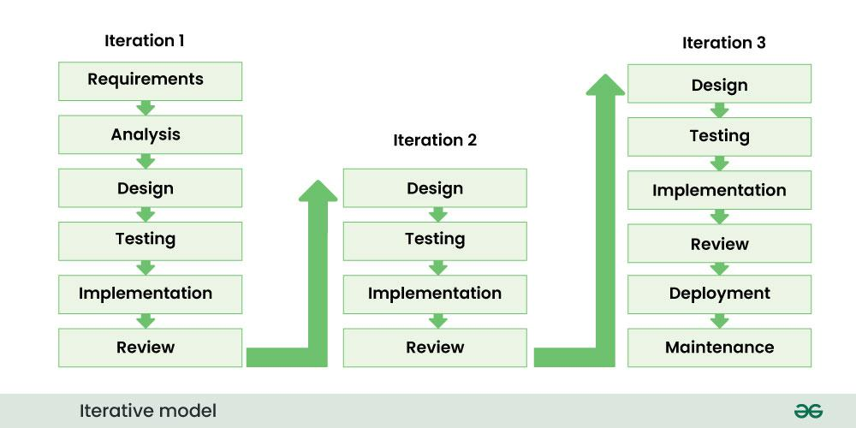

* **Advantages**:
  + Allows evolving requirements to be incorporated seamlessly.
  + Early detection of risks and issues through incremental development.
  + Feedback from users helps refine the product in subsequent iterations.
* **Limitations**:
  + Can become resource-intensive due to repeated cycles.
  + Requires robust planning to prevent scope creep.
  + May lead to incomplete system architecture if poorly managed.
* **Real-World Example**:  
  Development of a content management system (CMS) for a news website, where new features like article editing, publishing, and analytics are added iteratively.

**6. Spiral Model**

* **Description**:  
  The Spiral Model combines elements of iterative development with risk analysis. Each iteration (or spiral) includes four phases: Planning, Risk Analysis, Engineering, and Evaluation. The project evolves through spirals, with each spiral delivering a prototype or increment. It is ideal for complex projects with significant risks.

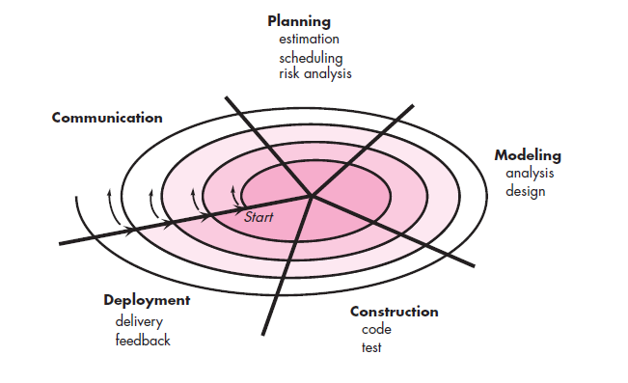

* **Advantages**:
  + Focuses on early risk identification and mitigation.
  + Flexible, allowing changes to be incorporated during development.
  + Works well for large and complex projects.
* **Limitations**:
  + High cost and time investment for risk management.
  + Requires expertise in risk analysis.
  + Complex to manage and implement.
* **Real-World Example**:  
  Development of banking software that involves significant risk analysis for security and compliance.

**7. Prototype Model**

* **Description**:  
  The Prototyping Paradigm Model focuses on building a working prototype of the system early in the development process. The prototype serves as a visual and functional representation of the final system, helping to refine unclear or ambiguous requirements. After gathering feedback and refining the prototype, the final system is developed.

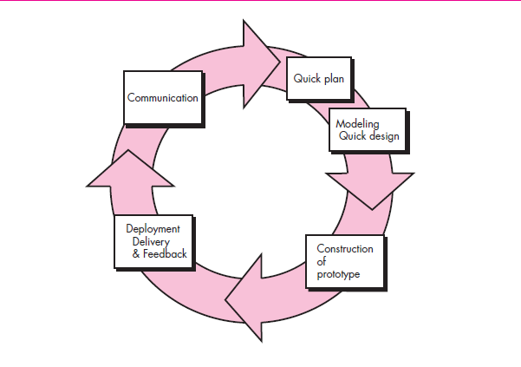

* **Advantages**:
  + Clarifies requirements early in the process, reducing misunderstandings.
  + Encourages user involvement, ensuring the product meets expectations.
  + Reduces risks by identifying issues early through prototype testing.
* **Limitations**:
  + Overemphasis on the prototype may delay the development of the actual system.
  + Can lead to scope creep if users continuously request changes.
  + Resource-intensive, requiring time and effort to build and refine prototypes.
* **Real-World Example**:  
  Developing a banking mobile application where a prototype is used to gather feedback on user interface designs and key functionalities before full-scale development.

**8. Agile Model**

* **Description**:  
  Agile is an iterative and incremental model that prioritizes flexibility, collaboration, and continuous delivery of functional software. Development occurs in short sprints (2-4 weeks), where requirements are reviewed and adjusted based on stakeholder feedback. It is highly adaptive and focuses on customer satisfaction.

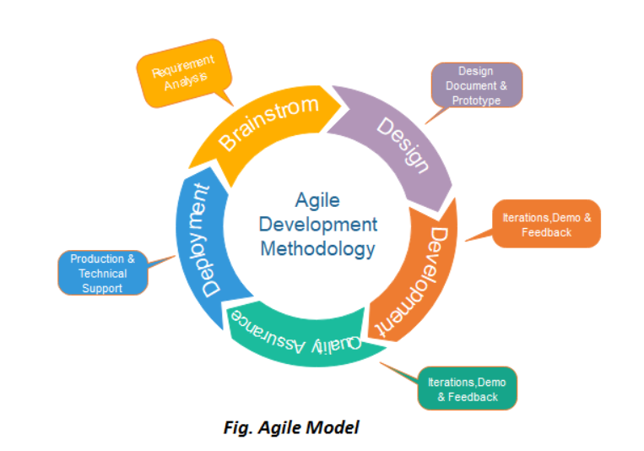

* **Advantages**:
  + Highly flexible, accommodating changes in requirements.
  + Continuous delivery of working software keeps stakeholders engaged.
  + Encourages collaboration between teams and customers.
* **Limitations**:
  + Requires experienced team members to handle dynamic requirements.
  + Difficult to predict costs and timelines due to evolving requirements.
  + Not ideal for projects with strict deadlines or budgets.
* **Real-World Example**:  
  Developing an AI chatbot with core features in early sprints and additional capabilities like multi-language support in later sprints.

**Conclusion :**

In conclusion, we explored various modeling methodologies, analyzing their applicability across different project categories with real-time examples and diagrammatic representations. We examined their advantages, limitations, and key differences, providing a comprehensive understanding of when and how each methodology should be applied. This study serves as a valuable reference for selecting the most suitable approach based on project requirements and constraints.