**Bansilal Ramnath Agarwal Charitable Trust’s**

**Vishwakarma Institute of Technology, Pune-37  *(An autonomous institute of Savitribai Phule Pune University)***



**Title : . To prepare Component and Deployment diagram for a defined problem.**

|  |  |
| --- | --- |
| **Year** | **Third** |
| **Branch** | **AI & DS** |
| **Division** | **AI-A** |
| **Batch** | **3** |
| **PRN** | **12320092** |
| **Roll no.** | **81** |
| **Name** | **Pandit Manasi Dilip** |
| **Subject** | **Software Design and Methodologies** |

**1. Introduction**

The Treasure Hunt Game System is an interactive game where players solve clues, interact with Augmented Reality (AR) elements, and progress through a series of challenges. The system involves various components such as game management, player tracking, scoring, leaderboard updates, and AR-based clue validation.

To understand the system's structure and deployment, we have designed:

* A Component Diagram to depict the internal architecture and interactions of the system's modules.
* A Deployment Diagram to illustrate the hardware and software setup for running the application.

**2. Component Diagram**

**2.1 Purpose**

The Component Diagram represents the high-level structure of the Treasure Hunt Game System. It showcases how different software components interact and manage game logic, player progress, and external interfaces (such as AR clues and the leaderboard).

**2.2 Components & Their Roles**

* Player Component: Handles player login, game start, clue scanning, and AR interactions.
* Treasure Hunt Component: Manages the game flow, total clues, and player progress.
* Game Environment Component: Controls difficulty levels and leaderboard updates.
* Leaderboard Component: Stores and updates player rankings.
* Score Manager Component: Calculates and resets player scores.
* AR Clue Component: Processes different clue types (image, audio, text) and validates them.
* Scannable Interface: Standardized way for scanning and verifying clues.
* Admin Panel Component: Allows game administrators to manage settings, modify leaderboard rankings, and update game configurations.

**2.3 Component Diagram Representation**

The diagram clearly defines relationships between components using associations and dependencies. The Scannable interface provides an abstraction layer for handling different types of AR clues. Game logic and scoring mechanisms are centralized, ensuring consistency.

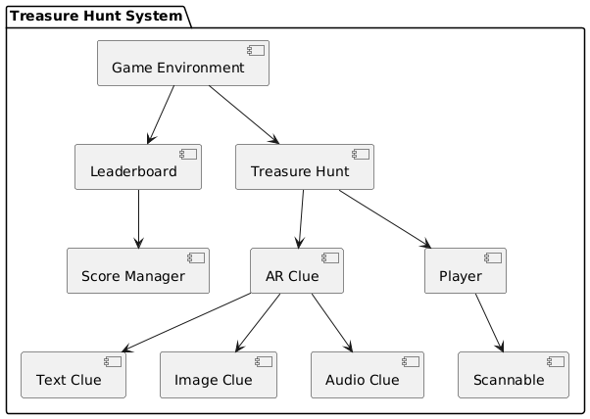

**3. Deployment Diagram**

**3.1 Purpose**

The Deployment Diagram illustrates the physical distribution of components across different hardware and network environments. It highlights how the system is deployed, including player devices, game servers, databases, and external storage services.

**3.2 Nodes & Their Roles**

* Player Device: Runs the Treasure Hunt App, allowing players to interact with AR clues and progress in the game.
* Game Server: Manages game logic, leaderboard updates, and player data processing.
* Cloud Infrastructure: Stores persistent data (game progress, scores, leaderboard) in the Game Database and Clue Storage.
* AR System: Processes scanned AR clues using the AR Clue Processor, validating and sending data back to the game environment.
* Admin Panel: Provides an interface for game administrators to update game settings, modify leaderboards, and adjust scoring rules.

**3.3 Deployment Diagram Representation**

The diagram uses clear node divisions to represent different system components. It employs color-coded arrows to define data flow and interactions between players, game logic, storage, and processing units.

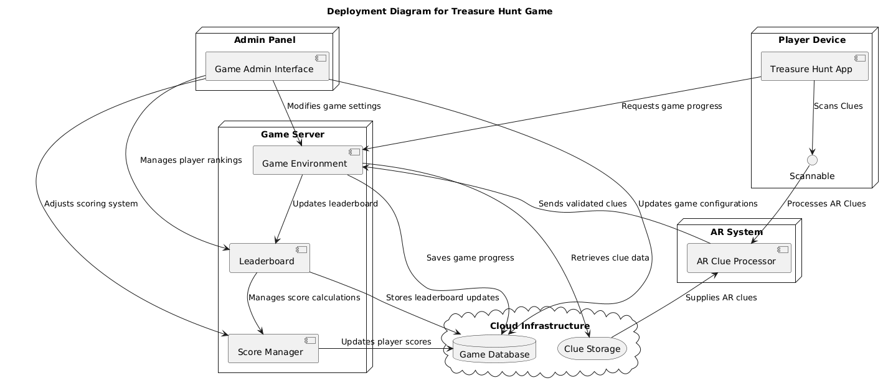

**Conclusion :**

The Component and Deployment Diagrams effectively illustrate the architecture and physical implementation of the Treasure Hunt Game System. These diagrams help in:

* Understanding software modularity and functional breakdown.
* Visualizing how the system is deployed and interconnected.
* Providing a structured approach for future development and optimization.

The system is designed for scalability, allowing future integration of new clue types, enhanced AR processing, and cloud-based game enhancements.