**Bansilal Ramnath Agarwal Charitable Trust’s**

**Vishwakarma Institute of Technology, Pune-37  *(An autonomous institute of Savitribai Phule Pune University)***



**Title : To explore Model-Driven Development (MDD) and Model-Driven Architecture (MDA), and to understand the significance of Model Transformation.**

|  |  |
| --- | --- |
| **Year** | **Third** |
| **Branch** | **AI & DS** |
| **Division** | **AI-A** |
| **Batch** | **3** |
| **PRN** | **12320092** |
| **Roll no.** | **81** |
| **Name** | **Pandit Manasi Dilip** |
| **Subject** | **Software Design and Methodologies** |

**1. Model-Driven Development (MDD)**

Model-Driven Development (MDD) is a methodology designed to accelerate software development, improve efficiency, and minimize costs. It is also referred to as Model-Driven Software Development (MDSD), Model-Driven Engineering (MDE), or Model-Driven Architecture (MDA).

In MDD, the primary focus is on creating a comprehensive software model before any code is written. This model serves as a blueprint that outlines how the software system should function. Once the model is complete, it can be used to generate code, which can then undergo testing using model-based testing (MBT) techniques before deployment.

Benefits of Model-Driven Development

**MDD offers several advantages over traditional development methods:**

* Increased Productivity : The model simplifies the engineering process by defining the intended behavior of the software upfront, reducing ambiguity and rework.
* Collaborative Development : Teams work together to construct models, fostering better communication between developers, product managers, and other stakeholders. This ensures clear definitions of the software’s functionality and purpose.
* Faster Iterations : Testing, rebuilding, and redeploying applications are faster in MDD compared to traditional methods, especially when developing multiple applications simultaneously.

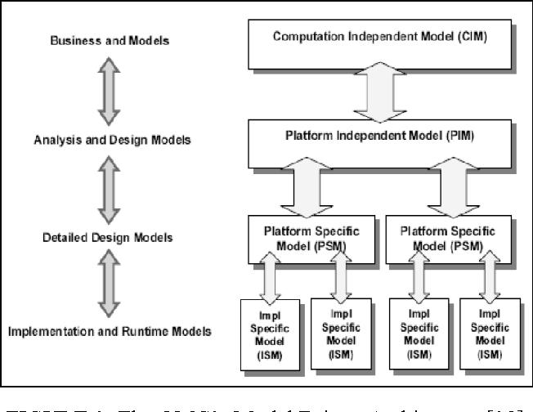

Fig. Model-Driven Development (MDD)

**Core Concepts of MDD**

MDD goes beyond simply having a model; it emphasizes abstraction and automation:

* **Abstraction** : Complex systems are broken down into simpler, more manageable components. This abstraction helps extract clean, well-defined code from the model.
* **Automation :** Once the model is transformed, automation tools generate working software. Domain-Specific Languages (DSLs), such as HTML or ColdFusion, are often used for this purpose. These languages can integrate with other programming languages like C++ or .NET and services like FTP.
* **Agile Integration :** MDD is often combined with Agile methodologies, leading to Agile Model-Driven Development (AMDD). In AMDD, short development cycles allow for iterative design and rapid feedback. Changes can be quickly incorporated into the model and reflected in the code.

**Tools for MDD**

Several tools support MDD:

* **IBM Rational Software Architect :** A modeling tool that uses Unified Modeling Language (UML) to design models for C++ and Java EE applications.
* **Simulink :** A MathWorks environment for modeling and simulating software. It automatically generates code based on the model.
* **Sirius :** An open-source tool from the Eclipse Foundation that allows users to create models using diagrams, data trees, and tables without requiring extensive technical knowledge.

**2. Model-Driven Architecture (MDA)**

The Model-Driven Architecture (MDA) is a framework developed by the Object Management Group (OMG) to address the challenges of change in software development. MDA achieves this by separating platform-independent models (PIMs) from platform-specific models (PSMs) and using transformation techniques to relate them.

* Platform-Independent Models (PIMs) : These models describe a system without including technology-specific details. For example, a generic description of a system would be considered a PIM.
* Platform-Specific Models (PSMs) : These models include technology-specific implementation details. For instance, describing a system using Java or Microsoft .NET would result in a PSM.

Transformation techniques convert PIMs into PSMs, detailing how the system utilizes the capabilities of its chosen platform. By maintaining a clear separation but connection between these models, developers can work from the perspective that best suits their understanding of the system. Transformations can occur repeatedly until the model reaches its target platform, whether it’s software or hardware.

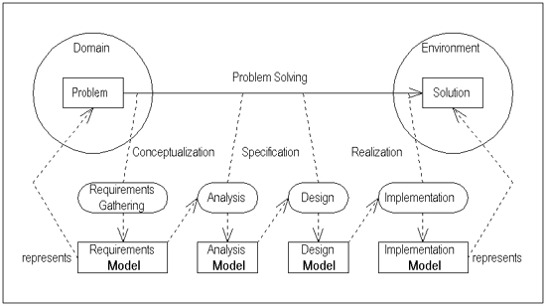

Fig. Model-Driven Architecture (MDA)

**Key Features of MDA**

* **Open and Vendor-Neutral :** MDA leverages OMG standards across various domains and technologies, ensuring flexibility and interoperability.
* **Lifecycle Support :** MDA supports the entire system development lifecycle, bridging the gap between requirements, technologies, and platforms as they evolve independently.
* **Long-Term Benefits :** MDA promotes flexibility, integration, maintenance, testing, simulation, portability, interoperability, and reusability.

**OMG’s Role in MDA**

The OMG oversees MDA through its Technology Committees (TCs), which provide standardization guidance.

* **Domain Technology Committees (DTCs) :** Focus on vertical markets like healthcare, finance, and telecommunications to capture domain-specific models.
* **Platform Technology Committees (PTCs) :** Address horizontal technologies like web services to capture technology-specific models.
* **Architecture Board (AB) :** Ensures coherence and consistency across all OMG standards.

**Conclusion**

Model-Driven Development (MDD) and Model-Driven Architecture (MDA) offer powerful approaches to software development. By emphasizing abstraction, automation, and model transformation, these methodologies enhance software quality, streamline validation processes, and reduce errors. Additionally, they provide cost-effective solutions that adapt to changing requirements and technological advancements. As a result, MDD and MDA contribute to long-term flexibility, reusability, and maintainability in software systems.