**Bansilal Ramnath Agarwal Charitable Trust’s**

**Vishwakarma Institute of Technology, Pune-37  *(An autonomous institute of Savitribai Phule Pune University)***



**Title : To study the types of MOF (Meta-Object Facility) and metamodel concepts for various diagrams in UML 2.0.**

|  |  |
| --- | --- |
| **Year** | **Third** |
| **Branch** | **AI & DS** |
| **Division** | **AI-A** |
| **Batch** | **3** |
| **PRN** | **12320092** |
| **Roll no.** | **81** |
| **Name** | **Pandit Manasi Dilip** |
| **Subject** | **Software Design and Methodologies** |

**Introduction to Metamodeling**

Metamodeling is a foundational concept in UML 2.0 that operates across multiple hierarchical levels, forming a layered architecture. This architecture ensures consistency, precision, and proper definition of modeling elements. The hierarchical structure allows for the clear separation of concerns between different abstraction levels, enabling both the modeling language itself and the models created using it to be well-defined and interoperable.

The **four-layer architecture of UML 2.0** metamodeling can be visualized as follows:

1. **M3 Layer (Meta-Meta Model):** Represents the highest level, where the Meta-Object Facility (MOF) resides.
2. **M2 Layer (Meta-Model):** Contains the definitions of UML itself, including its core constructs.
3. **M1 Layer (Model):** Where actual UML diagrams are created, representing the system being modeled.
4. **M0 Layer (Runtime Instances):** Represents the concrete implementations or runtime objects of the modeled system.

Each layer interacts with the one below it through transformation relationships. For example:

* MOF defines the rules for UML.
* UML describes valid models.
* Models instantiate into concrete objects at runtime.

This layered approach ensures that models are consistent, reusable, and aligned with the underlying standards.

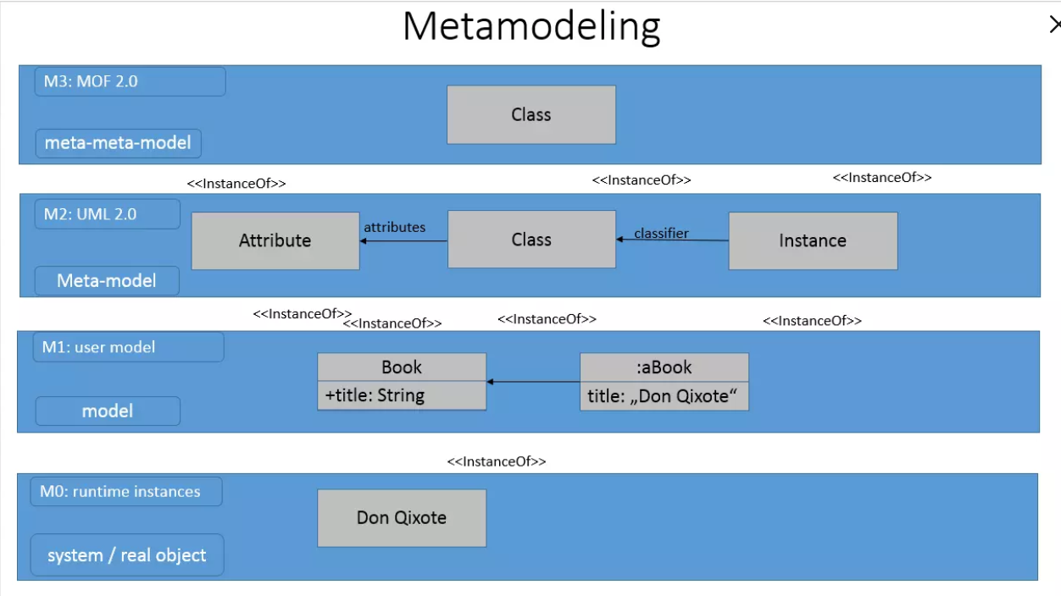

Fig. Architecture of UML 2.0

**Level M3: Meta-Meta Model (MOF)**

The Meta-Object Facility (MOF) serves as the foundation of UML's metamodeling architecture. At this level:

* Metadata Definitions: Establishes the fundamental constructs for defining metadata.
* Rules for Metadata Transfer: Specifies how metadata is shared and interpreted across tools and systems.
* XMI (XML Metadata Interchange): Defines a standardized format for exchanging object-oriented data between tools.
* OCL (Object Constraint Language): Provides declarative programming support for specifying constraints and conditions on models.

MOF ensures that all modeling languages, including UML, adhere to a common framework for defining their own metamodels. It acts as the "language of languages," enabling interoperability and consistency across different modeling tools and environments.

**Level M2: Meta-Model (UML 2.0)**

At the M2 level, UML 2.0 defines its core constructs and language elements. These definitions serve as the blueprint for creating UML models. Key components include:

1. **Language Units:**
   * Classes and Associations: Define the structure of the system.
   * Components and Interfaces: Represent modular parts of the system and their interactions.
   * Profiles for Customization: Allow UML to be tailored for specific domains or platforms.
   * Models for System Representation: Provide a high-level view of the system architecture.
2. **Core Infrastructure Elements:**
   * Packages and Namespaces: Organize model elements into logical groupings.
   * Attributes and Operations: Specify the properties and behaviors of classes.
   * Relationship Specifications: Define associations, dependencies, and other relationships between elements.

The M2 layer ensures that UML models are consistent, reusable, and aligned with the principles of object-oriented design.

**Level M1: Model Layer**

The M1 layer is where actual UML diagrams are created to represent the system being modeled. These diagrams fall into two main categories:

1. **Structure Diagrams:**
   * Class Diagrams: Illustrate the static structure of the system, including classes, attributes, and relationships.
   * Component Diagrams: Show the organization and dependencies between software components.
   * Deployment Diagrams: Represent the physical deployment of artifacts on hardware nodes.
   * Package Diagrams: Organize model elements into packages for better modularity.
2. **Behavior Diagrams:**
   * Activity Diagrams: Model workflows and processes within the system.
   * State Machine Diagrams: Capture the dynamic behavior of objects through state transitions.
   * Interaction Diagrams: Include sequence diagrams and communication diagrams to show how objects interact.
   * Sequence Diagrams: Focus on the order of messages exchanged between objects over time.

These diagrams provide a comprehensive view of the system, covering both its structural and behavioral aspects.

**Level M0: Runtime Instances**

The M0 layer represents the concrete implementation of the modeled system. At this level:

* Actual Objects: Instances of classes defined in the model.
* Runtime Data Records: Data stored and processed by the system during execution.
* Executing Instances: Components and modules that are actively running.
* Concrete Manifestations: Physical realizations of the designed elements, such as deployed applications or services.

The M0 layer bridges the gap between the abstract models and the real-world implementation, ensuring that the system behaves as intended.

**Practical Applications**

1. **Model Transformation:**
   * Converting Between Diagrams: Transforming one type of UML diagram into another (e.g., converting a class diagram into a sequence diagram).
   * Cross-Level Transformations: Moving between abstraction levels, such as generating code from a UML model.
   * Consistency Maintenance: Ensuring that changes in one part of the model are reflected consistently across all related elements.
2. **Tool Integration:**
   * Metadata Exchange: Sharing metadata between development tools using XMI.
   * Consistent Interpretation: Ensuring that models are interpreted uniformly across different tools and platforms.
   * Standardized Environment: Providing a common framework for modeling tools to interoperate seamlessly.
3. **Validation:**
   * Compliance Checking: Verifying that models adhere to UML standards and rules.
   * Instantiation Relationships: Ensuring that models are properly instantiated and aligned with their metamodels.
   * Architectural Integrity: Maintaining the integrity of the system architecture throughout the development lifecycle.

**Key Concepts Summary**

1. **Metamodel Hierarchy:**
   * Four distinct levels of abstraction (M3, M2, M1, M0).
   * Clear relationships and transformation paths between layers.
   * Ensures consistency and reusability across models.
2. **MOF Role:**
   * Acts as the foundation for UML metamodeling.
   * Enables metadata management and model interchange.
   * Provides a standardized framework for defining modeling languages.
3. **Model Consistency:**
   * Ensures proper instantiation of models.
   * Maintains architectural integrity and alignment with standards.
   * Supports evolution, refinement, and adaptation to changing requirements.

**UML diagrams: an overview**

The following overview shows the categories and possible applications of the individual UML diagram types in short form. If you want to visually represent a model-oriented software system, you should first select one of the UML diagram types according to the recommendation of the UML task force. Only then is it worthwhile to choose one of the many UML tools, since these often require a certain method. Then you can then create a UML diagram.

|  |  |  |
| --- | --- | --- |
| **Category** | **Diagram type** | **Use** |
| Structure diagrams | Class diagram | Represents classes |
| Structure diagrams | Object diagram | Shows a system’s state at a specific moment |
| Structure diagrams | Component diagram | Shows dependencies and structure components |
| Structure diagrams | Composite structure diagram | Divides modules or classes into their components, and clarifies their relationships |
| Structure diagrams | Package diagram | Groups classes into packages, represents package hierarchy and structure |
| Structure diagrams | Deployment diagram | Shows the distribution of components to computer nodes |
| Structure diagrams | Profile diagram | Illustrates usage relationships through stereotypes, boundary conditions, etc. |
| Behavior diagrams | Use case diagram | Represents various uses |
| Behavior diagrams | Activity diagram | Describes the behavior of different (parallel) processes in a system |
| Behavior diagrams | State machine diagram | Documents how an object is changed from one state to another through an event |
| Behavior diagrams - interaction diagrams | Sequence diagram | Represents the timing of interactions between objects |
| Behavior diagrams - interaction diagrams | Communication diagram | Shows the role distribution of objects within an interaction |
| Behavior diagrams - interaction diagrams | Timing diagram | Demonstrates the temporal limitation for events that lead to a change of state |
| Behavior diagrams - interaction diagrams | Interaction overview diagram | Shows how sequences and activities interact |

**Conclusion**

Understanding the types of MOF and metamodel concepts in UML 2.0 is essential for creating consistent, valid, and compliant models. The four-layer architecture provides a robust framework for defining modeling languages, creating models, and implementing systems. By leveraging the principles of metamodeling, developers can ensure that their models accurately reflect the system architecture while adhering to UML standards. This structured approach not only enhances the quality of software development but also promotes interoperability, maintainability, and scalability.

By mastering these concepts, practitioners can effectively utilize UML 2.0 to design complex systems, validate their correctness, and transform models into functional implementations.