**Bansilal Ramnath Agarwal Charitable Trust’s**

**Vishwakarma Institute of Technology, Pune-37  *(An autonomous institute of Savitribai Phule Pune University)***



**Title : To identify Entity, Control, Boundary objects and trace object interactions for scenarios from use cases.**

|  |  |
| --- | --- |
| **Year** | **Third** |
| **Branch** | **AI & DS** |
| **Division** | **AI-A** |
| **Batch** | **3** |
| **PRN** | **12320092** |
| **Roll no.** | **81** |
| **Name** | **Pandit Manasi Dilip** |
| **Subject** | **Software Design and Methodologies** |

**1. Introduction**

This report analyses two sequence diagrams to identify Entity, Control, and Boundary objects and trace their interactions within the system. The diagrams represent the workflow of an Augmented Reality (AR) treasure hunt game.

**2. Object Classification**

**2.1 Entity Objects**

Entity objects represent data-centric components that persist information across sessions and encapsulate core business logic.

* Game Data: Stores information about the created games, game settings, scores, and rankings.
* AR Clue System: Maintains and validates AR clues.
* Player Progress: Tracks the player's advancement in the treasure hunt.

**2.2 Control Objects**

Control objects manage the flow of data and interaction between the entity and boundary objects.

* Game Organizer: Responsible for creating and managing games.
* System Administrator: Ensures security, maintains system operations, and updates game settings.
* Permissions Manager: Checks and grants/denies access permissions for AR clue detection.
* Internet Connectivity Checker: Monitors network connectivity and alerts players about poor connectivity.

**2.3 Boundary Objects**

Boundary objects handle interactions between the user and the system.

* Mobile App Interface: Allows players to launch the game, discover AR clues, view interactive maps, and track progress.
* AR Scanner: Scans the environment for clues and displays detected AR hints.
* Visual Feedback System: Notifies the player of detected clues, errors, or system alerts.

**3. Object Interaction Tracing**

**Scenario 1: Player Engages in Treasure Hunt**

1. Player launches the mobile app → Boundary Object: Mobile App Interface interacts with the System.
2. Player discovers AR clues → Control Object: AR Clue System retrieves and validates clues.
3. Environment scanning begins → Boundary Object: AR Scanner interacts with the AR Clue System.
4. Clue validation occurs → Control Object: System verifies the validity of the clue.
5. Interactive maps displayed → Entity Object: Game Data provides relevant map details.
6. Scores and rankings updated → Entity Object: Player Progress records scores.

**Scenario 2: Permissions and Connectivity Handling**

1. Player activates AR scanner → Boundary Object: AR Scanner initiates the scanning process.
2. Permissions checked → Control Object: Permissions Manager verifies necessary access.
   * If granted, scanning continues.
   * If denied, an error message is displayed.
3. Clue detection process begins → Control Object: AR Clue System processes environment data.
   * If clues are found, they are displayed.
   * If no clues are found, an alert is generated.
4. Connectivity status checked → Control Object: Internet Connectivity Checker verifies network stability.
   * If weak, a warning message is shown.

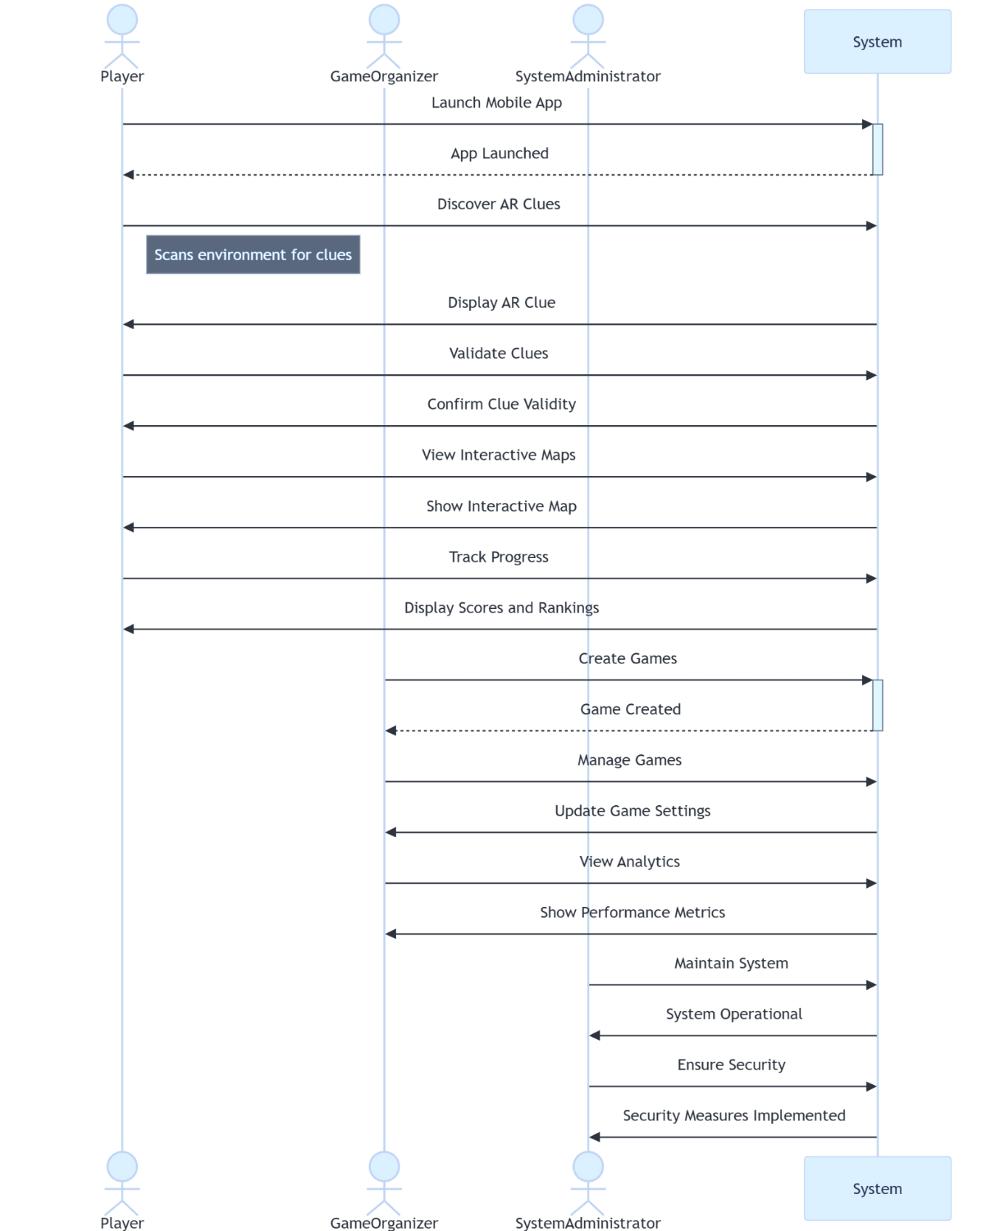

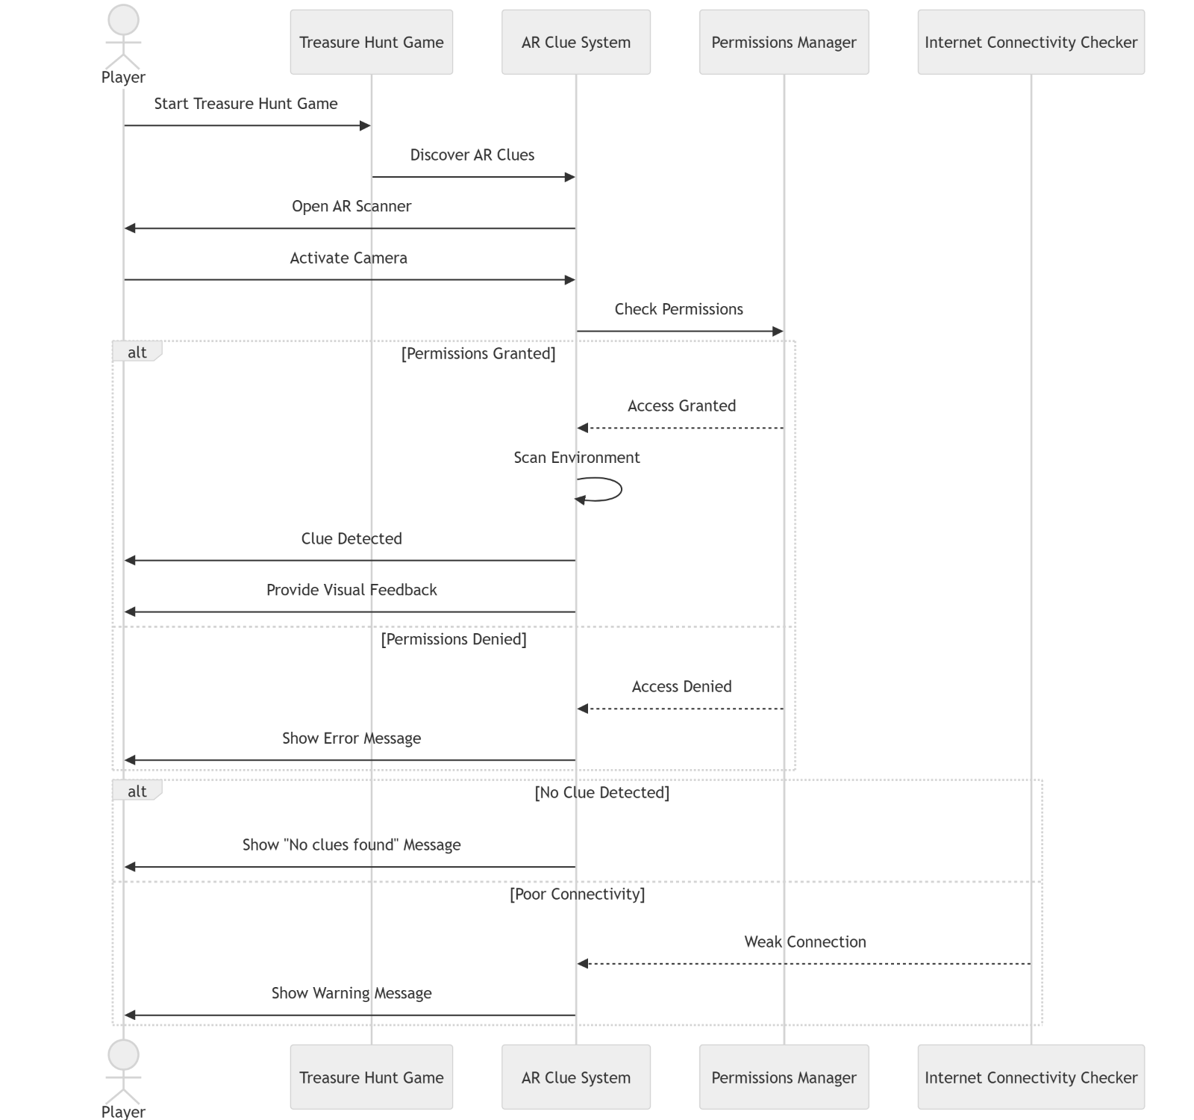

**Conclusion :**

By classifying objects into Entity, Control, and Boundary categories, we have traced interactions that define the AR treasure hunt game workflow. The Control objects facilitate smooth execution of game operations, while Entity objects ensure data persistence. Boundary objects provide an interface for user interaction, ensuring an engaging gaming experience. This structured classification helps in designing a well-organized, maintainable system architecture.