**Bansilal Ramnath Agarwal Charitable Trust’s**

**Vishwakarma Institute of Technology, Pune-37  *(An autonomous institute of Savitribai Phule Pune University)***



**Title : To identify object states, transitions, entry-exit points, concurrency, action parallelism and prepare a state chart diagram for given object scenario**

|  |  |
| --- | --- |
| **Year** | **Third** |
| **Branch** | **AI & DS** |
| **Division** | **AI-A** |
| **Batch** | **3** |
| **PRN** | **12320092** |
| **Roll no.** | **81** |
| **Name** | **Pandit Manasi Dilip** |
| **Subject** | **Software Design and Methodologies** |

1. **Introduction :**

The purpose of this report is to analyze the state diagram designed for anAR-based treasure hunt game. The diagram illustrates the various states the game can transition through, the interactions between them, and how error handling is incorporated to ensure smooth gameplay.

1. **Overview of the State Diagram :**

The state diagram consists of multiple statesrepresenting different phases of the game. It includes error-handling mechanisms, scanning procedures, and user interactions. The transitions between states are defined based on specific conditions such as finding a clue, connection loss, or permission denial.

1. **Key Components of the Diagram**

* Idle State: The starting point of the game where the player logs in.
* Active State: The player actively participates in the game and initiates the AR scanner.
* Scanning Process:
  + Checking Permissions: Ensures the user has granted necessary permissions.
  + Validating Clues: Determines if a clue is found or not.
* Clue Detected State: The player continues the treasure hunt upon finding a clue.
* Error Handling:
  + Connectivity Check: Verifies internet connection in case of network issues.
  + Permission Handling: Redirects the player to error handling if permissions are denied.
* Game Over State: The final state, where the player completes the hunt successfully or fails due to errors.

1. **Error Handling Mechanisms**

The diagram efficiently incorporates error handling with two key checks:

* Permissions Denied: Redirects to the error handling state if permissions are not granted.
* Connectivity Loss: Directs to a reconnection loop where the system attempts to reconnect. If unsuccessful, the game ends.

1. **Enhancements and Recommendations**

* Feedback System: Adding visual or textual feedback for players when they fail to detect a clue.
* Retry Mechanism: Implementing an automatic retry for scanning rather than requiring user intervention.
* Leaderboard Integration: Introducing a scoring system based on clue detection efficiency and time taken.

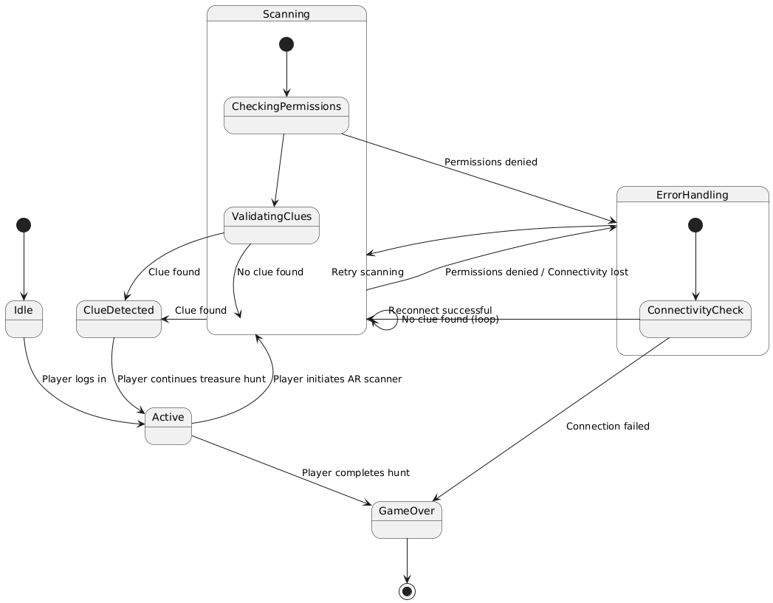

**Conclusion :**

The state diagram effectively maps out the logical flow of the AR-based treasure hunt game, ensuring a structured approach to scanning, error handling, and user interactions. Future improvements can enhance user engagement and game performance.