**Bansilal Ramnath Agarwal Charitable Trust’s**

**Vishwakarma Institute of Technology, Pune-37  *(An autonomous institute of Savitribai Phule Pune University)***



**Title : To prepare detailed Activity diagram with notational compliance to UML 2.0 indicating clear use of pins, fork-join, synchronization, datastores**

|  |  |
| --- | --- |
| **Year** | **Third** |
| **Branch** | **AI & DS** |
| **Division** | **AI-A** |
| **Batch** | **3** |
| **PRN** | **12320092** |
| **Roll no.** | **81** |
| **Name** | **Pandit Manasi Dilip** |
| **Subject** | **Software Design and Methodologies** |

**Introduction:**

The purpose of this report is to outline the logical flow of an Augmented Reality (AR)-based treasure hunt game. The flowchart depicts the sequence of actions and decision-making processes that guide a player from logging in to completing the game. The system is designed to enhance user engagement by integrating AR elements, interactive clues, and a scoring system.

**2. Flowchart Overview**

The flowchart consists of multiple stages, starting with the player's login and proceeding through various gameplay phases until the final score is displayed. It incorporates decision points that direct the player based on their interactions and progress in the game.

**3. Detailed Flow Analysis**

* **Player Login and Game Environment Setup**
  + The game begins when a player logs in.
  + The game environment is loaded.
  + A decision point determines whether the player is new or returning.
  + New players are shown a tutorial, while returning players resume from their last saved progress.
* **Game Start and AR Clue Scanning**
  + Once the game begins, players start the treasure hunt.
  + The system prompts the player to scan the surroundings for AR clues.
  + A decision point checks if there are more clues to find.
* **Interacting with AR Clues**
  + If a clue is detected, the game displays an AR hint.
  + The player interacts with the clue and scans the object.
  + The system validates the scanned object.
  + If the clue is correct, the player is awarded points, and the leaderboard is updated.
  + If the clue is incorrect, an error message is displayed.
* **Encouragement for Exploration**
  + If no clue is detected, the system encourages further exploration.
  + The loop continues until all clues are found.
* **Game Completion and Scoring**
  + Once all clues are found and processed, the game calculates and displays the final score.

**4. Key Features**

* User Engagement: The system dynamically interacts with the player by displaying AR hints and encouraging exploration.
* Decision-Based Flow: Multiple decision points ensure logical progression and appropriate feedback for the player.
* Scoring and Leaderboard: A structured point system rewards correct interactions, enhancing competitiveness.
* Error Handling: Incorrect attempts trigger an error message, providing necessary feedback for learning.

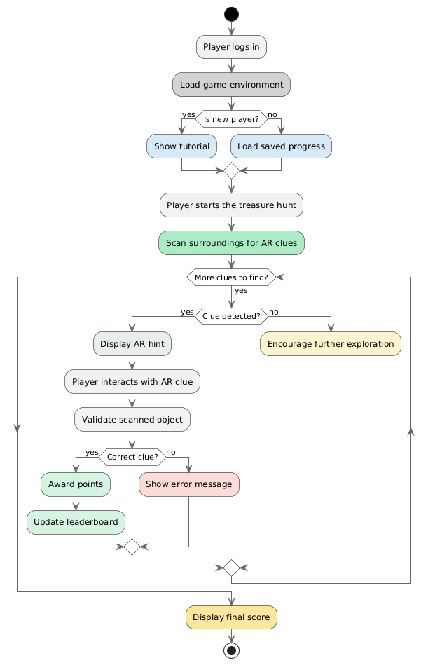

**Conclusion :**

This flowchart effectively captures the design of an interactive AR-based treasure hunt game. By integrating decision-making, feedback mechanisms, and an engaging user experience, it ensures a smooth and immersive gaming experience. The structured approach allows both new and returning players to enjoy the game while fostering exploration and competition.