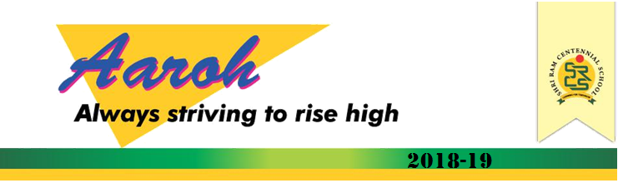

Dear Readers,

Greetings!

Very few have fully realized the wealth of sympathy, Kindness and generosity hidden in the soul of a child. The effort of every educator should be to unlock that treasure and SRCS is an excellent example where everyone strives indefatigably for this.

We have believed that “the heart of education is the education of the heart.”

We bring to you the beautiful start of our Academic session 2018-19.

We live today in a world that is so different from the one we were educated in. With the changing times we as educators need to pause and reflect on the current Education system. At SRCS before the beginning of the year we introspect our self’s whether we are well equipped to prepare our children to face the challenges that the future holds? Such questions are the factors that motivate us to go through continuous process of refection and thus we at SRCS are able to implement a well-balanced curriculum to ensure that the children get the best and they love their school and truly be prepared to face the challenges of Life.

Margaret mead said “Children must be taught how to think not what to think”.

**Kudoos to SRCSians for setting another bench Mark in AISSE-2018**

100% result achieved in Board Exams.Team SRCS feels immensely proud to announce that our students of class-X have brought laurels to both school and their parents with their Outstanding Performance in Board Exam.   
1. Jahnvi Sarda stood I by securing 92.5% marks  
2.Anish Manglani stood II by securing 88% marks  
3. Bhavanshi Dubey stood III by securing 86% marks  
The highlights of the results are:  
• 50% students got distinction, 80% students passed in First Divison.   
• In FIT, 34 students got distinction and 2 students Jahnvi Sarda & Rishabh Bhavasar got 100/100 marks.   
• 24 students got distinction in Hindi and 20 in English.   
• Subject wise highest scores are English - 91, Hindi - 99, Maths-94, Science - 96 and Social Science - 93.  
Congratulations once again for your fabulous performance! You deserve it every bit!  
Heartiest Congratulation to the proud parents..!!

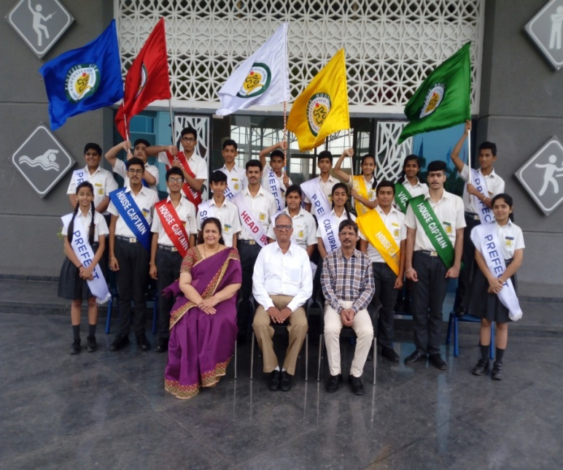**"A leader is the one who knows the way, goes the way and shows the way…"**The investiture Ceremony of SRCS was organised with great zeal and zest in the school. The ceremony was presided by the renowned educationist Mr.S.N.Patwardhan. Conducted with the highest degree of solemnity and passion, the event commenced with the lighting of the lamp, which signifies removal of darkness. This was followed by School Anthem. The student council was conferred with badges and sashes. They pledged to hold the school motto- Learning for Tomorrow through Hard work and Discipline. They also promised to carry out their duties with integrity, faith and excellence. Chief Guest Mr. S.N. Patwardhan in his address reminded the Council that with position comes the responsibility towards themselves, their school and Peers. He also encouraged the students to perform their duties & responsibilities well which had been shouldered to them on this auspicious day of Gurupurnima. Principal (Mrs). Bhavna Pujari congratulated and apprised the council to be honest and impartial in discharging their duties.She assured to extend a supporting hand to the students council for the smooth functioning of the school. Vice Principal Mr. Girish Belkar expressed desire that the newly inducted council will be the role model for the students.The ceremony concluded with the vote of thanks.  
The Student Council Members are- Rhitvik Verma-Head Boy,Jahnvi Sarda- Head Girl, Arpit Soni-Sports Captain, Rashi Modani –Cultural Captain,Tejas Patidar-Captain (Edison House), Akshita Mehta- V. Captain ( Edison House),Aman Wadhwani-Captain( Darwin House),Naman Jain-Captain (Einstein House), Kushagra Sharma-Captain (Newton House), Aastha Yadav –V. Captain (Darwin Hoouse), Atharav Sachdev-V.captain (Einstein House),Rajvardhan Patil-V.Captain (Newton House), House Prefects-Sumit Seth, Jitesh Wadhwani,Prashant Choudhary ,Jeet Agarwal, Yashi Shukla, Dhruv Soni, Harshi Shah, Aradhya Dhoot.  
Heartiest Congatulations to the newly elected Student Council…!!

. Adventurous trip in Queen of Hills…

Starry nights, followed by chilly mornings, walking in the fog with the cool mountain breeze while enjoying a Softy and the beautiful people – these were just some of the things which SRCians enjoyed during their seven days Adventurous trip from 29th April to 5th May' 2018 to Chail-Kufri and Shimla. They not only enjoyed camping opportunities, fun filled and adventurous activities like trekking, Bamboo Bridge, commando net but also enjoyed dart, shooting, musical nights along with their friends which would surely be helpful in developing students’ ability at an individual and personal level and allow them to take on greater challenges socially and academically. During their visit to Kufri, they also enjoyed wildlife parks, horse riding, breathtaking scenery, Village culture, Go Carting and finally shopping at the Mall Road captivated them and they purchased things as souvenir for their family and friends. The bonfire on the last night helped to bring the spirit of camaraderie and friendship to the fore. The tour got concluded with lots of learning experiences and sweet memories.

Super Splendid Camp Culmination…

# All’s well that ends Well# Super Splendid camp# fun # frolic # Merriment##  
The two days ‘Super Splendid camp’ organized by SRCS, Indore in alliance with TCS, Indore has been a productive and fruitful journey. Finally, it came to end today with a plethora of activities and great fanfare, where the children of various age groups not only learned many values but also showcased their creations through an exhibition wherein, they displayed craft items and a variety of sumptuous dishes made by them. A cultural Bonanza was also organized where the students presented eye captivating performances. The creative pieces of artifacts and interesting experiments that they learnt during the camp were displayed for gallery walk for the parents, who also graced the Prize Distribution ceremony and applauded the efforts of the staff and the students. They ignited the participants to develop their latent skills and talents. The ceremony ended with a vote of thanks to the parents who spared their valuable time & TCSians for their hospitality & maintaining this bond. All the students and their parents went back with immense happiness and jubilation.

Workshop on ClassRoom Management…

To make classroom more interactive, SRCS organised a workshop on “Classroom Management” at its main campus which was attended by the teachers of SRCS. The workshop focused on the key concern of classroom management with the use of effective teaching strategies. The resource person Mr. S. N. Patwardhan discussed and shared the different aspects of Class Room Management and the best methods adopted for the same. He also emphasised on how the best potential of students could be extracted by giving them a congenial and friendly environment. The workshop addressed questions giving teachers various practical eye-opening strategies they could use for managing student’s physical, academic and behaviour patterns.

Teacher’s Workshop on Team Work…

Great teamwork is the only way we create the breakthroughs that define our careers.”  
The ability to work as part of a team is one of the most important skills. It’s the work that blends individual strengths, so that they complement each other and in doing so, people brings together with a sense of camaraderie and shared vision. It creates a sense of belonging, encourages tolerance and team spirit, improves communications skills, and creates an atmosphere of community.  
Thus, to strengthen the bond between each other, Mrs. Bhavana Pujari, the Principal conducted a workshop on Team work which was attended by the teachers of SRCS. Thank you Ma’am for being a good mentor and a guiding force…

Sports Xtravaganza…

After the delightful and refreshing Summer Vacation, SRCS again echoed and become lively with the mellifluous voice of kiddos who not only enjoyed their lessons on the first day of the school but were enthralled and enthusiastically participated in the various Sports Activities during their Sports Period which is specially designed for their overall development and growth .

SGFI Football Trials

Students of SRCS participated in SFGI Football Trials which was conducted at Emerald Height School for different category. Yuvraj Chawda, Rohit Thakur, Aradhya Dhoot, Mohd. Reehan Patel and Akshat Mehta participated in U-14 Category. Sanidhya Sarda, Raghuveer Bakshi participated in U-17 category where as Navedhya Patel , Shubh Sharma & Prakshal Jain participated in U-19 Category.Shubh Sharma , Yuvraj Chawda, Rohit Thakur cleared their first level of trials and Aradhya Dhoot got selected for Final trials.  
Heartiest Congratulations to all the Participants ..!!

Inter School Badminton Competition @SGFI

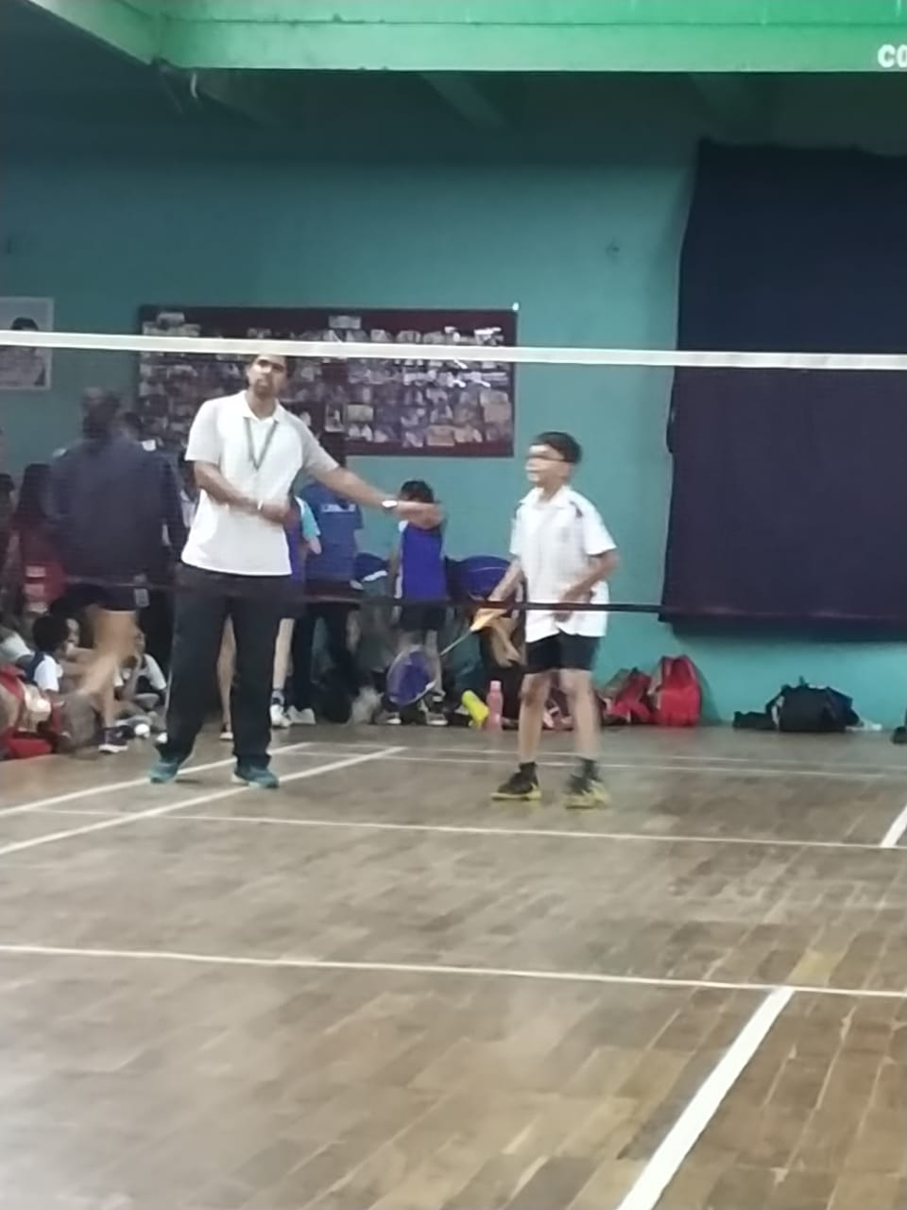 SRCSians participated in Inter School Badminton Competition organized by SGFI (The School Game Federation of India) in different categories. SGFI conducts competitions at the national level for various games and sports. It helps to improve the performance of school students. Unnat Jain, Shourya Soni, Darshil Dhakad participated in (U-14 Category),  
Harsh Chitte , Raj Gupta and Abhik Banerjee participated in (U-17 Category) where as Ujjawal Shukla ,Devesh Khemani ,Kushagra Sharma and Neeraj Patel participated in (U-19 Category). We are pleased to inform that Boys U-14 had reached to the Quarter Final after defeating Laurels International and walk over by Vidyasagar School.  
Kudos to all the Participants…

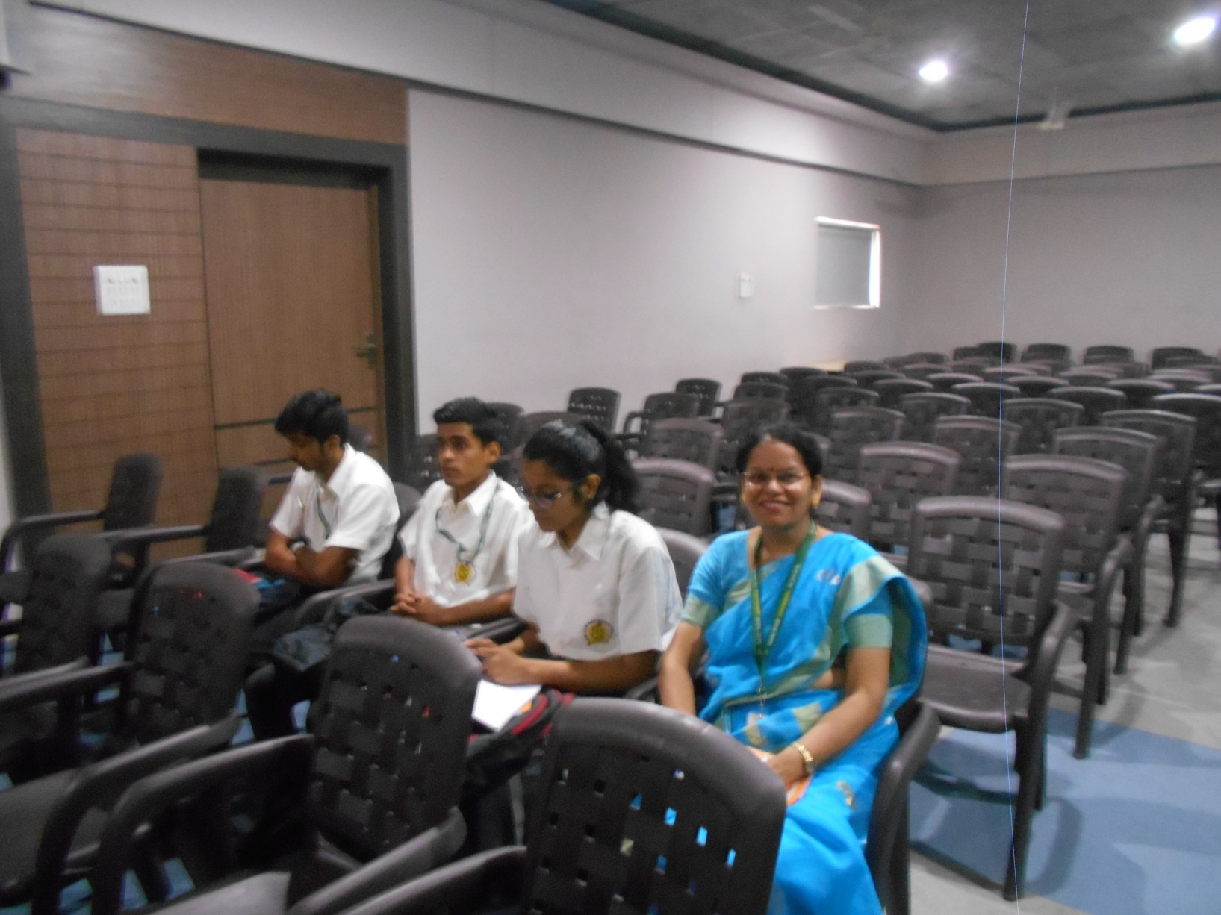[**A visit to Choithram Hospital to witness Renal transplant surgery**](https://www.facebook.com/media/set/?set=a.1977899528909341.1073744037.500345696664739&type=3)**.**

It is truly said that 'People learn more quickly by doing something or seeing something". Our students of class XII(Biology stream)-1. Néeraj Patel 2. Devansh Khemani 3. Vanshika Takhwani visited Choithram Hospital, Manikbagh to see live Renal transplant surgery.They came to know that how surgery is done in an aseptic environment, how anesthesia is given, who is eligible to donate kidney? and how long does it take to adjust in the body of the recipient? The transplantation was done by renowned doctors of Choithram Hospital- Dr.Chimanya, Dr. Sushila Bhatia and Dr. Pradeep Salgia. Our students also asked questions related to surgery. It was really a special learning opportunity for them.

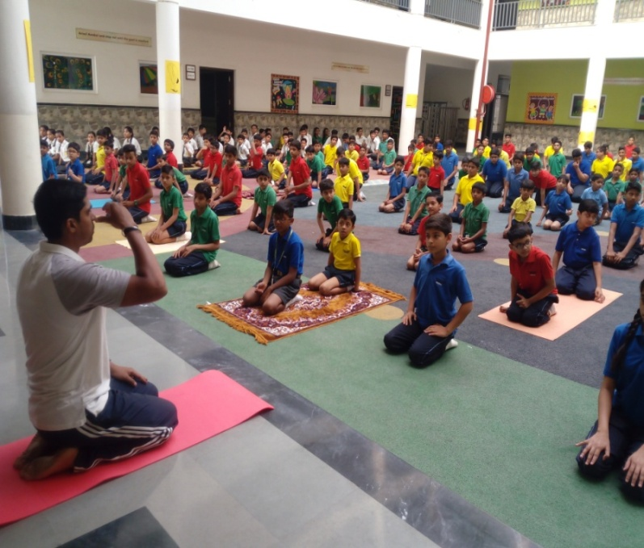International Yoga day

“Yoga is an invaluable gift of India's ancient tradition. It embodies unity of mind and body; thought and action; restraint and fulfillment; harmony between man and nature; a holistic approach to health and well-being. It is not about exercise but to discover the sense of oneness with yourself, the world and the nature. By changing our lifestyle and creating consciousness, it can help in well being."  
... ( Honorable Prime Minister Narendra Modi)

Shri Ram Centennial School celebrated third International Yoga Day by organizing a special yoga session in which the students performed various 'asanas'. The main aim was to raise awareness and ignite a passion for fitness and yoga among the students. In the present day, when students face stress, tension, fear, etc., simple asanas can help dispel these. Students were taught Surya Namaskar along with various asanas like Vajraasana,Matsayaasana,Bhujangaasana, Naukaasana, Anulom Vilom etc.

On this occasion, Ms.Bhavana Pujari , the Principal shared her views that Yoga is essential for inner and physical growth. It enhances the mental and physical well-being. She also motivated the students to make Yoga an important part of their daily routine to stay fit and healthy.

MUN Orientation Program-II

MUN Orientation Program –II was conducted from 06.07.18 to 07.07.18 at the main campus of SRCS which was participated by 14 students. The work shop commenced to acquaint the students with the concept and objectives of MUN. Mr. Nabeel, the resource person from Mumbai discussed the functioning of the UN and various related terms like agenda, draft resolution and motions like moderated caucus and unmoderated caucus, sponsors and signatories. He pointed out the roles students could choose in MUN like being delegates, media persons, photographers, cartoonists, conference staff and observers. The format of the draft resolution and the essential requirements of a strong draft resolution were discussed. During this workshop they took upon activities like debate, group discussions which not only infused confidence in them but also recharged them. They were also explained how to carry out their responsibilities as delegates and how to represent different countries. The participants were allotted different countries and were given topic ‘Educational Reforms in different countries’ for Group Discussion. They were also taught how to present their Draft Resolutions to the committee. All processes, including questioning and answering were practiced.

The resource person explained the delegates about the methods of researching and presenting their view points to the committee. He also explained the short comings of the students to them which he had observed during the training session and suggested the ways to overcome them.

Morning Assemblies

The morning starts at PW starts with the Assembly time…

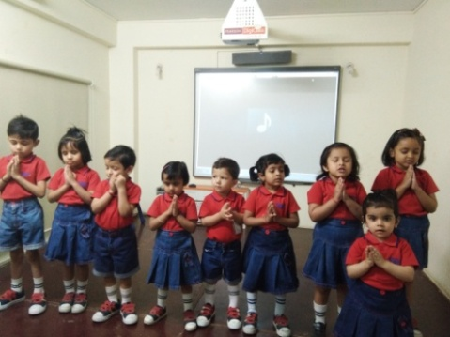The concepts at SRCS are taught through Role plays and other activities few

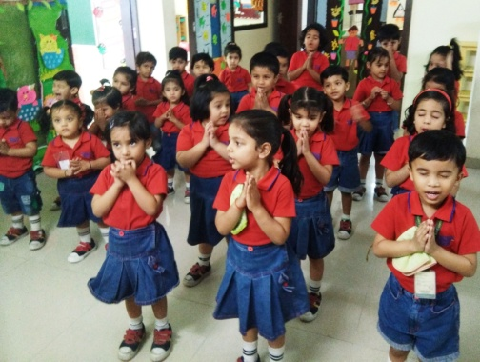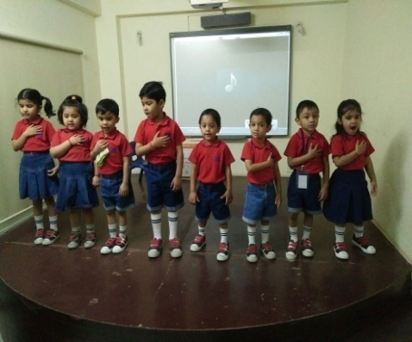Glimpses of the same.

Special Class Assemblies:-

**“Every child is a flower of its own kind and all together they make this world a beautiful garden”.**

OR

**“ When Skill And Determination Work Together, Expect A Masterpiece”**

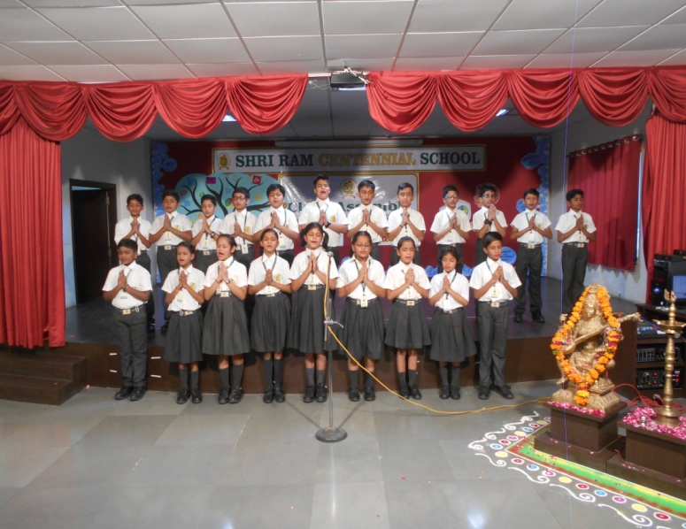SRCSians from Grade –Nursery to V conducted Special Assembly on various theme. They showcased their skills in front of their parents and their teachers through various activities such as Anchoring, speech, poem, group song, role play, mime, dance and many more. In these assemblies they were invested with certain responsibilities. Their efforts were also recognized and they were felicitated in front of their parents for their extra ordinary performance in different activities. Principal Mrs. Bhavna Pujari addressed the guest gathering. Parents were really mesmerized to witness the performance of their ward and they appreciated the hard work and all the efforts put in by the students and their teachers to make this event a successful one.

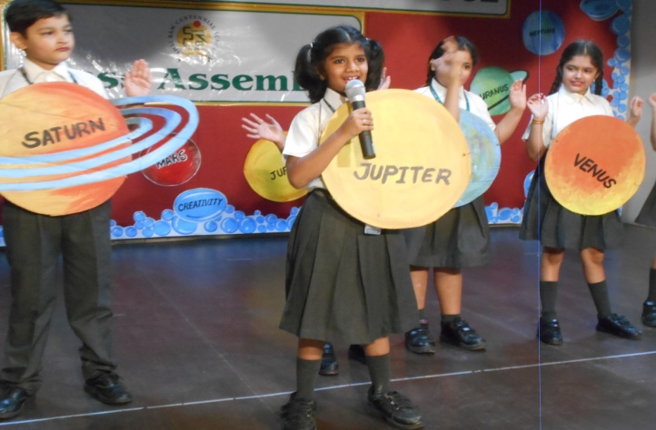

“GREEN SCHOOL PROJECT”

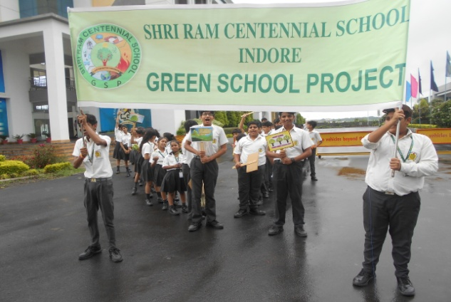Plantation Day:-

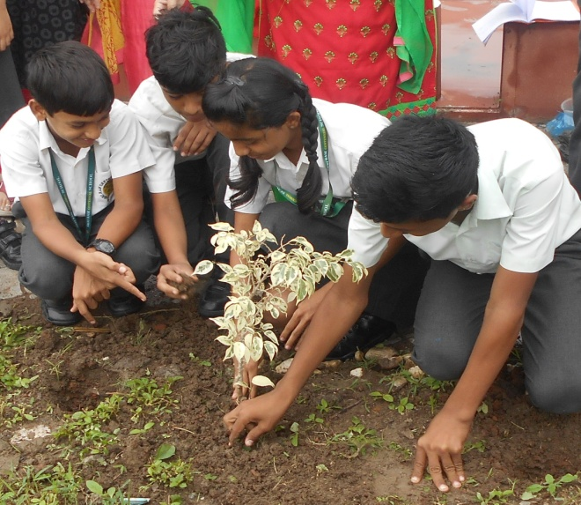Let us tread towards a greener Earth’ is an initiative by SRCS, Indore. The GSP club celebrated ‘Plantation Day’ and the Students took out rally to create awareness among peers and staff. SRCS have stepped up and taken this as a yearlong program to sensitize everyone around the vicinity with motto practice conservation today for the future generation. In the beginning of the academic year, students in the club learnt about the importance of tree plantation and keeping the environment clean and green. These students then created awareness program for other students through skit, dance, speeches and rally with slogans and posters.

Making of Solar Oven:-

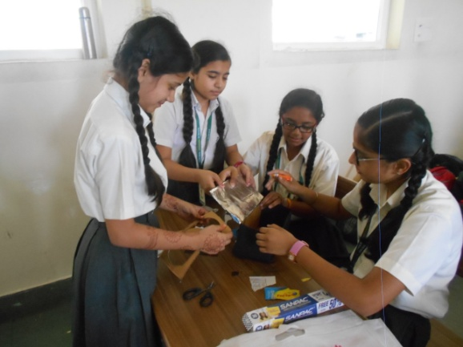Collecting sunlight for cooking has long been envisioned as one of the most favourable benefits that human beings can take from the sun. No doubt, safe and reliable solar cooking devices have great significance to the sustainability of environment and economy all over the world.  
Under the Green School Programme children made solar oven using house hold materials like cardboard box, black paint, aluminum foil and plastic cover.  
The goal of this project was to develop safer, reliable, and user-friendly solar ovens to be generally used for food cooking and heating purpose at outdoor and indoor locations.   
It was a good learning experience for children.

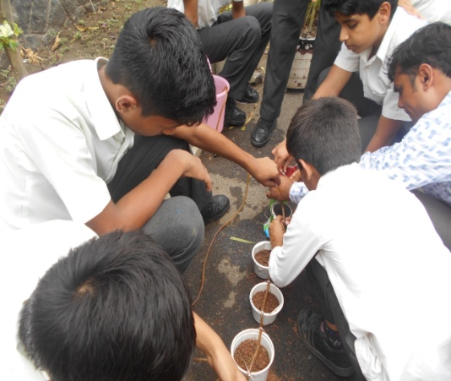Learning about Drip Irrigation System:-

Drip irrigation is a method of controlled irrigation in which water is slowly delivered to the root system of multiple plants. In this method water is either dripped on to the soil surface above the roots, or directly to the root zone.  
Under the Green School Programme, children prepared and demonstrated drip irrigation system. Seeds were sown and within a week they observed the growth of saplings. They find this project very interesting and and were able to develop scientific approach and intellect.

Nukkad Natak

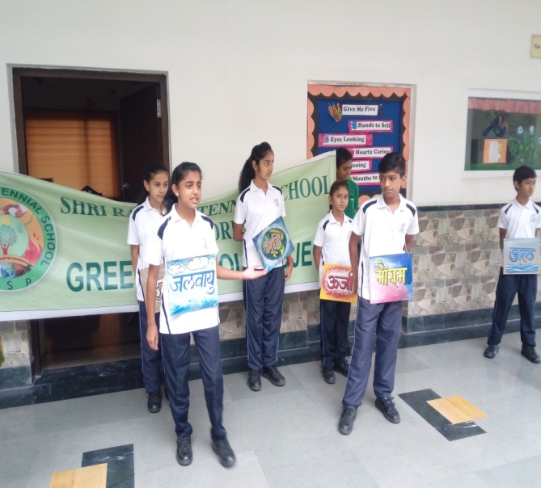Under the Green School Program the students of GSP Club have played a Nukkad Natak ‘Family of Environment’. It was performed in the morning assembly on 13th July. Through this Nukkad Natak students had highlighted the critical situation of the different elements of nature like: air, water, energy etc. Skit ended with the message to keep the environment healthy and clean.

[Inter House Competition 2018](https://www.facebook.com/media/set/?set=a.1849165401782755.1073743833.500345696664739&type=3)

**“Art enables us to find ourselves and lose ourselves at the same time.”**

The Inter House Art Competition which was held on Friday, 23rd June, 2018 for all the three levels i.e. Junior, Middle and Senior classes saw an exhibition of creative work involving- Drawing Scenery using different Shapes, Doll Making, Pot Painting and Decoration Competition. It aimed at encouraging creativity, inculcating aesthetic sense in the participants and show casing their innate abilities  
The students enthusiastically participated in the event. The competition not only brought out creativity and talent of the students but also developed a feeling of helping and sharing among them.

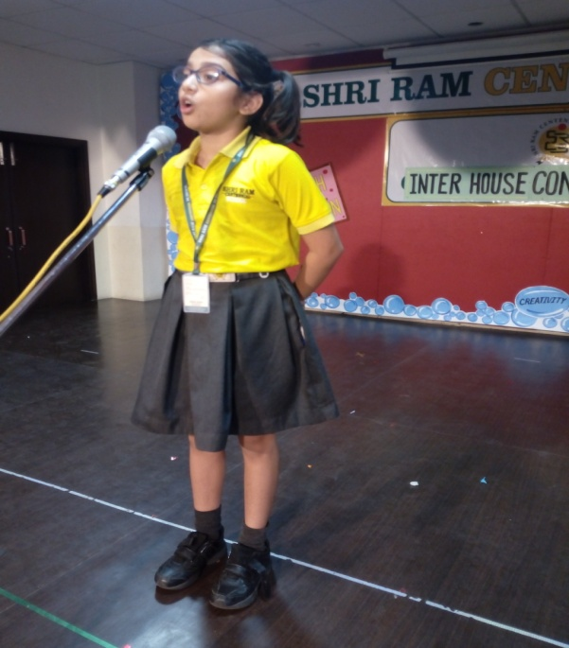Elocution & Extempore Competition

**“Admiration comes easy to a person, who is endowed with the fine art of public speaking, who adorns common thoughts with the grace of elocution, and the elegancy of style”**To enhance the communication skills in Students, an Inter House English Elocution & Extempore Competition was conducted for Level –I & II respectively on the 20th July, 2018 during House Activity period.  
Elocution Competition was conducted for classes III to V, where the students presented their topics with great enthusiasm. They were judged on the basis of content, clarity of speech, memory, pronunciation, expression and body language etc. The objective of this activity was to make the children more expressive, confident and spontaneous in their way of speaking. The Participants were: - Atharav Naresh (Darwin House), Sanidhya Sahu (Newton House), Gyayak Jain (Einstein House) and Shambhavi Shukla (Edison House).   
Extempore

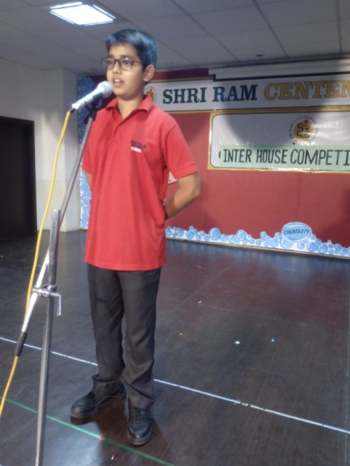Extempore is the art of public speaking that is carried out without preparation or forethought. It puts to test one’s ability to think on the spot and also their spontaneity. Students need to speak well in their personal lives, future workplaces and social interactions. Extempore is one such method which assists the students not only in thinking on their own but also in voicing their creative ideas with precision. The speakers were the students from the classesVI-VIII- Shivanshi Dubey (Darwin House), Aadi Jain (Newton House), Eva Skuniya (Edison House) and Aarushi Mishra (Einstein House).The students were asked to pick up chits for the topics and present it after the given time. All the participants got three minute to speak on the given topic.  
The judges Mrs.Vandana Bhargav, Mrs. Bhavna Sachar and Mrs. Deepali did the judgement on the basis of content, relevance to the topic, Delivery, organization and body language.

[Nurturing Sports Techniques](https://www.facebook.com/media/set/?set=a.1847033078662654.1073743819.500345696664739&type=3)…!!

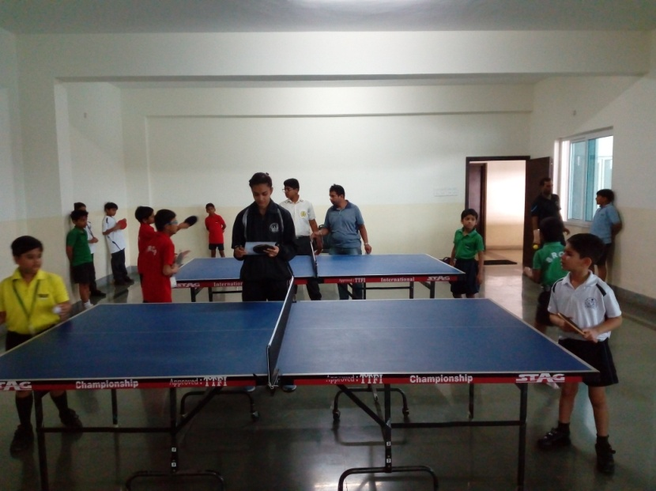Inter House Table Tennis Competition...

SRCS organised Inter House Table Tennis Competition on 30th July 2018 (Monday). All the four houses participated under three categories L-I (C-III-V),

L-II (C-VI-VIII) & L-III(C-IX-XII). Two participants from level and from each house participated in this competition.

Excitement & enthusiasm for the competition was at zenith. All participants played with great Zeal & displayed good sportsman spirit and team work. The school Principal Mrs. Bhavna Pujari appreciated the efforts put by all the participants and congratulated the winners for their outstanding performance.