“Job Portal with resume parsing and matching”
A Project Report Submitted in the partial fulfillment of the requirements for the award of the degree of
BACHELOR OF TECHNOLOGY
In
DEPARTMENT OF COMPUTER SCIENCE ENGINNERING
&
DEPARTMENT OF COMPUTER SCIENCE AND INFORMATION TECHNOLOGY
By
A V S N R AKHILA : 2520030022
MANASVI NILESH GHAG : 2520030335
Under the Esteemed Guidance of
Dr Spandana S
Assistant Professor
Department of Computer Science and Engineering



K L (Deemed to be) University
DEPARTMENT OF COMPUTER SCIENCE ENGINEERING
&
DEPARTMENT OF COMPUTER SCIENCE AND INFORMATION TECHNOL
Declaration
The Project Report entitled “Job Portal with resume parsing and matching” is a record of Bonafide work of A V S N R AKHILA - 2520030022, MANASVI NILESH GHAG - 2520030335 submitted in partial fulfillment for the award of B. Tech in Computer Science and Engineering (or) Computer Science and Information Technology to the K L University. The results embodied in this report have not been copied from any other departments/University/Institute.
A V S N R AKHILA – 2520030022
MANASVI NILESH GHAG – 2520030335

K L (Deemed to be) University
DEPARTMENT OF COMPUTER SCIENCE ENGINEERING
&
DEPARTMENT OF COMPUTER SCIENCE AND INFORMATION TECHNOLOGY
CERTIFICATE
This is certify that the mini project based report entitled “Job Portal with resume parsing and matching” is a bonafide work done and submitted by A V S N R AKHILA - 2520030022, MANASVI NILESH GHAG - 2520030335 in partial fulfillment of the requirements for the award of the degree of BACHELOR OF TECHNOLOGY in Department of Computer Science Engineering, K L (Deemed to be University), during the academic year 2024-2025.
Signature of the Guide
Signature of the Course Coordinator Signature of the HOD

ACKNOWLEDGEMENT
The success in this project would not have been possible but for the timely help and guidance rendered by many people. Our wish to express my sincere thanks to all those who has assisted us in one way or the other for the completion of my project.
Our greatest appreciation to my Course Coordinator Dr Yerragudipadu Subbarayudu, and my guide Dr Spandana S, Department of Computer Science which cannot be expressed in words for his/her tremendous support, encouragement and guidance for this project.
We express our gratitude to Dr. P Venkateshwara Roa (CSE)/Dr. Kaja Shareef (CSIT), Head of the Department for Computer Science Engineering/ Department for Computer Science and Information Technology for providing us with adequate facilities, ways and means by which we are able to complete this project-based Lab.
We thank all the members of teaching and non-teaching staff members, and also who have assisted me directly or indirectly for successful completion of this project. Finally, I sincerely thank my parents, friends and classmates for their kind help and cooperation during my work.
A V S N R AKHILA – 2520030022
MANASVI NILESH GHAG – 2520030335

Abstract
Recruitment on most online job portals still depends on keyword search for candidates and on manual resume screening for recruiters. A job seeker has to retype the contents of a resume into long forms, and a recruiter has to open every application to judge whether the applicant actually has the skills a role needs. HireHub is a full-stack web application developed to close this gap. It is a role-based job portal for three kinds of users, namely candidates, recruiters and administrators, that turns an uploaded resume into structured data and uses that data to rank job openings by how well a candidate's skills match each job's stated requirements.
When a candidate uploads a resume in PDF or DOCX format, the back end extracts its text (falling back to optical character recognition for scanned PDFs), sends the text to the Google Gemini API for structured extraction of skills, education, experience and certifications, and falls back to a built-in rule-based parser whenever the AI service is unavailable. The extracted skills are stored against the candidate's profile and are used to compute a match score for every open job, defined as the percentage of a job's required skills that the candidate possesses. The score is shown to the candidate as job recommendations and is stored on every application so that recruiters can compare applicants. Around this core, the system implements the full hiring workflow: job posting and editing, applications with a seven-state status pipeline, interview scheduling with a calendar view and structured feedback, offer letters for hired candidates, saved jobs, recruiter statistics and a role-aware home page.
The application is built with React 19 and Vite on the front end, Node.js and Express exposing a REST API on the back end, and MongoDB accessed through the Mongoose ODM as the database. Authentication uses JSON Web Tokens with bcrypt-hashed passwords, and every protected route is guarded by role-based middleware that also enforces ownership, so that recruiters can only act on their own job postings. The system was verified against an isolated in-memory database with 51 scripted API test cases and 17 automated user-interface test cases run in a real browser; all but one passed, and the single failure exposed a PDF parsing limitation that is documented in this report. The project demonstrates how a document-oriented database, a stateless REST API and an AI-assisted parsing pipeline can be combined to make hiring faster and more skill-focused for both job seekers and recruiters.
Index
S.  No. | Chapters | Topics | Page.no
 |  | Acknowledgement
 |  | Abstract | 1
1 | Introduction | 1.1 Background of the Project  1.2 Problem Statement  1.3 Scope of the Project  1.4 Objectives of the Project  1.5 Importance of the Application  1.6 Target Users / Audience | 4-7
2 | System Requirements | 2.1 Hardware Requirements  2.2 Software Requirements  2.3 Development Tools and Frameworks | 8-10
3 | Technology Stack | 3.1 Front-End Design  3.2 Back-End Design  3.3 Database Design  3.4 Version Control  3.5 APIs or External Services | 11-15
4 | System Architecture | 4.1 High-level Architecture Diagram  4.2 Description of Each Layer (Frontend, Backend, Database)  4.3 Deployment Architecture | 16-18
5 | Design | 5.1 ER Diagram / Database Schema | 19-23
6 | Implementation | 6.1 Module-wise Implementation  6.2 Front-end Logic (UI Rendering, State Management)  6.3 API Integration  6.4 Authentication and Authorisation | 24-31
7 | Features | 7.1 List of Main Features  7.2 How Each Feature Works (User Perspective + Technical Description) | 32-37
8 | Testing | 8.1 Postman Testing (Frontend/Backend)  8.2 Integration Testing  8.3 Tools Used for Testing  8.4 Test Cases and Results | 38-45
9 | Deployment | 9.1 Steps to Deploy  9.2 Environment Configuration  9.3 Hosting of Frontend and Backend | 46-48
10 | Challenges & Limitations | 10.1 Issues Faced During Development  10.2 Solutions Applied  10.3 Current Limitations or Known Bugs | 49-52
11 | Future Enhancements | 11.1 Planned Features  11.2 Possible Integrations or Optimisations | 53-54
12 | Conclusion | 12.1 Summary of the Project  12.2 What Was Achieved  12.3 Skills Learned During Development | 55-56
13 | References | - Official documentation, standards, papers and books used | 57-58
14 | Appendices | - Screenshots of the app  - Sample code snippets  - Installation/setup instructions  - User manual or guide  - Geo Tag photos with guide  - Review forms with guide signatures | 59-68

CHAPTER -1 INTRODUCTION
1.1 Background of the Project
Hiring has moved almost entirely online. Job seekers discover openings on portals, company career pages and professional networks, and recruiters receive applications through the same channels. The volume of applications that a single opening attracts has grown with this shift, and the effort of handling them has moved onto both sides of the process. Candidates repeatedly enter the same details into application forms, and recruiters spend a large share of their time reading resumes to decide which applicants are worth a closer look.
Most conventional job portals treat a resume as an attachment. The portal stores the file, but it does not understand what is inside it, so search and filtering depend on the keywords that a candidate typed into a profile and on the words that appear in a job title. Two people with the same skills can be ranked very differently because one of them described the skills with different words, and a recruiter has no quick way to see how closely an applicant's background matches the requirements written in a posting. The result is a process in which relevance is judged by hand, one document at a time.
At the same time, the tools needed to automate the first stage of this judgement have become widely accessible. Text can be extracted reliably from PDF and Word documents, optical character recognition (OCR) can recover text from scanned pages, and large language models offered through public APIs can turn unstructured resume text into structured fields such as skills, education and work history. When resumes are stored as structured data rather than as opaque files, comparing a candidate with a job becomes a computation instead of a reading task.
HireHub was developed as a project for the course Database Systems Engineering and Distributed Backend Development to apply these ideas in a complete, working system. It is a web-based job portal in which candidates upload a resume once, the system extracts their skills automatically, and every open job is scored against those skills. Recruiters post jobs with a list of required skills, review applicants together with their match scores and parsed resumes, move applications through a defined pipeline, schedule interviews, record interview feedback and issue offer letters, all inside the same application.
From a database and back-end perspective, the project is an exercise in modelling a real workflow as a set of related collections, exposing it through a stateless REST API, and protecting it with authentication and role-based authorisation. The domain contains clear entities (users, jobs, resumes, applications, interviews, offer letters and chatbot conversations) with one-to-many, many-to-many and one-to-one relationships between them, which makes it a suitable case study for document-database design with MongoDB and Mongoose. The application layer adds file handling, an external AI service with retry and fallback behaviour, and access rules that depend both on a user's role and on ownership of the data being accessed.
The system is implemented as two independent applications kept in one repository: a React single-page application in the job-portal-frontend folder and a Node.js/Express API in the job-portal-backend folder. The front end communicates with the back end only through JSON over HTTP, which keeps the two layers loosely coupled and allows each to be developed, run and deployed separately.
1.2 Problem Statement
Existing job portals do not measure how well a candidate fits a job. They rely on keyword search for discovery and on manual resume screening for selection, so the skills contained in a resume are never compared systematically with the skills a job requires. This creates the following specific problems:
- Resumes are not machine-readable inside the portal. A resume is stored as a file, so its skills, education and experience cannot be searched, compared or reused. Candidates are asked to re-enter the same information into forms.
- Relevance is judged by hand. Recruiters must open each application to decide whether the applicant has the required skills, which is slow and inconsistent when many applications arrive for one role.
- Candidates cannot see why a job suits them. Listings are ordered by date or keyword relevance rather than by how many of the required skills the candidate actually has.
- The hiring workflow is fragmented. Application status, interview arrangements, interview feedback and offer letters are often handled through e-mail and spreadsheets outside the portal, so neither side has a single, current view of where an application stands.
The problem addressed by HireHub is therefore to design and build a job portal that converts resumes into structured data automatically, scores every job against a candidate's extracted skills, and supports the complete path from application to offer letter within one role-based system, while keeping each user's data visible only to the people entitled to see it.
1.3 Scope of the Project
The scope of HireHub covers a web application for three user roles and the back-end services and database that support them. The following functions are within scope:
- User management: registration and login for candidates and recruiters (an administrator option is also offered on the registration form and accepted by the API), password hashing, token-based sessions and profile editing.
- Resume processing: upload of PDF and DOCX resumes up to 5 MB, text extraction, OCR for scanned PDFs, AI-based structured extraction with a rule-based fallback, and candidate correction of the extracted fields.
- Job management: creation, editing, opening and closing of job postings by recruiters, and public browsing and searching of open jobs.
- Matching: a skill-overlap match score for every open job, recommendations for candidates, and a stored score on every application for recruiters.
- Application workflow: applying, withdrawing, saved jobs, and recruiter-controlled status changes across the stages applied, under review, shortlisted, interview, rejected and hired.
- Interviews: scheduling (online, in-person or phone), rescheduling, cancellation, completion and structured feedback with 1–5 ratings.
- Offer letters: creation of an offer letter for a hired application, resending, viewing by the candidate and download as a text file.
- Dashboards and analytics: a role-aware home page for candidates and recruiters, recruiter statistics per job, and a platform analytics endpoint for administrators.
- AI assistant (API): a chatbot endpoint that answers career and recruiting questions using Gemini and stores conversation history.
The following items are outside the current scope: e-mail or SMS notifications, online payments, video interviewing, integration with external job boards, mobile applications, and a production deployment. The administrator dashboard in the user interface is presently a static overview that is not yet connected to the analytics endpoint, and the chatbot is available through the API but has no user-interface component; both are discussed in Chapter 10.
1.4 Objectives of the Project
The project was undertaken with the following objectives:
- Automate resume parsing. Convert an uploaded resume into structured skills, education, experience and certifications without manual data entry, and keep the system working when the AI service is unavailable.
- Score every job by skill match. Compute, for each open job, the percentage of its required skills that a candidate has, use the score to recommend jobs, and store it with each application.
- Support hiring from application to offer. Provide a single workflow for applying, reviewing, shortlisting, interviewing, recording feedback and issuing offer letters, with the current status visible to both parties.
- Enforce secure, role-based access. Authenticate users with signed tokens and hashed passwords, and restrict every operation by role and by ownership of the underlying data.
- Design a sound document database. Model the hiring domain as related MongoDB collections with validation, references, enumerations and unique indexes that protect data integrity.
- Deliver a responsive, usable interface. Present role-specific dashboards and pages that work on desktop and mobile screens.
1.5 Importance of the Application
The importance of HireHub lies in moving the first, most repetitive stage of screening from people to the system, while leaving decisions with the recruiter. Its value can be seen from several angles.
For candidates, a single upload replaces repeated form filling. The parsed skills are shown back to the candidate in a Resume Insights section, where they can be corrected, and the match score explains which openings suit them best. The Recommended tab on the jobs page and the AI Matches list on the home page turn the job list into a ranked list that is specific to the candidate.
For recruiters, every applicant arrives with a match score and a structured summary of the resume, so the applicants who meet most requirements are visible at once. Status changes and offer letters are handled on the recruiter's Applications page, interview scheduling and feedback on the Interviews page (reached directly from an applicant with the application pre-selected), and the recruiter's home page summarises active jobs, applicants, interviews and hires.
For data integrity and privacy, the back end enforces rules that a portal built on shared spreadsheets cannot: a candidate can apply to a job only once (a unique compound index on job and candidate), an offer letter can only be created for a hired application and only once per application, recruiters can only see and change applications and interviews for jobs they posted, and recruiter feedback from interviews is never returned to candidates.
As an academic case study, the application brings together the main topics of database systems and back-end development in one coherent product: schema design with references and constraints, aggregation for analytics, a REST API with consistent status codes, stateless authentication, file processing and integration with an external AI service with retries and graceful fallback.
1.6 Target Users / Audience
HireHub defines three user roles in its data model (candidate, recruiter and admin). Their needs and the parts of the system they use are summarised in Table 1.1.
Table 1.1: User roles of HireHub
User role | Who they are | What they use in HireHub
Candidate | Students, fresh graduates and experienced professionals looking for full-time roles, internships, part-time, contract or remote work. | Resume upload and Resume Insights, AI job matches, job search with filters, saved jobs, applications and their status, interview calendar, offer letters, profile.
Recruiter | Hiring managers and HR staff who post openings on behalf of a company. | Job posting and editing, applicant review with match scores and parsed resumes, status pipeline, interview scheduling and feedback, offer letters, hiring statistics, company profile.
Administrator | Platform operators responsible for overall monitoring. | Platform analytics endpoint (counts of candidates, recruiters, jobs, applications and interviews, and applications by status); access to all applications and interviews through the API.

The intended audience of the application is therefore twofold: individuals seeking employment who benefit from automatic matching, and organisations that want a lightweight, self-contained tool to manage hiring for their openings. Because the interface is a responsive web application, both groups can use it from a laptop or a phone without installing any software.
CHAPTER -2 SYSTEM REQUIREMENTS
This chapter specifies the hardware and software needed to develop, run and use HireHub. The requirements are derived from the technologies the project actually depends on, as declared in the package.json files of the front end and back end, and from the way the application is run locally during development. Where a figure is a recommendation rather than a hard limit imposed by a tool, it is stated as such.
2.1 Hardware Requirements
HireHub runs as three local processes during development: the Vite development server for the React front end, the Node.js process for the Express API, and a MongoDB database server (or a connection to a hosted MongoDB cluster). None of these is computationally heavy for a single developer, but the build tooling, the browser, the code editor and the OCR library together benefit from a reasonably modern machine.
Table 2.1: Hardware requirements for development
Component | Minimum (recommended for development) | Reason
Processor | 64-bit dual-core CPU (quad-core recommended) | Runs Node.js, the Vite dev server, MongoDB and a browser at the same time; resume OCR is CPU-bound.
Memory (RAM) | 8 GB (16 GB recommended) | Node.js processes, the browser and the editor run concurrently; Tesseract OCR loads a language model into memory.
Storage | Approximately 2 GB free space | Two node_modules folders, MongoDB data files, uploaded resumes, and OCR language data cached on first use (about 10 MB).
Network | Broadband Internet connection | Installing npm packages, calling the Gemini API, and downloading the OCR language data the first time a scanned PDF is processed.
Display | 1366 × 768 or higher | The dashboards are designed for desktop widths but are also responsive for mobile screens.

On the server side, the back end has modest requirements because it is a single stateless Node.js process. Its main resource needs arise during resume uploads: text extraction from PDF and DOCX files is fast, but when a scanned PDF contains fewer than 100 characters of embedded text the server renders up to five pages to images and runs OCR on them, which is the most CPU- and memory-intensive operation in the system. Uploaded files are stored on the server's local disk in an uploads folder, so the host also needs persistent storage proportional to the number of candidates (each resume is limited to 5 MB and only the latest resume per candidate is kept).
For end users the requirements are minimal. HireHub is used through a web browser, so any desktop, laptop, tablet or smartphone capable of running a current version of Chrome, Edge, Firefox or Safari is sufficient. The client stores only a small authentication record in the browser's local storage.
2.2 Software Requirements
The software environment consists of the JavaScript runtime and package manager, the database, the browser, and the libraries listed in the two package.json files. Table 2.2 lists the runtime and system software, and Tables 2.3 and 2.4 list the application libraries with the versions declared in the project.
Table 2.2: Runtime and system software
Software | Version / Notes | Purpose
Operating system | Windows 10/11, macOS or Linux | Any platform supported by Node.js and MongoDB; the project was developed on Windows.
Node.js | 18 or later (the backend README states 18+); the API tests in Chapter 8 were run on Node.js 24 | Runs the Express API and the Vite build tooling. Native fetch, FormData and ES modules are used.
npm | Bundled with Node.js | Installs dependencies and runs the scripts dev, start, build, preview and seed:jobs.
MongoDB | A local MongoDB server (default URI mongodb://127.0.0.1:27017/hirehub) or a hosted MongoDB cluster | Stores all application data; only the MONGODB_URI value changes between local and hosted databases.
Web browser | Current Chrome, Edge, Firefox or Safari | Runs the React single-page application.
Google Gemini API key | Optional | Enables AI resume parsing and chatbot replies; without a key the system uses its rule-based parser and fallback chatbot replies.

Table 2.3: Front-end dependencies (job-portal-frontend/package.json)
Package | Declared version | Role in the front end
react, react-dom | ^19.1.1 | Component-based user interface and rendering.
react-router-dom | ^7.8.2 | Client-side routing and protected routes.
framer-motion | ^12.23.12 | Entrance and hover animations on dashboard cards and lists.
lucide-react | ^0.468.0 | Icon set used throughout the interface.
three, @react-three/fiber, @react-three/drei | ^0.179.1, ^9.3.0, ^10.7.6 | Declared as dependencies but not imported by the current source code (see Chapter 10).
vite, @vitejs/plugin-react | ^7.1.3, ^5.0.2 | Development server with hot reload and production bundler.

Table 2.4: Back-end dependencies (job-portal-backend/package.json)
Package | Declared version | Role in the back end
express | ^4.21.1 | HTTP server, routing and middleware.
mongoose | ^8.8.3 | Schemas, validation, references and queries for MongoDB.
jsonwebtoken | ^9.0.2 | Signing and verifying JSON Web Tokens.
bcryptjs | ^2.4.3 | Password hashing with a cost factor of 10.
multer | ^1.4.5-lts.1 | Multipart file upload, file-type filter and 5 MB size limit.
pdf-parse | ^1.1.1 | Text extraction from PDF resumes.
mammoth | ^1.8.0 | Text extraction from DOCX resumes.
pdf-to-img, tesseract.js | ^7.0.0, ^7.0.0 | Rendering scanned PDF pages to images and running OCR on them.
@google/generative-ai | ^0.21.0 | Client for the Google Gemini API (resume extraction and chatbot).
cors, dotenv | ^2.8.5, ^16.4.5 | Cross-origin access for the front end; loading configuration from a .env file.
nodemon (dev) | ^3.1.7 | Automatic restart of the API during development (npm run dev).

2.3 Development Tools and Frameworks
The project was built with a small set of widely used tools. Their roles are summarised below.
- Visual Studio Code was used as the code editor for both applications, with its integrated terminal for running the development servers.
- Git and GitHub were used for version control and for sharing the code between team members (Section 3.4).
- Vite provides the front-end development server on port 5173 with hot module replacement, and produces the optimised production bundle with npm run build.
- nodemon restarts the Express server automatically when back-end files change (npm run dev).
- npm scripts standardise common tasks: dev, build and preview in the front end; dev, start and seed:jobs in the back end.
- Seed script (scripts/seedJobs.js, run with npm run seed:jobs) creates demonstration recruiter accounts and approximately 150 varied job postings so that matching and search can be exercised with realistic data. It is safe to re-run because it skips recruiters and jobs that already exist.
- Browser developer tools were used to inspect network requests between the React application and the API, and to test responsive layouts.
- Microsoft PowerPoint was used for the project poster, whose architecture and ER diagrams are reused in Chapters 4 and 5.
The main frameworks are React on the client and Express on the server. React structures the interface as reusable function components that hold their own state with hooks, while Express structures the API as routers and middleware functions. Mongoose sits between Express and MongoDB, giving the otherwise schema-less database a defined schema with types, required fields, enumerations, default values and indexes. Together these choices keep the entire stack in one language, JavaScript, which simplified development and allowed the same data shapes (for example the structure of a parsed resume) to be used on both sides of the API.
CHAPTER -3 TECHNOLOGY STACK
HireHub uses a JavaScript-based stack in which a React single-page application talks to a Node.js and Express REST API, and the API stores its data in MongoDB through Mongoose. This combination is often called the MERN stack. Using one language across the whole system meant that request and response bodies, validation rules and data shapes could be reasoned about in the same terms on both sides. This chapter describes how each part of the stack was used in the project and why it was chosen.
3.1 Front-End Design
The front end lives in the job-portal-frontend folder and is built with React 19 and Vite 7. React was chosen because the interface consists of many repeating, data-driven elements (job cards, applicant rows, interview entries, status chips and statistics tiles) that map naturally onto reusable components, and because its hooks (useState, useEffect) make it straightforward to load data from the API and keep the screen in sync with it. Vite was chosen as the build tool for its fast development server with hot module replacement and its simple configuration; the project needs only the official React plugin.
The source is organised into a small number of files. src/main.jsx mounts the application inside a BrowserRouter. src/App.jsx contains the application's pages and shared components as function components, together with helper functions for formatting dates, salaries and status labels. src/api.js is the only module that talks to the back end: it exports one asynchronous function per API operation (for example login, uploadResume, getMatches, applyToJob, scheduleInterview and createOffer), each of which builds the request, attaches the bearer token and converts error responses into JavaScript errors with the server's message. src/components/JobsMegaMenu.jsx holds a navigation component, and src/styles.css contains all styling.
Routing is handled by React Router 7. Public routes include the home page (/), login (/login), registration (/register) and the About page (/about). Candidate routes are /jobs, /jobs/:id, /applications, /interviews and /profile; recruiter routes are /recruiter/jobs, /recruiter/applications, /recruiter/interviews and /recruiter/profile; and the administrator route is /admin. Every route other than the public ones is wrapped in a ProtectedRoute component that redirects unauthenticated visitors to the login page and sends users with the wrong role to their own dashboard. The home route is role-aware: logged-out visitors see the marketing landing page, while logged-in candidates and recruiters see their own overview.
Styling is written in plain CSS rather than a CSS framework. The stylesheet defines the colour palette, typography, layout grids and the dashboard components, and uses media queries so that the navigation collapses into a mobile menu and multi-column layouts stack vertically on narrow screens. Framer Motion adds short entrance animations and hover effects to cards and list items, and lucide-react supplies the icons used in navigation, buttons and statistics tiles.
State management is deliberately simple. Each page owns its data in local component state and loads it from the API when it mounts. The only state shared across the whole application is the authentication record (token, role, name and e-mail), which is kept in the browser's localStorage under the key hirehub_auth and read by helper functions whenever a page needs to know who is logged in. This avoids the need for a global state library in an application whose pages are largely independent. Section 6.2 describes this logic in detail.
3.2 Back-End Design
The back end lives in the job-portal-backend folder and is a Node.js application written with ES modules ("type": "module") using the Express 4 framework. Express was chosen because it is minimal and explicit: the request pipeline is a sequence of middleware functions, which made it easy to add authentication, role checks and file uploads only to the routes that need them. The code follows a layered structure in which each folder has a single responsibility, as shown in Table 3.1.
Table 3.1: Back-end project structure
Folder / file | Responsibility
server.js | Creates the Express app, enables CORS for the configured origins, parses JSON bodies, serves the uploads folder statically, mounts all routers under /api, returns 404 for unknown API routes, handles uncaught errors, connects to MongoDB and starts listening (default port 8000).
config/db.js | Connects to MongoDB using MONGODB_URI and logs connection events.
routes/ | Ten router modules (auth, jobs, candidate, matches, applications, interviews, admin, chatbot, recruiter, offers) that map HTTP methods and paths to controller functions and attach middleware.
controllers/ | Request handlers containing the business rules: validation, ownership checks, database operations and response formatting.
models/ | Seven Mongoose schemas: User, Job, Resume, Application, Interview, OfferLetter and Conversation.
middleware/ | auth.js (requireAuth, requireRole) and upload.js (Multer disk storage, file-type filter and size limit).
utils/ | resumeParser.js (text extraction, OCR and rule-based parsing), aiResumeParser.js (Gemini extraction with chunking, retries and fallback) and matchScore.js (skill-overlap score).
scripts/seedJobs.js | One-time script that creates demonstration recruiters and job postings.

Each request passes through the same stages: Express matches the route, requireAuth verifies the JSON Web Token in the Authorization header and attaches the user's id, role and e-mail to the request, requireRole rejects users whose role is not allowed for that route, and the controller then applies finer rules (for example, that a recruiter may only update applications for jobs they posted) before reading or writing the database. All responses are JSON, and errors use conventional HTTP status codes: 400 for invalid input, 401 for missing or invalid credentials, 403 for insufficient permissions, 404 for missing resources, 409 for conflicts such as duplicate e-mail addresses or duplicate applications, and 500 for unexpected failures.
The back end also hosts the two compute-heavy services of the system. The resume pipeline extracts text with pdf-parse or mammoth, recovers text from scanned PDFs with pdf-to-img and tesseract.js, and structures it with Gemini or the rule-based parser. The match-score function compares a candidate's skills with a job's required skills. Both are pure modules in utils/, so they can be replaced or improved without changing any route.
3.3 Database Design
HireHub stores its data in MongoDB, a document-oriented database, and accesses it through Mongoose 8. MongoDB suits the domain because several entities have naturally nested, variable-length structure: a parsed resume contains arrays of education and experience entries whose length differs from candidate to candidate, a conversation contains an ordered list of messages, and interview feedback is a small group of related ratings. These are stored as embedded sub-documents inside their parent document, so they are read and written together without joins.
Entities that have an independent life cycle or are shared between users are stored in separate collections and linked by references (ObjectId values with a ref to the target model). For example, an Application references the Job, the candidate User and the Resume it was submitted with, and an Interview references its Application, Job, candidate and the recruiter who scheduled it. Mongoose's populate() is used in the controllers to replace these references with the referenced documents' selected fields when building responses. The design therefore combines embedding for owned, bounded data with referencing for relationships between independent entities.
Mongoose schemas provide the validation that MongoDB itself does not enforce: required fields, string trimming and lower-casing (for e-mail addresses), numeric ranges (1 to 5 for interview ratings), enumerations (job types, application stages, interview modes and statuses, offer statuses, user roles) and default values. Data integrity rules that span documents are enforced with indexes: a unique index on User.email, a unique compound index on Application(job, candidate) that prevents duplicate applications, and a unique index on OfferLetter.application that allows at most one offer letter per application. Every schema enables automatic createdAt and updatedAt timestamps. The full schema is presented in Chapter 5.
The connection string is supplied through the MONGODB_URI environment variable, so the same code runs against a local MongoDB server or a hosted cluster without modification. The administrator analytics endpoint demonstrates MongoDB's aggregation framework by grouping applications by status with a $group stage, while the remaining statistics are computed with countDocuments queries run in parallel.
3.4 Version Control
The project is version-controlled with Git and hosted in a GitHub repository. All work is on the main branch, which tracks the origin/main branch on GitHub. The repository holds both applications under a project-files folder, alongside project deliverables such as the review presentation.
A .gitignore file keeps generated and sensitive files out of the repository: both node_modules folders, the back end's .env file (which holds the database URI, JWT secret and API key), uploaded resumes in job-portal-backend/uploads/ (an empty .gitkeep file preserves the folder itself), operating-system files, log files and PowerPoint lock files. Excluding .env is particularly important, because it ensures that secrets are never committed; instead, the repository provides .env.example with the variable names and placeholder values that each developer copies and fills in locally.
The commit history records the main milestones of the repository's organisation, including the initial upload of the project files, the initial commit, a merge with the GitHub copy of main, the addition of the PowerPoint lock-file rule to .gitignore, and the restructuring of the code into the project-files folder. Using Git allowed team members to work on the code independently, review each other's changes and return to earlier versions when needed.
Repository: https://github.com/ManasviGhag/DBSE-DBD_Project_HireHub
3.5 APIs or External Services
HireHub depends on only one external network service, the Google Gemini API. All other capabilities, including PDF and DOCX text extraction and OCR, are provided by open-source libraries that run inside the back-end process.
Google Gemini API
The Gemini API is accessed through the official @google/generative-ai client library using the key in the GEMINI_API_KEY environment variable. It is used for two purposes:
- Structured resume extraction (utils/aiResumeParser.js). The resume text is sent with an instruction prompt and a JSON response schema that requires four fields: skills, education, experience and certifications. Because the response MIME type is set to application/json, the model returns machine-readable data that is parsed directly. The model identifier configured in the code is gemini-3.8-flash. Resumes longer than 15,000 characters are split into chunks of about 12,000 characters at paragraph, line or sentence boundaries, processed one after another, and merged with duplicates removed.
- Career and recruiting assistant (controllers/chatbotController.js). Messages are sent to the gemini-2.5-flash model with a role-specific system instruction (one for candidates, one for recruiters and administrators) and the previous messages of the conversation as chat history.
The integration was designed to fail gracefully. If no API key is configured, resume parsing uses the rule-based parser and the chatbot returns a clearly labelled fallback reply. If a Gemini call fails because of rate limiting (HTTP 429) or temporary overload (HTTP 503), the parser retries up to four times, waiting for the delay suggested by the API or using exponential back-off capped at 30 seconds; a daily-quota error is not retried. Any other failure also falls back to the rule-based parser, so a resume upload never fails merely because the AI service is unavailable.
Local libraries used in place of external services
- pdf-parse extracts the text layer of PDF resumes.
- mammoth extracts raw text from DOCX resumes.
- pdf-to-img and tesseract.js render scanned PDF pages to images and recognise their text. The English language data for Tesseract (about 10 MB) is downloaded once on first use and cached in the operating system's temporary folder, which is the only other network access the back end performs.
- bcryptjs and jsonwebtoken provide password hashing and token-based authentication without relying on an external identity provider.
HireHub does not use payment gateways, e-mail delivery services, cloud file storage or third-party authentication. The offer-letter "resend" action, for example, records a new sent time but does not send an e-mail. These are natural extensions and are listed in Chapter 11.
CHAPTER -4 SYSTEM ARCHITECTURE
4.1 High-level Architecture Diagram
HireHub follows a three-tier client–server architecture. The presentation tier is a React single-page application running in the user's browser; the application tier is a stateless Node.js and Express REST API; and the data tier is a MongoDB database accessed through Mongoose. Three supporting components inside the application tier carry out resume parsing, match scoring and the AI chatbot. Figure 4.1 shows these components and the way they communicate.
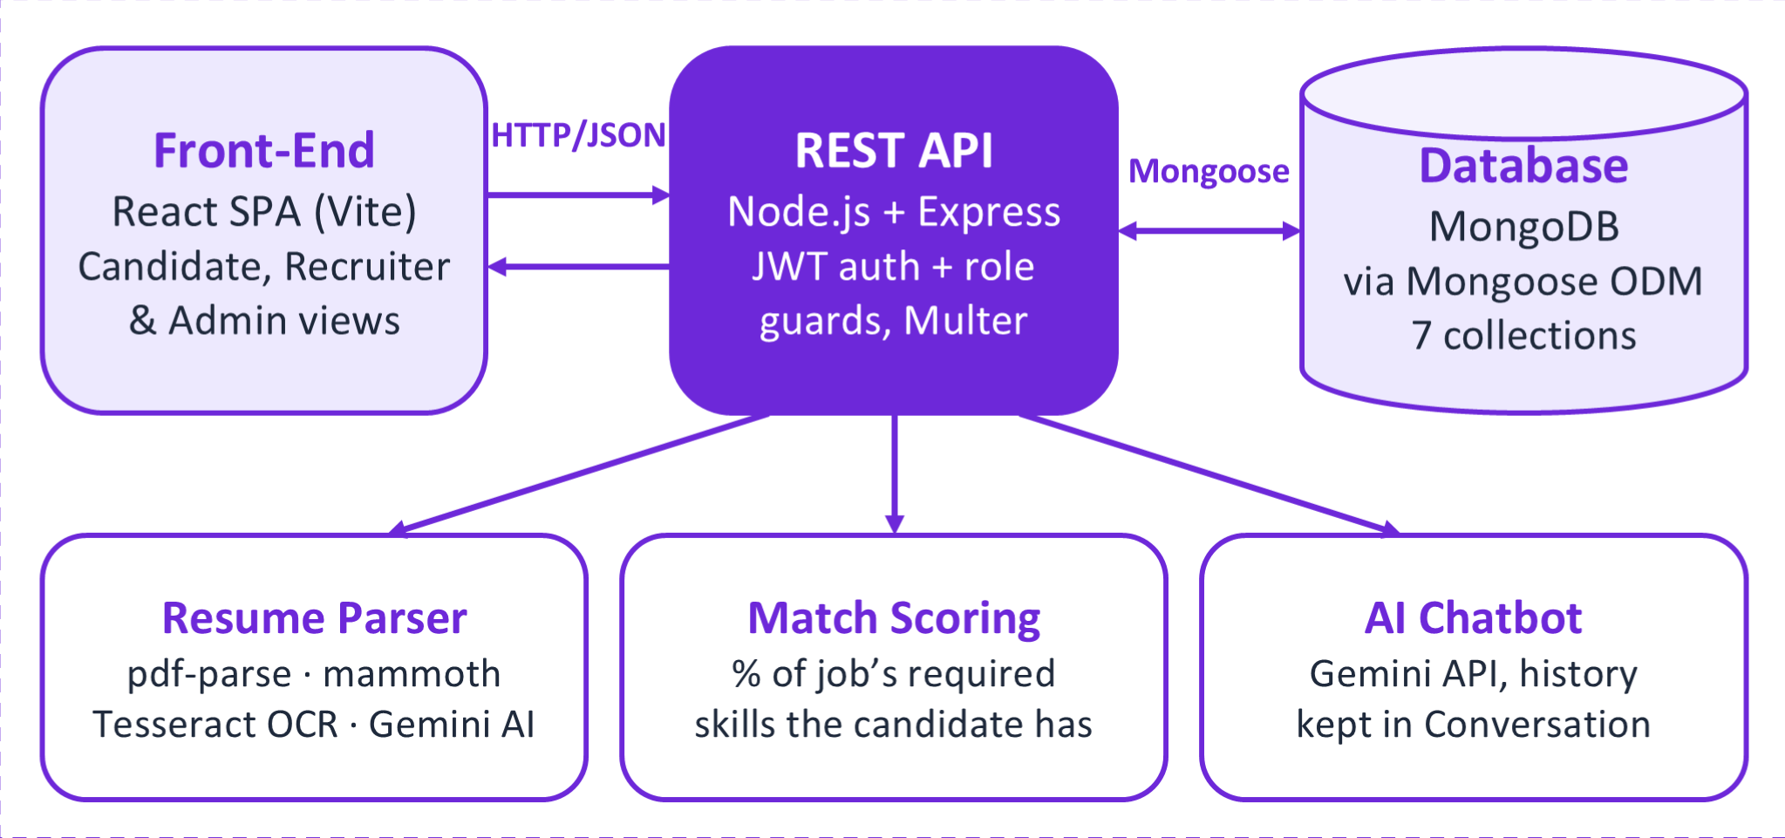
Figure 4.1: High-level architecture of HireHub
Communication between the tiers is strictly layered. The browser never connects to the database; it sends HTTP requests with JSON bodies (or multipart form data for resume uploads) to the API and receives JSON responses. The API is the only component that reads or writes MongoDB, and it is also the only component that calls the Gemini API, so the API key never reaches the browser. Because the API keeps no session state in memory (every request carries its own signed token), any number of API instances could serve the same front end and database.
A typical request, such as a candidate applying to a job, flows through the architecture as follows: (1) the React page calls applyToJob(jobId, token) in api.js; (2) the function sends POST /api/jobs/:job_id/apply with an Authorization: Bearer header; (3) Express routes the request through requireAuth, which verifies the token; (4) the controller checks that the user is a candidate, loads the job, rejects a duplicate application, loads the candidate's skills and latest resume, computes the match score and inserts the Application document; and (5) the API returns 201 Created with the new application, which the page uses to update its state.
4.2 Description of Each Layer (Frontend, Backend, Database)
Frontend (presentation layer)
The frontend is responsible for everything the user sees and interacts with. It renders public pages (landing page, login, registration and About), the role-specific home pages, and the candidate and recruiter dashboards, each of which uses a shared DashboardLayout with a sidebar for navigation between Jobs, Applications, Interviews and Profile. It validates simple input in the browser (for example, required fields in the job-posting and offer-letter forms), formats data for display (relative times such as "6 days ago", salary ranges, interview modes and status labels), and keeps the user's authentication record in localStorage.
The frontend contains no business rules that the server relies on. It hides actions a user cannot perform (a recruiter does not see the Apply button, and the offer-letter panel appears only for hired applications), but every rule is enforced again by the API. The address of the API is read from the VITE_API_URL environment variable at build time and defaults to http://localhost:8000/api.
Backend (application layer)
The backend exposes the REST API and implements all business logic. Its internal layers are routes (URL and method mapping, middleware attachment), middleware (authentication, role checks and file upload), controllers (validation, ownership checks and orchestration), models (schemas and database access) and utilities (resume parsing and match scoring). The routes are mounted under the /api prefix: /api/auth, /api/jobs, /api/candidate, /api/matches, /api/applications (and /api/jobs/:job_id/apply), /api/interviews, /api/offers, /api/recruiter, /api/admin and /api/chatbot, plus a /api/health endpoint for monitoring. Uploaded resume files are stored on disk and served read-only under /uploads so that recruiters can open an applicant's original resume.
The backend also coordinates the slower operations. A resume upload performs text extraction, optional OCR, AI extraction or rule-based parsing, removal of the candidate's previous resume and its file, insertion of the new Resume document, and an update of the candidate's skills and years of experience, all within a single request handler.
Database (data layer)
The data layer is a MongoDB database with seven collections, one per Mongoose model: users, jobs, resumes, applications, interviews, offerletters and conversations. It stores account data (with passwords only as bcrypt hashes), job postings, parsed resumes, the application pipeline, interview records with feedback, offer letters and chatbot history. Referential links are stored as ObjectIds and resolved by the application with populate(), and integrity constraints are enforced by unique indexes and schema validation. The design of this layer is detailed in Chapter 5.
Table 4.1: Summary of architectural layers
Layer | Technology | Main responsibilities
Presentation | React 19, React Router 7, Vite 7, CSS, Framer Motion | Rendering pages and dashboards, routing and route protection, calling the API, storing the session token.
Application | Node.js, Express 4, JWT, bcrypt, Multer, Gemini client, pdf-parse, mammoth, Tesseract | REST endpoints, authentication and authorisation, validation, resume processing, match scoring, chatbot.
Data | MongoDB with Mongoose 8 | Persistent storage of seven collections, schema validation, unique indexes, aggregation for analytics.

4.3 Deployment Architecture
HireHub has not been deployed to a public host. During development it runs entirely on a developer's machine, with the three processes shown in Table 4.2. The front end runs on the Vite development server, which proxies nothing and simply serves the React application; the browser then calls the API directly on its own port, which is permitted by the API's CORS configuration.
Table 4.2: Local development deployment
Process | Started with | Default address
React front end (Vite dev server) | npm run dev in job-portal-frontend | http://localhost:5173
Express API | npm run dev (nodemon) or npm start in job-portal-backend | http://localhost:8000/api
MongoDB | Local mongod service, or a hosted cluster referenced by MONGODB_URI | mongodb://127.0.0.1:27017/hirehub

Because the tiers communicate only over HTTP and are configured entirely through environment variables, the same code can be deployed to separate hosts without changes to the source. A deployment architecture for production is proposed in Chapter 9: the front end is built into static files with npm run build and served from a static hosting service or content delivery network; the API runs as a Node.js web service with its environment variables set in the host's configuration; and the database is a managed MongoDB cluster. Two aspects of the current design must be addressed in such a deployment: uploaded resumes are stored on the API server's local disk, which requires persistent storage (or a move to object storage), and CORS_ORIGIN must be set to the public address of the front end. The project does not currently include a continuous-integration pipeline, container files or infrastructure configuration.
CHAPTER -5 DESIGN
5.1 ER Diagram / Database Schema
The data model of HireHub was derived directly from the Mongoose schemas in job-portal-backend/models/. Figure 5.1 presents it as an Entity–Relationship diagram in Chen notation: rectangles are entities, ovals are attributes (the key attribute _id is underlined), diamonds are relationships, and the labels 1, N and M give the cardinality at each end of a relationship. For readability the diagram shows each entity's key and its most important attributes; the complete attribute lists follow in Tables 5.1 to 5.7.
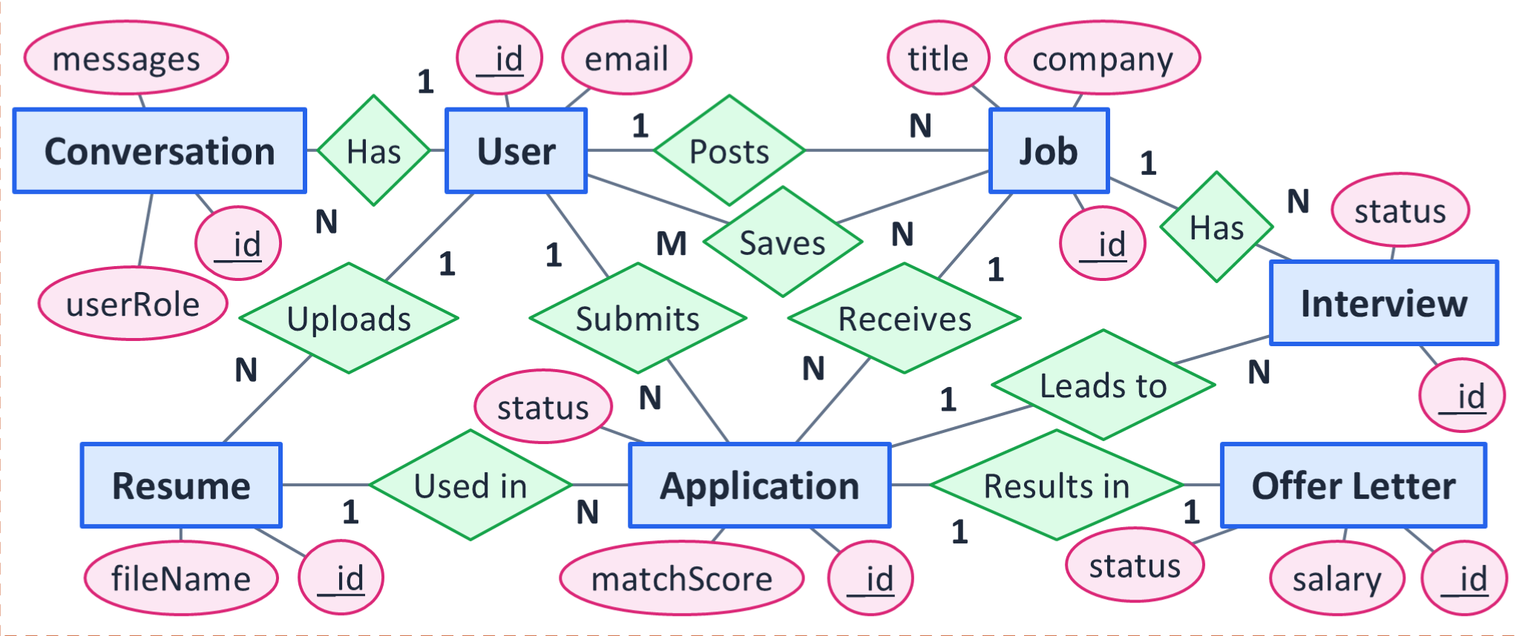
Figure 5.1: ER diagram of the HireHub database (Chen notation)
The relationships shown in the diagram correspond to references stored in the documents:
- User Posts Job (1:N) – Job.postedBy references the recruiter who created the job.
- User Saves Job (M:N) – User.savedJobs is an embedded array of { job, savedAt } entries, so one user can save many jobs and one job can be saved by many users.
- User Uploads Resume (1:N) – Resume.candidate references the candidate. The schema allows many resumes per user, although the upload logic keeps only the latest one.
- User Submits Application (1:N) – Application.candidate references the applicant.
- User Has Conversation (1:N) – Conversation.user references the user who chatted with the assistant.
- Job Receives Application (1:N) – Application.job references the job applied for.
- Job Has Interview (1:N) – Interview.job references the job the interview is for.
- Resume Used in Application (1:N) – Application.resume references the resume that was the candidate's latest when they applied (optional).
- Application Leads to Interview (1:N) – Interview.application references the application; one application may have several interview rounds.
- Application Results in Offer Letter (1:1) – OfferLetter.application references the application and is unique, so an application has at most one offer letter.
Some documents also hold denormalised references that duplicate a relationship already reachable through another entity, for faster and simpler queries: Interview.candidate and Interview.scheduledBy, and OfferLetter.candidate, OfferLetter.job and OfferLetter.recruiter. For example, storing the candidate on each interview lets the API fetch a candidate's interviews with a single query on candidate rather than first finding all of the candidate's applications. These shortcut references are listed in the tables but are omitted from the ER diagram because they do not represent separate relationships.
All seven schemas enable Mongoose timestamps, which add createdAt and updatedAt fields maintained automatically on every insert and update. Every document also has the primary key _id of type ObjectId generated by MongoDB. These three fields are not repeated in each table below. The notation "ref → X" means that the field stores the ObjectId of a document in collection X.
Table 5.1: users collection (model User)
Field | Type | Key / constraint | Description
name | String | Required, trimmed | Display name of the user.
email | String | Required, unique index, lower-cased, trimmed | Login identifier; duplicates are rejected with HTTP 409.
password | String | Required | bcrypt hash (cost 10); never returned in API responses.
role | String | Required, enum: candidate, recruiter, admin; default candidate | Determines which routes and pages the user can access.
company, industry, companyWebsite, companyDescription | String | Optional, trimmed | Recruiter company profile.
skills | [String] | — | Candidate skills copied from the latest parsed resume; used for match scoring.
experienceYears | Number | Default 0 | Years of experience estimated from the resume text.
title, phone, location, linkedin, github, about | String | Optional, trimmed | Candidate profile details (phone and location are also used by recruiters).
savedJobs | [{ job, savedAt }] | job: ref → Job, required; savedAt: Date, default now | Bookmarked jobs (the M:N Saves relationship).

Table 5.2: jobs collection (model Job)
Field | Type | Key / constraint | Description
title | String | Required, trimmed | Job title, searchable with a case-insensitive pattern.
company | String | Required, trimmed | Hiring company.
location | String | Optional, trimmed | Work location; also used to infer remote or hybrid work in the jobs page filters.
type | String | Enum: full-time, part-time, internship, contract, remote; default full-time | Employment type.
description | String | Required | Full job description.
requiredSkills | [String] | — | Skills used as the denominator of the match score.
experienceRequired | Number | Default 0 | Required experience in years.
salaryRange | String | Optional | Free-text salary range (for example "6-8 LPA").
postedBy | ObjectId | ref → User, required | Recruiter who posted the job (Posts relationship).
status | String | Enum: open, closed; default open | Only open jobs are listed publicly and scored for matches.

Table 5.3: resumes collection (model Resume)
Field | Type | Key / constraint | Description
candidate | ObjectId | ref → User, required | Owner of the resume (Uploads relationship).
fileName | String | Required | Original file name shown in the interface.
filePath | String | Required | Location of the stored file in the uploads folder.
rawText | String | — | Full text extracted from the file (or recovered by OCR).
parsedSkills | [String] | — | Skills extracted by Gemini or the rule-based parser; editable by the candidate.
parsedExperienceYears | Number | Default 0 | Largest "N years" figure found in the text.
education | [{ degree, institution, year }] | Embedded, strings, default "" | Education entries.
experience | [{ title, company, duration, description }] | Embedded, strings, default "" | Work and internship entries.
certifications | [String] | — | Certificate and course names.

Table 5.4: applications collection (model Application)
Field | Type | Key / constraint | Description
job | ObjectId | ref → Job, required; part of unique index (job, candidate) | Job applied for (Receives relationship).
candidate | ObjectId | ref → User, required; part of unique index (job, candidate) | Applicant (Submits relationship). The compound index allows one application per candidate per job.
resume | ObjectId | ref → Resume, optional | Latest resume at the time of applying (Used in relationship).
matchScore | Number | Default 0 (0–100) | Skill-overlap score calculated when the application is created.
status | String | Enum: applied, under_review, shortlisted, interview, rejected, hired, withdrawn; default applied | Current stage in the hiring pipeline.

Table 5.5: interviews collection (model Interview)
Field | Type | Key / constraint | Description
application | ObjectId | ref → Application, required | Application being interviewed (Leads to relationship).
job | ObjectId | ref → Job, required | Job for the interview (Has relationship).
candidate | ObjectId | ref → User, required | Denormalised reference to the candidate.
scheduledBy | ObjectId | ref → User, required | Recruiter who scheduled the interview (denormalised).
scheduledAt | Date | Required | Date and time of the interview.
mode | String | Enum: online, in-person, phone; default online | How the interview is conducted.
notes, interviewerName, type, location, meetingLink | String | Optional (trimmed except notes) | Details shown to the candidate; type is, for example, Technical or HR.
feedback | { technicalSkills, communication, problemSolving, comments, recommendation } | Embedded; ratings are Numbers with min 1 and max 5 | Recruiter's assessment, never returned to candidates.
status | String | Enum: scheduled, completed, cancelled; default scheduled | Interview state; feedback is allowed only when completed.

Table 5.6: offerletters collection (model OfferLetter)
Field | Type | Key / constraint | Description
application | ObjectId | ref → Application, required, unique | Hired application the offer belongs to (Results in, 1:1).
candidate | ObjectId | ref → User, required | Denormalised reference to the candidate.
job | ObjectId | ref → Job, required | Denormalised reference to the job.
recruiter | ObjectId | ref → User, required | Recruiter who issued the offer.
position, company | String | Required, trimmed | Role offered and employer name.
joiningDate, offerExpiry | Date | Required | Start date and date by which the offer must be accepted.
employmentType | String | Required, trimmed | For example full-time or internship.
salary | String | Required, trimmed | Compensation offered.
workLocation, reportingTo, additionalTerms | String | Optional, trimmed | Further terms of the offer.
status | String | Enum: draft, sent; default draft | The API creates offers with status sent.
sentAt | Date | — | Time the offer was sent; updated by the resend action.

Table 5.7: conversations collection (model Conversation)
Field | Type | Key / constraint | Description
user | ObjectId | ref → User, required | Owner of the conversation (Has relationship).
userRole | String | Required, enum: candidate, recruiter, admin | Role at the time of the conversation; selects the assistant's system prompt.
messages | [{ role, content }] | Embedded; role enum: user, assistant; content required; per-message timestamps | Ordered chat history sent back to Gemini as context.

The schema reflects several deliberate design decisions. Interview feedback is embedded in the interview because it has no meaning on its own and is always read with the interview; the controller excludes it with a projection (select("-feedback")) when a candidate requests their interviews. Saved jobs are embedded in the user because the list is small and always belongs to one user, and the API uses an $ne condition in the update filter so that saving the same job twice does not create a duplicate entry. The match score is stored on the application, rather than recomputed, so that recruiters see the score that applied when the candidate applied even if the candidate later edits their skills. Finally, all status fields are enumerations validated by Mongoose, which ensures that the pipeline can only contain the stages the application understands.
CHAPTER -6 IMPLEMENTATION
This chapter describes how HireHub was implemented. Section 6.1 walks through the back-end modules and the rules each one enforces, Section 6.2 explains how the React front end renders pages and manages state, Section 6.3 documents the REST API and how the front end calls it, and Section 6.4 describes authentication and authorisation. File and function names refer to the project source code.
6.1 Module-wise Implementation
6.1.1 Authentication module
Implemented in controllers/authController.js and routes/authRoutes.js. The register handler requires name, email, password and role, checks that the role is one of candidate, recruiter or admin, and rejects an e-mail address that already exists (compared in lower case) with HTTP 409. The password is hashed with bcrypt.hash(password, 10) before the user is created, and the company name is stored only for recruiters. The login handler looks the user up by lower-cased e-mail and compares the password with bcrypt.compare; both an unknown e-mail and a wrong password return the same 401 message, "Invalid email or password", so the response does not reveal which accounts exist. Both handlers return a signed token and the user object with the password field removed by a sanitizeUser helper.
6.1.2 Candidate profile and resume module
Implemented in controllers/candidateController.js with routes under /api/candidate. The upload route chains requireAuth, requireRole("candidate") and Multer's uploadResumeFile.single("resume"). Multer stores the file in the uploads folder under a unique name made of a timestamp and a random number, accepts only .pdf and .docx extensions and limits the size to 5 MB. The uploadResume handler then:
- extracts the text with extractTextFromResume (Section 6.1.3);
- structures it with parseResumeWithAI, which uses Gemini when configured and the rule-based parser otherwise;
- deletes the candidate's previous Resume documents and their files from disk, so that each candidate has exactly one current resume;
- creates a new Resume document with the raw text and the extracted skills, experience years, education, experience and certifications; and
- copies the skills and years of experience to the candidate's User document, because match scoring reads them from there.
The updateResumeDetails handler (PATCH /api/candidate/resume) lets a candidate correct the extracted fields. Each field must be an array; string lists are trimmed and de-duplicated case-insensitively, entry lists keep only the expected keys and drop completely blank rows, and an edited skills list is also written back to the User document so that match scores update immediately. deleteResume removes the latest resume together with its stored file and resets the candidate's skills and experience to their empty state. getProfile returns the user without the password together with the latest resume, and updateProfile accepts a role-specific whitelist of fields (personal details for candidates; company details for recruiters) and refuses an empty name. Saved jobs are handled by saveJob, unsaveJob and getSavedJobs, which add to, remove from and populate the embedded savedJobs array.
6.1.3 Resume parsing pipeline
Resume parsing is split between utils/resumeParser.js and utils/aiResumeParser.js. Text extraction depends on the file type. For a PDF, pdf-parse reads the text layer; if fewer than 100 characters are found the document is treated as a scan, its first five pages are rendered to images with pdf-to-img, and tesseract.js recognises their text, keeping whichever result is longer. For a DOCX file, mammoth.extractRawText returns the document text. Any other type raises an error.
When GEMINI_API_KEY is set, parseResumeWithAI asks Gemini for a JSON object conforming to a response schema with skills, education, experience and certifications. The prompt instructs the model not to invent skills, to use empty strings for fields it cannot find, and to follow a worked example of the expected output. Long resumes are split into chunks and the chunk results are merged with duplicate skills and entries removed. The numeric years of experience are always computed with a regular expression that finds the largest "N years" or "N yrs" figure in the text, rather than asked of the model. If there is no key, or if Gemini fails after its retries, the same output shape is produced by the rule-based functions parseSkillsFromText, parseEducationLines, parseExperienceEntries and parseCertifications.
The rule-based parser is substantial in its own right (over 800 lines). It recognises section headings such as Education, Experience, Skills and Certifications in many spellings, matches skills against a dictionary of technologies with aliases (for example "js" and "ecmascript" map to JavaScript, "golang" to Go), detects degree names and institutions with patterns, recognises date ranges such as "Jun 2023 – Aug 2023" or "2022 – Present" to separate experience entries, and identifies certifications by keywords. Its output is heuristic, which is why candidates can review and edit it.
6.1.4 Matching module
Match scoring is a single function, calculateMatchScore(candidateSkills, job), in utils/matchScore.js. It lower-cases both lists, counts how many of the job's required skills appear in the candidate's skill set, and returns the percentage rounded to a whole number between 0 and 100. A job that lists no required skills receives a neutral score of 50. The function is used in two places: GET /api/matches scores every open job for the logged-in candidate and returns them sorted from the highest score to the lowest, and applyToJob stores the score on the new application.
Listing 6.1: utils/matchScore.js
// Returns a 0-100 score based on overlap between candidate skills and job's required skills
export function calculateMatchScore(candidateSkills = [], job) {
const requiredSkills = (job.requiredSkills || []).map((s) => s.toLowerCase());
const candidateSet = new Set(candidateSkills.map((s) => s.toLowerCase()));

if (requiredSkills.length === 0) return 50; // neutral score if job lists no required skills

const matched = requiredSkills.filter((skill) => candidateSet.has(skill));
const skillScore = (matched.length / requiredSkills.length) * 100;

return Math.round(Math.min(100, Math.max(0, skillScore)));
}

For example, a job requiring JavaScript, React, Node.js and MongoDB scores 75% for a candidate whose resume contains JavaScript, React and MongoDB, which is exactly the result observed in test case TC-21 in Chapter 8.
6.1.5 Jobs module
Implemented in controllers/jobController.js. GET /api/jobs is public and returns open jobs, newest first, with the recruiter's name and company populated; it supports optional query parameters q (title), location, type and experience=fresher. POST /api/jobs allows only recruiters and administrators, requires a title, company and description, and records the logged-in recruiter as postedBy. PATCH /api/jobs/:id updates only whitelisted fields, refuses edits by recruiters who did not post the job, re-checks the required fields, and returns HTTP 400 when Mongoose rejects an invalid enumeration value (for example an unknown job type). Closing and reopening a job is an update of its status field.
6.1.6 Applications module
Implemented in controllers/applicationController.js. applyToJob allows only candidates, returns 404 for an unknown job and 409 if the candidate has already applied, and creates the application with the candidate's latest resume and the calculated match score. getApplications returns different data for each role: a candidate receives their own applications, a recruiter receives the applications for jobs they posted, and an administrator receives all applications; in every case the job, candidate and resume are populated and the newest come first. updateApplicationStatus accepts only the stages a recruiter may set (applied, under_review, shortlisted, interview, rejected, hired) and checks job ownership. withdrawApplication lets candidates delete only their own applications.
6.1.7 Interviews module
Implemented in controllers/interviewController.js. scheduleInterview requires an applicationId and scheduledAt, checks that the recruiter owns the job, copies the job and candidate references from the application into the interview, and moves the application's status to interview. getMyInterviews returns a candidate's interviews with the feedback field excluded, and a recruiter's or administrator's interviews with the job, candidate and application status populated, sorted by date. updateInterview reschedules (rejecting invalid dates) and changes the status to scheduled, completed or cancelled. submitFeedback is accepted only after the interview has been marked completed and requires three whole-number ratings from 1 to 5 for technical skills, communication and problem solving, plus optional comments and a recommendation.
6.1.8 Offer letters module
Implemented in controllers/offerController.js. createOffer requires an application whose status is hired, rejects a second offer for the same application with 409, copies the whitelisted offer fields from the request, and stores the offer with status sent and the current time as sentAt. getOfferForApplication returns the offer (or null if none exists yet) to the candidate who applied or to the recruiter who owns the job. getCandidateOffers lists a candidate's sent offers, newest first, which drives the congratulations banner on the candidate's home page. resendOffer updates the sent time; it does not send an e-mail.
6.1.9 Recruiter, administrator and chatbot modules
controllers/recruiterController.js provides two read-only endpoints for recruiters. getRecruiterStats loads the recruiter's jobs and their applications and returns, per job, the number of applicants and the counts in the under-review, shortlisted, interview and hired stages, together with overall totals including the number of active (open) jobs. getApplicants groups applications by candidate, so that a candidate who applied to several of the recruiter's jobs appears once with all their applications listed, and attaches each candidate's most recent parsed resume. controllers/adminController.js provides getAnalytics, which runs five countDocuments queries in parallel and a $group aggregation of applications by status. controllers/chatbotController.js stores each exchange in a Conversation document, continues an existing conversation when a valid conversationId belonging to the user is supplied, and calls Gemini with the role-specific system prompt, or returns the fallback reply when no key is configured.
6.2 Front-end Logic (UI Rendering, State Management)
Rendering and page structure
The React application is composed of function components. App renders the Navbar, a Routes table and a footer. Pages for logged-in users are wrapped in DashboardLayout, which draws the sidebar for the user's role (Jobs, Applications, Interviews and Profile, with role-specific paths) and a Logout button, and renders the page content beside it. Larger pages are composed of smaller components; for example, the candidate's Applications page uses StatusChip and ApplicationDetail, the recruiter's Applications page uses ApplicationStageTrack, ResumeSummary and HiringActions, and both Interviews pages use a shared InterviewCalendar. Offer letters are displayed by OfferLetterView inside a modal dialog and can be downloaded as a text file generated in the browser with a Blob.
The home route renders a different page depending on who is logged in. Home reads the stored authentication record and renders CandidateHome for candidates, RecruiterHome for recruiters and the public landing page for everyone else. CandidateHome shows a greeting with an Upload/Update Resume button, offer-letter banners, statistics tiles, a Profile Boost card summarising the parsed resume, the editable Resume Insights section, the top four AI matches, a profile-completion card and an application-progress timeline. RecruiterHome shows a Post a New Job button, KPI tiles (active jobs, total applicants, interviews and hires), recent applications, upcoming interviews and the recruiter's jobs.
State management
Each page keeps its own data in component state created with useState, loads it in a useEffect hook when the page mounts, and shows loading and error messages while doing so. Data that is needed together is loaded in parallel with Promise.all (for example the candidate home page loads the profile and applications together, and then loads matches only if a resume exists). Effects use a cancelled flag in their clean-up function so that a response arriving after the user has navigated away does not update an unmounted component. After a successful change, such as a resume upload or a status update, the page either replaces the affected item in state with the server's response or reloads the relevant data, so the screen always reflects what the server stored.
Derived views are computed during rendering rather than stored. On the candidate jobs page, the list of all open jobs and the list of matches are fetched once; the search text, filters (job type, work mode, experience band, minimum salary, location and skill), the selected tab (All, Recommended or Saved) and the sort order (newest, oldest, title or best match) are kept in state, and the visible list is recalculated from them on every render. Work mode is inferred from the job type and location text (remote, hybrid or on-site), and the Recommended tab shows matches with a score above zero. Profile completion is computed as the percentage of eight items that are present: resume, skills, title, phone, location, LinkedIn, GitHub and an About section.
Authentication state is the only global state. saveAuth stores the token, role, name and e-mail in localStorage under hirehub_auth after login or registration, getAuth reads it, and clearAuth removes it on logout. Because the record lives in storage rather than in a React context, every component reads the current user directly, and a page reload keeps the user logged in until the token expires.
6.3 API Integration
All communication with the back end goes through src/api.js. A shared helper, parseJsonOrThrow, reads the JSON body of every response and throws an Error carrying the server's message when the status is not successful, so that each page can display the server's own explanation (for example "You have already applied to this job"). Each exported function corresponds to one endpoint, sets the method and headers, and includes the bearer token for protected routes. Listing 6.2 shows the pattern.
Listing 6.2: Request pattern in src/api.js (abridged)
const API_BASE_URL = import.meta.env.VITE_API_URL || "http://localhost:8000/api";

async function parseJsonOrThrow(response, fallbackMessage) {
let data = {};
try { data = await response.json(); } catch { /* no JSON body */ }
if (!response.ok) throw new Error(data.message || fallbackMessage);
return data;
}

export async function uploadResume(file, token) {
const form = new FormData();
form.append("resume", file);
const response = await fetch(`${API_BASE_URL}/candidate/resume`, {
method: "POST",
headers: { Authorization: `Bearer ${token}` },
body: form,
});
return parseJsonOrThrow(response, "Resume upload failed");
}

Table 6.1 lists every route registered by the back end, with the roles allowed by the route's middleware. Routes marked "any" require a valid token but no particular role; ownership rules applied inside the controllers are described in Section 6.4.
Table 6.1: REST API endpoints (31 route handlers and a health check)
Method | Endpoint | Access | Purpose
GET | /api/health | Public | Health check; returns {status: "ok"}.
POST | /api/auth/register | Public | Create an account and return a token.
POST | /api/auth/login | Public | Log in and return a token.
GET | /api/jobs | Public | List open jobs (optional q, location, type, experience).
POST | /api/jobs | Any (recruiter/admin in controller) | Create a job.
PATCH | /api/jobs/:id | Recruiter, admin | Edit, close or reopen a job.
POST | /api/candidate/resume | Candidate | Upload and parse a resume (multipart field resume).
PATCH | /api/candidate/resume | Candidate | Correct the parsed resume fields.
DELETE | /api/candidate/resume | Candidate | Remove the latest resume.
GET | /api/candidate/profile | Candidate, recruiter | Profile and latest resume.
PUT / PATCH | /api/candidate/profile | Candidate, recruiter | Update profile fields (two routes, same handler).
GET | /api/candidate/saved-jobs | Candidate | List saved jobs.
POST | /api/candidate/saved-jobs/:job_id | Candidate | Save a job.
DELETE | /api/candidate/saved-jobs/:job_id | Candidate | Remove a saved job.
GET | /api/matches | Candidate | All open jobs with match scores, best first.
POST | /api/jobs/:job_id/apply | Any (candidate in controller) | Apply to a job.
GET | /api/applications | Any (filtered by role) | List applications visible to the user.
PATCH | /api/applications/:id/status | Recruiter, admin | Change an application's stage.
DELETE | /api/applications/:id | Candidate | Withdraw an application.
POST | /api/interviews | Recruiter, admin | Schedule an interview.
GET | /api/interviews | Candidate, recruiter, admin | List interviews visible to the user.
PATCH | /api/interviews/:id | Recruiter, admin | Reschedule or change interview status.
POST | /api/interviews/:id/feedback | Recruiter, admin | Record interview feedback.
POST | /api/offers | Recruiter, admin | Create an offer letter for a hired application.
GET | /api/offers/candidate | Candidate | List the candidate's offers.
GET | /api/offers/application/:applicationId | Any (ownership in controller) | Offer for one application.
PATCH | /api/offers/:id/resend | Recruiter, admin | Mark an offer as re-sent.
GET | /api/recruiter/stats | Recruiter, admin | Per-job and total hiring statistics.
GET | /api/recruiter/applicants | Recruiter, admin | Applicants grouped by candidate with latest resume.
GET | /api/admin/analytics | Admin | Platform totals and applications by status.
POST | /api/chatbot/message | Any | Send a message to the AI assistant.

The front end uses all of these endpoints except three: the administrator analytics endpoint and the chatbot endpoint, which have no user-interface component yet, and the PATCH variant of the profile route (the client uses PUT). The jobs pages call GET /api/jobs without query parameters and apply search and filters in the browser, as described in Section 6.2. Resume files are opened by building a URL to the server's /uploads folder from the stored file path with the helper resumeFileUrl.
6.4 Authentication and Authorisation
Authentication
HireHub uses stateless authentication with JSON Web Tokens. After a successful registration or login, the server signs a token whose payload contains the user's id, role and e-mail, using the secret in JWT_SECRET and an expiry taken from JWT_EXPIRES_IN (seven days by default). The client stores the token and sends it on every protected request in the header Authorization: Bearer <token>. Passwords are never stored or returned in plain text; they are hashed with bcrypt using a cost factor of 10, and the hash is removed from every user object returned by the API.
Listing 6.3: middleware/auth.js
export function requireAuth(req, res, next) {
const header = req.headers.authorization || "";
const token = header.startsWith("Bearer ") ? header.slice(7) : null;
if (!token) {
return res.status(401).json({ message: "Missing or malformed Authorization header" });
}
try {
const payload = jwt.verify(token, process.env.JWT_SECRET);
req.user = payload; // { id, role, email }
next();
} catch (err) {
return res.status(401).json({ message: "Invalid or expired token" });
}
}

// Usage: requireRole("recruiter", "admin")
export function requireRole(...allowedRoles) {
return (req, res, next) => {
if (!req.user || !allowedRoles.includes(req.user.role)) {
return res.status(403).json({ message: "You do not have access to this resource" });
}
next();
};
}

Authorisation
Authorisation is applied in two layers. The first is role-based: requireRole is attached to routes and rejects users whose role is not in the allowed list with HTTP 403 (Table 6.1). The second is ownership-based and is implemented in the controllers, because it depends on the data being accessed rather than on the route. The ownership rules are:
- A recruiter can edit only jobs whose postedBy is their own id.
- A recruiter sees, and can change the status of, only applications for jobs they posted; a candidate sees only their own applications and can withdraw only those.
- A recruiter can schedule interviews, change them and record feedback only for jobs they posted; a candidate sees only their own interviews, without the feedback.
- Offer letters can be created and resent only by the recruiter who owns the job; an offer can be viewed only by that recruiter or by the candidate who applied.
- A chatbot conversation is continued only if it belongs to the requesting user.
- Administrators bypass ownership checks and can see all applications, applicants and interviews.
On the client side, the ProtectedRoute component redirects visitors without a stored token to /login and redirects users whose role is not allowed on a route to their own dashboard. This improves the user experience but is not relied on for security: because every rule above is enforced by the API, a user who altered the client could still not read or change another user's data. ProtectedRoute, the navigation bar and the role helpers compare the stored role case-insensitively, since the API returns roles in lower case.
CHAPTER -7 FEATURES
7.1 List of Main Features
Table 7.1 lists the main features of HireHub, the role that uses each one and its status in the current implementation. All features marked "In user interface" are reachable from the React application; the two features marked "API only" are implemented and tested on the back end but do not yet have a screen.
Table 7.1: Main features of HireHub
No. | Feature | Used by | Status
F1 | Registration, login and role-aware home page | All | In user interface
F2 | Resume upload with automatic parsing (PDF/DOCX, OCR, Gemini or rule-based) | Candidate | In user interface
F3 | Resume Insights review and correction | Candidate | In user interface
F4 | Job search, filters and sorting | Candidate | In user interface
F5 | AI job matches and recommendations | Candidate | In user interface
F6 | Saved jobs | Candidate | In user interface
F7 | Applying, application tracking and withdrawal | Candidate | In user interface
F8 | Candidate interview calendar | Candidate | In user interface
F9 | Offer letter notification, viewing and download | Candidate | In user interface
F10 | Candidate and recruiter profiles | Candidate, recruiter | In user interface
F11 | Job posting and management | Recruiter | In user interface
F12 | Applicant review with match scores and parsed resumes | Recruiter | In user interface
F13 | Application status pipeline | Recruiter | In user interface
F14 | Interview scheduling, updates and feedback | Recruiter | In user interface
F15 | Offer letter creation and resend | Recruiter | In user interface
F16 | Hiring statistics dashboard | Recruiter | In user interface
F17 | Platform analytics | Administrator | API only (UI page shows static figures)
F18 | AI career and recruiting assistant | All | API only
F19 | Responsive layout with mobile navigation | All | In user interface

7.2 How Each Feature Works (User Perspective + Technical Description)
F1 – Registration, login and role-aware home page
User perspective. A visitor opens the landing page, chooses Get Started, enters a name, e-mail address and password, and selects whether they are a candidate or a recruiter (the form also offers an Admin option; see Section 10.3). Recruiters add their company details afterwards on their Profile page. The login form asks for a name or username as well as the e-mail address and password, although only the e-mail address and password are checked. After registering or logging in, the user is taken to the home page, which now shows their own overview instead of the marketing page, and the navigation bar shows Dashboard and Logout buttons.
Technical description. The form calls registerUser or login in api.js. The API validates the fields, hashes the password, signs a JWT and returns it with the user object. saveAuth stores the token, role, name and e-mail in localStorage. The Home component reads this record on every navigation and renders CandidateHome, RecruiterHome or the landing page accordingly; logging out clears the record and returns to /.
F2 – Resume upload with automatic parsing
User perspective. On the home page or the Profile page, a candidate clicks Upload Resume and chooses a PDF or Word (DOCX) file. After a short wait the Profile Boost card reports that the resume is AI-ready, shows the file name, and the Resume Insights section lists the skills, experience, education and certifications that were found. Uploading again replaces the previous resume.
Technical description. The file is sent as multipart form data to POST /api/candidate/resume. Multer validates the extension and size and stores the file; the controller extracts text (with OCR for scanned PDFs), parses it with Gemini or the rule-based parser, replaces any earlier resume and its file, saves the new Resume document and copies the skills and experience years to the user. The response contains the structured fields, and the page reloads the profile and the matches so that recommendations reflect the new skills immediately.
F3 – Resume Insights review and correction
User perspective. Because automatic parsing can miss or misread information, the Resume Insights section has an Edit button. The candidate can add or remove skills, edit education and experience rows and certifications, and save the changes.
Technical description. ResumeInsightsEditor sends the edited arrays to PATCH /api/candidate/resume. The server validates that each field is an array, trims and de-duplicates the values, drops blank rows, saves the resume and, when skills change, updates User.skills. The page then refreshes the profile and matches, so an added skill raises the corresponding match scores at once.
F4 – Job search, filters and sorting
User perspective. The Jobs page lists open jobs as cards showing the title, company, location, employment type and work mode, salary, required skills and, for candidates with a resume, the match percentage. The candidate can search by keyword and location, filter by job type, work mode (remote, hybrid or on-site), experience band, minimum salary, location and skill, and sort by newest, oldest, title or best match. Selecting a job opens a details page with the full description.
Technical description. The page fetches all open jobs from the public GET /api/jobs endpoint once and applies search, filters and sorting in the browser, recomputing the visible list on every render from the values held in state. Work mode is inferred from the job's type and location text, and the salary filter reads the upper bound of the salary range text. Search terms entered on the landing page are passed to the Jobs page as a q query parameter in the URL.
F5 – AI job matches and recommendations
User perspective. After uploading a resume, the candidate sees a Best Match tile and an AI Matches list of the four highest-scoring jobs on the home page, a Recommended tab on the Jobs page, and a match percentage on each job card and job details page. Jobs that require more of the candidate's skills appear first.
Technical description. GET /api/matches applies calculateMatchScore to every open job using the skills stored on the candidate's user document and returns the jobs sorted by score. The front end keeps the scores in a map keyed by job id to annotate cards and to implement the best-match sort, and the Recommended tab shows matches with a score above zero.
F6 – Saved jobs
User perspective. A candidate can bookmark a job with the save icon on its card and later find it under the Saved tab of the Jobs page; clicking the icon again removes it.
Technical description. POST and DELETE /api/candidate/saved-jobs/:job_id add to and remove from the embedded savedJobs array on the user document. The add operation uses an update filter that matches only when the job is not already saved, so repeated clicks cannot create duplicates; GET /api/candidate/saved-jobs populates the jobs, drops entries whose job no longer exists and sorts by the time saved. The Saved Jobs tile on the candidate home page shows the current number of saved jobs, loaded with the same endpoint.
F7 – Applying, application tracking and withdrawal
User perspective. The candidate clicks Apply on a job. The Applications page lists every application with a status chip (Applied, Under Review, Shortlisted, Interview, Selected or Not selected); selecting one shows its details, the match score, a stage tracker and, if the candidate is hired, the offer letter. An application can be withdrawn while it is still in progress. The home page summarises progress in a Your Journey timeline.
Technical description. Applying calls POST /api/jobs/:job_id/apply, which stores the current match score and latest resume and is protected against duplicates by both a controller check and the unique compound index on job and candidate. The list comes from GET /api/applications, filtered to the candidate by the server. Withdrawal calls DELETE /api/applications/:id, which verifies that the application belongs to the candidate before deleting it.
F8 – Candidate interview calendar
User perspective. The Interviews page shows a monthly calendar with the candidate's interviews and a list of upcoming and past interviews. Each interview shows the job, date and time, mode (online, in-person or phone), interview type, interviewer, meeting link or location, notes from the recruiter and general preparation tips.
Technical description. The page calls GET /api/interviews, for which the server returns only the candidate's own interviews and excludes the recruiter's feedback with a projection. InterviewCalendar groups interviews by day for the visible month, and isUpcomingInterview separates upcoming scheduled interviews from completed, cancelled or past ones.
F9 – Offer letter notification, viewing and download
User perspective. When a recruiter sends an offer, the candidate's home page shows a congratulations banner naming the position and company with a View Offer Letter button. The letter states the position and company, lists the work location, employment type, joining date, salary or stipend and reporting manager, includes the date by which the offer must be accepted and any additional terms, and can be downloaded as a text file.
Technical description. The home page calls GET /api/offers/candidate and renders a banner for each sent offer; the Applications page calls GET /api/offers/application/:applicationId for a hired application. offerLetterText formats the letter and downloadOfferLetter creates a Blob in the browser and triggers a download, so no file is generated on the server.
F10 – Candidate and recruiter profiles
User perspective. Candidates maintain a professional title, phone number, location, LinkedIn and GitHub links and an About section, and manage their resume; a profile-completion percentage encourages them to fill in missing items. Recruiters maintain their name, phone, location and company details (company name, industry, website and description), and see a hiring overview of their own activity.
Technical description. Both profiles use GET /api/candidate/profile and PUT /api/candidate/profile. The server accepts only the fields allowed for the user's role, trims them and rejects an empty name. Profile completion is calculated on the client from eight items.
F11 – Job posting and management
User perspective. A recruiter clicks Post a New Job on the home page or the Jobs page and fills in the title, company, location, employment type, description, required skills (comma-separated), experience required and salary range. The recruiter's Jobs page lists every job with its applicant counts by stage, and each job can be edited, closed or reopened.
Technical description. PostJobModal validates the required fields in the browser and calls POST /api/jobs or, when editing, PATCH /api/jobs/:id. Closing or reopening a job sends only the new status. The per-job counts come from GET /api/recruiter/stats. Closed jobs disappear from the public list and from match scoring because both only consider open jobs.
F12 – Applicant review with match scores and parsed resumes
User perspective. The recruiter's Applications page lists applicants for the recruiter's jobs and can be filtered by job, stage and experience and searched by name. Selecting an applicant shows their e-mail address, the match score for the selected job, the stage tracker, the candidate's skills and education from the parsed resume, and a link to open the original resume file.
Technical description. The page loads GET /api/applications and GET /api/recruiter/applicants in parallel. The applicants endpoint groups applications by candidate and attaches the latest resume; ResumeSummary renders it, falling back to the skills on the user record. The resume file link is built by resumeFileUrl from the stored file path and opens the file served statically under /uploads.
F13 – Application status pipeline
User perspective. For each application the recruiter moves the candidate through the stages Applied, Under Review, Shortlisted, Interview and finally Hired or Rejected. The candidate sees the change on their Applications page and home-page timeline.
Technical description. Status buttons call PATCH /api/applications/:id/status. The server accepts only the six recruiter-settable stages and checks that the recruiter owns the job; the updated application is returned with its job, candidate and resume populated so the page can replace it in state. ApplicationStageTrack maps each status to its position in the pipeline for display.
F14 – Interview scheduling, updates and feedback
User perspective. From an applicant, the recruiter chooses Schedule Interview, which opens the Interviews page with that application selected. The recruiter sets the date and time, interview type (Screening, Technical, HR, Managerial or Final), mode, meeting link or location, interviewer and notes. Interviews appear on a calendar and can be rescheduled, cancelled or marked completed. After completion, the recruiter records ratings from 1 to 5 for technical skills, communication and problem solving, comments and a recommendation (Strong Hire, Hire, Maybe or No Hire).
Technical description. The schedule form posts to POST /api/interviews, which also sets the application's status to interview. Only applications that are not rejected, hired or withdrawn are offered for scheduling. Updates use PATCH /api/interviews/:id and feedback uses POST /api/interviews/:id/feedback; the server refuses feedback for an interview that is not completed and validates the ratings.
F15 – Offer letter creation and resend
User perspective. When an application is marked Hired, a Hiring Actions panel appears with a Create Offer Letter button. The recruiter completes the offer form, reviews a preview of the letter and then sends it; afterwards the panel shows the letter with options to view, download or resend it.
Technical description. HiringActions loads any existing offer with GET /api/offers/application/:applicationId, creates one with POST /api/offers and resends with PATCH /api/offers/:id/resend. The server allows offers only for hired applications and only one per application, enforced by both a check and a unique index.
F16 – Hiring statistics dashboard
User perspective. The recruiter's home page shows the number of active jobs, total applicants, interviews and hires, together with recent applications, upcoming interviews and a list of the recruiter's jobs with applicant counts.
Technical description. RecruiterHome loads GET /api/recruiter/stats, GET /api/applications and GET /api/interviews in parallel. The statistics are calculated on the server from the recruiter's jobs and their applications.
F17 – Platform analytics (API only)
User perspective. An administrator would see counts of candidates, recruiters, jobs, applications and interviews and a breakdown of applications by status. The current Admin page in the user interface displays fixed sample figures and is not yet connected to this data.
Technical description. GET /api/admin/analytics is restricted to the admin role and combines five countDocuments queries executed in parallel with an aggregation pipeline that groups applications by status (verified in test case TC-43).
F18 – AI career and recruiting assistant (API only)
User perspective. The assistant is intended to answer questions about job searching, resumes and interview preparation for candidates, and about job postings, screening and interviews for recruiters. A chat interface has not yet been added to the front end.
Technical description. POST /api/chatbot/message accepts a message and an optional conversation id, stores both the user's message and the reply in a Conversation document, and sends the conversation history to Gemini with a role-specific system instruction. Without an API key it returns a clearly labelled fallback reply (verified in test case TC-45).
F19 – Responsive layout with mobile navigation
User perspective. The application can be used on phones and tablets: the navigation collapses into a menu button, and dashboard grids and cards stack into a single column on narrow screens.
Technical description. Layout is implemented with CSS grid and flexbox in styles.css, with media queries that change column counts and hide the dashboard sidebar on small screens; the Navbar component toggles the mobile menu with a state variable and closes it on navigation.
CHAPTER -8 TESTING
Testing aimed to confirm that every REST endpoint behaves as specified for valid input, rejects invalid input with the correct status code, and enforces the role and ownership rules described in Chapter 6; that the modules work together across a complete hiring flow; and that the main user journeys work in a real browser. This chapter explains how the API and the user interface were tested, which tools were used, and the test cases with their actual results. All results reported in this chapter come from test runs carried out on 2 October 2026 against the final version of the code, including the corrections described in Section 10.2.
8.1 Postman Testing (Frontend/Backend)
The project repository does not contain a Postman collection (an earlier version of the back-end README referred to one, and the README has since been corrected), so no Postman results are claimed in this report. Instead, the API was exercised with a scripted HTTP client that sends exactly the requests a Postman collection would contain and records each response automatically (Section 8.3). This made the run repeatable: the full suite can be executed again in a few seconds against a fresh database and produces the same results.
Every API test case in Table 8.3 can be reproduced manually in Postman (or any HTTP client) using the information in the table and the conventions below, which also serve as the specification for building a Postman collection for the project:
- Base URL: http://localhost:8000/api for the development server (the isolated test runs used port 8100).
- Content type: JSON bodies are sent with the header Content-Type: application/json. Resume uploads are sent as multipart/form-data with the file in a field named resume.
- Authentication: call POST /auth/register or POST /auth/login, copy the token from the response and send it on protected requests in the header Authorization: Bearer <token>. In Postman this is conveniently stored as a collection variable.
- Accounts: the role-based tests need four accounts: a candidate, a recruiter, a second recruiter (to test ownership) and an administrator.
- Identifiers: ids returned by earlier requests (job, application, interview and offer ids) are used in the paths of later requests, so the cases are executed in the order listed.
The front end was tested separately through the browser (Section 8.2 and Table 8.4), because Postman exercises only the API. The API client in src/api.js sends the same requests as the API tests, so the API tests also validate the contract on which the React application relies.
8.2 Integration Testing
Integration testing was carried out at two levels. At the API level, the test cases were written as one ordered scenario in which each step depends on the data created by the previous ones, rather than as isolated unit tests:
- register a candidate, two recruiters and an administrator, and log in;
- create two jobs as the first recruiter (Frontend Developer requiring JavaScript, React, Node.js and MongoDB; Backend Developer requiring Node.js, Express and MongoDB);
- upload a resume as the candidate and verify the parsed fields and the match scores for both jobs;
- correct the parsed skills and apply to the Frontend job;
- review the application as its recruiter, change its status, schedule an interview, complete it and record feedback;
- mark the application hired, create an offer letter and retrieve it as the candidate;
- check recruiter statistics, administrator analytics, saved jobs, the chatbot, withdrawal of a second application, removal of the resume (including its file) and the upload size limit.
Integration points verified by this scenario include: the resume upload updating both the Resume and User collections and thereby changing match scores (TC-20, TC-21, TC-23, TC-24); scheduling an interview moving the related application to the Interview stage (TC-32); offer creation depending on the application's status and on the unique index on the application (TC-38 to TC-40); recruiter statistics aggregating jobs and applications (TC-42); access rules that depend on data owned by other users (TC-16, TC-28); and resume removal deleting both the database record and the stored file (TC-47, TC-50).
At the user-interface level, the production build of the React application was opened in Google Chrome and driven by an automated browser script (Playwright) that performs the same actions as a user: filling in forms, clicking buttons, choosing filter values, uploading a file and downloading the offer letter. Two browser sessions were used at once, one logged in as a candidate and one as a recruiter, so that an action taken by one role (for example shortlisting an application) could be checked from the other role's screen. These cases are listed in Table 8.4.
Isolation of test data. No test used the project's real database. A temporary MongoDB instance was started in memory with mongodb-memory-server, and a separate copy of the back-end code was started against it on port 8100 with test-only environment values and no Gemini API key, so that resume parsing used the rule-based parser and the chatbot returned its fallback reply. For the user-interface tests the front end was built into a temporary folder with VITE_API_URL pointing to this test API and served on port 5180, and the database was filled with the project's own demonstration jobs (scripts/seedJobs.js, about 150 jobs). All test accounts used reserved example.test e-mail addresses. The temporary database was discarded when the test server stopped, and uploaded test files were written to a temporary folder outside the project.
Front-end build. The React application was compiled with Vite's production build (writing its output outside the project folder). The build completed successfully, transforming 1,993 modules, and produced a JavaScript bundle of about 506 kB (151 kB compressed), for which Vite printed its standard advisory that chunks larger than 500 kB could be split. No build errors were reported.
8.3 Tools Used for Testing
Table 8.1: Testing tools
Tool | Purpose in testing
Node.js (v24) with the built-in fetch, FormData and Blob APIs | API test script that sends each HTTP request, including multipart resume uploads, and compares the status code and response body with the expected result.
Playwright (playwright-core) with Google Chrome | Automated browser tests of the user interface (Table 8.4), including file upload, dialogs and file download.
mongodb-memory-server | Temporary, isolated MongoDB server so that tests never touch the real database.
Mongoose (from the back end's dependencies) | Dropping the temporary database before a run so that every run starts from an empty state.
Project seed script (npm run seed:jobs) | Loading demonstration jobs into the temporary database for the user-interface tests.
Microsoft Word | Producing realistic test resumes in PDF and DOCX format.
PyMuPDF | Producing a PDF with a different internal structure to test the robustness of PDF parsing (TC-49).
Vite build | Compiling the front end to detect build-time errors and to produce the build used by the browser tests.
Server console log | Confirming the cause of failures, such as the PDF parsing error in TC-49.

The API test data consisted of four accounts, two jobs, a one-page resume describing a candidate with JavaScript, React, MongoDB, Git, HTML and CSS skills, a B.Tech degree, one internship and one certification (saved as both PDF and DOCX), a plain text file used as an invalid upload, a 6 MB file used to test the size limit, and a PDF of the same resume generated by a different library.
8.4 Test Cases and Results
Table 8.2 summarises the API results by module, and Table 8.3 lists every executed API test case with its request, expected result, actual result and status. Of 51 executed API cases, 50 passed and 1 failed. Table 8.4 lists the user-interface test cases; all 17 were executed in Chrome and 17 passed.
Table 8.2: Summary of test results
Module | Executed | Passed | Failed
System | 2 | 2 | 0
Auth | 9 | 9 | 0
Jobs | 6 | 6 | 0
Resume | 10 | 9 | 1
Matching | 1 | 1 | 0
Applications | 8 | 8 | 0
Interviews | 7 | 7 | 0
Offers | 4 | 4 | 0
Recruiter | 1 | 1 | 0
Admin | 1 | 1 | 0
Saved jobs | 1 | 1 | 0
Chatbot | 1 | 1 | 0
User interface (Table 8.4) | 17 | 17 | 0
Total | 68 | 67 | 1

Table 8.3: API test cases and results (executed 2 October 2026)
ID | Endpoint | Request / input | Expected result | Actual result | Status
TC-01 | GET /api/health | No body | 200 with {status: "ok"} | 200 {status: "ok"} | Pass
TC-02 | GET /api/unknown-route | No body | 404 "Route not found" | 404 "Route not found" | Pass
TC-03 | POST /api/auth/register | Body without password and role | 400 validation message | 400 "name, email, password and role are required" | Pass
TC-04 | POST /api/auth/register | role = "superuser" | 400 invalid role | 400 "role must be candidate, recruiter or admin" | Pass
TC-05 | POST /api/auth/register | Valid candidate details | 201 with JWT token; password not returned | 201, token issued: true, password field in response: false | Pass
TC-06 | POST /api/auth/register | Same email again | 409 duplicate account | 409 "An account with this email already exists" | Pass
TC-07 | POST /api/auth/register | Valid recruiter details with company | 201 with JWT token | 201, role "recruiter", company "Example Corp" | Pass
TC-08 | POST /api/auth/login | Correct email, wrong password | 401 "Invalid email or password" | 401 "Invalid email or password" | Pass
TC-09 | POST /api/auth/login | Correct credentials (email in upper case) | 200 with JWT token | 200, token issued: true | Pass
TC-10 | GET /api/applications | No Authorization header | 401 missing header | 401 "Missing or malformed Authorization header" | Pass
TC-11 | GET /api/applications | Authorization: Bearer invalid.token.value | 401 invalid token | 401 "Invalid or expired token" | Pass
TC-12 | POST /api/jobs | Candidate token, valid job body | 403 only recruiters can post | 403 "Only recruiters can post jobs" | Pass
TC-13 | POST /api/jobs | Recruiter token, description missing | 400 required fields | 400 "title, company and description are required" | Pass
TC-14 | POST /api/jobs | Recruiter token, valid job (4 required skills) | 201 job created, status open | 201, status "open" | Pass
TC-15 | GET /api/jobs?q=frontend | Public request, no token | 200 list containing the new job | 200, 1 job(s) returned, new job included: true | Pass
TC-16 | PATCH /api/jobs/:id | Different recruiter edits the job | 403 not the owner | 403 "You can only edit jobs you posted" | Pass
TC-17 | PATCH /api/jobs/:id | Owner sets type = "freelance" | 400 enum validation error | 400 (validation error) | Pass
TC-18 | POST /api/candidate/resume | Multipart request with no file | 400 no file uploaded | 400 "No resume file uploaded (field name must be 'resume')" | Pass
TC-19 | POST /api/candidate/resume | Upload a .txt file | 400 "Only .pdf and .docx resumes are accepted" | 400 "Only .pdf and .docx resumes are accepted" | Pass
TC-20 | POST /api/candidate/resume | Upload a text-based PDF resume exported from MS Word (no Gemini key: rule-based parser) | 201 with extracted skills, education, experience, certifications | 201; skills [JavaScript, React, MongoDB, Git, HTML, CSS, Web Development, REST APIs]; education 1; experience 1; certifications 1; experience years 2 | Pass
TC-21 | GET /api/matches | Candidate token after resume upload | 200; jobs ranked by % of required skills matched | 200; Frontend Developer (Test): 75%; Backend Developer (Test): 33% | Pass
TC-22 | PATCH /api/candidate/resume | parsedSkills sent as a string | 400 must be an array | 400 "parsedSkills must be an array" | Pass
TC-23 | PATCH /api/candidate/resume | parsedSkills with duplicates and blanks, adding Node.js | 200; list de-duplicated, profile skills updated | 200; skills [JavaScript, React, MongoDB, Git, HTML, CSS, Web Development, REST APIs, Node.js] | Pass
TC-24 | POST /api/jobs/:id/apply | Candidate applies to the Frontend job | 201 with stored matchScore | 201; matchScore 100; status "applied" | Pass
TC-25 | POST /api/jobs/:id/apply | Same candidate applies again | 409 already applied | 409 "You have already applied to this job" | Pass
TC-26 | POST /api/jobs/:id/apply | Recruiter token | 403 only candidates can apply | 403 "Only candidates can apply to jobs" | Pass
TC-27 | GET /api/applications | Recruiter token | 200; only applications for this recruiter's jobs | 200; 1 application(s) | Pass
TC-28 | GET /api/applications | Other recruiter's token | 200; empty list (no access to other jobs) | 200; 0 application(s) | Pass
TC-29 | PATCH /api/applications/:id/status | status = "withdrawn" (not recruiter-settable) | 400 invalid status | 400 (status list returned) | Pass
TC-30 | PATCH /api/applications/:id/status | status = "shortlisted" | 200; status updated | 200; status "shortlisted" | Pass
TC-31 | POST /api/interviews | applicationId without scheduledAt | 400 required fields | 400 "applicationId and scheduledAt are required" | Pass
TC-32 | POST /api/interviews | Valid online interview with meeting link | 201; application moves to "interview" | 201; application status now "interview" | Pass
TC-33 | POST /api/interviews/:id/feedback | Feedback while still "scheduled" | 400 must be completed first | 400 "Mark the interview as completed before adding feedback" | Pass
TC-34 | PATCH /api/interviews/:id | status = "completed" | 200; interview completed | 200; status "completed" | Pass
TC-35 | POST /api/interviews/:id/feedback | technicalSkills = 6 | 400 rating must be 1-5 | 400 "technicalSkills must be a whole number from 1 to 5" | Pass
TC-36 | POST /api/interviews/:id/feedback | Ratings 4/5/4 with comments | 200; feedback saved | 200; feedback {"t":4,"c":5,"p":4} | Pass
TC-37 | GET /api/interviews | Candidate token | 200; candidate's interview without recruiter feedback | 200; 1 interview(s); feedback visible: false | Pass
TC-38 | POST /api/offers | Offer for an application that is not "hired" | 400 only for hired applications | 400 "Offer letters can only be sent for hired applications" | Pass
TC-39 | POST /api/offers | Status set to "hired", then valid offer | 201; offer status "sent" | 201; offer status "sent" | Pass
TC-40 | POST /api/offers | Second offer for the same application | 409 offer already exists | 409 "An offer letter already exists for this application" | Pass
TC-41 | GET /api/offers/candidate | Candidate token | 200; one sent offer | 200; 1 offer(s), position "Frontend Developer" | Pass
TC-42 | GET /api/recruiter/stats | Recruiter token | 200; totals reflect 2 open jobs, 1 applicant, 1 hire | 200; openings 2, applicants 1, hires 1 | Pass
TC-43 | GET /api/admin/analytics | Candidate token, then admin token | 403 for candidate; 200 with totals for admin | candidate 403; admin 200 (candidates 1, recruiters 2, jobs 2) | Pass
TC-44 | POST /api/candidate/saved-jobs/:job_id | Save the Backend job twice, then list | 201; saved once; list contains it | 201; saved list length 1 | Pass
TC-45 | POST /api/chatbot/message | Empty message, then a question (no GEMINI_API_KEY) | 400 for empty; 200 with fallback reply and conversationId | empty 400; question 200, conversationId returned: true, mock reply: true | Pass
TC-46 | DELETE /api/applications/:id | Candidate applies to Backend job, then withdraws | 200 "Application withdrawn" | 200 "Application withdrawn" | Pass
TC-47 | DELETE /api/candidate/resume | Candidate token | 200; resume removed, profile skills reset | 200 "Resume removed"; latestResume now null; skills 0 | Pass
TC-50 | DELETE /api/candidate/resume | Check the uploaded file after TC-47 removed the resume | Stored resume file no longer exists on disk | file exists after delete: false | Pass
TC-51 | POST /api/candidate/resume | Upload a 6 MB .pdf (over the 5 MB limit) | 400 "File too large" | 400 "File too large" | Pass
TC-48 | POST /api/candidate/resume | Upload the same resume as a .docx file | 201 with the same extracted fields as the PDF | 201; skills [JavaScript, React, MongoDB, Git, HTML, CSS, Web Development, REST APIs]; education 1; experience 1; certifications 1 | Pass
TC-49 | POST /api/candidate/resume | Upload a valid PDF produced by a different generator (PyMuPDF, cross-reference stream) | 201 with extracted fields | 500 "Resume upload/parsing failed" (server log: pdf-parse "bad XRef entry") | Fail

Notes on the API results.
- TC-19 and TC-51 confirm that invalid uploads are client errors: a .txt file returns HTTP 400 with the message "Only .pdf and .docx resumes are accepted", and a file over 5 MB returns HTTP 400 "File too large". Before the correction described in Section 10.2, the .txt upload returned HTTP 500 with the same message.
- TC-47 and TC-50 confirm that removing a resume deletes both the database record and the uploaded file; before the correction, the file remained on disk.
- TC-20 and TC-48 show that PDF and DOCX versions of the same resume produce identical extracted fields with the rule-based parser. The parsed company name of the internship was returned as "Example Labs (" because the source line contained the dates in parentheses; such small heuristic artefacts are the reason candidates can edit the extracted fields (TC-23).
- TC-21 and TC-24 confirm the match-score calculation: three of four required skills gave 75% for the Frontend job and one of three gave 33% for the Backend job; after the candidate added Node.js in TC-23, the stored score at the time of applying was 100%.
- TC-49 failed. A valid PDF whose internal cross-reference table is stored as a compressed stream (as written by some PDF libraries) could not be read by the bundled version of pdf-parse, which is based on pdf.js 1.10.100; the server logged "bad XRef entry" and returned HTTP 500. The same resume exported from Microsoft Word was parsed correctly (TC-20). This known issue is discussed in Section 10.3.
Table 8.4: User-interface test cases and results (executed in Chrome, 2 October 2026)
ID | Screen / action | Steps | Expected result | Actual result | Status
UI-01 | Register | Open /register, enter details, keep Candidate selected, submit | Account created; home page shows the candidate overview | Redirected to /; candidate overview shown ("Good morning, Riya Test 👋") | Pass
UI-02 | Login with wrong password | Log out, open /login, enter a wrong password | Error "Invalid email or password"; user stays on login | Alert "Invalid email or password" shown; still on /login | Pass
UI-03 | Protected route | While logged out, open /applications | Redirected to /login | Redirected to /login | Pass
UI-04 | Resume upload | Candidate home: Upload Resume with a PDF | Profile Boost shows "AI-ready" and the file name; Resume Insights lists parsed fields | "AI-ready" and file name shown; Resume Insights: 8 skills (JavaScript, React, MongoDB, Git, HTML, CSS…), 3 experience/education/certification rows | Pass
UI-05 | Edit insights | Resume Insights: Edit, add Node.js and Express, Save | Skill shown; match percentages refresh | Node.js and Express added to skills; top match scores 75%/75%/75%/67% → 100%/100%/83%/80% | Pass
UI-06 | Job filters | Jobs page: work mode Remote, salary 6+ LPA, sort by Best match | Only matching jobs shown, highest match first | 22 jobs shown; all Remote: true; all salary ranges reach 6+ LPA: true (lowest upper bound 7.5 LPA); match scores in descending order: true (100, 60, 33, 0, 0, 0…) | Pass
UI-07 | Save job | Click the save icon on a job, open the Saved tab | Job appears under Saved | "Frontend Developer (Test)" saved and listed under the Saved tab | Pass
UI-08 | Apply | Search for the recruiter's job, open it, click Apply Now; open Applications | Application listed with status Applied and match score | Listed on /applications with status Applied | Pass
UI-09 | Post job | Recruiter home: Post a New Job, fill the form, submit | Success message; job listed on the recruiter's Jobs page | "Job posted successfully" shown; job listed on /recruiter/jobs | Pass
UI-10 | Status change | Recruiter Applications: select the applicant, click Shortlist | Status chip and stage tracker update; candidate sees Shortlisted | Recruiter view shows Shortlisted; candidate's Applications page shows Shortlisted | Pass
UI-11 | Schedule interview | Applicant: Schedule Interview, enter date, time, link and interviewer | Interview appears on both calendars; application shows Interview | Interview on 2026-10-05 10:30 listed for recruiter and candidate; candidate application shows Interview | Pass
UI-12 | Feedback | Open the interview, Mark Completed, enter ratings and comments, Save Feedback | Feedback saved; not visible to the candidate | Interview marked Completed; feedback saved and shown to recruiter; visible to candidate: false | Pass
UI-13 | Offer letter | Hire the applicant, Create Offer Letter, fill dates, Preview, Send; candidate opens and downloads the letter | Candidate home shows the congratulations banner; letter downloads as text | Banner "Congratulations…" shown on candidate home; letter downloaded as Offer-Letter-Nimbus-Labs-Frontend-Engineer-R5.txt | Pass
UI-14 | Responsive layout | Open the site at 390 px width and open the menu | Menu button replaces navigation; cards stack in one column | At 390 px: menu button visible true, nav links hidden true, menu opens true, stat cards in one column true | Pass
UI-15 | Candidate navigation link | Logged-in candidate opens the home page | Logged-in candidate sees the For Candidates link in the navigation bar | For Candidates link present for logged-in candidate: true | Pass
UI-16 | Saved Jobs tile | Candidate opens the home page after saving a job | Tile on the candidate home page shows the number of saved jobs | Tile shows 1; API reports 1 saved job(s) | Pass
UI-17 | Resume file picker | Inspect the resume upload controls on the candidate home page | Upload controls offer only PDF and DOCX files | accept attribute on 2 upload control(s): .pdf,.docx | Pass

Notes on the user-interface results. UI-15, UI-16 and UI-17 were added as regression tests for the corrections in Section 10.2: before those corrections, the For Candidates link was not shown to logged-in candidates, the Saved Jobs tile always displayed 0, and the upload controls also offered .doc files that the server rejects. The first version of the user-interface suite (UI-01 to UI-14), run against the code before the corrections, also passed all fourteen cases. Capturing the screenshots in Appendix A additionally revealed one defect that the test cases did not cover: the recruiter's applicant view always reports "No education details on file" for applications that have a resume attached, even when the parsed resume contains education entries (Section 10.3).
CHAPTER -9 DEPLOYMENT
HireHub has not yet been deployed to a public server; it is currently run on developers' machines. This chapter therefore documents, first, the exact procedure for running the system locally from the scripts and configuration files in the repository, which is the deployment that was actually used during development and testing; and second, a deployment approach for making the application publicly available. The second part is a proposal and is labelled as such: no hosting provider, domain or production URL has been set up.
9.1 Steps to Deploy
9.1.1 Local deployment (used during development)
The following steps start the complete system on a single computer. They assume Node.js and npm are installed and that a MongoDB server is running locally or that a hosted MongoDB connection string is available.
- Obtain the source code by cloning the project's GitHub repository, and open the project-files folder.
- Install the back-end dependencies: open a terminal in job-portal-backend and run npm install.
- Create the back-end configuration: copy .env.example to .env and fill in the values described in Section 9.2 (at minimum MONGODB_URI and JWT_SECRET). To enable the AI features, also set GEMINI_API_KEY; it is optional.
- Optionally load demonstration data with npm run seed:jobs, which creates demo recruiter accounts and about 150 job postings and can safely be run more than once.
- Start the API with npm run dev (with automatic restart through nodemon) or npm start (plain Node.js). The console reports the MongoDB connection and "HireHub backend running on http://localhost:8000". Opening http://localhost:8000/api/health should return {"status":"ok"}.
- Install the front-end dependencies: open a second terminal in job-portal-frontend and run npm install.
- If the API is not at the default address, create a .env file in job-portal-frontend containing VITE_API_URL (Section 9.2).
- Start the front end with npm run dev and open the address printed by Vite, normally http://localhost:5173.
For a production-style local check, the front end can be compiled with npm run build, which writes static files to the dist folder, and served with npm run preview.
9.1.2 Proposed public deployment
Proposed. The steps below describe how the existing code could be deployed publicly without changes to its source, because both applications are configured entirely through environment variables. Provider names are given only as examples of suitable services.
- Database: create a managed MongoDB cluster (for example MongoDB Atlas), create a database user with a strong password, restrict network access to the API host, and note the connection string.
- API: deploy job-portal-backend to a Node.js hosting service (for example Render or Railway) or a virtual machine. Set the build command to npm install and the start command to npm start, and set the environment variables in the host's settings rather than in a committed file.
- Resume storage: attach a persistent disk to the API service for the uploads folder, because the current code stores uploaded resumes on the local file system and many hosting services discard local files when a service restarts. A more scalable alternative is to change the upload handling to object storage.
- Front end: build job-portal-frontend on a static hosting service (for example Vercel or Netlify) with the build command npm run build and output folder dist, and set VITE_API_URL to the public API address so that it is embedded in the build. Configure the host to serve index.html for all paths, so that React Router can handle routes such as /jobs/123 on a page reload.
- Connect the tiers: set the API's CORS_ORIGIN to the public front-end address, then verify /api/health, registration, login, resume upload and the hiring flow on the deployed system.
- Optional seeding: run npm run seed:jobs once against the production database only if demonstration data is wanted.
9.2 Environment Configuration
All configuration is supplied through environment variables. The back end loads them from a .env file with dotenv (an .env.example template is committed; the real .env is excluded by .gitignore), and the front end reads variables prefixed with VITE_ at build time. Table 9.1 lists every variable the code reads. Real values, in particular secrets, must never be committed to the repository or included in documentation.
Table 9.1: Environment variables
Variable | Application | Required | Purpose and default
PORT | Back end | No | Port the API listens on; default 8000.
MONGODB_URI | Back end | Yes | MongoDB connection string; the server refuses to start without it. The example file uses a local database named hirehub.
JWT_SECRET | Back end | Yes | Secret used to sign and verify tokens; must be a long random string.
JWT_EXPIRES_IN | Back end | No | Token lifetime; default 7d.
GEMINI_API_KEY | Back end | No | Google Gemini API key; when absent, resume parsing uses the rule-based parser and the chatbot returns a fallback reply.
CORS_ORIGIN | Back end | No | Comma-separated list of front-end origins allowed to call the API; default http://localhost:5173.
VITE_API_URL | Front end | No | Base URL of the API, embedded at build time; default http://localhost:8000/api.

Two further runtime settings are fixed in code rather than configured: the maximum upload size of 5 MB and the allowed resume extensions (.pdf and .docx) in middleware/upload.js, and the folder used to cache the OCR language data, which is a hirehub-tesseract folder inside the operating system's temporary directory.
9.3 Hosting of Frontend and Backend
Current hosting. Both applications are currently hosted locally during development, as summarised in Table 4.2: the React application on the Vite development server at port 5173 and the Express API at port 8000, connected to MongoDB through MONGODB_URI. No public URL exists for the application.
Proposed hosting. Because the front end is a static single-page application after it has been built, it is best hosted on a static hosting service or content delivery network, which serves files quickly from locations close to users and needs no server management. The back end is a long-running Node.js process that needs environment variables, outbound access to the Gemini API, a connection to MongoDB and, in the current design, persistent disk storage for resumes; it is therefore best hosted on a Node.js platform service or a virtual machine. Separating the two in this way matches the architecture in Chapter 4 and allows each tier to be scaled independently: additional API instances can be added behind a load balancer because the API is stateless, provided that resume files are moved to shared object storage.
Table 9.2: Proposed hosting plan (not yet implemented)
Tier | Proposed hosting | Key configuration
Front end (static build) | Static hosting or CDN (for example Vercel or Netlify) | VITE_API_URL set to the public API URL; rewrite all paths to index.html.
Back end (Express API) | Node.js web service (for example Render or Railway) or a virtual machine | All back-end variables from Table 9.1; persistent disk for uploads; HTTPS.
Database | Managed MongoDB cluster (for example MongoDB Atlas) | Dedicated database user; network access limited to the API host; automated backups.

Production hosting should also enable HTTPS on both tiers (most of the services mentioned provide certificates automatically), keep JWT_SECRET and GEMINI_API_KEY in the host's secret settings, and add request rate limiting to the API before it is exposed publicly, as recommended in Chapters 10 and 11.
CHAPTER -10 CHALLENGES & LIMITATIONS
This chapter records the main technical problems encountered while building HireHub, the solutions adopted for them, and the limitations and known bugs of the current version. The issues described in Section 10.1 and in Table 10.1 are those evidenced in the source code, where the solutions and the reasons for them are documented in comments. Table 10.2 lists defects that were found by reviewing the code and testing it for this report, and that have since been corrected. The limitations and known bugs in Section 10.3 are those that remain in the current version.
10.1 Issues Faced During Development
- Unreliable AI availability. Resume parsing depends on an external AI model whose availability changes over time. The code records that the model originally used, gemini-2.5-flash, became unavailable to newly created API keys and returned HTTP 404, which would have made every resume upload fail. The project also had to work for team members who had no API key at all.
- Rate limits on the free tier. The Gemini free tier allows only a small number of requests per minute (the code notes five), and returns HTTP 429 when the limit is exceeded or HTTP 503 when the service is overloaded. Uploading several resumes in quick succession, or a long resume that requires several calls, could therefore fail intermittently.
- Long resumes. Sending an entire long resume in one request risked exceeding practical input sizes, while truncating it would silently lose later sections such as certifications.
- Scanned resumes. Many resumes are PDFs produced by scanning or by image-based export, which contain no text layer. For these files pdf-parse returns little or no text, so neither parser had anything to work with.
- Inconsistent resume layouts. Resumes use many different headings, bullet styles, date formats and ways of naming the same skill, which makes rule-based extraction error-prone.
- Keeping skills consistent across collections. Match scores are calculated from the skills stored on the user document, while the parsed data lives in the resume document. Any update to one had to be reflected in the other, including when a candidate edits or removes their resume.
- Multiple resumes and orphaned files. Without a rule, repeated uploads would accumulate many resumes per candidate, with ambiguity about which one an application should use and with old files remaining on disk.
- Data that belongs to other users. Recruiters must not see or change applications, interviews or offers for jobs posted by other recruiters, and candidates must not see recruiters' interview feedback. Route-level role checks alone could not express these rules.
- Role value casing. The API stores and returns roles in lower case (for example recruiter), whereas parts of the front end were written with capitalised role names, which caused role checks to fail where the two were compared directly.
10.2 Solutions Applied
Table 10.1: Issues and the solutions applied
Issue | Solution in the code
Unreliable AI availability | The model name is a single constant in aiResumeParser.js, changed to a currently available model. Every failure path falls back to the built-in rule-based parser, and when no key is configured the rule-based parser is used from the start, so uploads never fail because of the AI service.
Rate limits | extractChunk retries on HTTP 429 and 503 up to four attempts, waiting for the retry delay suggested by Gemini or using exponential back-off capped at 30 seconds. A per-day quota error is recognised and not retried, so the user is not kept waiting for a quota that will not recover.
Long resumes | Text longer than 15,000 characters is split into chunks of about 12,000 characters at paragraph, line or sentence boundaries, the chunks are processed sequentially to respect rate limits, and the results are merged with duplicates removed.
Scanned resumes | If a PDF yields fewer than 100 characters, its first five pages are rendered to images and recognised with Tesseract OCR; the longer of the two texts is used. The OCR libraries are loaded only when needed.
Inconsistent layouts | The rule-based parser recognises many heading variants, bullet characters, date-range formats and skill aliases. Because no parser is perfect, candidates can review and correct every extracted field in the Resume Insights editor.
Consistency across collections | Uploading, editing and deleting a resume all update User.skills (and experience years) in the same request handler, so match scores always use the current skills.
Multiple resumes | Each upload deletes the candidate's previous resume documents and their files before saving the new one, so a candidate has exactly one current resume.
Data ownership | Ownership checks were added in the controllers (comparing job.postedBy with the requesting user), candidates' interview queries exclude the feedback field, and unique indexes prevent duplicate applications and offers.
Role casing | Shared helpers such as isCandidateRole and ProtectedRoute compare roles in lower case; the last remaining case-sensitive comparison, in the navigation bar, was corrected as listed in Table 10.2.

The review of the code carried out while preparing this report, together with the tests in Chapter 8, identified six further defects. They were corrected in the project code as summarised in Table 10.2, and each correction was verified by the test cases listed.
Table 10.2: Defects corrected after the code review
Defect found | Correction (file and function) | Verified by
The For Candidates link was never shown to logged-in candidates, because the navigation bar compared the stored role with "Candidate" while the API stores "candidate". | job-portal-frontend/src/App.jsx, Navbar: the candidate check now compares the role in lower case, like the recruiter check. | UI-15
Uploading a file other than PDF or DOCX returned HTTP 500, and a file over 5 MB was also reported as a server error. | job-portal-backend/middleware/upload.js, fileFilter: the rejection error now carries status 400. job-portal-backend/server.js, error handler: Multer errors (such as the size limit) are returned with status 400. | TC-19, TC-51
Removing a resume deleted the database record but left the uploaded file on disk. | job-portal-backend/controllers/candidateController.js, deleteResume: the stored file is now deleted as well (a missing file is logged, not treated as an error). | TC-47, TC-50
The resume upload controls offered .doc files, which the server always rejects. | job-portal-frontend/src/App.jsx: the accept attribute of the five resume file inputs (in CandidateHome and CandidateProfile) is now .pdf,.docx. | UI-17
The Saved Jobs tile on the candidate home page always showed 0 with the note "Coming soon". | job-portal-frontend/src/App.jsx, CandidateHome: the saved-jobs count is loaded with getSavedJobs and shown in the tile. | UI-16
The README and .env.example described an Anthropic API key, a Postman collection that does not exist, an incorrect setup folder and an outdated description of resume parsing. | job-portal-backend/.env.example now lists GEMINI_API_KEY; job-portal-backend/README.md was corrected accordingly. | Document review

10.3 Current Limitations or Known Bugs
Known bugs
- Some valid PDFs cannot be parsed. The bundled pdf-parse 1.1.1 uses pdf.js 1.10.100, which fails on PDFs whose cross-reference table is stored as a compressed stream. Such uploads return HTTP 500 "Resume upload/parsing failed" (test case TC-49). Common exports, such as PDFs saved from Microsoft Word, are parsed correctly (TC-20).
- Education is missing from the recruiter's applicant view. The page passes the application's own resume reference to ResumeSummary in preference to the candidate's full latest resume. Because GET /api/applications populates only the file name, path and date of that resume, the Education section reports "No education details on file" for every application that has a resume attached, even when education was extracted. The skills shown are correct because they fall back to the skills stored on the user record. This was found while capturing Figure 14.7.
- The login form requires an unused field. The login page asks for a "Name / Username" and will not submit without it, although the API authenticates by e-mail and password only and ignores the name.
Limitations
- Matching is exact skill overlap only. The score counts exact (case-insensitive) matches between skill names, so related skills (for example "React" and "React.js") are treated as different unless the parser normalises them, and experience, education and location are not considered in the score.
- Administrator dashboard not connected. The /admin page displays fixed sample figures; the working analytics endpoint is not yet used by the interface.
- No chatbot interface. The AI assistant is available only through the API.
- Security hardening is incomplete. Any visitor can register as an administrator, because the registration form offers an Admin option and the registration endpoint accepts the admin role; there is no rate limiting or account lock-out on login; tokens cannot be revoked before they expire; and the token is stored in localStorage, which is readable by any script running on the page.
- No notifications. Status changes, interviews and offers are visible only inside the application; no e-mails are sent, and the offer "resend" action only records a new time.
- Local file storage. Resumes are stored on the API server's disk, which complicates horizontal scaling and some hosting platforms (Chapter 9).
- Scale. Job lists and applicant lists are not paginated; the jobs page loads all open jobs and filters them in the browser, and match scoring computes a score for every open job on each request.
- Heuristic parsing. Without Gemini, extraction relies on patterns and a skill dictionary; small artefacts occur (for example a trailing parenthesis in a company name in TC-20).
- No automated tests in the repository and no continuous-integration pipeline; the test run in Chapter 8 was carried out with a separate script.
- Unused dependencies and bundle size. The Three.js packages are installed but not used, and the production JavaScript bundle is about 506 kB, above Vite's recommended 500 kB chunk size.
CHAPTER -11 FUTURE ENHANCEMENTS
HireHub already implements the complete path from resume upload to offer letter, but several improvements would make it more accurate, more secure and ready for public use. The enhancements below follow directly from the limitations identified in Chapter 10 and from features whose back-end support already exists.
11.1 Planned Features
- Semantic job matching. Replace or complement the exact skill-overlap score with a similarity measure based on text embeddings of the resume and the job description, so that related skills and equivalent wording are recognised. The score could also weight required experience, education and location, and explain which skills are missing for each job.
- Chatbot interface grounded in live data. Add a chat panel to the candidate and recruiter dashboards that uses the existing /api/chatbot/message endpoint, and give the assistant read-only access to the user's own data (for example, "What is the status of my application to this job?" or "Which applicants for this role have React experience?") through controlled tool functions.
- Working administrator dashboard. Connect the /admin page to /api/admin/analytics and add management functions such as viewing and deactivating users and closing inappropriate job postings.
- Notifications. Send e-mail (and optionally in-app) notifications when an application's status changes, when an interview is scheduled, rescheduled or cancelled, and when an offer letter is sent, so that the offer "resend" action actually delivers the letter.
- Offer acceptance. Let candidates accept or decline an offer in the application, recording the decision and notifying the recruiter.
- Candidate search for recruiters. Allow recruiters to search all candidates who have opted in by skill, experience and location, using the structured resume data.
- Downloadable PDF offer letters generated on the server with the company's details, instead of the current text file.
- Multiple resume versions. Allow candidates to keep several resumes (for example, one per type of role) and choose which one to submit with each application.
11.2 Possible Integrations or Optimisations
- Security hardening: restrict the admin role to accounts created by an existing administrator, add rate limiting to authentication and upload routes, store tokens in HTTP-only cookies or add short-lived access tokens with refresh tokens, and add request validation middleware for all bodies.
- Robust PDF processing: upgrade the PDF extraction library to a current version of pdf.js (or use a maintained alternative) to fix the failure on PDFs with compressed cross-reference streams (TC-49).
- Cloud storage for resumes: store uploaded files in object storage (for example Amazon S3 or Google Cloud Storage) with signed download links, which also allows the API to scale to multiple instances.
- Pagination and indexing: paginate job, application and applicant lists on the server, move search and filtering to MongoDB queries, and add indexes on frequently filtered fields such as Job.status, Job.postedBy and Application.candidate.
- Caching match scores: compute and store scores when a resume or job changes rather than on every request, which becomes important as the number of jobs grows.
- Automated testing and CI: add the API test suite from Chapter 8 to the repository with a test runner, add front-end tests for the main user journeys, and run both automatically on every push with a continuous-integration service.
- Deployment: implement the hosting plan proposed in Chapter 9, with HTTPS, monitoring through the /api/health endpoint and regular database backups.
- Front-end performance: remove the unused Three.js dependencies and split the application into lazily loaded route bundles to reduce the initial download.
- Calendar and meeting integration: export interviews to calendar applications (iCalendar files) and generate meeting links automatically.
CHAPTER -12 CONCLUSION
12.1 Summary of the Project
HireHub is a role-based job portal that turns resumes into structured data and uses that data to match candidates with jobs. Candidates upload a PDF or DOCX resume once; the system extracts its text, recovers text from scanned documents with OCR, and structures it into skills, education, experience and certifications using the Google Gemini API or, when the AI service is unavailable, a rule-based parser. Every open job is scored by the percentage of its required skills that the candidate has, and the scores drive personalised recommendations for candidates and are stored on each application for recruiters.
Around this core, the application supports the complete hiring workflow: job posting and management, applications with a defined status pipeline, interview scheduling with calendars and structured feedback, offer letters for hired candidates, saved jobs, profiles and recruiter statistics. The system is built as a React single-page application, a Node.js and Express REST API with 31 route handlers, and a MongoDB database of seven collections modelled with Mongoose. Access is protected by JSON Web Tokens, bcrypt password hashing and role- and ownership-based authorisation.
12.2 What Was Achieved
The objectives set out in Section 1.4 were met as follows:
Table 12.1: Objectives and outcomes
Objective | Outcome
Automate resume parsing | Achieved. PDF and DOCX resumes are parsed automatically, scanned PDFs are handled with OCR, and the AI pipeline falls back to a rule-based parser, so uploads work with or without an API key. Candidates can correct the results. One limitation remains for PDFs with compressed cross-reference streams (TC-49).
Score every job by skill match | Achieved. Match scores are computed for all open jobs, power recommendations and sorting, and are stored on each application (verified in TC-21 and TC-24).
Support hiring from application to offer | Achieved. Applications, the status pipeline, interviews with feedback and offer letters are implemented end to end in both the API and the user interface (TC-24 to TC-41).
Enforce secure, role-based access | Achieved for role and ownership checks (TC-10 to TC-12, TC-16, TC-26, TC-28, TC-37, TC-43). Further hardening, such as restricting administrator registration and rate limiting, is planned (Chapter 11).
Design a sound document database | Achieved. Seven collections with validation, enumerations, references, embedded sub-documents and unique indexes protect data integrity (Chapter 5; TC-25 and TC-40).
Deliver a responsive, usable interface | Achieved for candidates and recruiters, with role-aware home pages and responsive layouts; the administrator page and chatbot interface remain to be connected.

In measurable terms, 51 API test cases covering every route group and 17 user-interface test cases executed in Chrome were run on the final code; 67 of the 68 passed, the front end builds without errors, and six defects found during the review were corrected and verified (Table 10.2). The project therefore delivers a working, tested foundation for an AI-assisted recruitment platform, together with a clear list of the improvements needed before public deployment.
12.3 Skills Learned During Development
Building HireHub developed skills across database design, back-end engineering and front-end development:
- Database design: modelling a real workflow as related MongoDB collections, choosing between embedding and referencing, and protecting integrity with schema validation, enumerations and unique compound indexes; using populate and the aggregation framework.
- REST API design: organising an Express application into routes, middleware, controllers, models and utilities; designing consistent endpoints and status codes; and handling multipart file uploads.
- Security: implementing stateless authentication with JWT, hashing passwords with bcrypt, and separating role-based route protection from ownership-based authorisation in controllers.
- Integrating external AI services: prompting a large language model for structured JSON output with a response schema, chunking long inputs, handling rate limits with retries and back-off, and designing a fallback so the system degrades gracefully.
- Document processing: extracting text from PDF and DOCX files and applying OCR to scanned documents, and writing heuristic text parsers with regular expressions.
- Front-end development: building a multi-page React application with React Router, protected routes, component state and effects, parallel data loading, client-side filtering and sorting, and responsive CSS.
- Testing: writing an ordered integration test scenario, isolating test data with an in-memory database, and analysing failures from server logs.
- Collaboration and tooling: using Git and GitHub, environment-based configuration that keeps secrets out of the repository, npm scripts and Vite.
CHAPTER -13 REFERENCES
The following official documentation, standards, papers and books were used for the design, implementation and testing of HireHub. Online resources were consulted during development in 2026.
- Meta Platforms, Inc., "React Documentation." [Online]. Available: https://react.dev/
- Vite Contributors, "Vite Guide." [Online]. Available: https://vite.dev/guide/
- Remix Software, Inc., "React Router Documentation." [Online]. Available: https://reactrouter.com/
- OpenJS Foundation, "Node.js Documentation." [Online]. Available: https://nodejs.org/docs/latest/api/
- OpenJS Foundation, "Express 4.x API Reference." [Online]. Available: https://expressjs.com/en/4x/api.html
- MongoDB, Inc., "The MongoDB Manual." [Online]. Available: https://www.mongodb.com/docs/manual/
- Mongoose Contributors, "Mongoose Documentation." [Online]. Available: https://mongoosejs.com/docs/
- Google, "Gemini API Documentation." [Online]. Available: https://ai.google.dev/gemini-api/docs
- M. Jones, J. Bradley and N. Sakimura, "JSON Web Token (JWT)," RFC 7519, Internet Engineering Task Force, May 2015. [Online]. Available: https://www.rfc-editor.org/rfc/rfc7519
- N. Provos and D. Mazières, "A Future-Adaptable Password Scheme," in Proc. USENIX Annual Technical Conference, FREENIX Track, Monterey, CA, USA, 1999.
- R. T. Fielding, "Architectural Styles and the Design of Network-based Software Architectures," Ph.D. dissertation, University of California, Irvine, 2000.
- P. P. Chen, "The Entity-Relationship Model—Toward a Unified View of Data," ACM Transactions on Database Systems, vol. 1, no. 1, pp. 9–36, 1976.
- R. Smith, "An Overview of the Tesseract OCR Engine," in Proc. 9th International Conference on Document Analysis and Recognition (ICDAR), 2007, pp. 629–633.
- C. de Ruijt and S. Bhulai, "Job Recommender Systems: A Review," arXiv preprint arXiv:2111.13576, 2021.
- S. Bradshaw, E. Brazil and K. Chodorow, MongoDB: The Definitive Guide, 3rd ed. Sebastopol, CA, USA: O'Reilly Media, 2019.
- S. Chacon and B. Straub, Pro Git, 2nd ed. Berkeley, CA, USA: Apress, 2014. [Online]. Available: https://git-scm.com/book
- Express.js, "Multer – Node.js middleware for handling multipart/form-data." [Online]. Available: https://github.com/expressjs/multer
- Project Naptha, "Tesseract.js – Pure JavaScript OCR." [Online]. Available: https://github.com/naptha/tesseract.js
- M. Williamson, "Mammoth .docx to HTML converter (mammoth.js)." [Online]. Available: https://github.com/mwilliamson/mammoth.js
- Mozilla, "PDF.js." [Online]. Available: https://mozilla.github.io/pdf.js/
- Typegoose, "mongodb-memory-server." [Online]. Available: https://github.com/typegoose/mongodb-memory-server
- Motion Division, "Motion (formerly Framer Motion) Documentation." [Online]. Available: https://motion.dev/docs
- MDN Web Docs, "Fetch API." [Online]. Available: https://developer.mozilla.org/en-US/docs/Web/API/Fetch_API
CHAPTER -14 APPENDICES
Appendix A – Screenshots of the App
Figures 14.1 and 14.2 show the role-aware home page of the running application for a logged-in candidate and a logged-in recruiter.
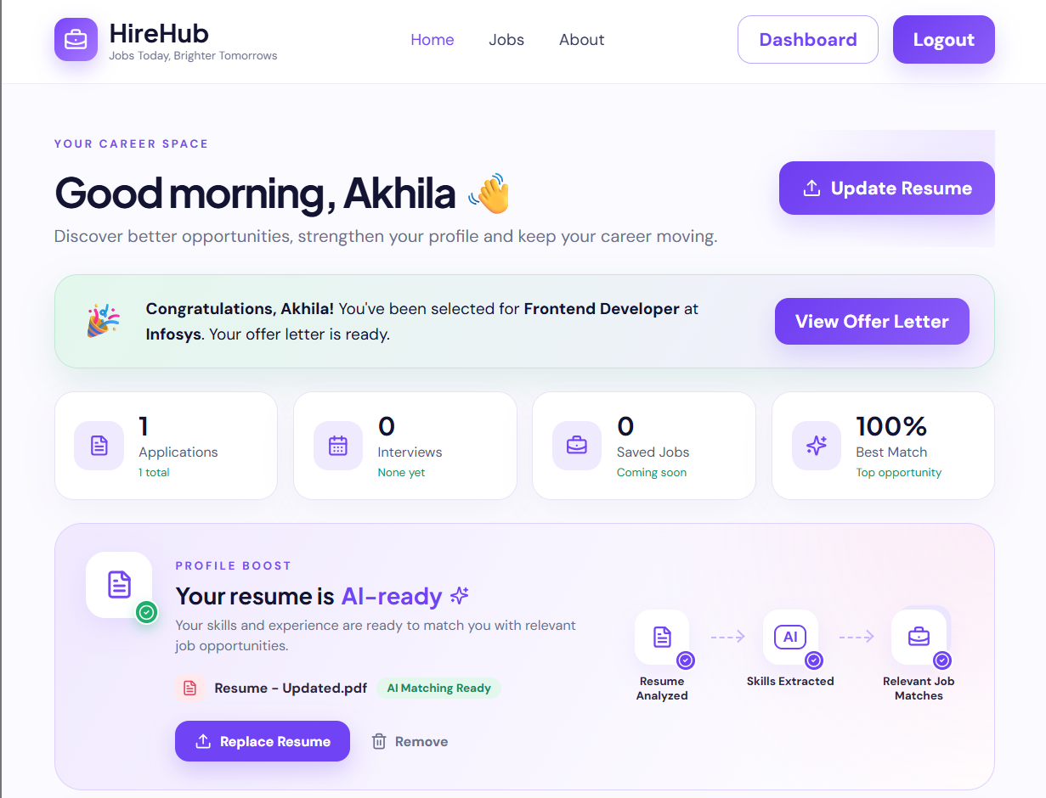
Figure 14.1: Candidate home page – career space, offer banner, statistics and Profile Boost
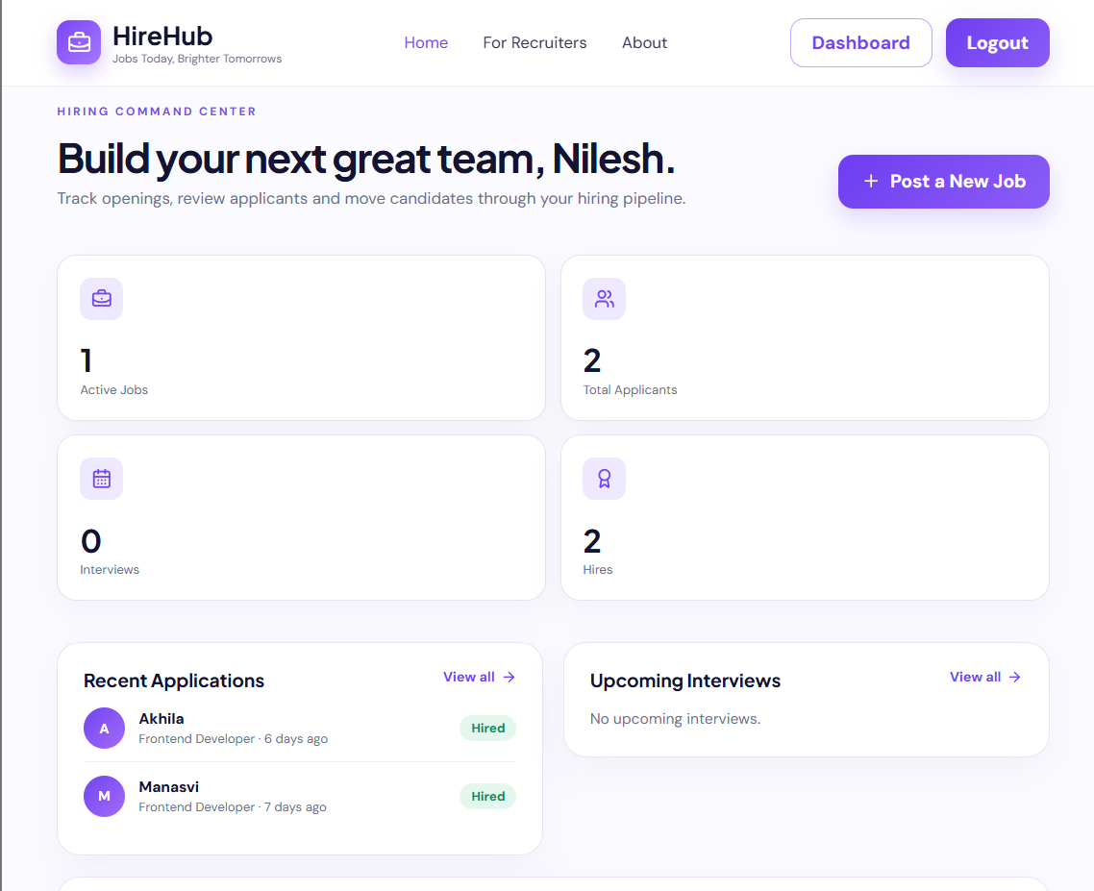
Figure 14.2: Recruiter home page – hiring command center, KPIs and recent applications
Figures 14.3 to 14.9 show the remaining screens. They were captured from a separate test instance of the application loaded with the project's seeded demonstration jobs and a small demonstration scenario; all names, e-mail addresses and companies in them are fictional.
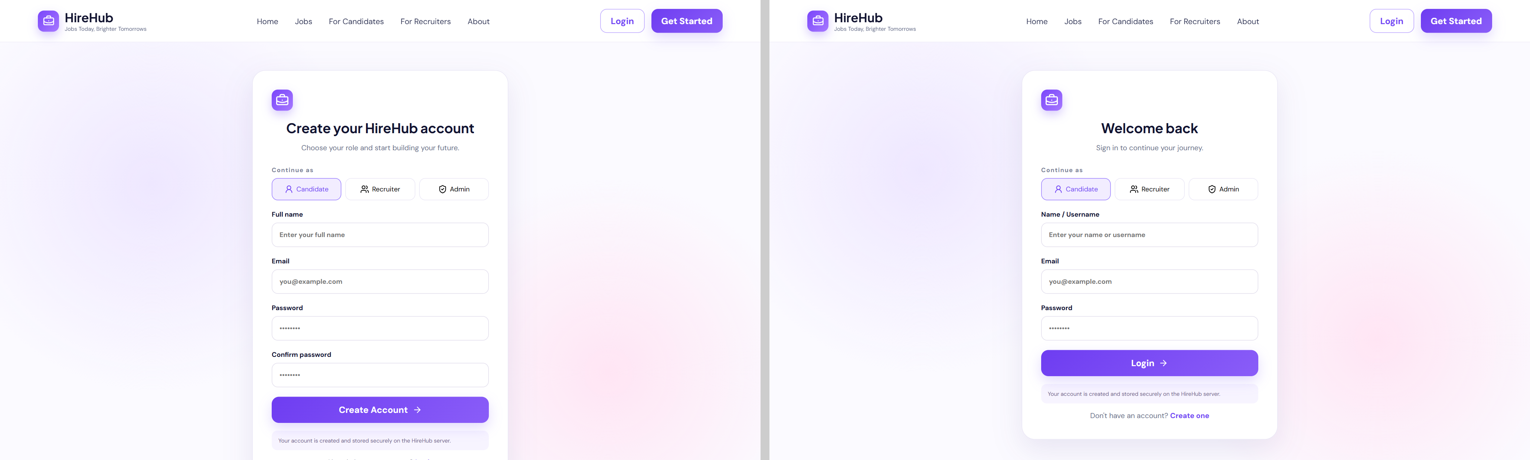
Figure 14.3: Registration (left) and login (right) pages
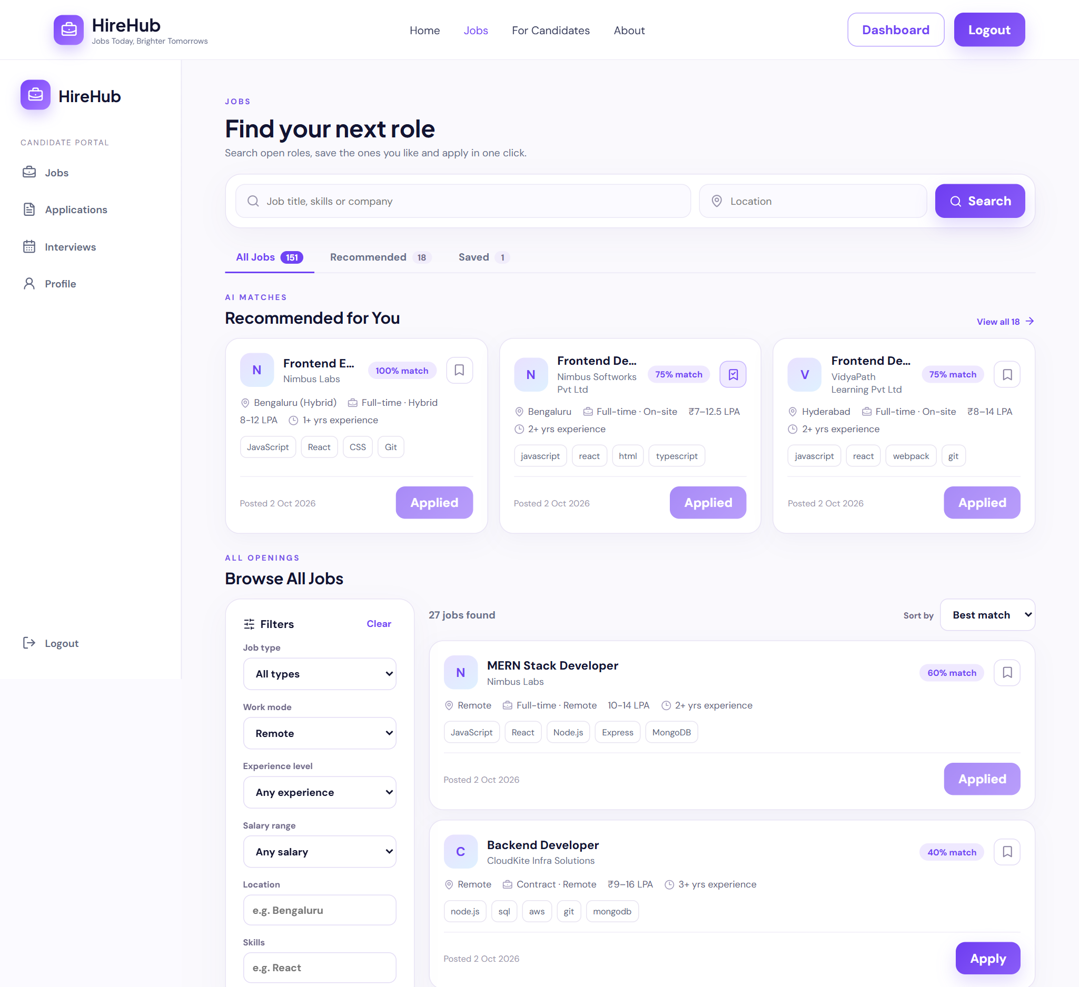
Figure 14.4: Candidate Jobs page – tabs, AI recommendations, filters and best-match sorting
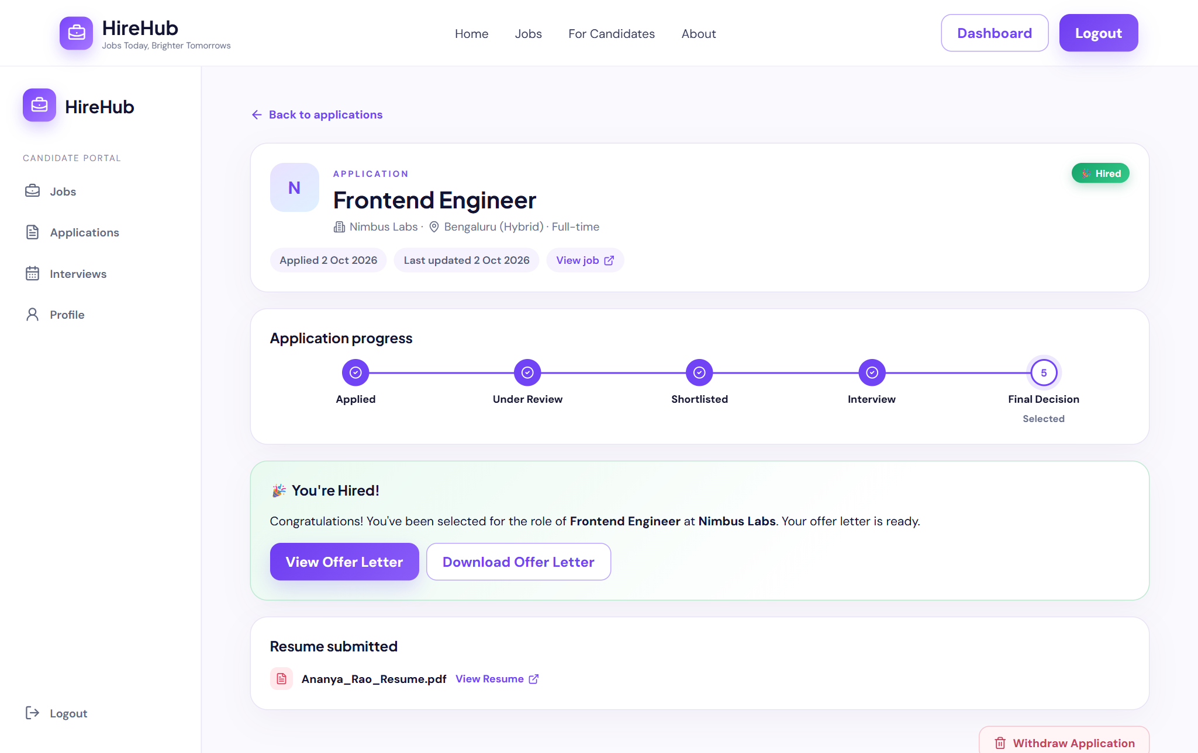
Figure 14.5: Candidate application detail – stage tracker and offer letter for a hired application
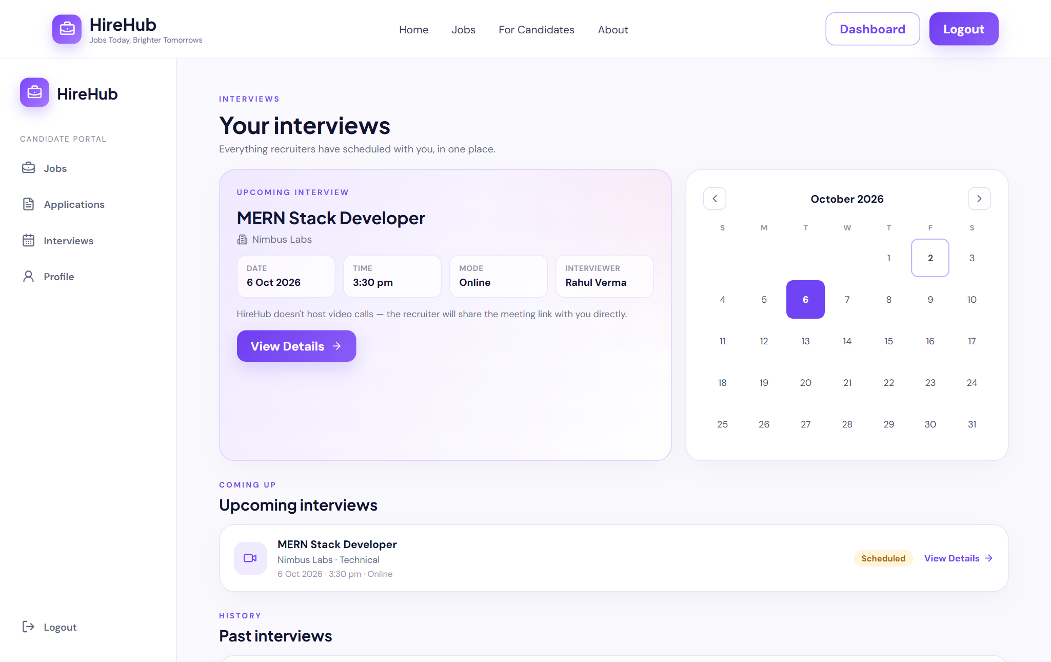
Figure 14.6: Candidate Interviews page – upcoming interview, calendar and history
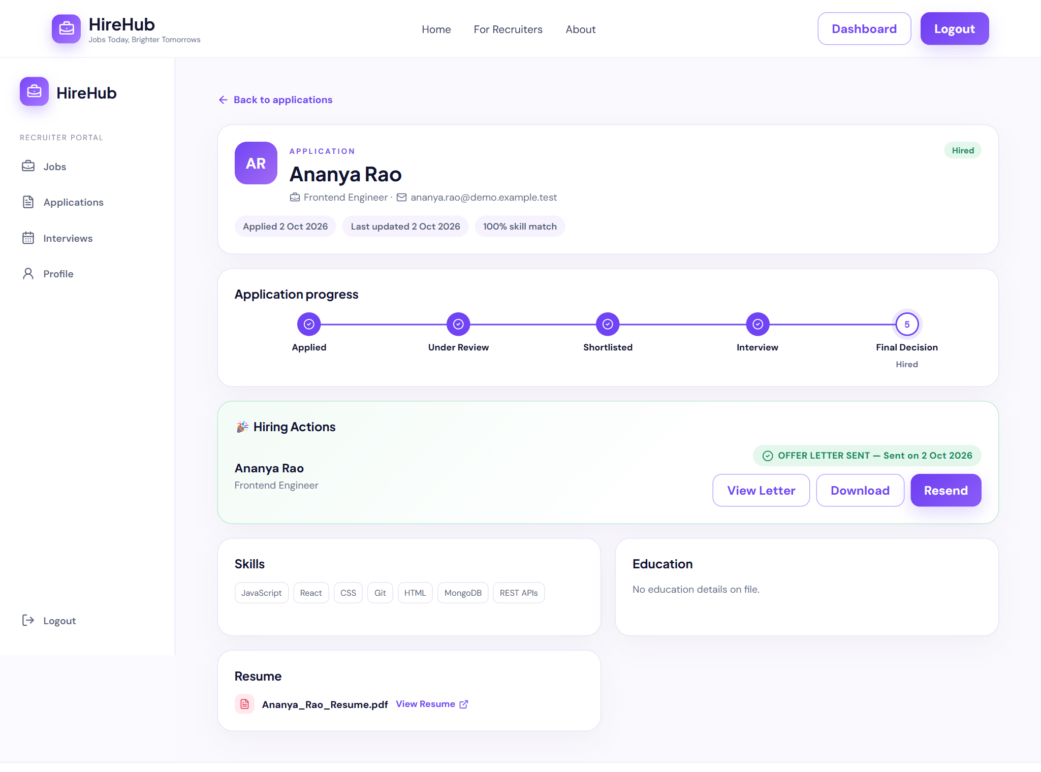
Figure 14.7: Recruiter applicant view – match score, stage tracker, Hiring Actions and parsed resume
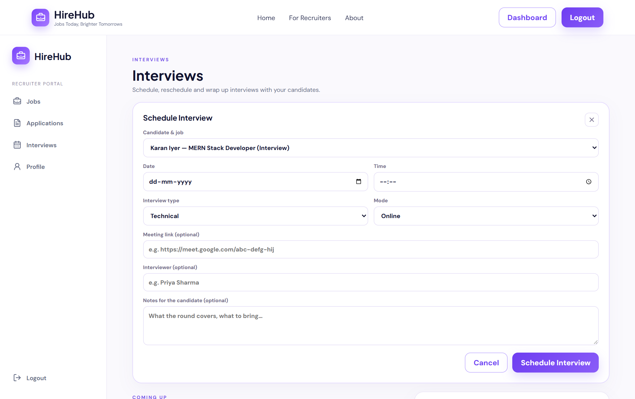
Figure 14.8: Recruiter Interviews page – scheduling form
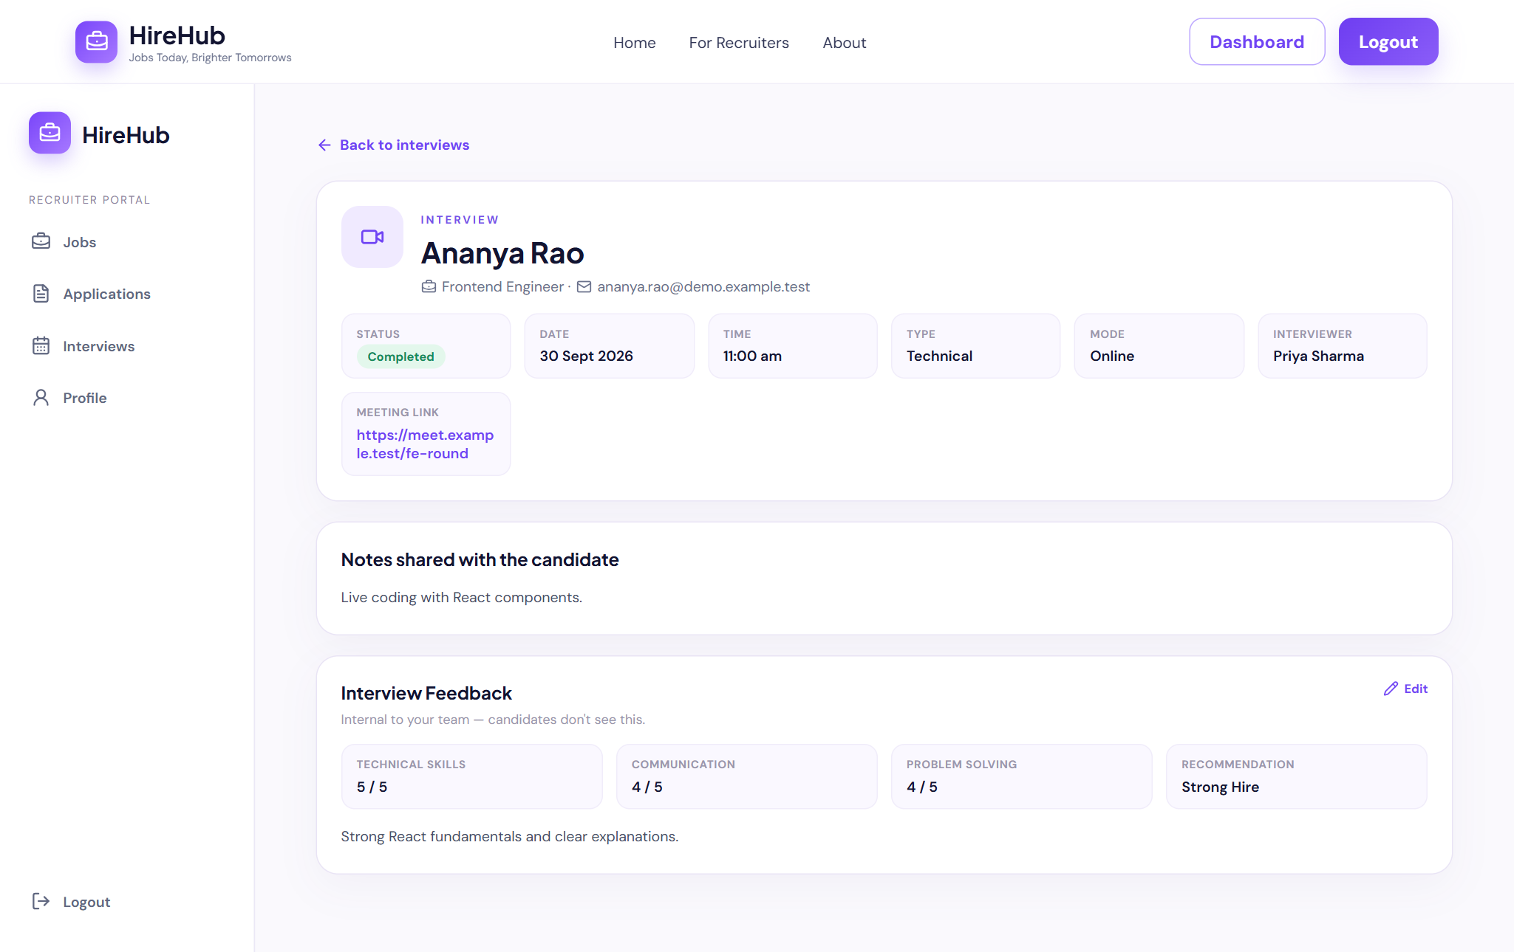
Figure 14.9: Recruiter interview detail – completed interview with feedback
Appendix B – Sample Code Snippets
The following excerpts are taken unchanged from the project source code (some long files are shown in part).
Listing 14.1: job-portal-backend/models/Application.js (schema and index)
const applicationSchema = new mongoose.Schema(
{
job: { type: mongoose.Schema.Types.ObjectId, ref: "Job", required: true },
candidate: { type: mongoose.Schema.Types.ObjectId, ref: "User", required: true },
resume: { type: mongoose.Schema.Types.ObjectId, ref: "Resume" },
matchScore: { type: Number, default: 0 }, // 0-100
status: {
type: String,
enum: ["applied", "under_review", "shortlisted", "interview", "rejected", "hired", "withdrawn"],
default: "applied",
},
},
{ timestamps: true }
);

// A candidate can only apply once per job
applicationSchema.index({ job: 1, candidate: 1 }, { unique: true });

Listing 14.2: job-portal-backend/controllers/applicationController.js (applyToJob)
export async function applyToJob(req, res) {
try {
if (req.user.role !== "candidate") {
return res.status(403).json({ message: "Only candidates can apply to jobs" });
}

const { job_id } = req.params;
const job = await Job.findById(job_id);
if (!job) return res.status(404).json({ message: "Job not found" });

const existing = await Application.findOne({ job: job_id, candidate: req.user.id });
if (existing) {
return res.status(409).json({ message: "You have already applied to this job" });
}

const user = await User.findById(req.user.id);
const latestResume = await Resume.findOne({ candidate: req.user.id }).sort({ createdAt: -1 });
const matchScore = calculateMatchScore(user.skills, job);

const application = await Application.create({
job: job_id,
candidate: req.user.id,
resume: latestResume ? latestResume._id : undefined,
matchScore,
});

return res.status(201).json({ application });
} catch (err) {
console.error("[applyToJob]", err);
return res.status(500).json({ message: "Could not submit application" });
}
}

Listing 14.3: job-portal-backend/middleware/upload.js (file filter and limits)
function fileFilter(req, file, cb) {
const allowed = [".pdf", ".docx"];
const ext = path.extname(file.originalname).toLowerCase();
if (allowed.includes(ext)) {
cb(null, true);
} else {
cb(new Error("Only .pdf and .docx resumes are accepted"));
}
}

export const uploadResumeFile = multer({
storage,
fileFilter,
limits: { fileSize: 5 * 1024 * 1024 }, // 5MB
});

Listing 14.4: job-portal-frontend/src/App.jsx (ProtectedRoute)
function ProtectedRoute({ children, roles }) {
const auth = getAuth();

if (!auth?.isAuthenticated) {
return <Navigate to="/login" replace />;
}

if (roles) {
const normalizedRoles = roles.map((r) => r.toLowerCase());
if (!normalizedRoles.includes((auth.role || "").toLowerCase())) {
return <Navigate to={getDashboardPath(auth.role)} replace />;
}
}

return children;
}

Appendix C – Installation / Setup Instructions
Prerequisites: Node.js 18 or later with npm, and either a running MongoDB server or a hosted MongoDB connection string. A Google Gemini API key is optional.
Listing 14.5: Setup commands
# 1. Back end
cd project-files/job-portal-backend
npm install
copy .env.example .env # macOS/Linux: cp .env.example .env
# edit .env: set MONGODB_URI, JWT_SECRET, CORS_ORIGIN and (optionally) GEMINI_API_KEY
npm run seed:jobs # optional: demo recruiters and ~150 jobs
npm run dev # API on http://localhost:8000 (npm start without nodemon)

# 2. Front end (second terminal)
cd project-files/job-portal-frontend
npm install
# optional .env: VITE_API_URL=http://localhost:8000/api
npm run dev # open http://localhost:5173

# 3. Production build of the front end
npm run build # output in dist/
npm run preview # serve the build locally

To verify the installation, open http://localhost:8000/api/health, which should return {"status":"ok"}, then register a candidate and a recruiter in the browser and follow the user guide in Appendix D. The variables used in .env are described in Table 9.1.
Appendix D – User Manual / Guide
For candidates
- Open the application, choose Get Started, select Candidate and register with your name, e-mail and password.
- On the home page, click Upload Resume and select your resume as a PDF or DOCX file of up to 5 MB. Wait for the Profile Boost card to show that your resume is AI-ready.
- Check the Resume Insights section. Click Edit to correct or add skills, education, experience and certifications, then save.
- Open Jobs. Use the search box and filters, switch to the Recommended tab to see jobs that match your skills, or sort by best match. Use the bookmark icon to save jobs for later (Saved tab).
- Open a job to read the full description and your match percentage, and click Apply.
- Follow your applications under Applications. The status chip and stage tracker show where each application stands; you can withdraw an application that is still in progress.
- When an interview is scheduled, open Interviews to see it on the calendar with its date, time, mode, meeting link or location and notes.
- If you are selected, a congratulations banner appears on your home page. Click View Offer Letter to read the offer and download it.
- Complete your Profile (title, phone, location, LinkedIn, GitHub and About) to raise your profile-completion score.
For recruiters
- Register with the Recruiter option, then open Profile and enter your company details.
- On the home page or the Jobs page, click Post a New Job and enter the title, company, location, type, description, required skills (comma-separated), experience and salary range. Required skills are used to calculate candidates' match scores.
- Manage your jobs on the Jobs page: edit a posting, or close it to stop receiving applications and reopen it later.
- Open Applications to review applicants. Filter by job, stage or experience, select an applicant to see the match score, parsed resume and original resume file, and move the application through the stages Under Review, Shortlisted, Interview, Hired or Rejected.
- Click Schedule Interview for an applicant, fill in the date, time, type, mode and meeting link or location, and save. Manage interviews from the Interviews page: reschedule, cancel or mark them completed, then record feedback ratings and a recommendation.
- When an applicant is Hired, use Hiring Actions to create the offer letter, preview it and send it to the candidate. Sent offers can be viewed, downloaded or re-sent.
- Use the home page to monitor active jobs, applicants, interviews and hires.
Appendix E – Geo Tag Photos with Guide
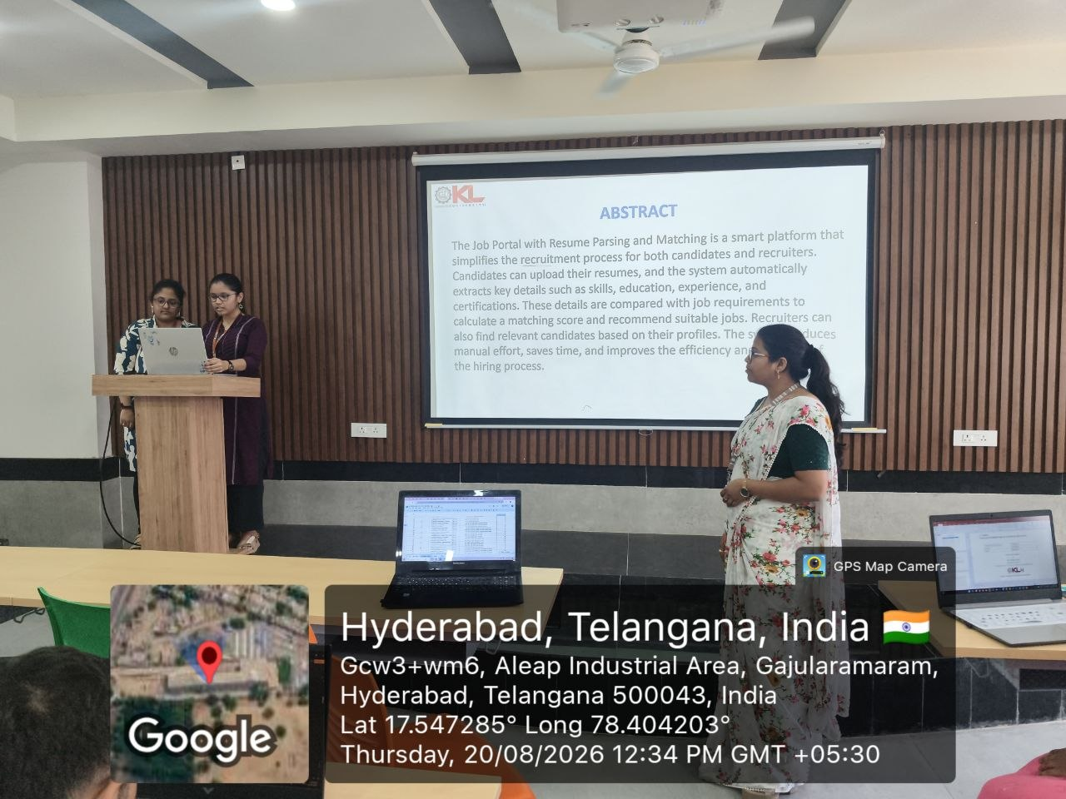

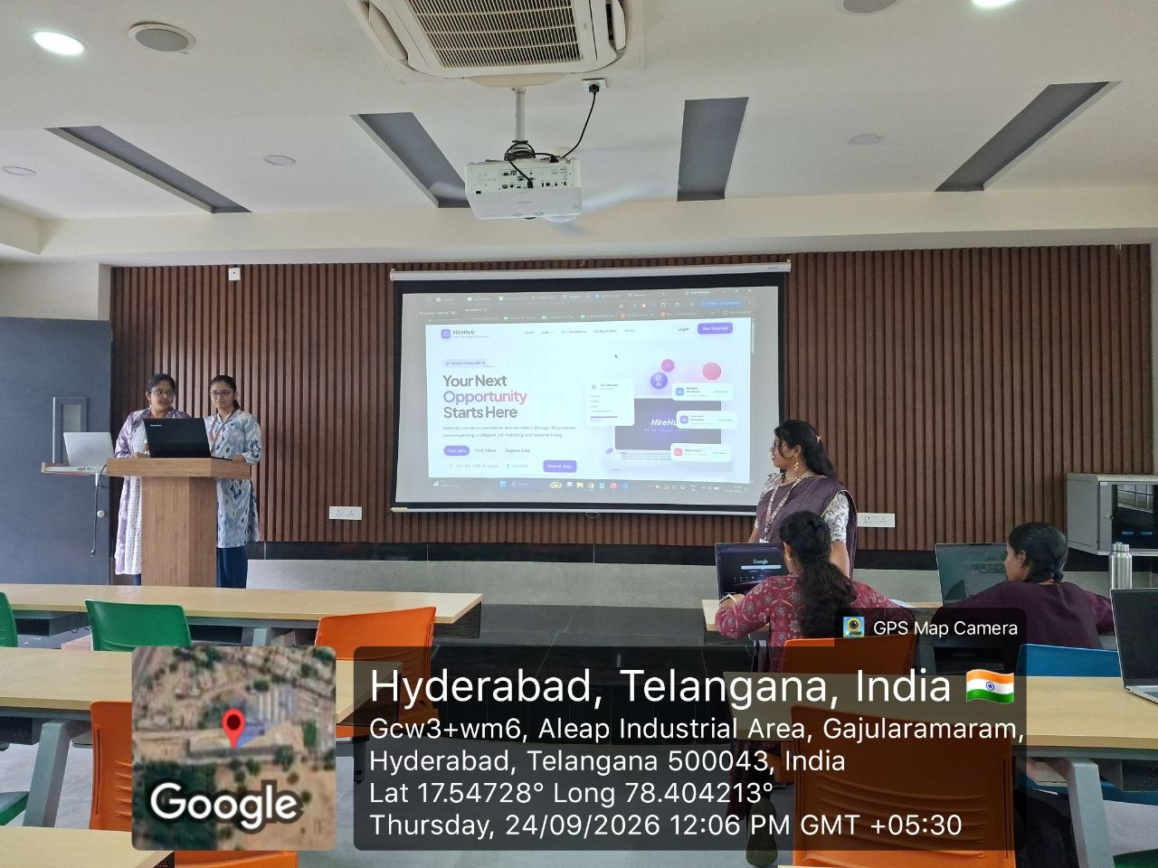

Appendix F – Review Forms with Guide Signatures
PLACEHOLDER
Scanned review form with guide signature – Review 1

PLACEHOLDER
Scanned review form with guide signature – Review 2

