**Setup**

Step 1: Create your API project in Gdrive and activate google drive API

<https://console.developers.google.com/apis>

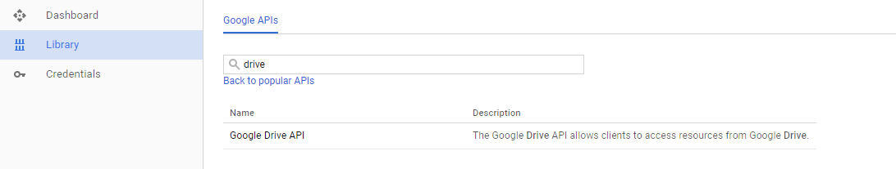

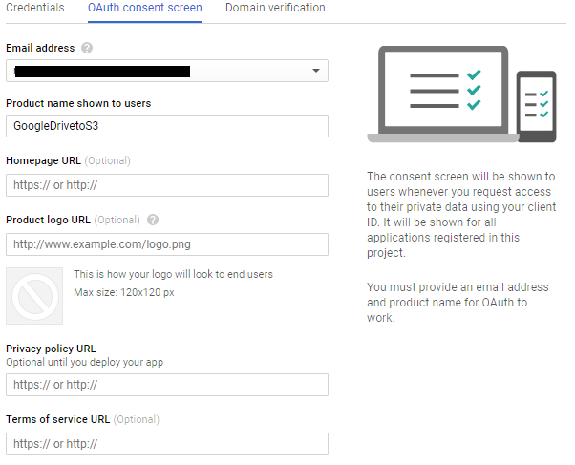

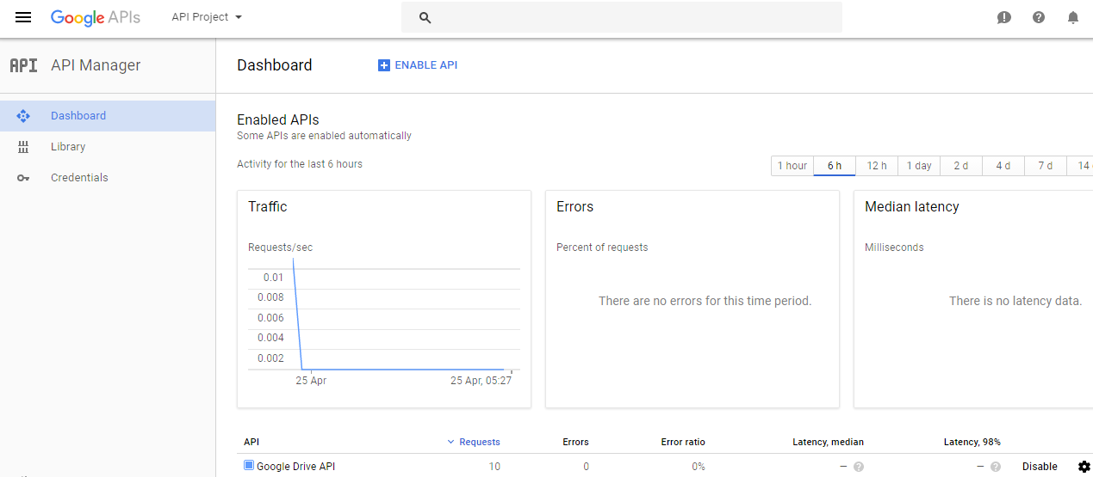

Step2: download credential for your api

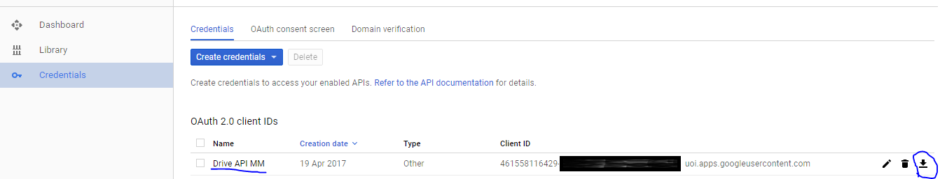

Step3. Rename download file to client_secret.json, keep in same folder where you kept script

Step4: Create IAM user only for programmatic access with fullS3access policy. Download the credential file and keep safe. And update script with your S3 credentials in S3client function

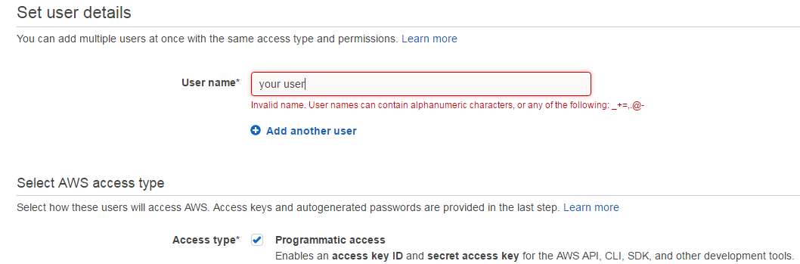

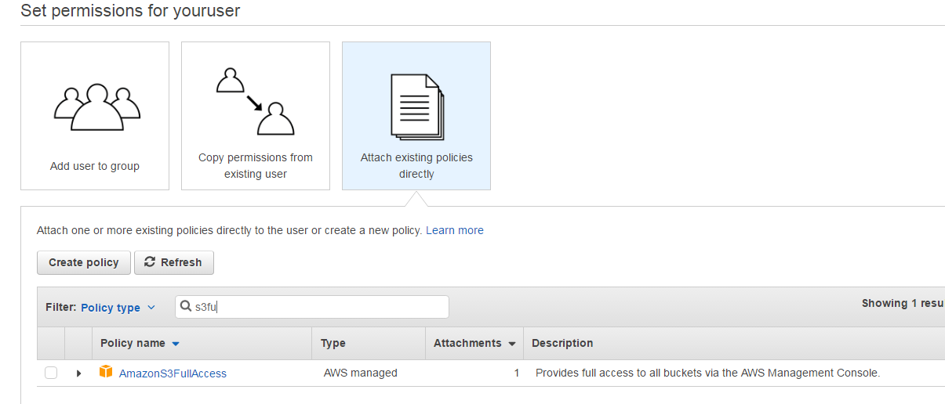

Download the access key for this user.

Step5: Install python and pkgs in your machine

1. Download python 3.6.X from <https://www.python.org/downloads/windows/> as per your OS bits. Test like below

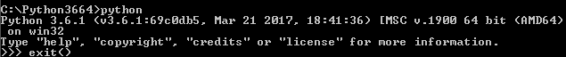

1. Install pip, script at <https://bootstrap.pypa.io/get-pip.py> .
2. Setup windows path variable (update folder location as per your installed folder)

update path variable C:\Python34;C:\Python34\Scripts;%USERPROFILE%\AppData\Roaming\Python\Scripts



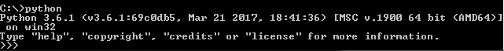

1. Run python and pin command to chk version from any folder on cmd
   1. Python –version
2. Pip install packages
   1. pip install progress_bar,
   2. pip install logbook,
   3. pip install boto3,
   4. pip install --upgrade google-api-python-client
   5. pip install --upgrade --user awscli

step6: when you run for first time, it will ask for authentication to access Gdrive. Will give you link and follow the screen when you paste it in browser. After verification, will give you code to paste back in cmd. This is one time action until credential file deleted to authorize API access.

**To run:**

**sample command syntax:**

D:\>python "Gdrive Download_MM.py" --folder_id ‘Your gdrive folder id’

--bucket ‘your bucket name’ --keyprefix ‘your folder keyprefix’ --matchfile "your filename specific" --noauth_local_webservere

Note: only folder id and bucket are required parameter

**Imp Params:**

--folder_id : it you Google drive ID, end value of your folder URI,

--bucket: This you S3 bucket name

--keyprefix: this is your folder path in S3 where you want upload. See S3 breadcrum

--loglevel

--pagesize: how many files per page you want, default 100

--startpage: any particular page you like to start upload, use to resume

--endpage: give if only particular pages you like to, default will process till last file

--matchfile: one particular file to upload

**Help:** type help to see param def

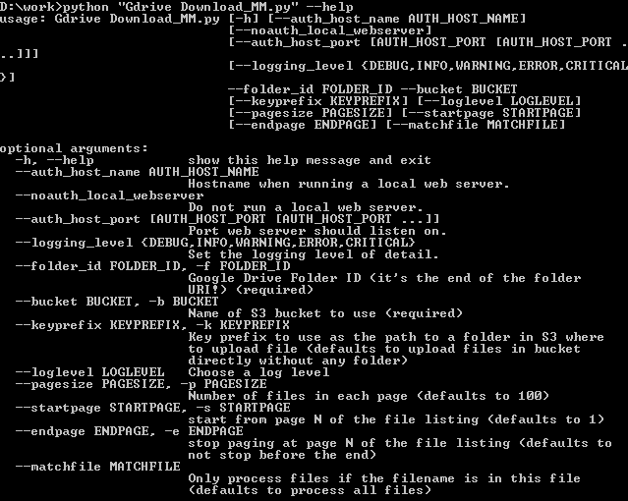

**few Output Screen:**

