CLOUD SECURITY ASSIGNMENT
Unit 3: Set Up a Web Application on Amazon EC2
Amazon Linux 2023 • Apache HTTP Server • AWS EC2
Student Name | Manasvi Tripathi
Department | Department of Cyber Security
University | Sanjivani University
AWS Region | Asia Pacific (Mumbai) — ap-south-1
Platform | Amazon Web Services (AWS) — EC2

1. Aim
To launch an Amazon EC2 instance using Amazon Linux, configure secure network access, connect to the instance using SSH, install and configure the Apache web server, deploy a simple HTML page, and verify that the page is accessible through a web browser.

2. Requirements
- AWS account with access to Amazon EC2.
- Amazon Linux 2023 EC2 instance with a public IPv4 address.
- EC2 key pair for SSH access.
- Security Group allowing SSH (TCP port 22) from My IP and HTTP (TCP port 80) for browser access.
- Web browser and terminal access through EC2 Instance Connect or SSH.

3. Procedure

Step 1 — Launch an EC2 instance
Open AWS Console → EC2 → Instances → Launch instances. Enter a suitable instance name, select Amazon Linux 2023, choose an available instance type, select or create a key pair, and configure the network settings. Launch the instance and wait until it is running and its status checks pass.

Step 2 — Configure the Security Group
Configure the inbound rules as follows. SSH is restricted to the student's public IP address. HTTP is allowed publicly so the deployed web page can be opened in a browser.
Type | Protocol | Port | Source
SSH | TCP | 22 | My IP (public-IP/32)
HTTP | TCP | 80 | 0.0.0.0/0 (Anywhere IPv4)
Security note: Do not expose SSH to 0.0.0.0/0. Restrict SSH to a trusted source IP. HTTP can be public for this simple web-server demonstration.

Step 3 — Connect to the instance
In EC2 → Instances, select the Amazon Linux instance and click Connect. Choose EC2 Instance Connect and connect with the default username ec2-user. If using an SSH client instead, use the downloaded private key and the instance's public IPv4 address.

Step 4 — Update packages and install Apache
Run these commands in the instance terminal:
sudo dnf update -y
sudo dnf install httpd -y
sudo systemctl enable --now httpd
sudo systemctl status httpd
The service status should show Active: active (running). If the httpd service is not found, verify that the installation command completed successfully before starting the service.

Step 5 — Create and deploy the HTML page
Run the following command to create a simple web page:
echo '<h1>Welcome to My AWS Web Server</h1><p>My web application is running successfully on Amazon EC2.</p>' | sudo tee /var/www/html/index.html
This writes the HTML content to Apache's default web root at /var/www/html/index.html.

Step 6 — Verify in a web browser
Copy the instance's Public IPv4 address from the EC2 console and open this address in a browser using HTTP, for example: http://YOUR_PUBLIC_IP. Replace YOUR_PUBLIC_IP with the actual address of your instance. The page should display the heading “Welcome to My AWS Web Server” and the confirmation sentence.

4. Security configuration summary
Setting | Configuration | Reason
SSH | TCP 22 — My IP only | Limits remote administration access.
HTTP | TCP 80 — 0.0.0.0/0 | Allows the public browser to access the demo page.
Operating system | Amazon Linux 2023 | Linux environment for hosting Apache.
Web server | Apache httpd | Serves the HTML page over HTTP.

5. Screenshot
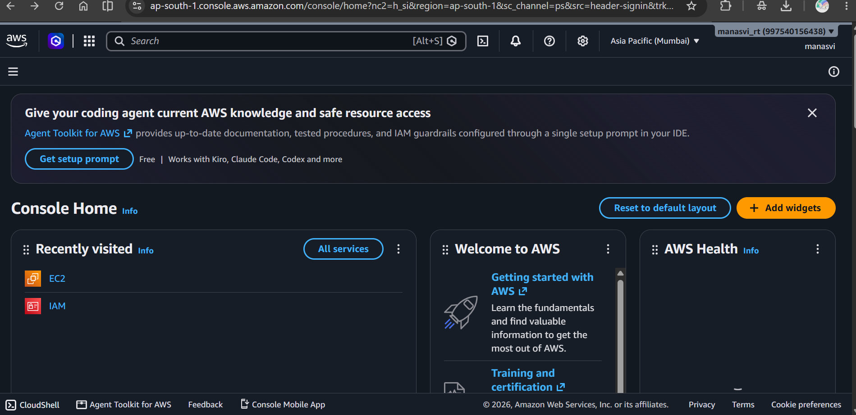
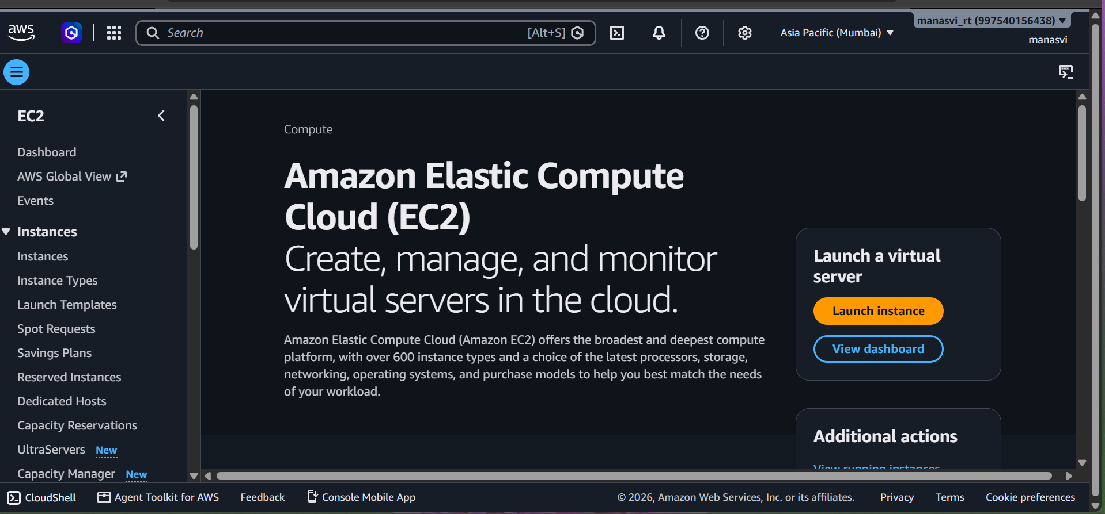
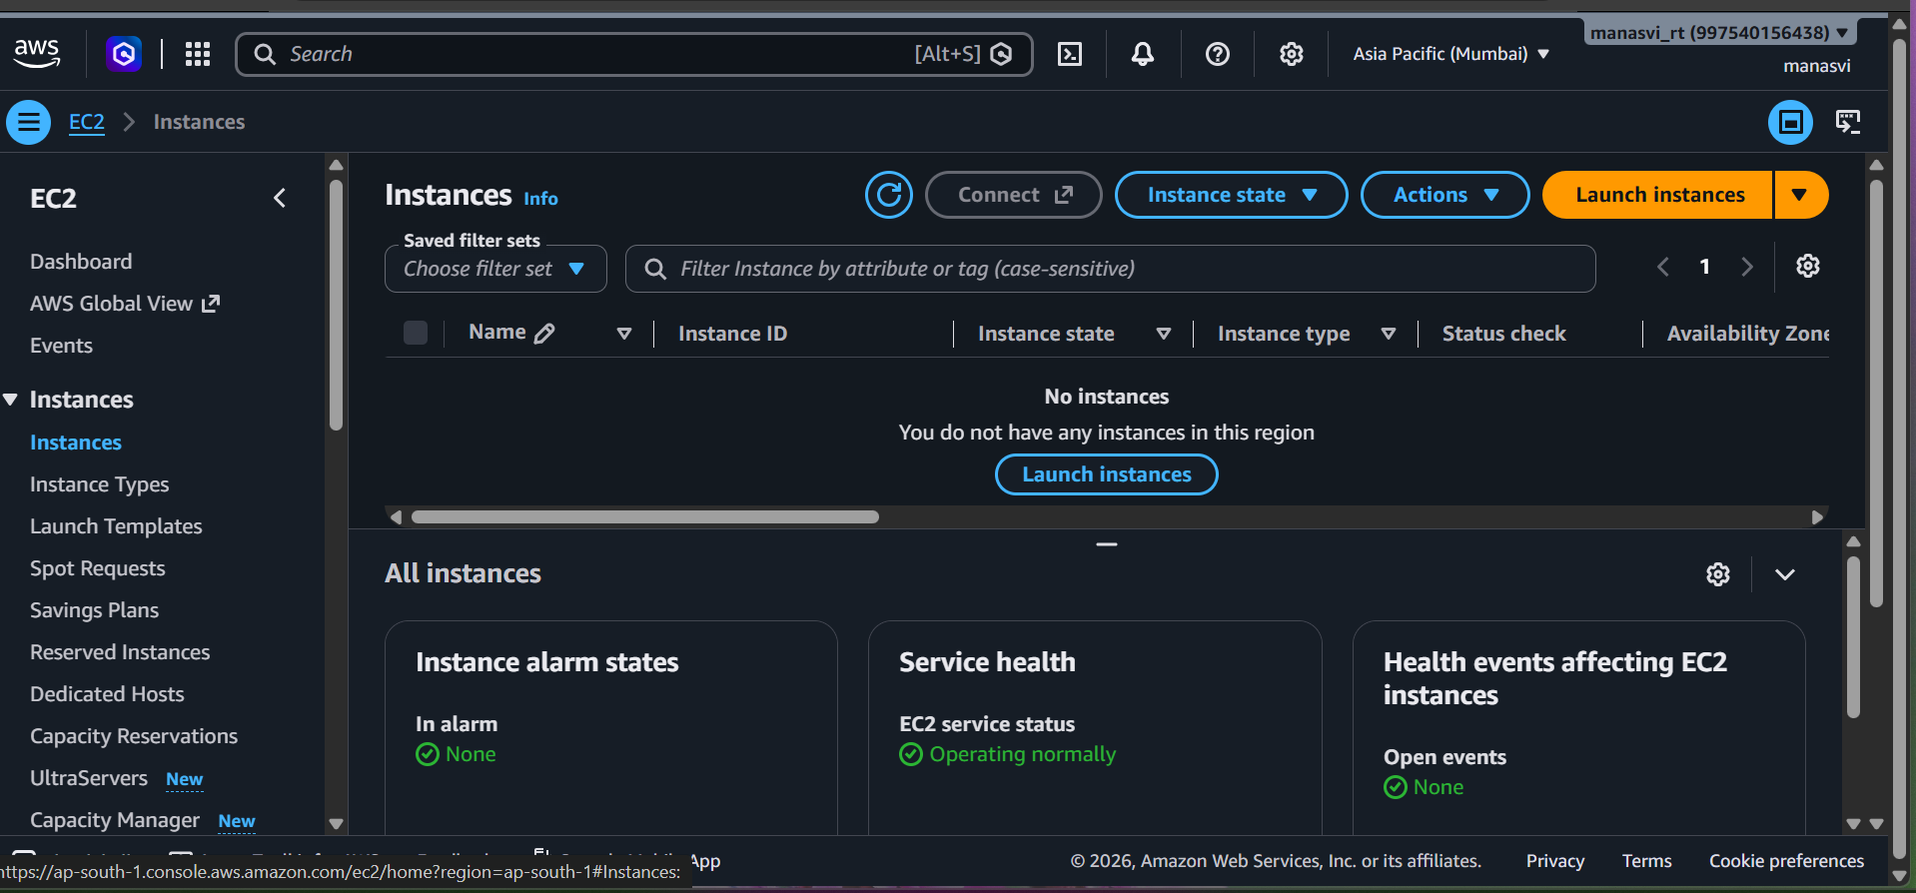
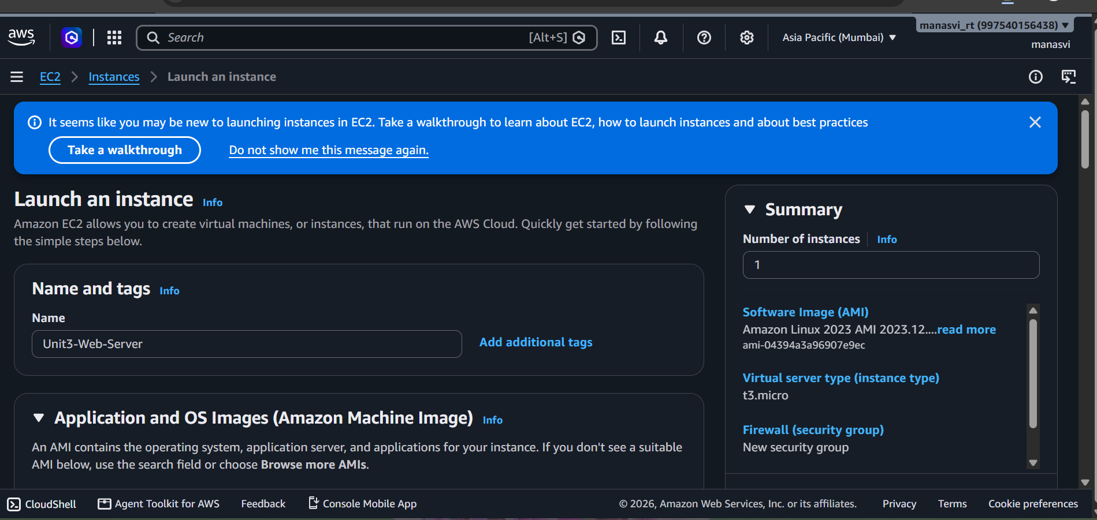
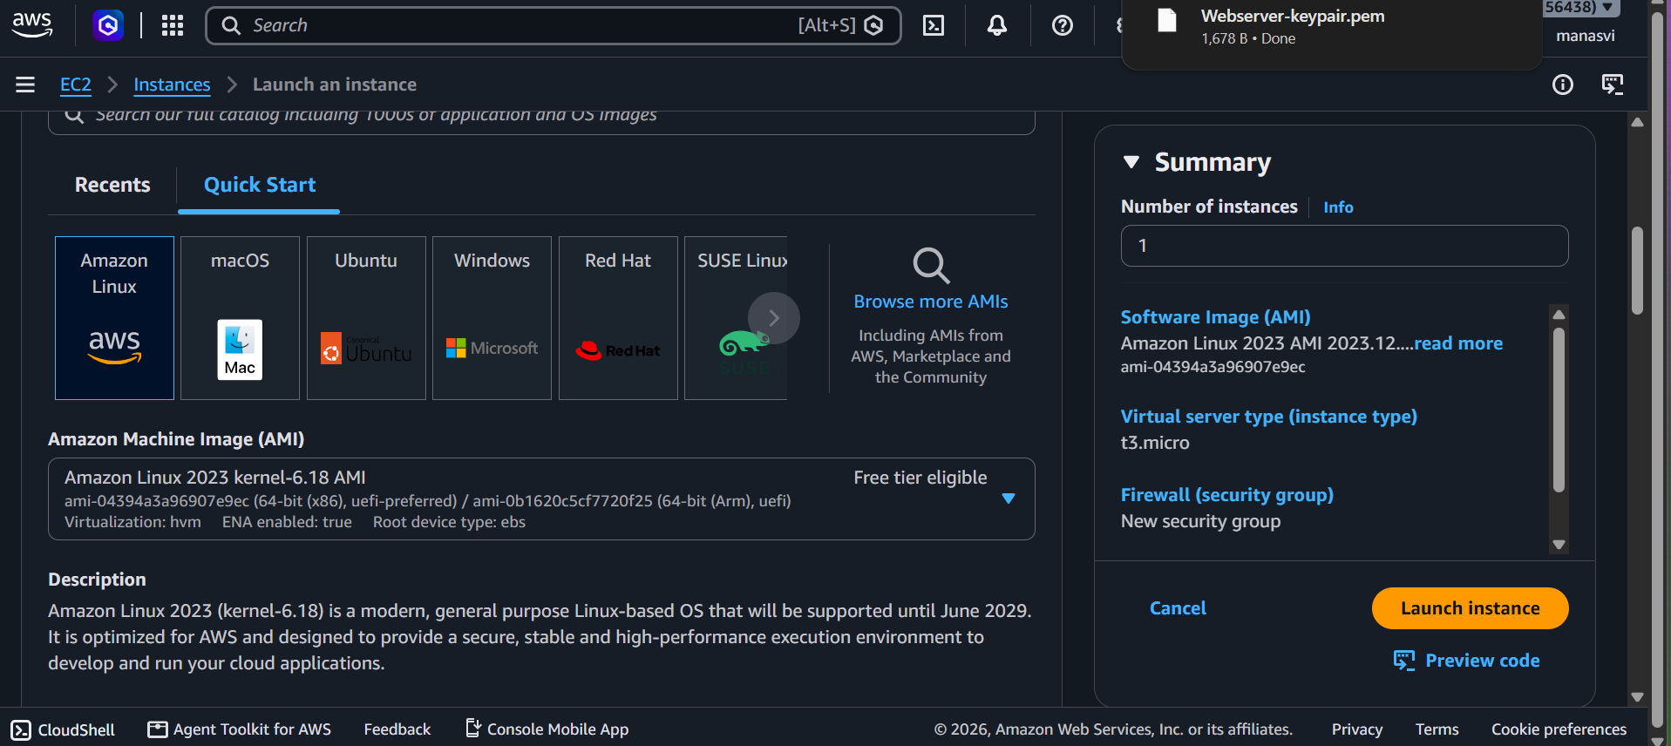
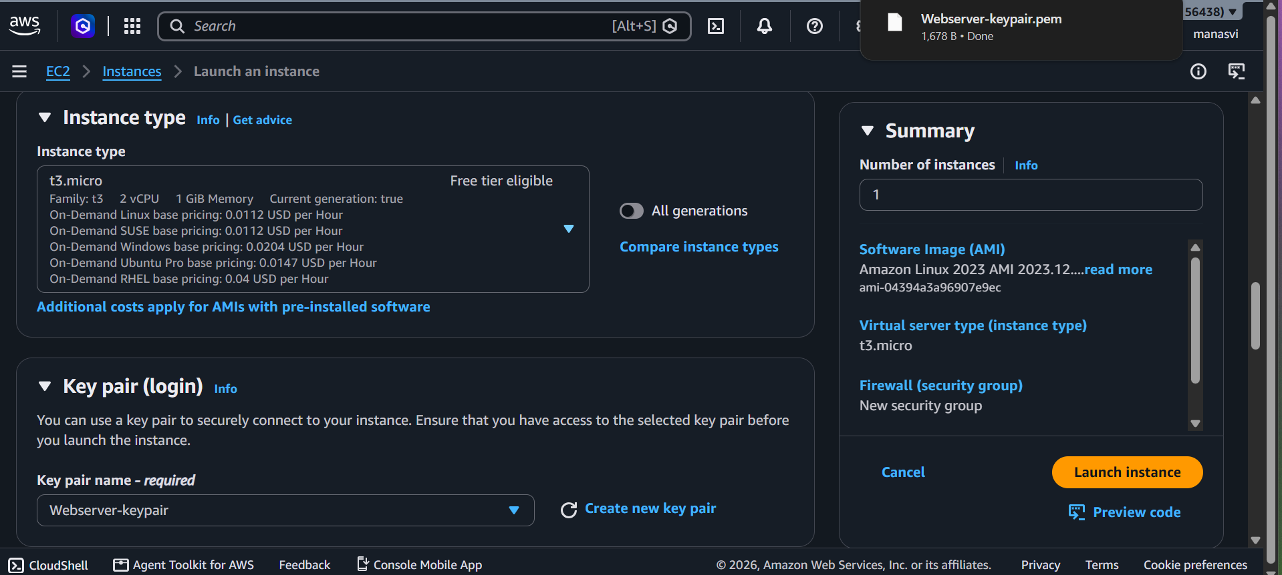
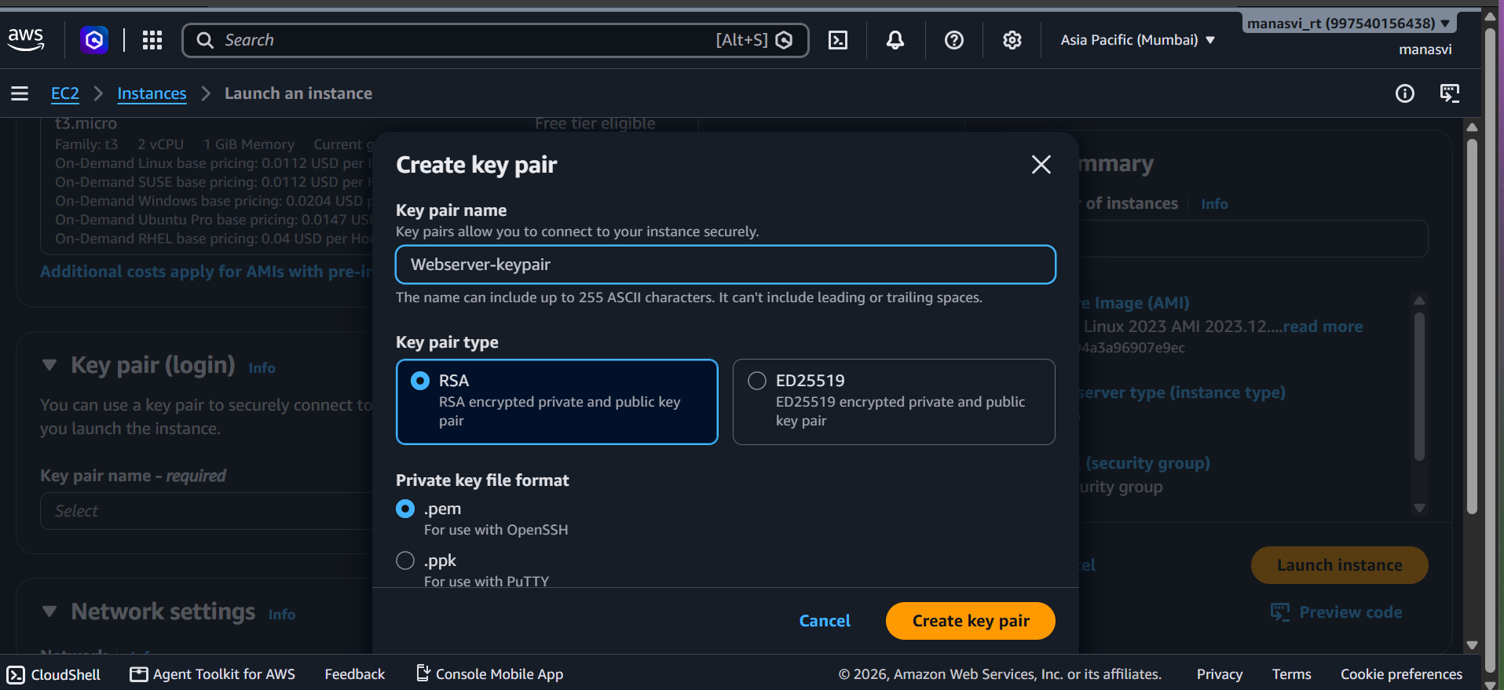
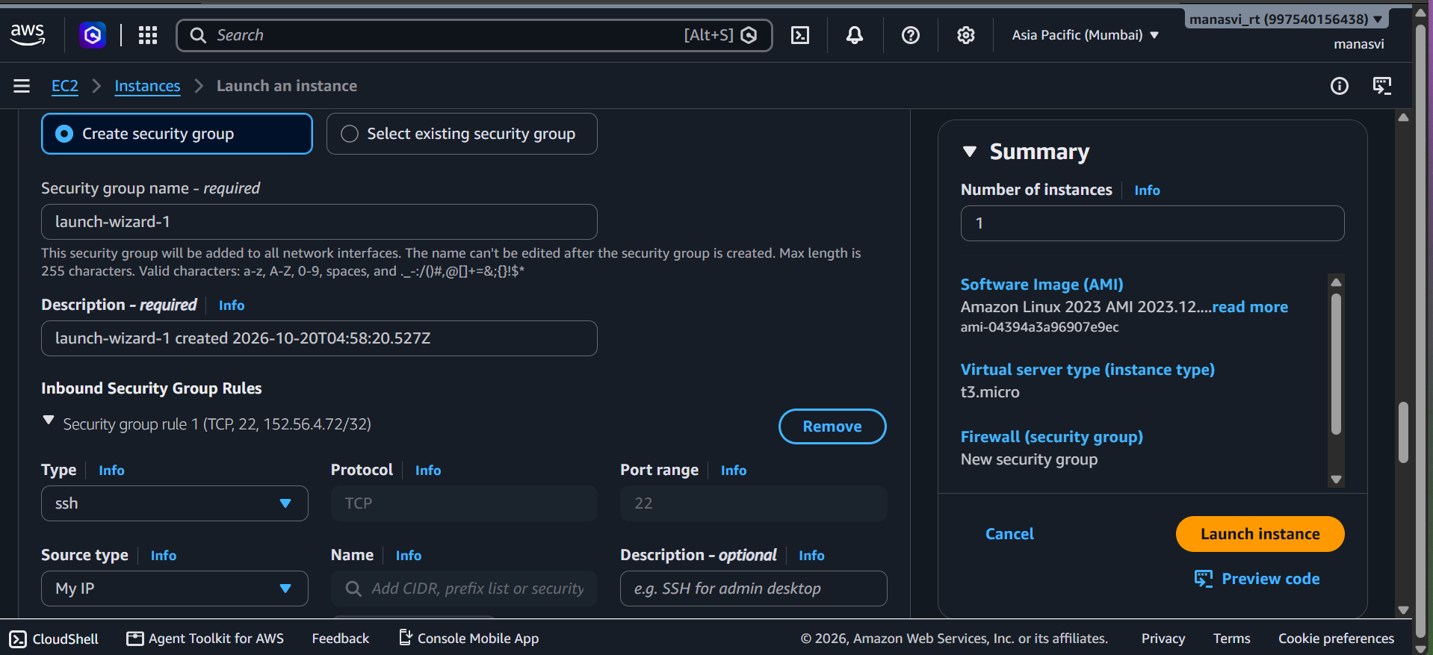
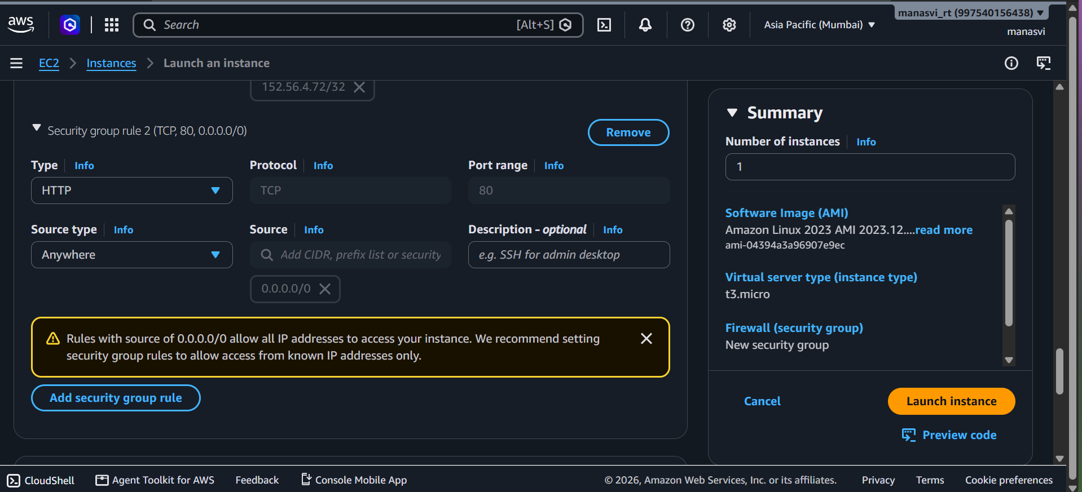
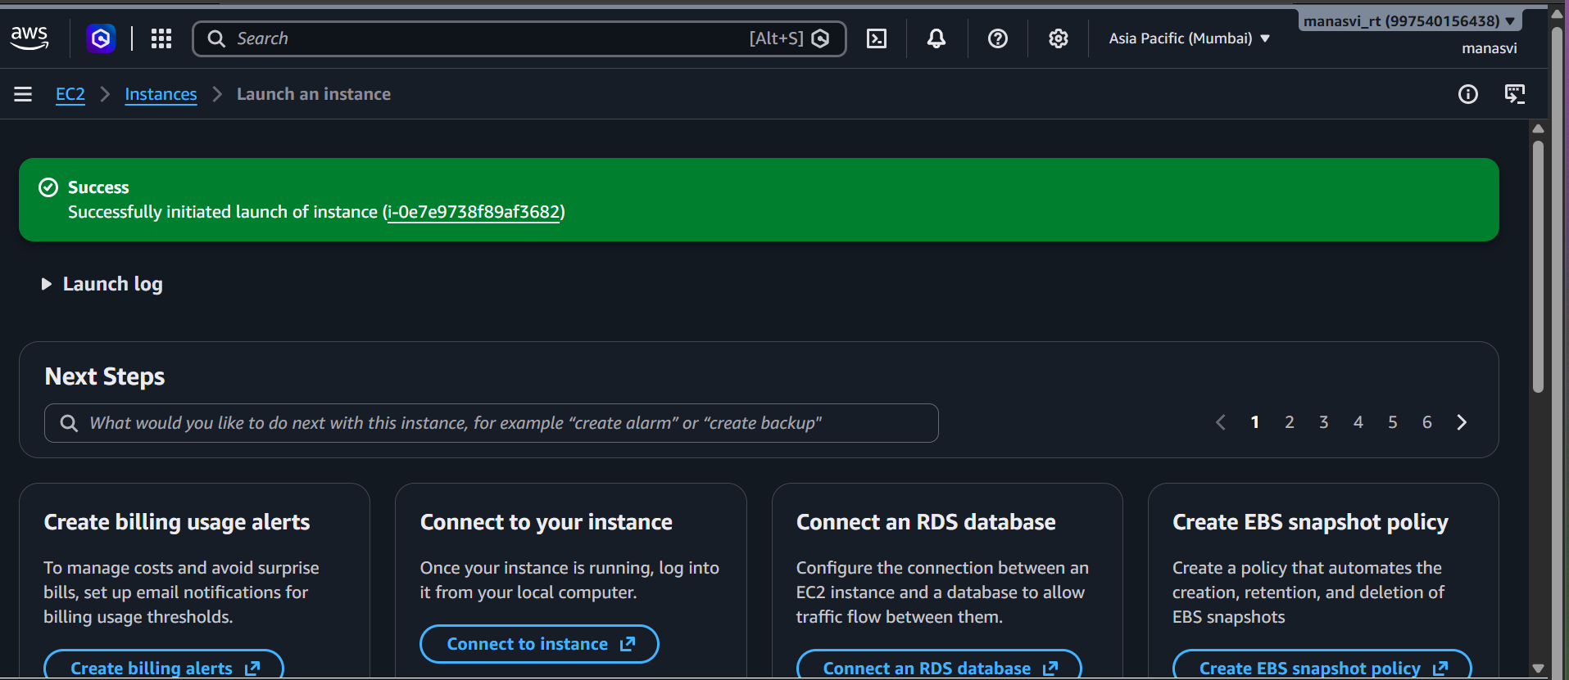
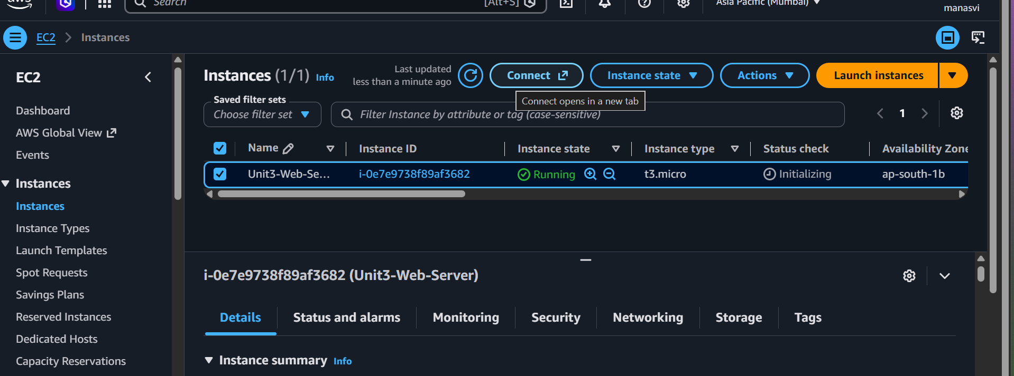
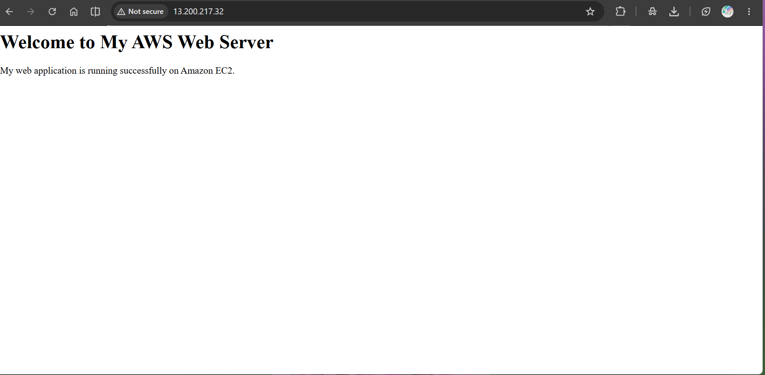

6. Result
An Amazon Linux EC2 instance was launched and accessed through EC2 Instance Connect. Apache was installed and started, a simple HTML welcome page was placed in the default web directory, and the page was opened successfully in a browser using the instance's public IPv4 address.

7. Conclusion
This practical demonstrated how to deploy a basic web application on AWS EC2. It covered instance launch, Security Group configuration, SSH-based access, Apache installation and service management, HTML deployment, and browser verification. Restricting SSH to My IP reduces unnecessary exposure while allowing HTTP access for the web demonstration.

