CLOUD SECURITY CAPSTONE PROJECT
Deploy a Secure Three-Tier Application on AWS Using Terraform
Project Report
Submitted by: Manasvi Tripathi
PRN:2124UCSF1104
Department: Cyber Security
Sanjivani University
Academic Year: 2025–2026

Abstract
This project demonstrates the design and deployment of a secure, scalable application environment on Amazon Web Services (AWS) using Infrastructure as Code (IaC) with Terraform. A Virtual Private Cloud (VPC) was created with public and private subnet tiers. An internet-facing Application Load Balancer (ALB) receives HTTP requests and forwards traffic to an application server running on an EC2 instance in a private subnet. Security groups control communication between tiers. VPC Flow Logs are delivered to Amazon S3, and AWS CloudTrail is enabled to record account activity. The database tier was defined in Terraform for a planned Amazon RDS MySQL deployment; it was not provisioned during this implementation to avoid additional costs.

1. Introduction
Cloud environments require secure network segmentation, controlled access, monitoring, and repeatable deployment. This project uses AWS networking and compute services with Terraform to build and verify a multi-tier application foundation. The configuration separates public entry points from private application resources and includes logging mechanisms to support visibility and auditing.

2. Objectives
- Create an AWS VPC with a defined IPv4 address range.
- Provision public, private application, and private database subnets across Availability Zones.
- Deploy an internet-facing Application Load Balancer in public subnets.
- Run the application server on an EC2 instance in a private subnet.
- Use security groups to restrict traffic between application tiers.
- Enable VPC Flow Logs and store network records in Amazon S3.
- Enable AWS CloudTrail for API activity auditing.
- Use Terraform to manage infrastructure configuration consistently.

3. Tools and AWS Services
- Amazon Web Services (AWS) Console
- Terraform (Infrastructure as Code)
- AWS CLI
- Visual Studio Code
- Amazon VPC, Subnets, Internet Gateway and Route Tables
- Amazon EC2 (Amazon Linux)
- Application Load Balancer and Target Group
- AWS Security Groups
- Amazon S3
- VPC Flow Logs
- AWS CloudTrail
- Terraform provider: hashicorp/aws

4. Architecture
The deployed traffic path is shown below. The RDS database tier is planned and represented in the Terraform configuration, but was not deployed.
Internet / User Browser
↓ HTTP
Internet-facing Application Load Balancer (Public Subnets)
↓ Forward to Target Group
EC2 Application Server (Private App Subnet)
↓ Planned database connection
Amazon RDS MySQL (Private DB Subnets — NOT DEPLOYED)
Monitoring and logging: VPC Flow Logs → Amazon S3; AWS CloudTrail → Amazon S3.

5. Network Design
VPC name: capstone-vpc
VPC ID: vpc-0d67d3e25eeae749a
IPv4 CIDR: 10.0.0.0/16
Subnet tier | CIDR blocks | Purpose
Public | 10.0.1.0/24, 10.0.2.0/24 | ALB and internet-facing entry
Private application | 10.0.11.0/24, 10.0.12.0/24 | Application server resources
Private database | 10.0.21.0/24, 10.0.22.0/24 | Reserved for database tier
An Internet Gateway is attached to the VPC. Public subnet routing uses the Internet Gateway. Private application and database subnets do not have a NAT Gateway route in this cost-conscious implementation.

6. Implementation

6.1 Terraform configuration
Infrastructure resources were declared in main.tf and managed using Terraform. The configuration defines the VPC, subnet tiers, routing, security groups, load balancer, target group, EC2 application server, and logging resources.

6.2 VPC and subnet deployment
A VPC with CIDR 10.0.0.0/16 was created. Six project subnets were configured across two Availability Zones: two public, two application-private, and two database-private subnets.

6.3 Application server
An Amazon Linux EC2 instance (t3.micro) was deployed in the private application subnet. Its private IP address is 10.0.11.6. The web application is served using Python HTTP server managed by systemd

6.4 Load balancing
An internet-facing Application Load Balancer named capstone-web-alb was deployed in the public subnets. The ALB listener forwards requests to the capstone-app-tg target group. Target health was verified as healthy

6.5 Security groups
Three security groups were created: capstone-alb-sg (sg-01259309ae062c525), capstone-app-sg (sg-0389f35dbb9506c90), and capstone-db-sg (sg-02a7ed114dfe5f40d). They are intended to separate internet-facing access, application access, and database access

6.6 Database tier (planned)
Terraform configuration includes an RDS MySQL 8.0 instance definition with private DB subnet group, encryption, and non-public accessibility. The database instance was not deployed; therefore, database connectivity was not tested

6.7 VPC Flow Logs
VPC Flow Logs were enabled for all traffic for the VPC and configured to deliver log files to the S3 bucket manasvi-capstone-flowlogs-2026. The Flow Log status was verified as ACTIVE

6.8 AWS CloudTrail
The capstone-security-trail trail was created in the Mumbai region with multi-region coverage, global service events, log file validation, and S3 delivery. Logging status was verified as enabled

7. Security Measures
- Network segmentation between public, application-private, and database-private subnet tiers.
- Application server placed in a private subnet without a public IP.
- Internet traffic enters through the ALB rather than directly reaching the EC2 application instance.
- Security groups define tier-specific traffic controls.
- Database configuration specifies private accessibility and encrypted storage (planned; not deployed).
- VPC Flow Logs capture network traffic metadata for monitoring.
- CloudTrail records AWS API activity and supports auditing.
- S3 server-side encryption was verified for the logging bucket.

8. Testing and Results
Test | Result
Terraform validation and apply | Successful; infrastructure resources provisioned/updated
VPC and subnet state | VPC and subnet resources shown as Available
EC2 status | Instance i-08b78ce2cdac339de is Running; status checks passed
ALB state | capstone-web-alb reported Active and internet-facing
Target group | Application target reported Healthy
Browser test | Public ALB DNS opened the Secure Three-Tier Application page
VPC Flow Logs | Flow Log fl-01fd5ab390456afa1 reported ACTIVE; S3 log objects observed
CloudTrail | capstone-security-trail logging enabled
RDS MySQL | Not deployed; database connection test not performed

9. Screenshots / Evidence
The following screenshots document the implementation and verification.
Figure 1. Terraform VPC and subnet definitions (main.tf)
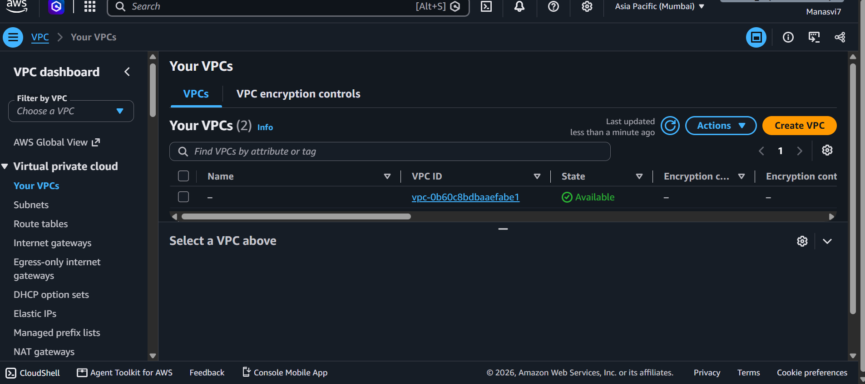
Figure 2. VPC and Flow Logs status
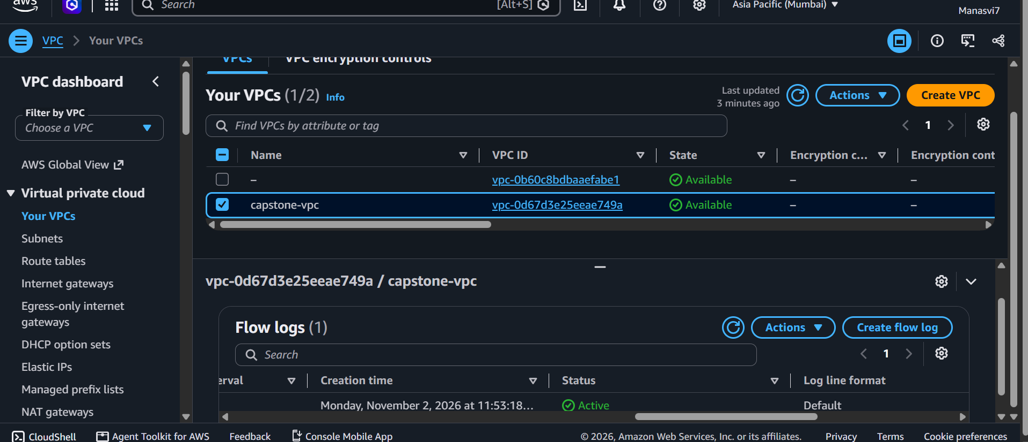
Figure 3. VPC list / capstone VPC
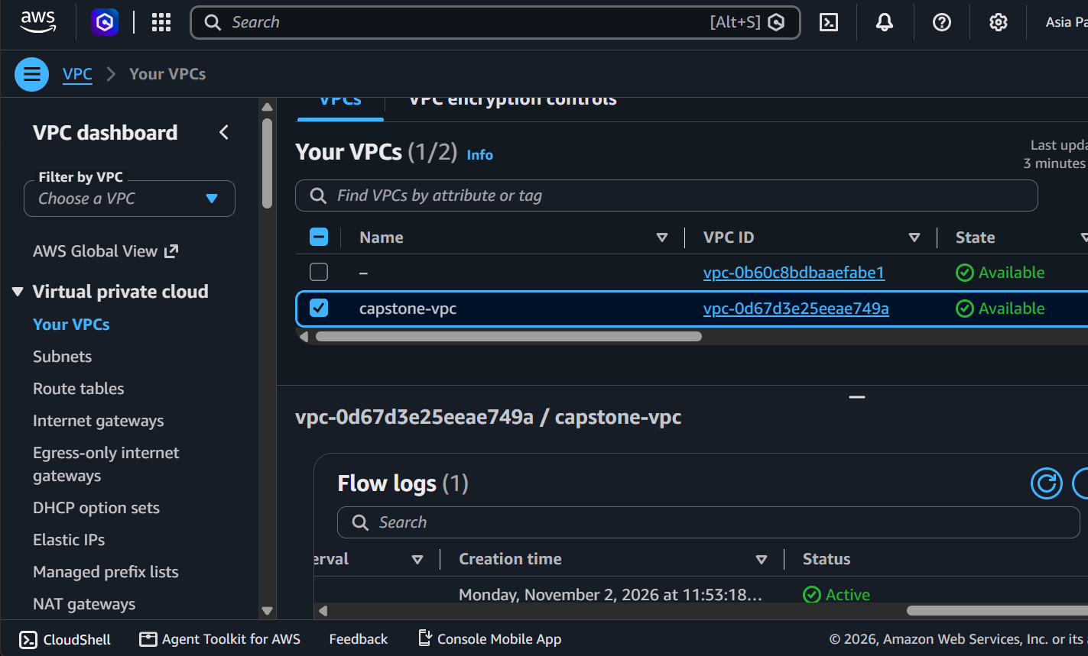
Figure 4. Subnet configuration
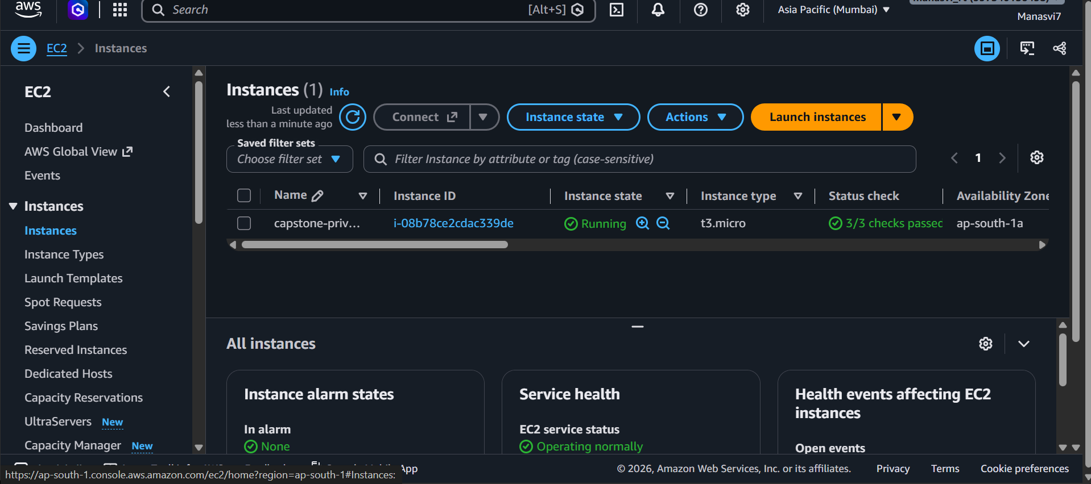
Figure 5. EC2 application instance
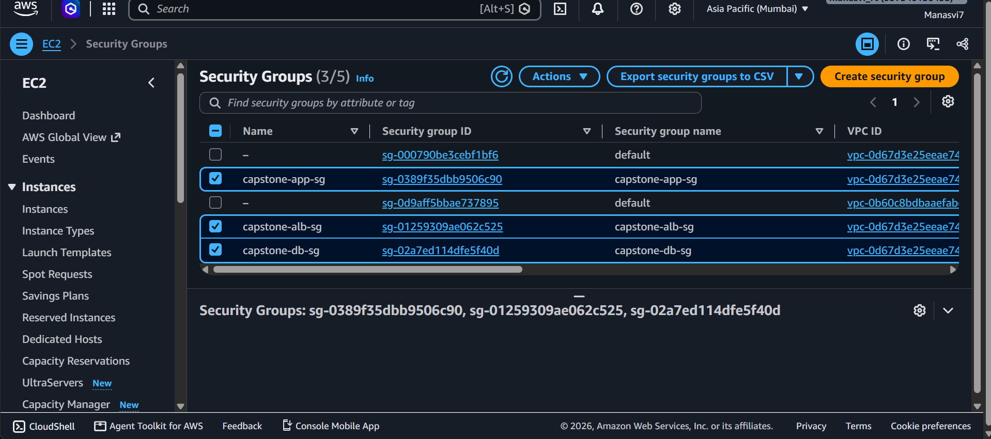
Figure 6. Security groups
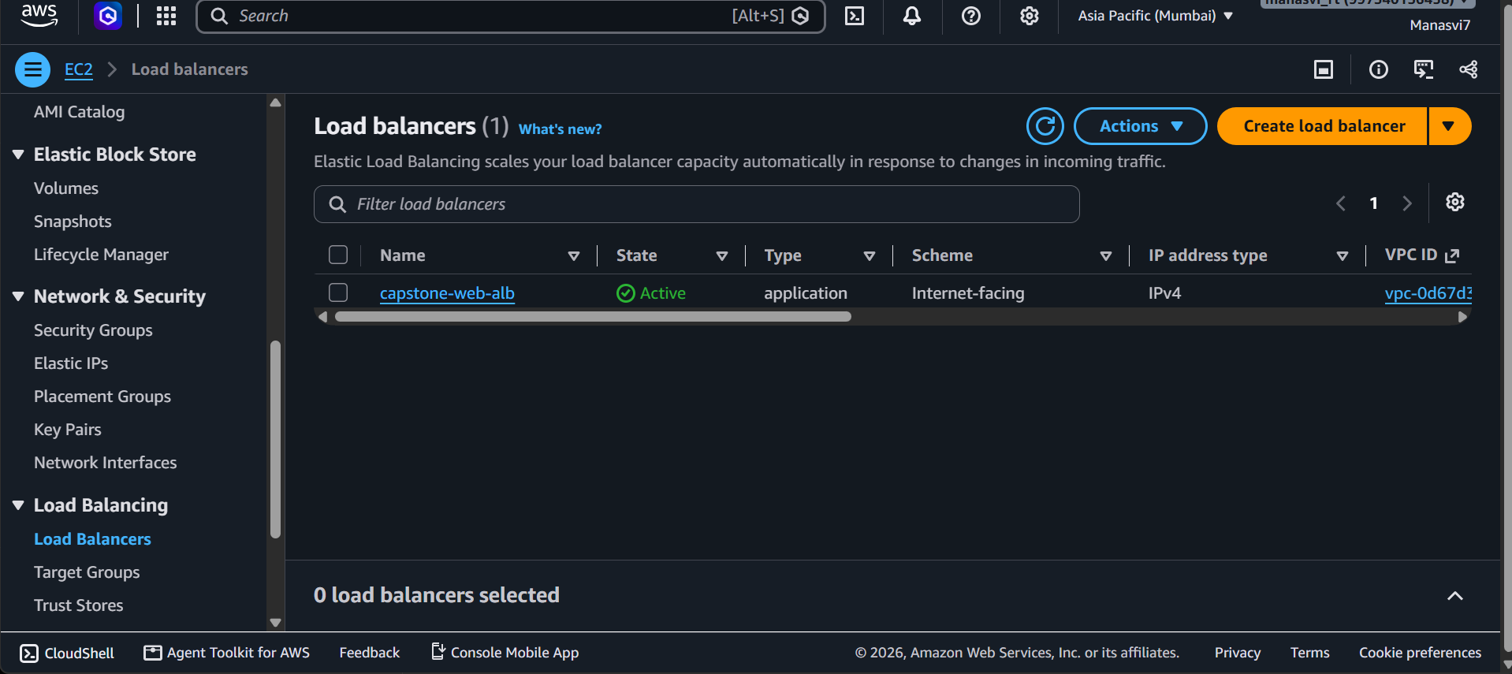
Figure 7. Application Load Balancer
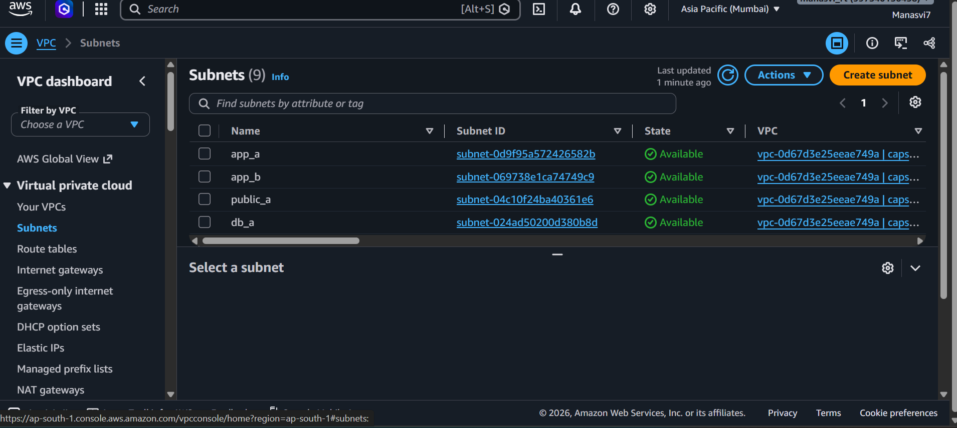
Figure 8. Deployed web application
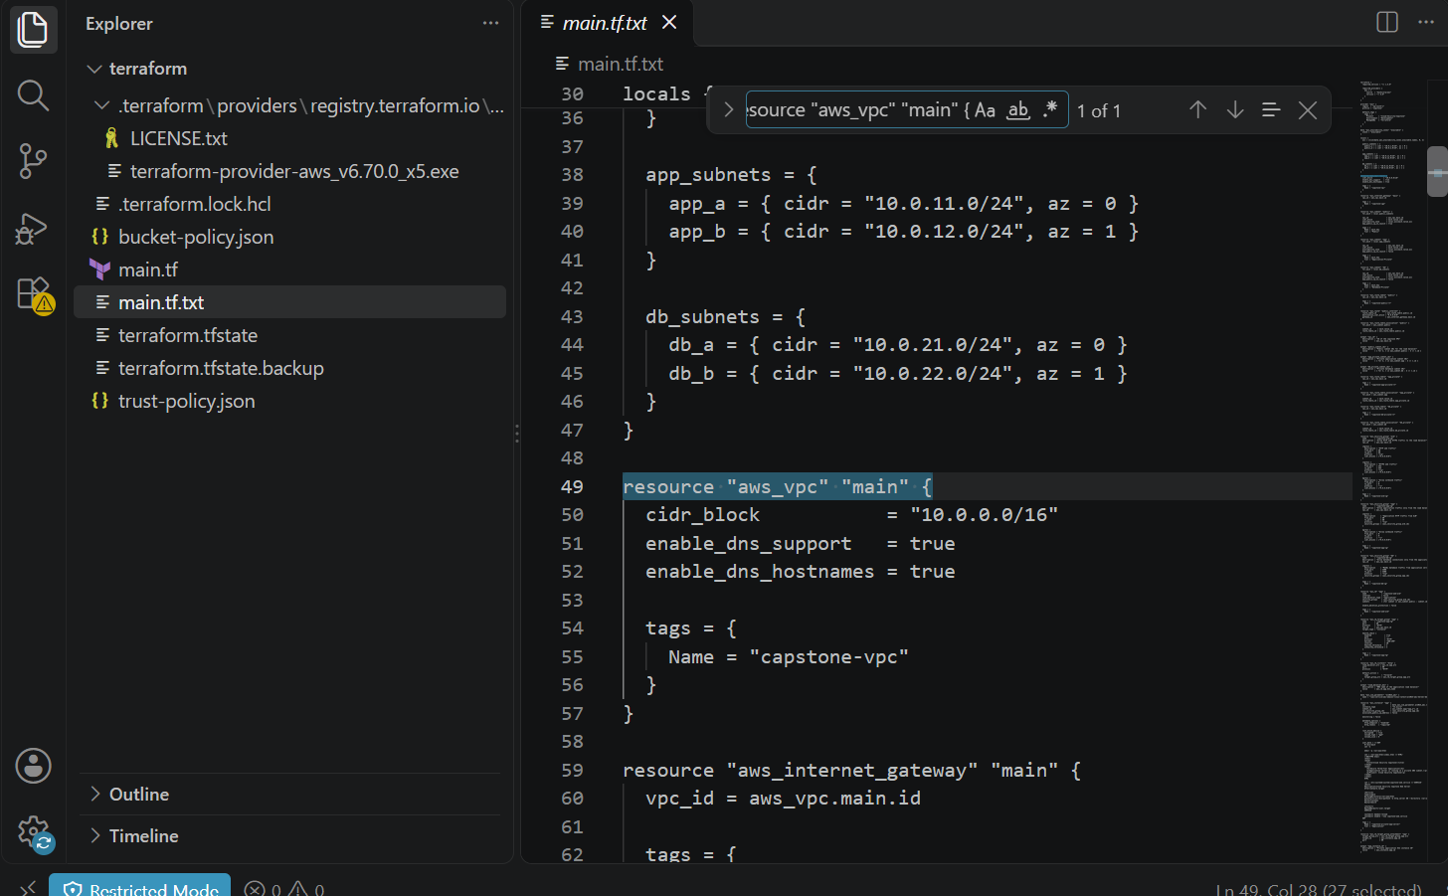
Figure 9. CloudTrail trail and logging status
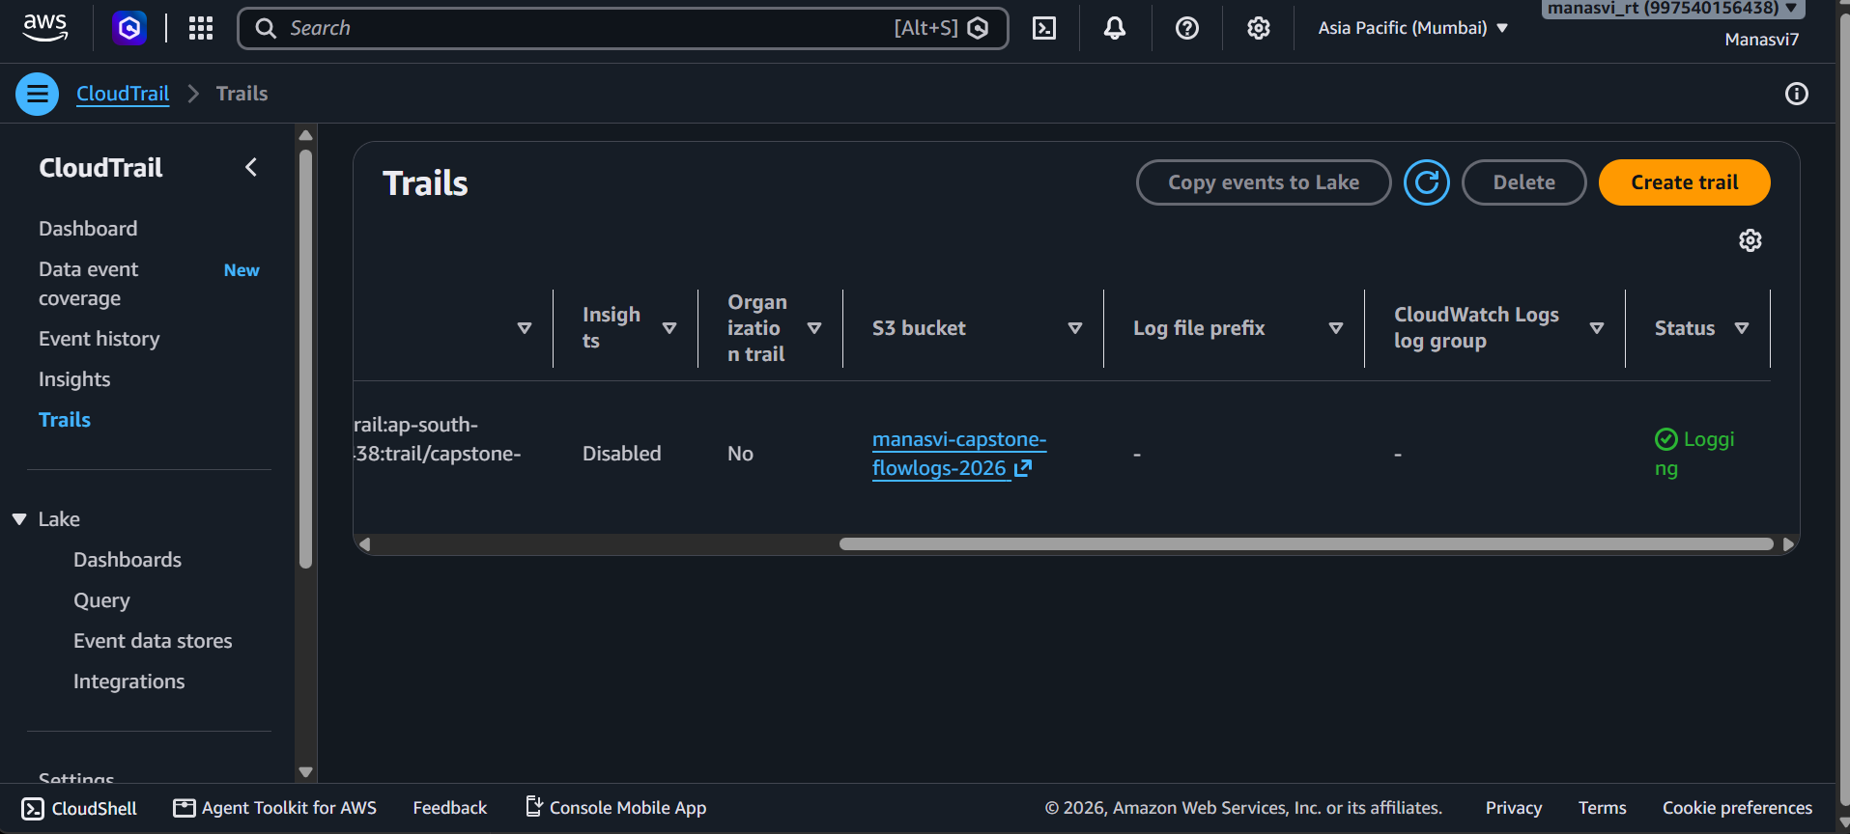
Figure 10. Additional VPC / subnet console evidence
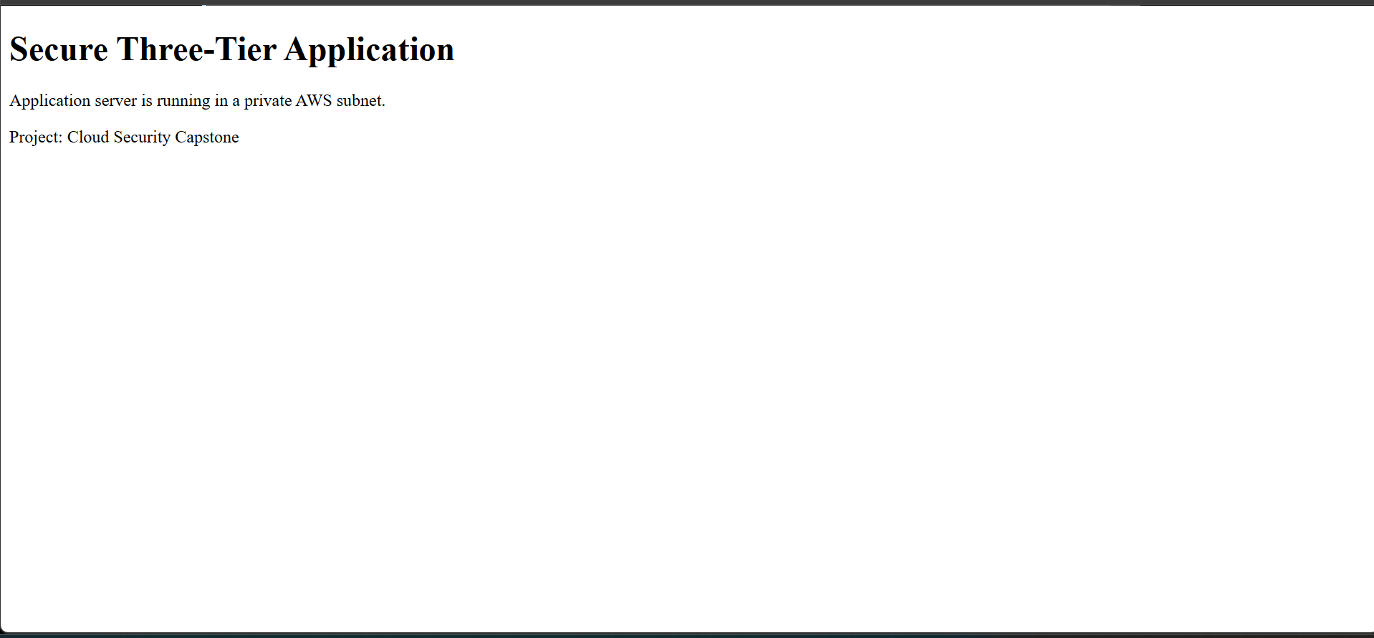

10. Limitations and Future Scope
- Provision and validate Amazon RDS MySQL after reviewing the AWS billing and available credits.
- Configure HTTPS on the ALB using an AWS Certificate Manager certificate and a domain name.
- Add NAT Gateway only if private instances require outbound internet access and budget permits.
- Improve the application with a real backend API, health endpoint, and database integration.
- Consider AWS WAF, alarms, dashboards, and automated security checks.
- Use stricter least-privilege security group rules and document inbound/outbound rules in detail.

11. Conclusion
The capstone successfully demonstrates Terraform-based deployment of a segmented AWS network and a working application delivery path. The public Application Load Balancer forwards traffic to an EC2 application server located in a private subnet. VPC Flow Logs and CloudTrail provide network and API activity visibility, with logs delivered to Amazon S3. The database tier has been prepared in Terraform but remains undeployed due to cost considerations. The project provides a foundation for further development into a fully integrated, secure three-tier cloud application.

