Early Disease Prediction Using Machine Learning on Health Data
Complete Project Planning, System Architecture and Implementation Guide
Project Planning Document

1. Project Overview
The proposed project is an Explainable Machine Learning-Based System for Early Disease Risk Prediction Using Health Data. The system will accept health-related parameters, process them through disease-specific machine-learning pipelines, estimate risk for selected diseases, and present the result through a web dashboard.
The recommended first version focuses on three diseases: diabetes, heart disease, and chronic kidney disease. Each disease will have its own trained model because the available datasets, useful features, preprocessing requirements, and clinical variables differ across diseases.

2. Recommended System Design
The most effective design for this project is: separate disease-specific ML models + disease-specific preprocessing + a common FastAPI backend + PostgreSQL database + React frontend + SHAP-based model explanations.
This approach is more appropriate than one universal model because the three disease datasets do not contain the same variables and each disease can require a different preprocessing and modeling strategy.

3. High-Level Architecture
User → React Web Application → FastAPI Backend → Disease-specific ML Model → Prediction + SHAP Explanation → React Dashboard. The backend also stores health records and prediction history in PostgreSQL.

4. Technology Stack

Layer | Recommended Technology
Programming / ML | Python, Pandas, NumPy, Scikit-learn, XGBoost (optional), SHAP, Matplotlib, Seaborn
Frontend | React.js, JavaScript, HTML, CSS, Axios, Recharts or Chart.js
Backend | FastAPI, Pydantic, SQLAlchemy, JWT authentication, REST APIs
Database | PostgreSQL
Development & Testing | VS Code, Jupyter Notebook, Git, GitHub, Postman
Deployment | Vercel + Render/Railway or AWS; Docker optional
Frontend: React.js, JavaScript, HTML, CSS, Axios, and a charting library such as Recharts or Chart.js.
Backend: FastAPI, Pydantic, SQLAlchemy, JWT authentication, and REST APIs.
Database: PostgreSQL.
Development and testing: VS Code, Jupyter Notebook, Git, GitHub, and Postman.
Deployment: Vercel for the frontend and Render/Railway or AWS for the backend and database. Docker can be added as an advanced deployment option.

5. Diseases and Dataset Plan

Disease | Dataset | Typical Features
Diabetes | Pima Indians Diabetes Database | Pregnancies, glucose, blood pressure, skin thickness, insulin, BMI, diabetes pedigree function, age, outcome
Heart disease | UCI Heart Disease | Age, sex, chest-pain type, resting BP, cholesterol, fasting blood sugar, ECG, max heart rate, exercise angina, ST depression, slope, vessels, thalassemia, target
Chronic kidney disease | UCI Chronic Kidney Disease | Age, BP, specific gravity, albumin, sugar, glucose, blood urea, serum creatinine, sodium, potassium, hemoglobin, blood-cell counts, hypertension, diabetes, appetite, anemia, class
Heart disease: UCI Heart Disease dataset. Typical attributes include age, sex, chest-pain type, resting blood pressure, cholesterol, fasting blood sugar, resting ECG, maximum heart rate, exercise-induced angina, ST depression, slope, vessels, thalassemia, and target.
Chronic kidney disease: UCI Chronic Kidney Disease dataset. Typical variables include age, blood pressure, specific gravity, albumin, sugar, blood glucose, blood urea, serum creatinine, sodium, potassium, hemoglobin, blood-cell counts, hypertension, diabetes, appetite, anemia, and class.

6. Dataset Organization
Keep the raw datasets separate and create processed versions after cleaning.
Suggested structure: datasets/heart/heart.csv; datasets/diabetes/diabetes.csv; datasets/kidney/kidney.csv; processed/heart_clean.csv; processed/diabetes_clean.csv; processed/kidney_clean.csv.

7. Machine Learning Strategy
For every disease, compare multiple supervised classification algorithms rather than assuming one model is best.

Algorithm | Purpose / Role
Logistic Regression | Baseline classification model
Decision Tree | Interpretability
Random Forest | Strong tabular baseline
XGBoost | Optional advanced model
SVM / KNN | Additional comparison if required
Select the final model using validation results and the project’s predefined evaluation criteria. Do not use predetermined performance numbers.

8. ML Pipeline
For each disease: raw dataset → exploratory data analysis → data cleaning → missing-value handling → duplicate removal → outlier analysis → categorical encoding → feature selection/engineering → train/test split → scaling where appropriate → model training → cross-validation/hyperparameter tuning → evaluation → final model selection → model serialization.

9. Data Preprocessing
Handle missing numerical values with an appropriate strategy such as median imputation and categorical values with a suitable categorical strategy such as most-frequent imputation. Avoid replacing all missing values with zero unless zero is semantically correct.
Encode categorical features using ordinal encoding or one-hot encoding as appropriate. Apply StandardScaler to algorithms that benefit from feature scaling, such as Logistic Regression or SVM.
Use stratified train/test splitting for classification where appropriate so class proportions are preserved.

10. Model Evaluation
Evaluate each model using Accuracy, Precision, Recall/Sensitivity, Specificity, F1 Score, ROC-AUC, and a Confusion Matrix. For a health-risk screening project, recall/sensitivity and false-negative behavior deserve particular attention.
Metric | Purpose
Accuracy | Overall proportion of correct predictions
Precision | Correctness of positive predictions
Recall / Sensitivity | Ability to identify positive cases
Specificity | Ability to identify negative cases
F1 Score | Balance of precision and recall
ROC-AUC | Ranking/discrimination performance
Confusion Matrix | Breakdown of prediction outcomes
Training Time | Computational cost
Create a model comparison table with columns such as Model, Accuracy, Precision, Recall, F1, ROC-AUC, and training time. Report the actual values obtained from your experiments.

11. Explainable AI
Add SHAP to explain model predictions. The dashboard can show an estimated risk probability/category and the features that contributed most to that individual prediction.
Important distinction: SHAP values explain the behavior of the trained model for an input; they do not prove that a feature causes a disease.

12. Database Design
Use PostgreSQL with at least four logical tables: users, health_records, predictions, and model_information.

Table | Key Fields | Purpose
users | id (PK), name, email, password_hash, created_at | User accounts
health_records | id (PK), user_id (FK), age, gender, height, weight, BMI, blood pressure, heart rate, glucose, cholesterol, smoking status, created_at | Stored health data
predictions | id (PK), user_id (FK), health_record_id (FK), disease, risk_probability, risk_category, model_version, created_at | Prediction history
model_information | id (PK), disease, algorithm, version, accuracy, precision, recall, F1, ROC-AUC, trained_at | Model metadata
Relationship: one user can have many health records; one health record can have many predictions. Model information stores the version and evaluation metadata for the model used.

13. Backend Architecture

Area | Files / Components
Core | main.py, database.py, models.py, schemas.py, crud.py
Routes | routes/auth.py, routes/health.py, routes/prediction.py
ML | ml/heart_model.py, ml/diabetes_model.py, ml/kidney_model.py, ml/model_loader.py
Models | saved_models/
FastAPI should validate inputs, authenticate users, call the correct preprocessing/model pipeline, return a structured prediction response, and store the result in PostgreSQL.

14. REST API Plan

Method | Endpoint | Purpose
POST | /api/register | Create an account
POST | /api/login | Authenticate and return an access token
POST | /api/health-record | Save a health record
POST | /api/predict/heart | Generate heart-disease risk estimate
POST | /api/predict/diabetes | Generate diabetes risk estimate
POST | /api/predict/kidney | Generate kidney-disease risk estimate
GET | /api/predictions | Retrieve authenticated user's prediction history

15. Frontend Plan
React pages/components: Home, About Project, Register, Login, Dashboard, Health Profile, Heart Prediction, Diabetes Prediction, Kidney Prediction, Prediction History, and Health Dashboard.
Each prediction page should use validated form inputs and display the estimated probability/category, model explanation, and an appropriate medical-safety notice. The dashboard can show health metrics, recent predictions, and historical trends.

16. Recommended Project Folder Structure
Early-Disease-Prediction/ frontend/ backend/ datasets/ notebooks/ reports/ README.md requirements.txt .gitignore.
Backend can contain routes/, ml/, saved_models/, database.py, models.py, schemas.py, and main.py. Notebooks can contain separate EDA/modeling notebooks for heart, diabetes, and kidney datasets.

17. Implementation Plan
Phase 1 — Research (2–3 days): understand disease prediction, supervised classification, datasets, evaluation metrics, and explainable AI.
Phase 2 — Dataset collection and understanding (about 2 days): obtain public datasets, inspect columns and targets, identify missing values, duplicates, class imbalance, and data quality issues.
Phase 3 — Preprocessing and EDA (3–4 days): clean each dataset, visualize distributions/correlations, encode categories, handle missing values, analyze outliers, and prepare reproducible pipelines.
Phase 4 — Model development (5–7 days): train baseline and advanced classifiers, use validation/cross-validation, tune selected models, compare metrics, and save the final pipelines.
Phase 5 — Explainability (2–3 days): integrate SHAP and produce feature-importance/explanation visualizations.
Phase 6 — Backend (4–5 days): implement FastAPI, PostgreSQL, SQLAlchemy, authentication, prediction endpoints, and history endpoints.
Phase 7 — Frontend (5–7 days): implement React authentication, forms, dashboards, prediction results, history, and charts.
Phase 8 — Integration and testing (about 3 days): connect React → FastAPI → ML models → PostgreSQL, test valid/invalid inputs, authentication, model calls, and database operations.

18. Testing Strategy
ML testing: dataset validation, preprocessing checks, cross-validation, confusion matrices, ROC curves, and metric verification.
API testing: use Postman for authentication, health-record creation, prediction endpoints, and history retrieval.
Frontend testing: empty/invalid fields, API failures, loading states, responsive layout, login errors, and prediction-result rendering.
Security testing: verify password hashing, token handling, authorization, environment variables, and database access controls.

19. Security and Privacy
Because the project handles health-related information, implement password hashing, authentication/authorization, input validation, HTTPS in deployment, environment variables for secrets, restricted database access, and a clear privacy notice.
Do not hard-code database passwords, secret keys, or API credentials. Never commit .env files or real patient information to GitHub.

20. Deployment Plan
Recommended architecture: Internet → React frontend → FastAPI backend → PostgreSQL database, with the backend loading the versioned ML pipelines.
A student-friendly deployment is React on Vercel, FastAPI on Render/Railway, and PostgreSQL through a managed cloud database. AWS can be used instead if cloud deployment is part of the course requirement.

21. Basic vs Advanced Features
Basic version: registration/login, health-data forms, three disease predictions, PostgreSQL storage, prediction history, and dashboard.
Advanced version: SHAP explanations, health trends, model comparison, PDF reports, email reports, admin dashboard, model versioning, Docker, cloud deployment, and additional datasets/diseases.

22. Future Scope
Potential future work includes mobile applications, wearable-device integration, real-time monitoring, additional disease models, federated learning, more advanced explainability, personalized risk assessment, and integration with electronic health-record systems. These should be described as future scope unless actually implemented.

23. Recommended Final Architecture
The final recommended architecture is: Health Data → Common Validation Layer → disease-specific preprocessing/model pipelines (Diabetes, Heart, Kidney) → risk estimate → SHAP explanation → dashboard; with FastAPI as the common service layer and PostgreSQL for authenticated user data and prediction history.
This architecture balances research value, implementation complexity, modularity, explainability, and future scalability. It also lets each disease model be improved independently without redesigning the entire application.

24. Important Medical/Research Limitation
The system must be presented as a machine-learning risk-screening or educational system, not a clinical diagnostic device. Public datasets may have demographic, sampling, measurement, and labeling limitations. Model performance on a public dataset does not establish clinical effectiveness on a different population. Any real-world clinical deployment would require appropriate validation, governance, privacy protection, and professional/regulated review.

Technology Summary
Layer | Recommended Technology
Programming / ML | Python, Pandas, NumPy, Scikit-learn, XGBoost, SHAP
Visualization | Matplotlib, Seaborn, Recharts/Chart.js
Frontend | React.js, JavaScript, HTML, CSS, Axios
Backend | FastAPI, Pydantic, SQLAlchemy, JWT
Database | PostgreSQL
Development | VS Code, Jupyter Notebook
Testing | Postman, Pytest
Version Control | Git, GitHub
Deployment | Vercel + Render/Railway or AWS

Suggested Final Workflow
1. Collect and understand public datasets.
2. Perform EDA and disease-specific preprocessing.
3. Train and compare multiple classification models.
4. Validate and select the final model for each disease.
5. Save the complete preprocessing + model pipeline.
6. Build FastAPI endpoints for prediction and history.
7. Store users, health records, predictions, and model metadata in PostgreSQL.
8. Build React forms and dashboards.
9. Add SHAP explanations and safety notices.
10. Test, document, and deploy.

Expected Final Deliverables
• Working React web application
• FastAPI backend with REST APIs
• Three trained disease-specific ML pipelines
• PostgreSQL database schema
• EDA and model-training notebooks
• Model comparison and evaluation report
• SHAP explanation visualizations
• ER diagram, architecture diagram, DFD/UML diagrams as required
• Project report and presentation
• GitHub repository with README and setup instructions
• Deployed demo, if required

25. UML Use Case Diagram
The following UML use-case diagram identifies the two main actors—User and Admin—and the major functions of the system. The User can register/login, manage a profile, enter health data, request disease predictions, view results and history, view model explanations, and access reports. The Admin can manage users and ML models and can access relevant management functions.
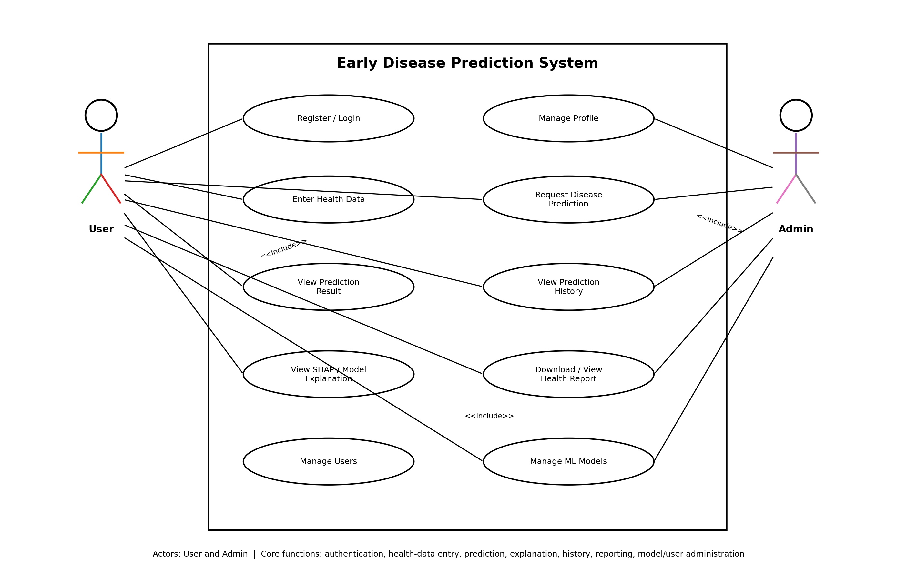
Figure 1. UML Use Case Diagram for the Early Disease Prediction System.

Use Case Descriptions

Use Case | Description
Register / Login | User creates an account or authenticates to access protected health and prediction features.
Manage Profile | User maintains basic profile information required by the application.
Enter Health Data | User enters disease-specific health parameters through validated forms.
Request Disease Prediction | User selects a disease and submits health data to the FastAPI prediction endpoint.
View Prediction Result | System returns an estimated probability/risk category and model version.
View Prediction History | User retrieves previous predictions stored in PostgreSQL.
View SHAP / Model Explanation | System displays important model features contributing to the prediction.
Download / View Health Report | System presents or generates a report containing the prediction and supporting information.
Manage Users | Admin can view/manage application users according to the project's authorization rules.
Manage ML Models | Admin can monitor model versions and evaluation metadata and manage model deployment according to the implementation.

26. Complete End-to-End System Flow
The complete system flow below shows how data moves from the user interface through authentication, health-data collection, disease-specific preprocessing, machine-learning prediction, explainability, database storage, and final dashboard/report output.
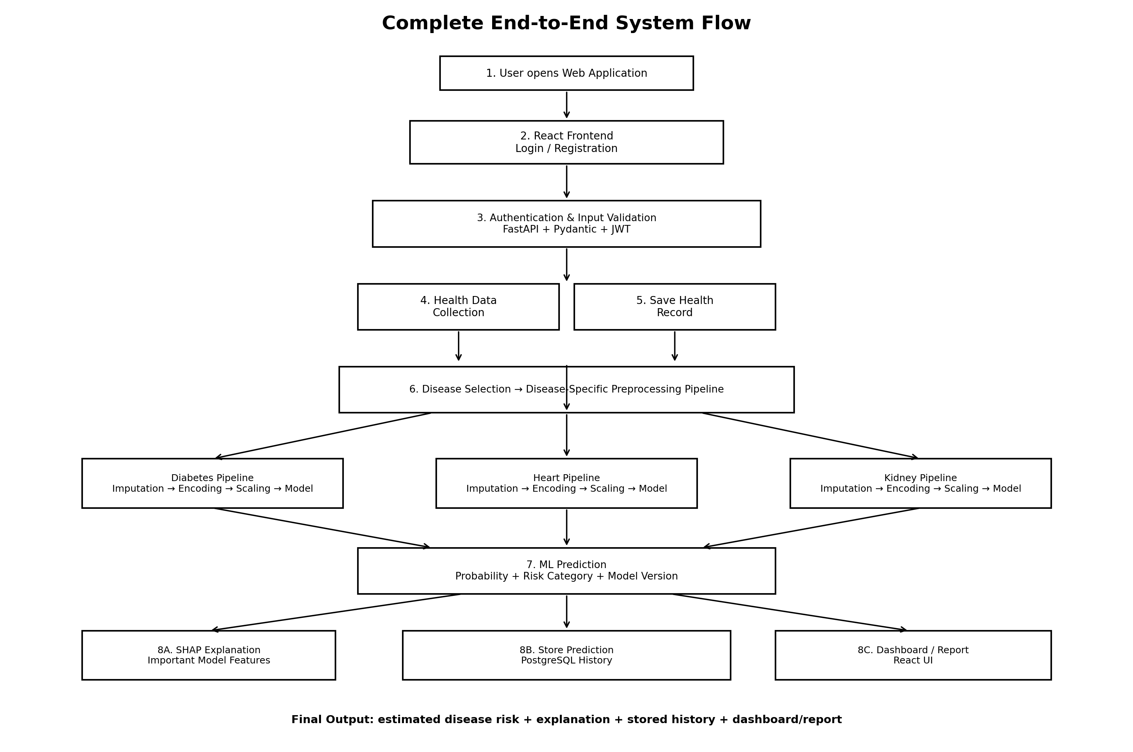
Figure 2. Complete end-to-end flow of the proposed ML system.

Detailed Flow
1. User Access: The user opens the React web application and selects registration or login.
2. Authentication: FastAPI validates credentials and issues an authenticated session/token. Protected endpoints require authorization.
3. Health Data Entry: The user enters the parameters required by the selected disease model. Frontend and backend validation prevent invalid or missing values where possible.
4. Health Record Storage: The validated health record can be stored in PostgreSQL and associated with the authenticated user.
5. Disease Selection: The user chooses diabetes, heart disease, or kidney disease. The backend routes the request to the corresponding model pipeline.
6. Disease-Specific Preprocessing: The selected pipeline applies the same transformations used during model training, such as imputation, encoding, scaling, and feature ordering.
7. ML Prediction: The trained model generates an estimated probability and a predefined risk category. The response includes the model version for traceability.
8. Explainability: SHAP or another explanation method is used to show which input features were influential for the model output.
9. Database Storage: Prediction details, timestamp, user reference, probability, risk category, and model version are stored in PostgreSQL.
10. Dashboard and Report: React displays the result, explanation, historical predictions, and optional report information.
11. Monitoring / Administration: Admin functionality can monitor users, model versions, and evaluation metadata without exposing sensitive information unnecessarily.

27. Data Flow Between Components

Data Path | Data / Purpose
React → FastAPI | JSON request containing authenticated user context and validated health features.
FastAPI → ML Pipeline | disease-specific feature dictionary/data frame.
ML Pipeline → Model | transformed numerical feature vector in the exact training feature order.
Model → FastAPI | probability/prediction and model metadata.
FastAPI → SHAP | input and model/predictor used to generate an explanation.
FastAPI → PostgreSQL | user record, health record, prediction result, explanation metadata where appropriate, and model version.
FastAPI → React | JSON response containing result, probability/risk category, explanation data, and timestamp.

28. Complete Project Execution Order
1. Finalize project scope and disease selection.
2. Collect public datasets and document dataset sources/licensing.
3. Perform EDA separately for each disease.
4. Clean and preprocess each dataset.
5. Build reproducible training pipelines.
6. Train baseline models.
7. Train Random Forest and optional XGBoost/other models.
8. Evaluate using appropriate classification metrics and cross-validation.
9. Select and save the final pipeline for each disease.
10. Build the PostgreSQL schema.
11. Develop FastAPI authentication and health/prediction endpoints.
12. Connect saved ML pipelines to FastAPI.
13. Build React authentication, forms, dashboard, results, and history.
14. Add SHAP explanations.
15. Integrate React, FastAPI, ML, and PostgreSQL.
16. Test end-to-end workflows and invalid inputs.
17. Document results, limitations, architecture, diagrams, and setup.
18. Deploy the application if required.

