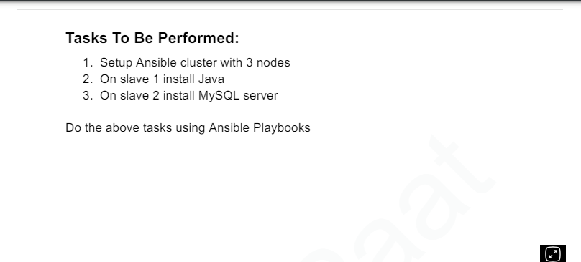

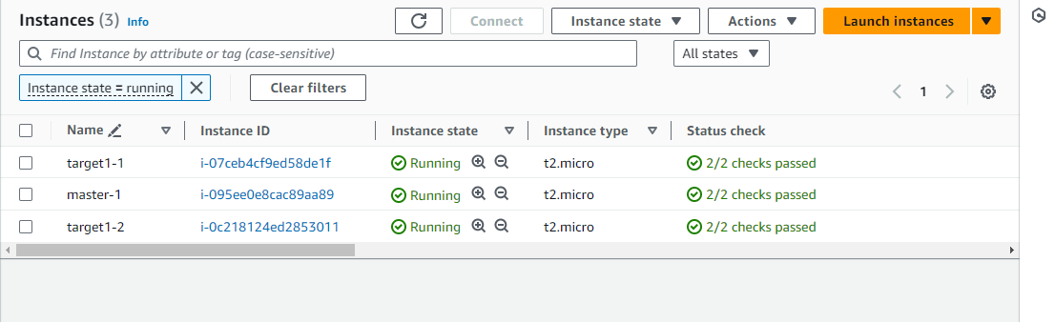

Create the host file

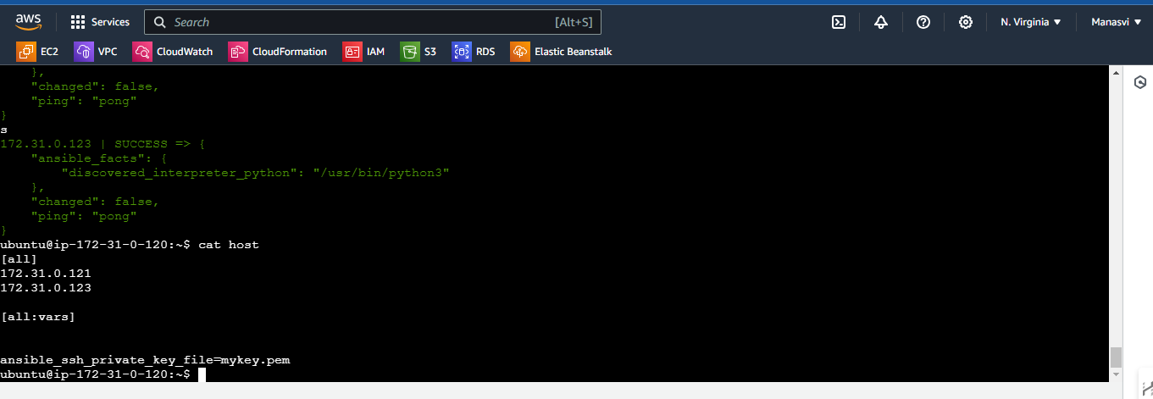

Creating the key pair



Set permission for the key pair okay



Host file is pinging the server

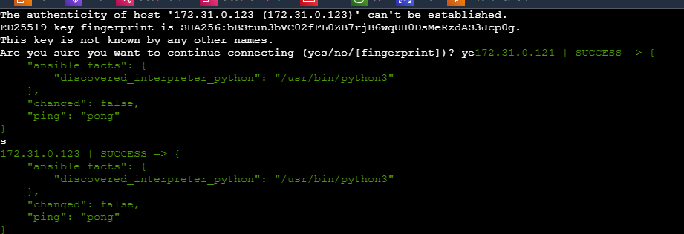

The host file looks like this

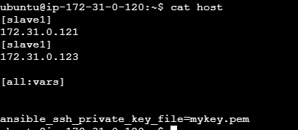

The playbook looks like this

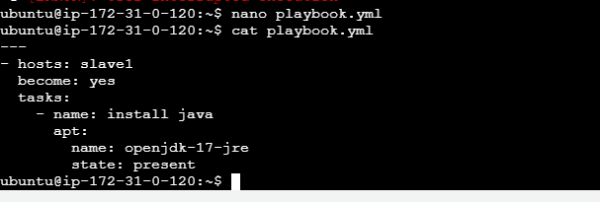

Installed java on one of the servers

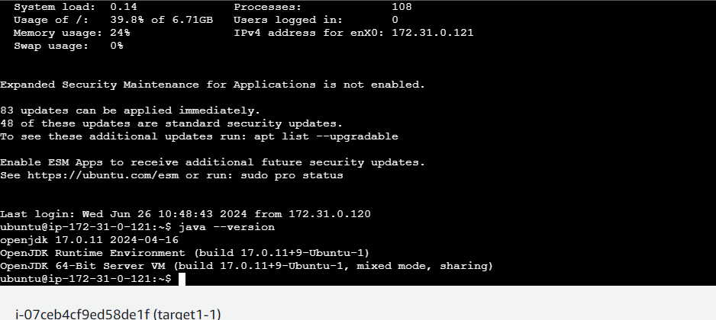

Installed java on 1 of the slaves

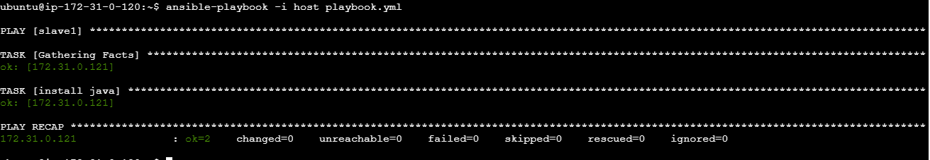

Second part :

Installing the mysql agent on the other server

