Installing Kubernetes on the slave and on the control plane
// Install docker
sudo apt update
sudo apt install docker.io -y
sudo systemctl status docker
sudo systemctl start docker
sudo usermod -aG docker ubuntu
sudo usermod -aG docker $USER
newgrp docker
sudo su -
usermod -aG docker jenkins
usermod -aG docker ubuntu
systemctl restart docker

//Install kubectl and kubeadm on both
sudo apt-get update -y
sudo apt-get install -y apt-transport-https ca-certificates curl gpg
sudo mkdir -p -m 755 /etc/apt/keyrings
curl -fsSL https://pkgs.k8s.io/core:/stable:/v1.30/deb/Release.key | sudo gpg --dearmor -o /etc/apt/keyrings/kubernetes-apt-keyring.gpg
echo 'deb [signed-by=/etc/apt/keyrings/kubernetes-apt-keyring.gpg] https://pkgs.k8s.io/core:/stable:/v1.30/deb/ /' | sudo tee /etc/apt/sources.list.d/kubernetes.list
sudo apt-get update -y
sudo apt-get install -y kubelet kubeadm kubectl
sudo apt-mark hold kubelet kubeadm kubectl
sudo swapoff -a
sudo sed -i '/ swap / s/^(.*)$/#\1/g' /etc/fstab
free -m
sudo tee /etc/modules-load.d/k8s.conf <<EOF
overlay
br_netfilter
EOF
sudo modprobe overlay
sudo modprobe br_netfilter
sudo tee /etc/sysctl.d/kubernetes.conf<<EOF
net.bridge.bridge-nf-call-ip6tables = 1
net.bridge.bridge-nf-call-iptables = 1
net.ipv4.ip_forward = 1
EOF
sudo sysctl --system
sudo apt install -y curl gnupg2 software-properties-common apt-transport-https ca-certificates
curl -fsSL https://download.docker.com/linux/ubuntu/gpg | sudo gpg --dearmor -o /etc/apt/trusted.gpg.d/docker-archive-keyring.gpg
sudo add-apt-repository "deb [arch=amd64] https://download.docker.com/linux/ubuntu $(lsb_release -cs) stable"
sudo apt update -y
sudo apt install -y containerd.io
sudo mkdir -p /etc/containerd
sudo containerd config default|sudo tee /etc/containerd/config.toml
sudo sed -i 's/SystemdCgroup \= false/SystemdCgroup \= true/g' /etc/containerd/config.toml
sudo systemctl restart containerd
sudo systemctl enable containerd
systemctl status containerd

// Kubeadm init in master only
kubeadm init --apiserver-advertise-address=172.31.3.229(masternodeprivateip) --pod-network-cidr=10.244.0.0/16

after this copy and save the command of kubeadm join

now run this command
To start using your cluster, you need to run the following as a regular user:

mkdir -p $HOME/.kube
sudo cp -i /etc/kubernetes/admin.conf $HOME/.kube/config
sudo chown $(id -u):$(id -g) $HOME/.kube/config

now run
kubectl apply -f https://raw.githubusercontent.com/flannel-io/flannel/master/Documentation/kube-flannel.yml

after this run kubeadm join command

that you got

kubeadm join 172.31.0.124:6443 --token 7yfy0j.aq7e0g9ue9ihrv8t \
--discovery-token-ca-cert-hash sha256:6eee8021c409d12771d416663e27dafa501ce77372eeab88b6ea02e84d0d8ac0

Deployment.yml
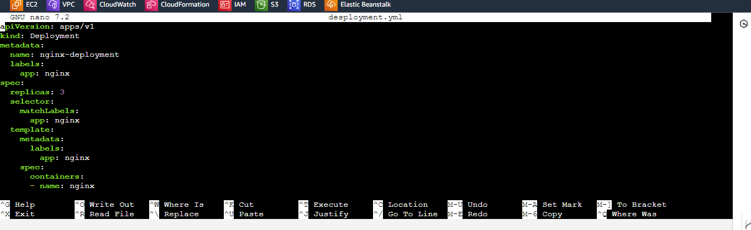

Created a deployment with 3 pods

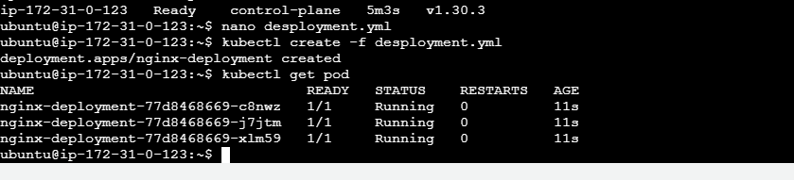

Assignment2
create a service on the existing deployment and see what happens

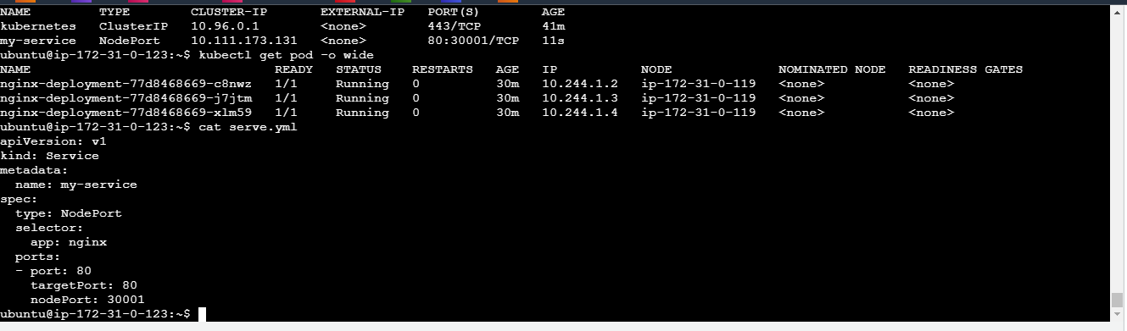
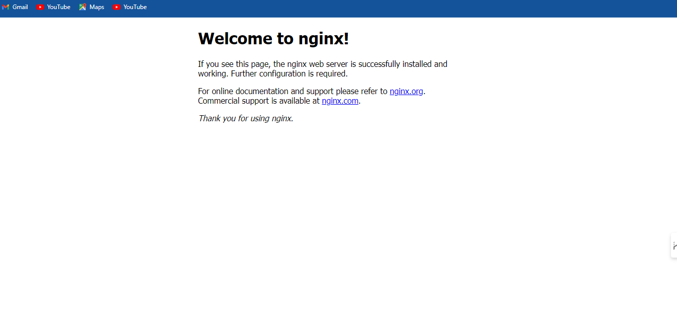

apiVersion: v1
kind: Service
metadata:
name: my-service
spec:
type: NodePort
selector:
app: nginx
ports:
- port: 80
targetPort: 80
nodePort: 30001

Assignment 3

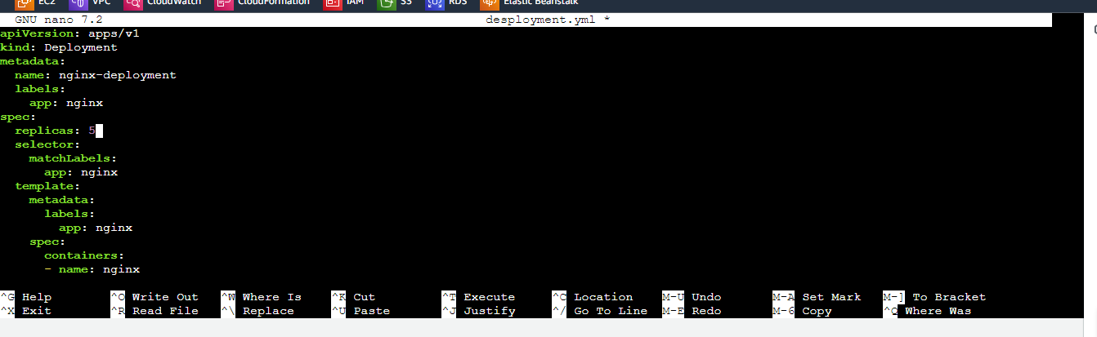

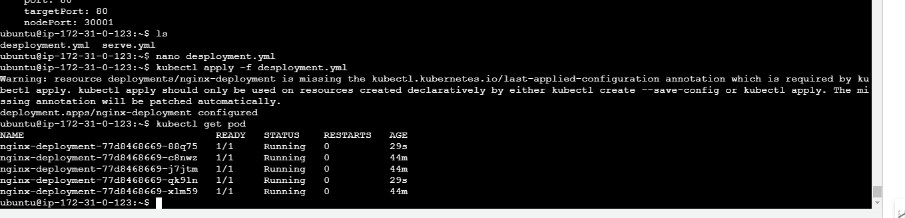

Assignment4
Changing it to cluster Ip and applying

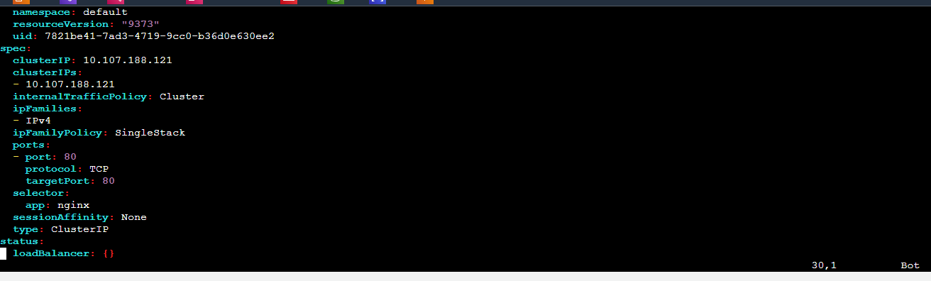
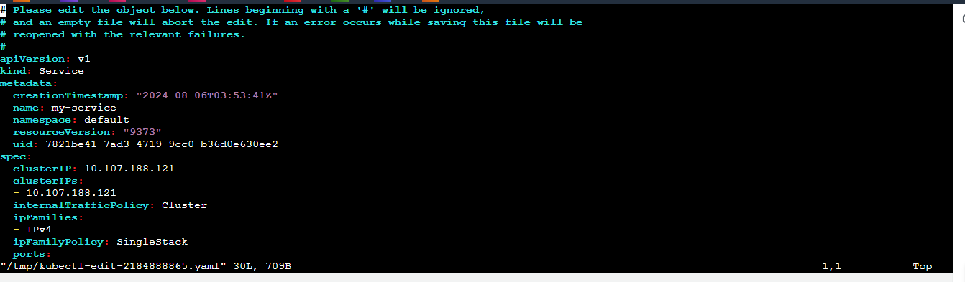
Able to access from the slave server

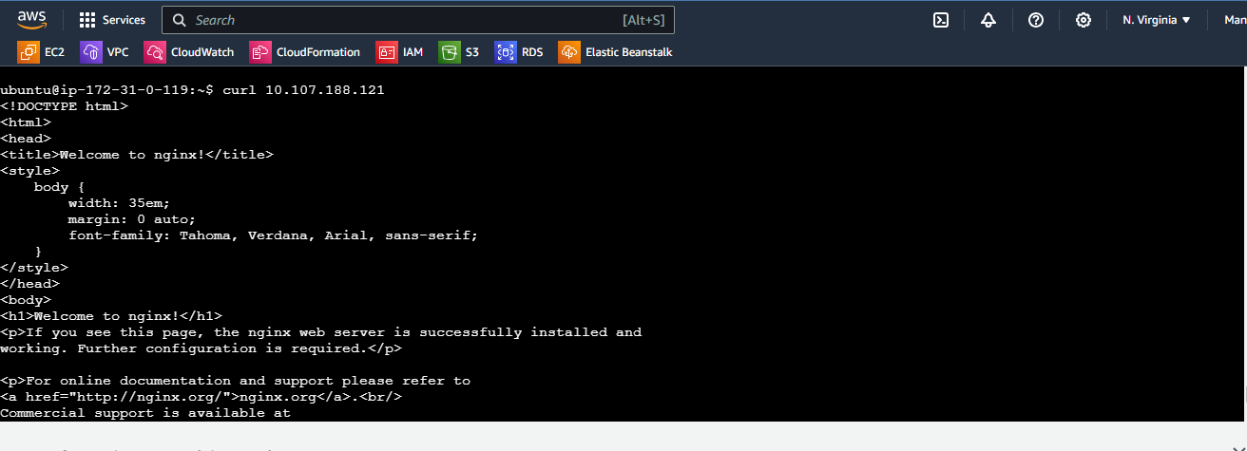

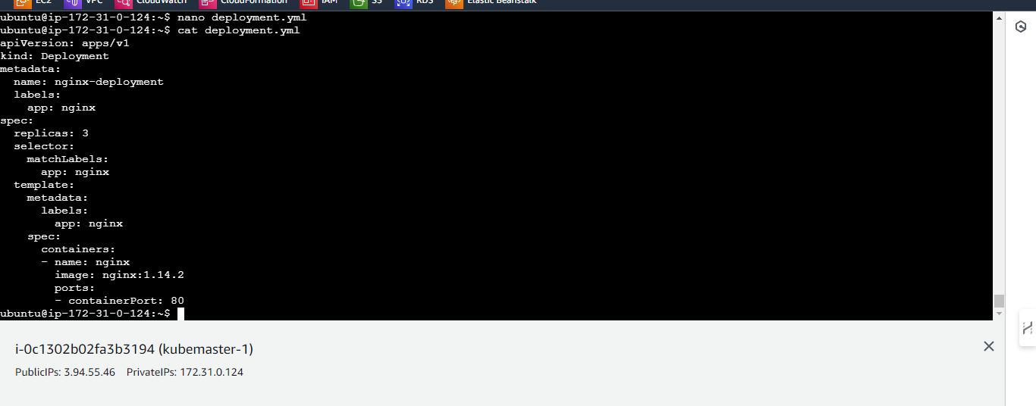

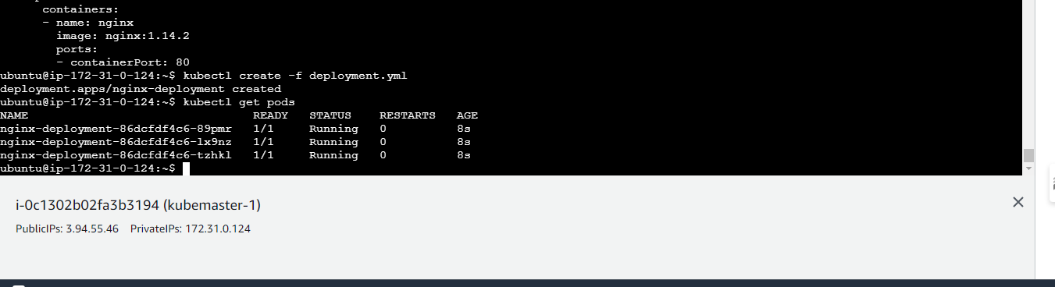

Assignment 2
Creating a service
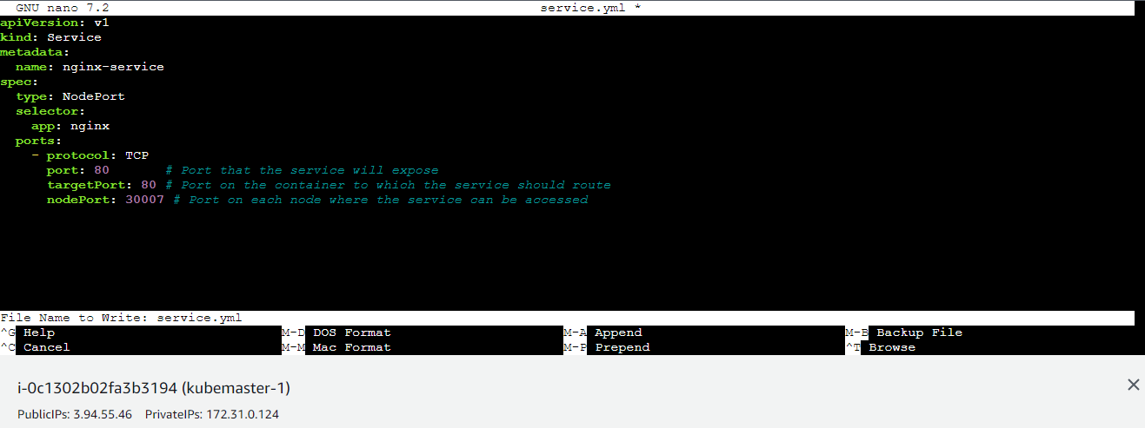
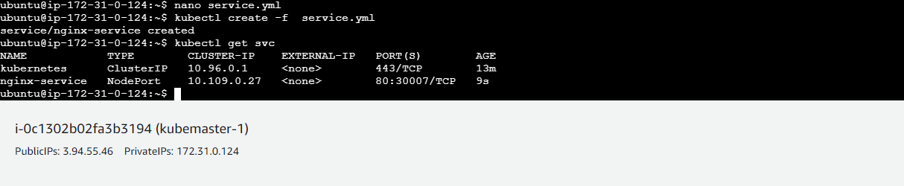
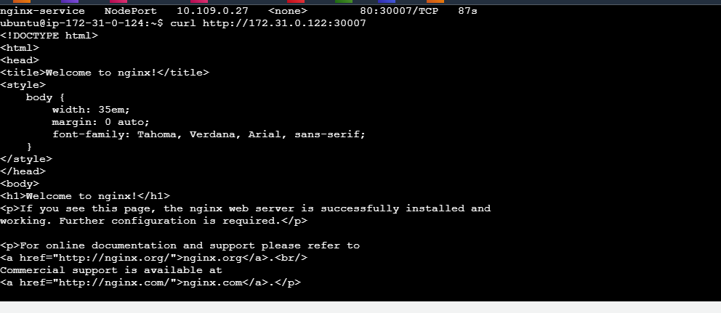

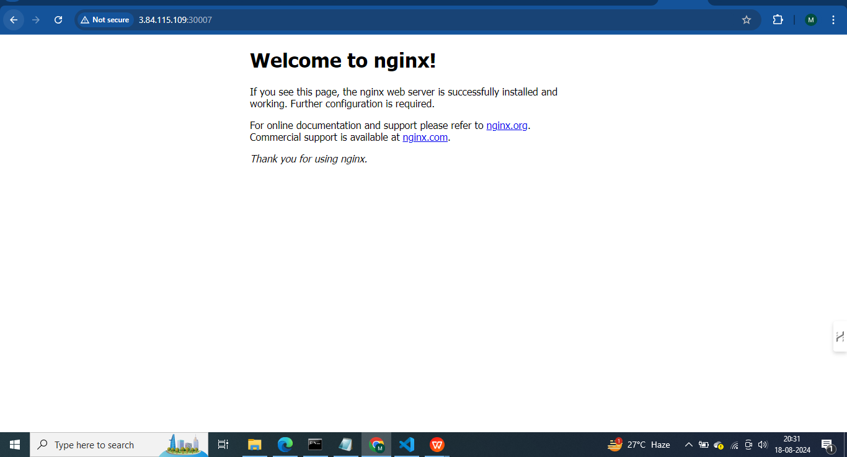

Assignment 3

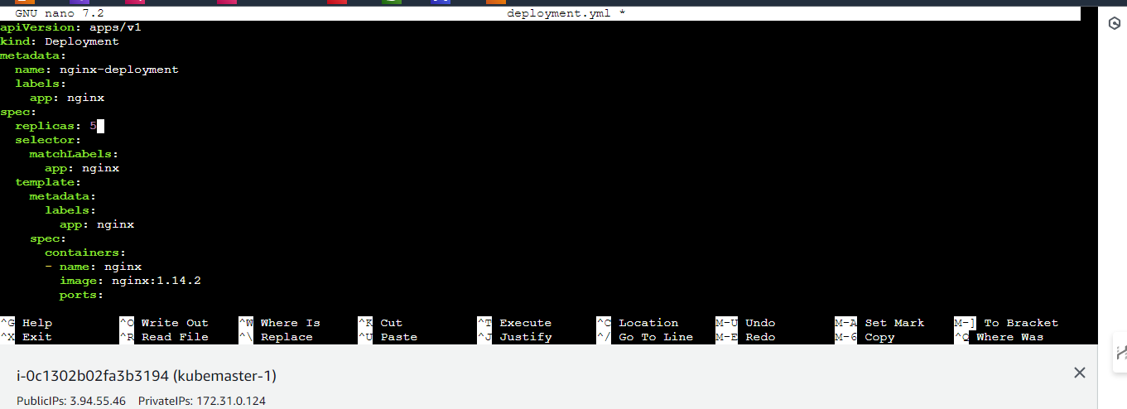
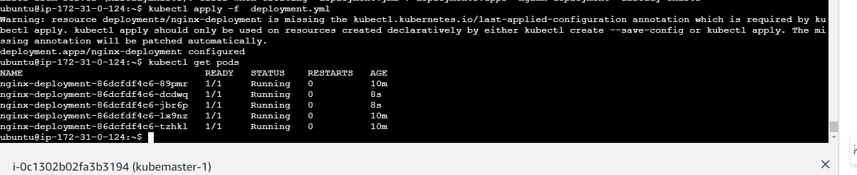
Assignment 4
