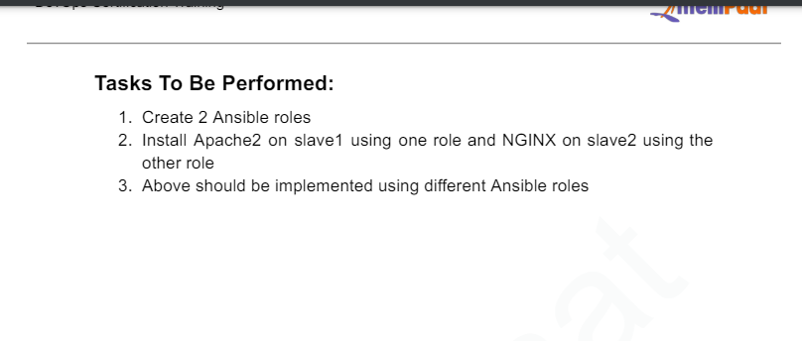
52 mkdir roles
53 cd roles
54 ansible-galaxy init apache
55 ls
56 cd apache
57 ls
58 cd tasks
59 ls
60 nano main.yml
61 ls
62 rm apache
63 rm -f apache
64 rmdir apache
65 rm -r
66 rm -r apache
67 ls
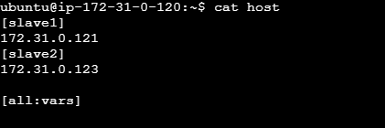

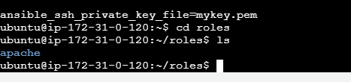
Created a role named apache and then created a role in main.yml file
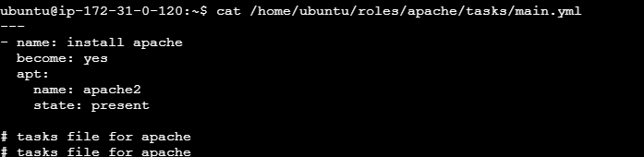
Created a playbook for that role
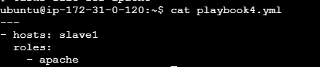

Now creating another role nginx

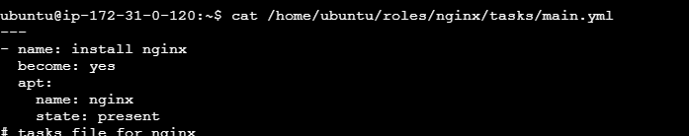
Playbook5.yml is created
