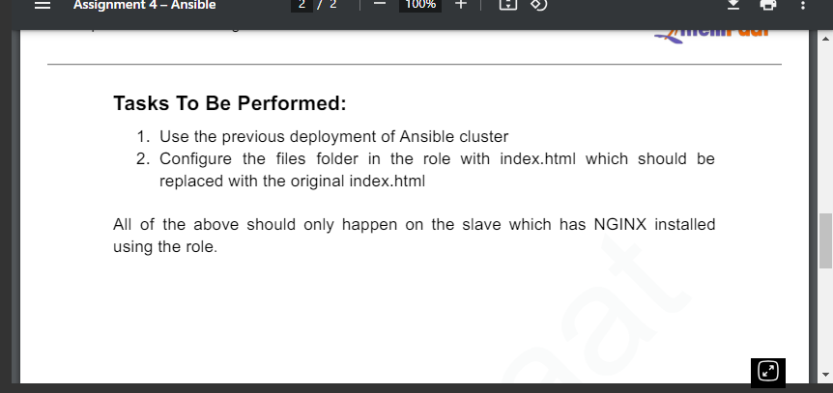
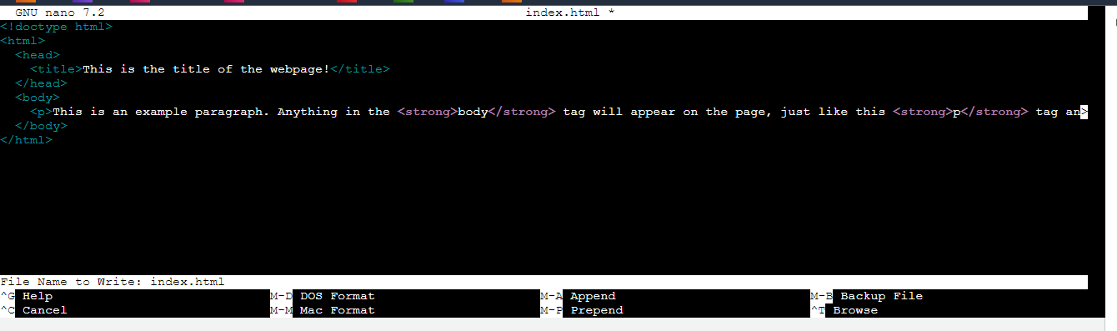
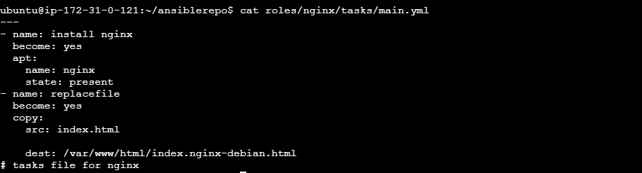
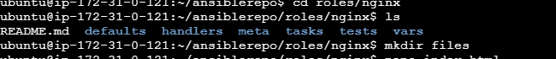
Created a file and added the index file in it
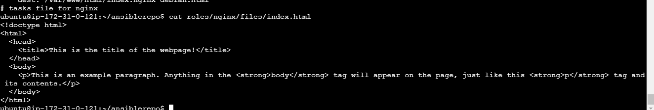
Ran the playbook
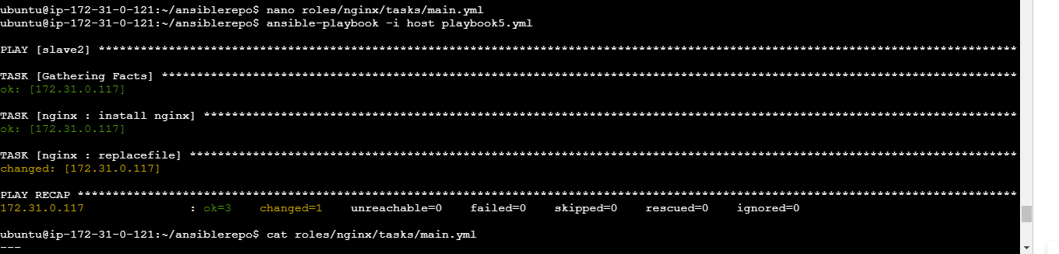

The server with nginx
