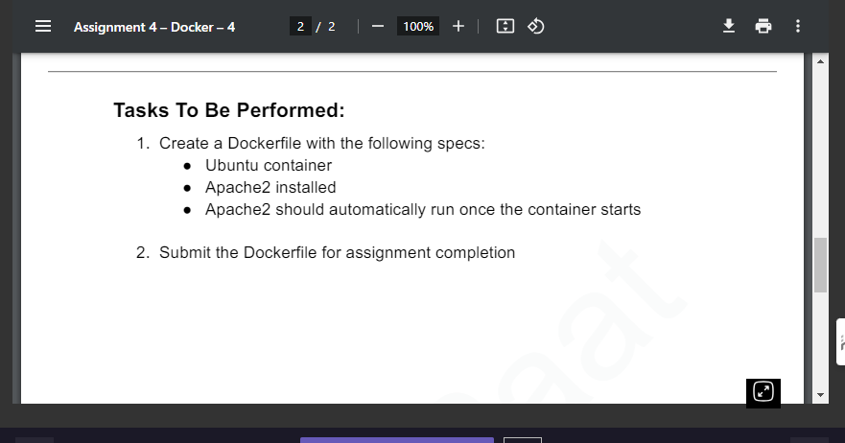

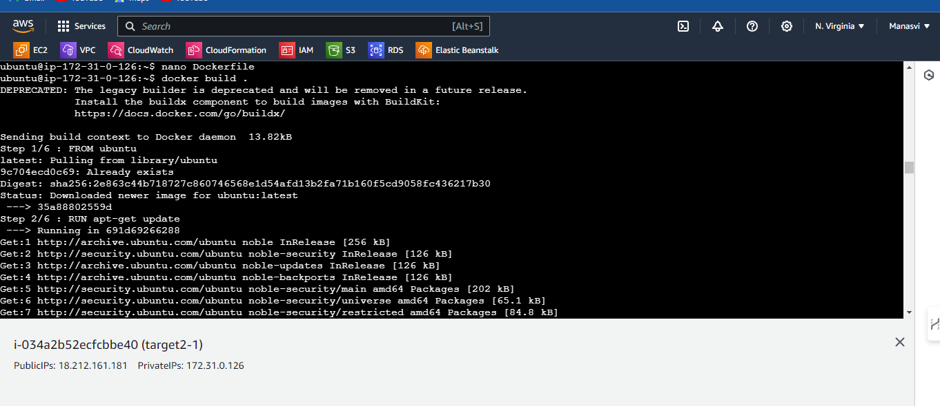
Docker file

FROM ubuntu
RUN apt-get update
RUN apt-get install apache2 -y
COPY ./ www/var/html
ENTRYPOINT apachectl -D FOREGROUND
EXPOSE 8000

