Container history
root@d12d95c7ad68:/# history
1 apt-get install apache2
2 exit
3 history

Server history
1 docker --version
2 sudo apt update
3 sudo apt install docker.io -y
4 sudo systemctl status docker
5 sudo systemctl start docker
6 sudo usermod -aG docker ubuntu
7 sudo systemctl start docker
8 docker --version
9 sudo docker pull ubuntu
10 sudo docker images
11 sudo docker run -itd -p 80:81 ubuntu
12 sudo docker container ls
13 sudo docker exec -it d12d95c7ad68
14 sudo docker exec -it d12d95c7ad68 /bin/bash
15 sudo docker exec -it d12d95c7ad68
16 sudo docker exec -it d12d95c7ad68 /bin/bash
17 history

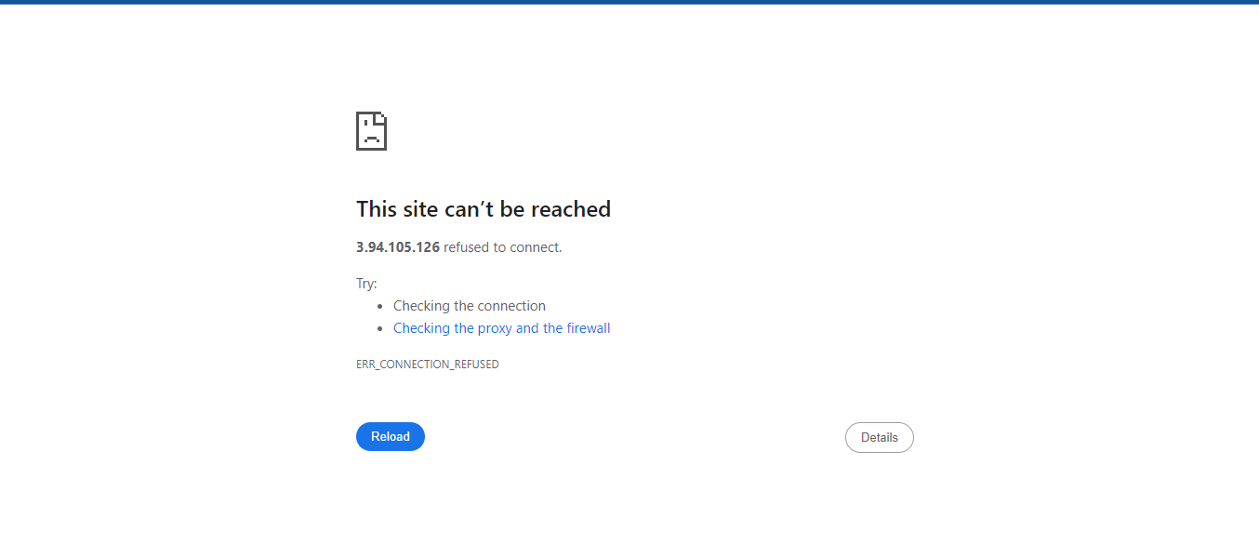
No reachable because the apache service wasn’t started

