docker push manasvidocker/firstrepo:mewimg-latest
sudo docker push mewimg:new
84 sudo docker images
86 sudo docker tag mewimg:latest manasvidocker/firstrepo:mewimg-latest
87 sudo docker push manasvidocker/firstrepo:mewimg-latest
In the earlier ec2 instance

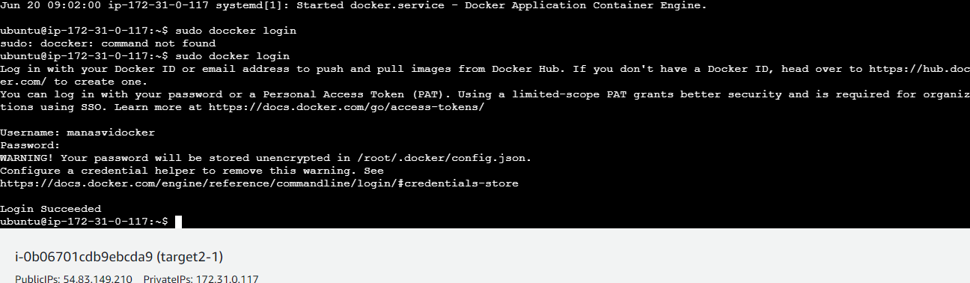

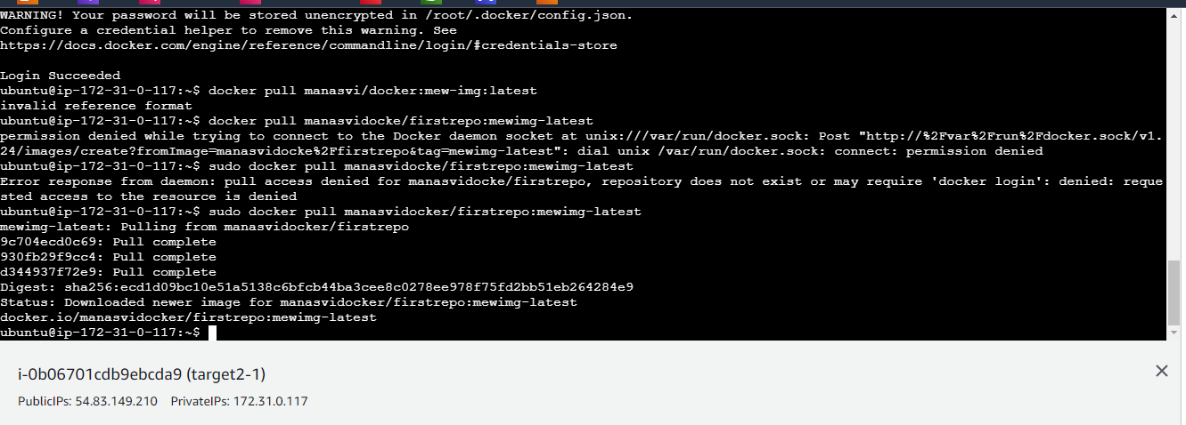

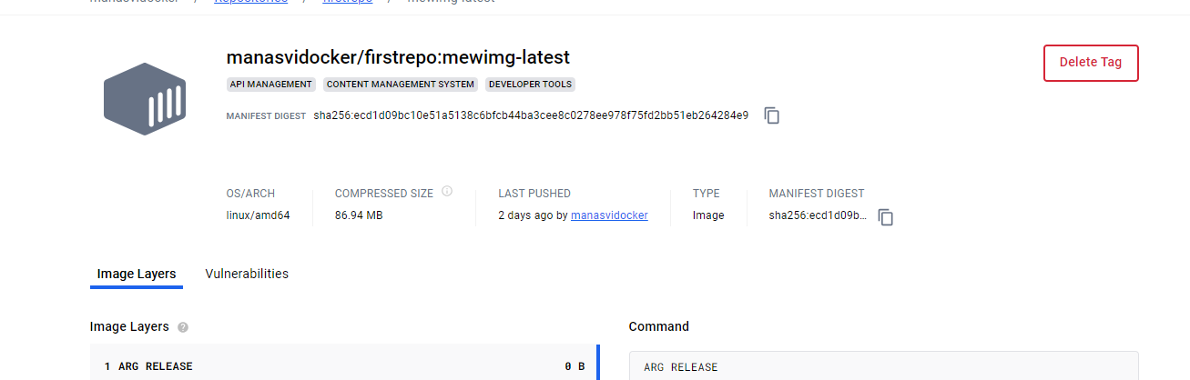
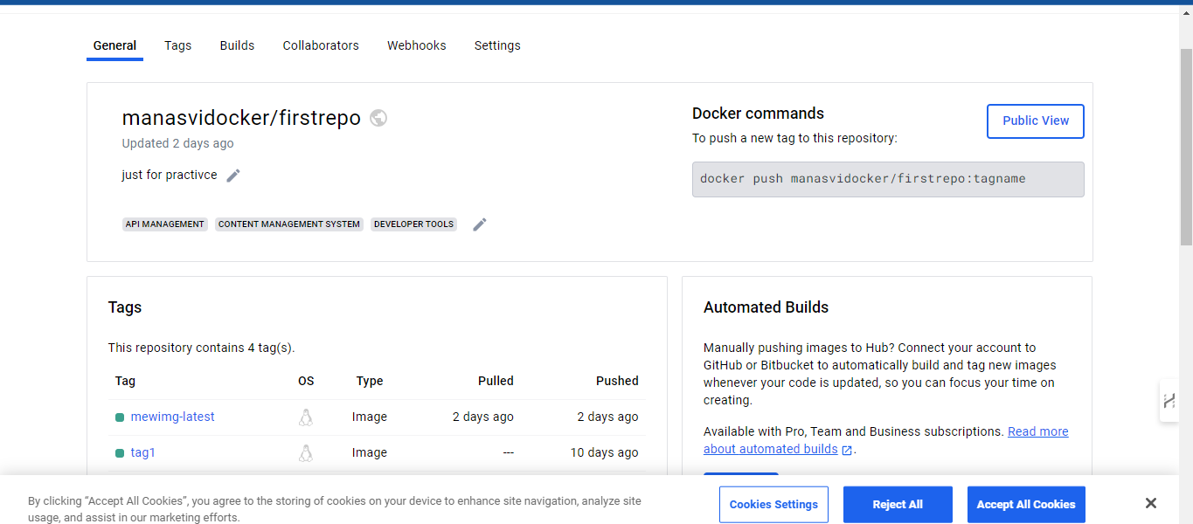

docker pull manasvidocker/firstrepo:mewimg-latest

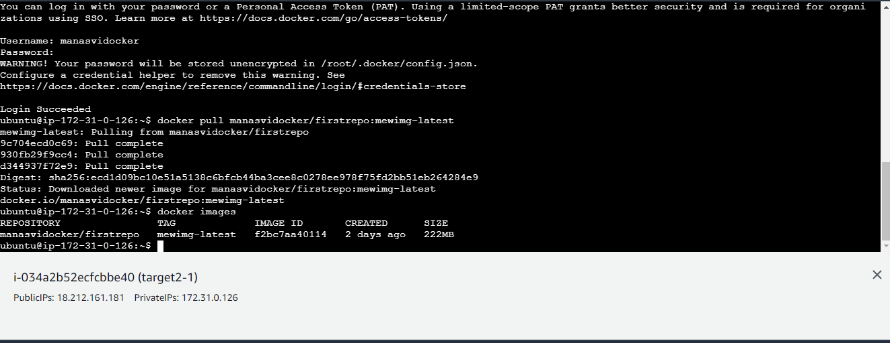
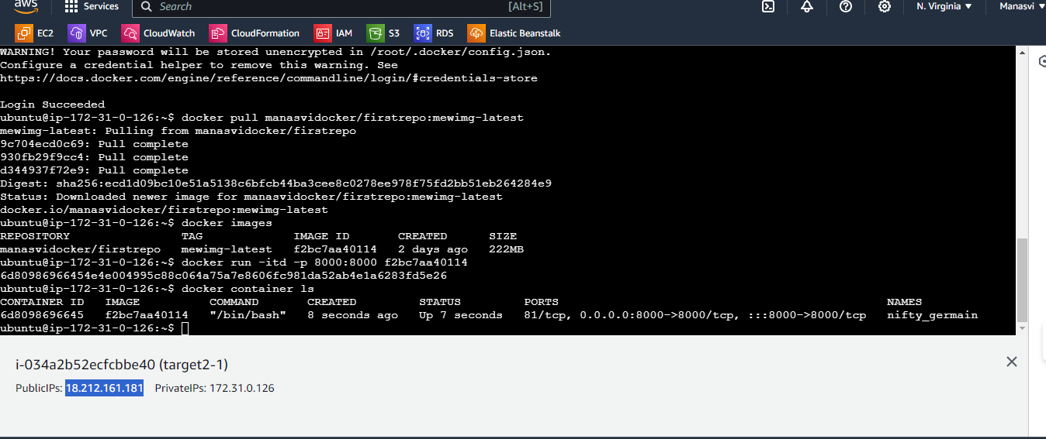

Launched at 8000 port
