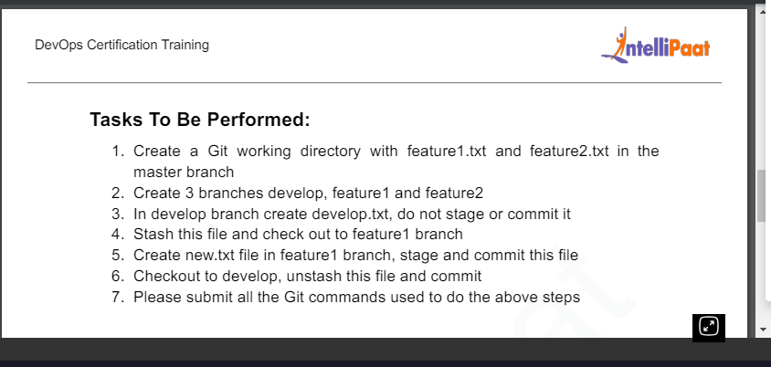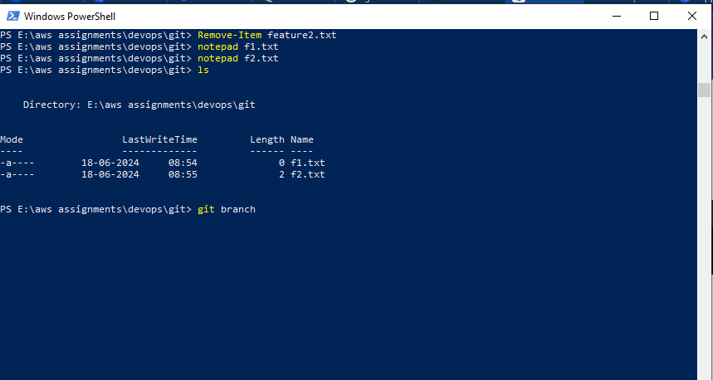
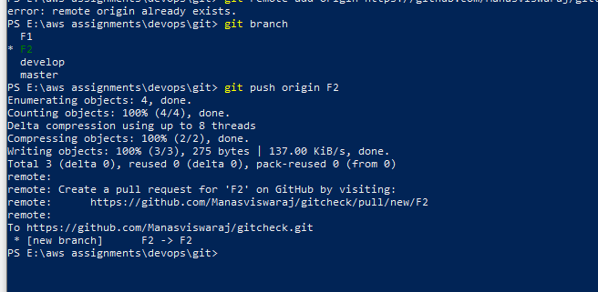
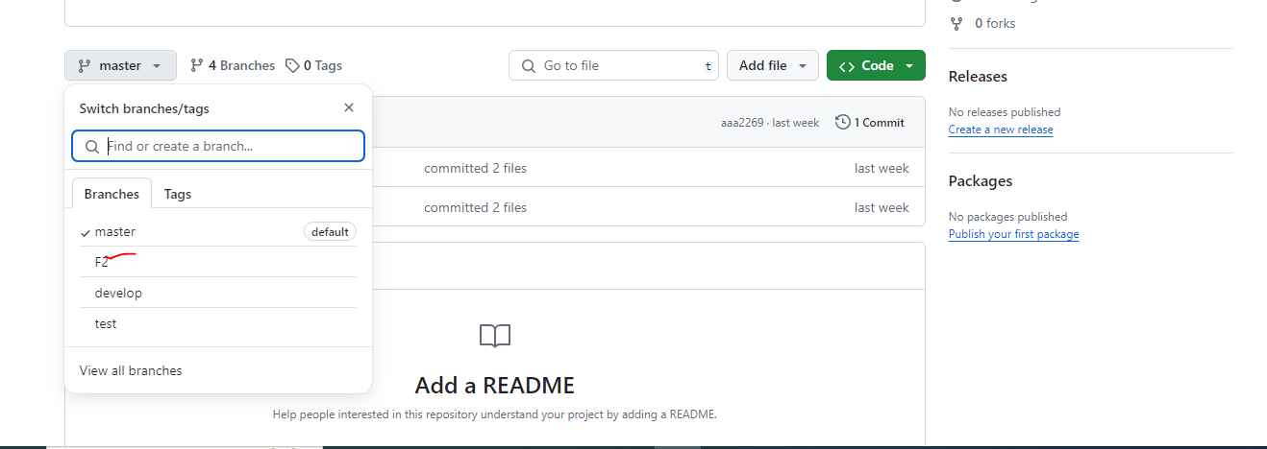
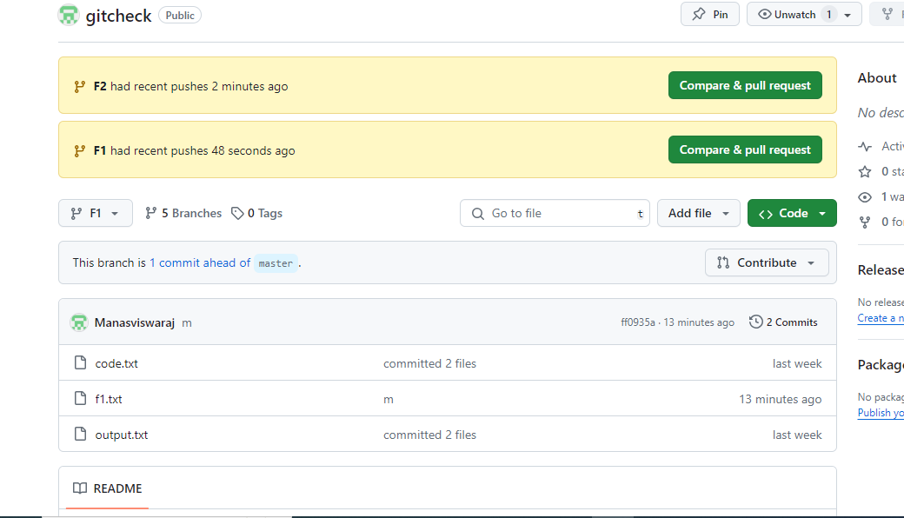

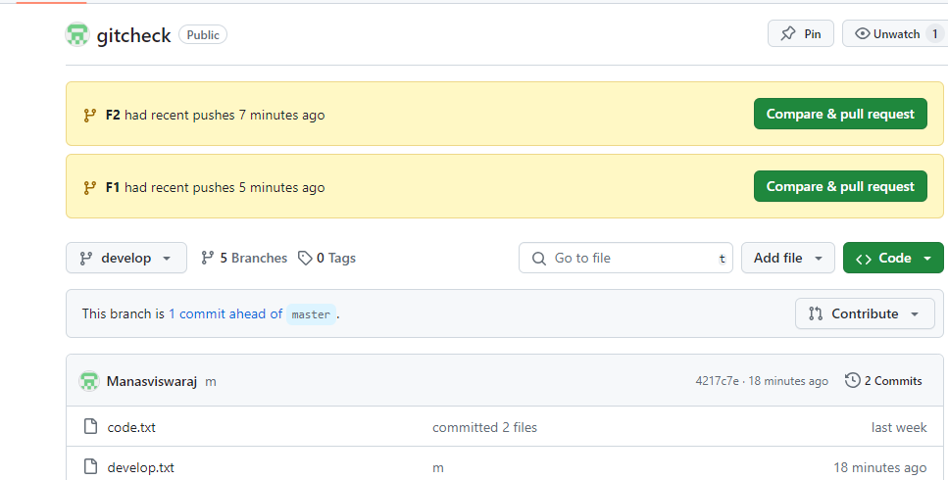

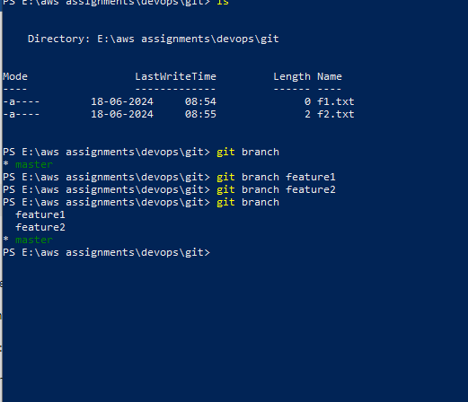
2 notepad f1.txt
33 notepad f2.txt
34 ls
35 git branch
36 git branch feature1
37 git branch feature2
38 git branch
39 git branch develop
40 git checkout deveop
41 git checkout develop
42 ls
43 notepad develop.txt
44 got stash develiop.txt
45 got stash develop.txt
46 git stash develop.txt
47 git stash
48 ls
49 git checkout feature1
50 notepad new.txt
51 git add new.txt
52 git commit
53 git commit -m "m1"
54 git checkout develop
55 git stash pop develop.txt
56 git stash pop
57 git commit -m "m2"

