**Instructions to Run the Streamlit App for Screen Recorder with Webcam Overlay**

Step 1 : Install Python

Ensure that Python is installed on your system. You can download and install the latest version of Python from the official website.

<https://www.python.org/downloads/>

Step 2 : Install required libraries

Open a command prompt or terminal and install the necessary python libraries using pip, a package manager for Python. Run the following commands :

* pip install streamlit
* pip install pillow
* pip install numpy
* pip install screeninfo
* pip install opencv-python

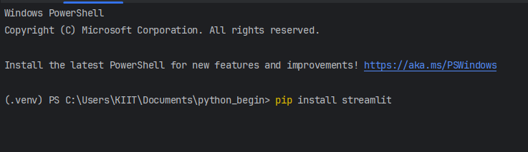

Step 3 : Download the python script

Download the provided Python script (recorder_streamlit.py) from the GitHub repository to your local machine and save it in any directory of your choice.

Step 4 : Run the Streamlit app

To run the Streamlit app, open a command prompt or terminal and run the following command : streamlit run “path_to_your_python_file”

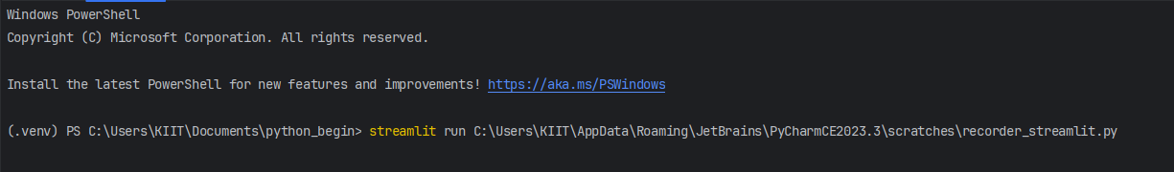

Step 5 : Access the Streamlit app

Once the Streamlit app is running, you will see a message indicating that the app is running and a local URL where you can access it (usually <http://localhost:8501>). You will be redirected to your default web browser where you can access the Streamlit app or open a web browser and paste the provided URL to access the Streamlit app.

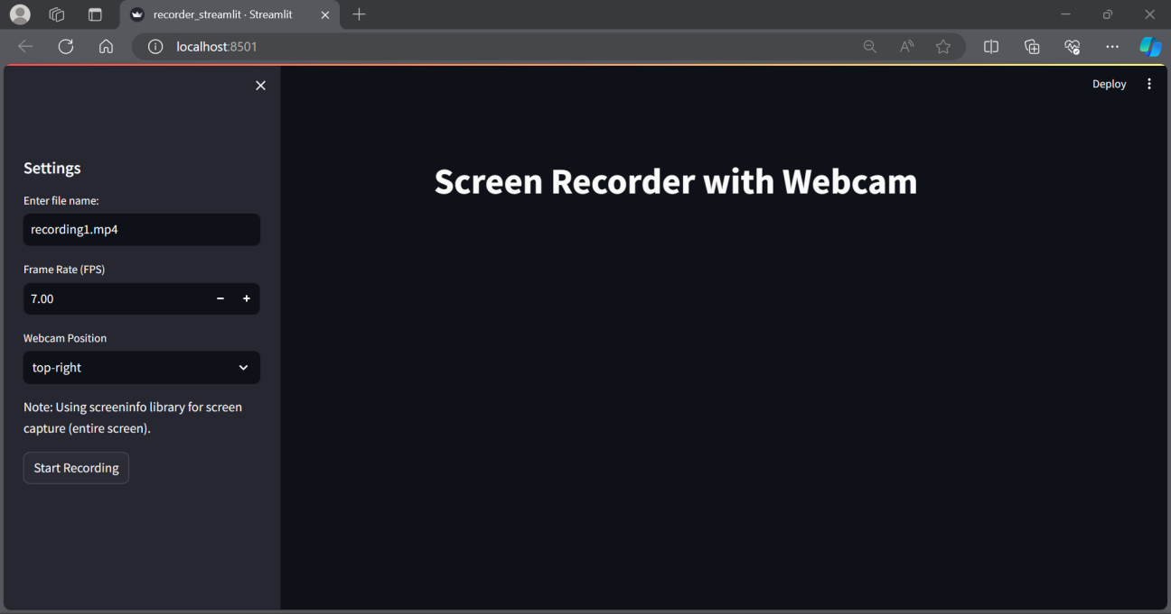

Step 6 : Configure Settings

In the Streamlit app interface, you can configure the recording settings including file name, frame rate (FPS)(minimum value of 1.00 and ideally 5.00) and the webcam frame position according to your preferences.

Step 7 : Start Recording

Click the Start Recording button to initiate the screen recording. The app will begin capturing your screen along with the webcam feed according to the configured settings.

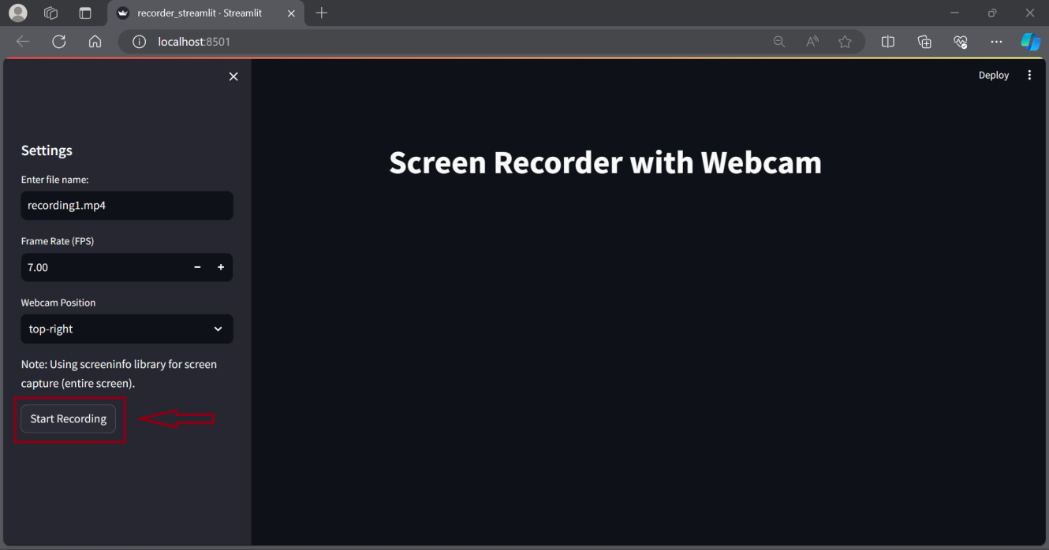

Step 8 : Stop recording

To stop the recording press the stop button at the top right corner or you can either close the Streamlit app window.

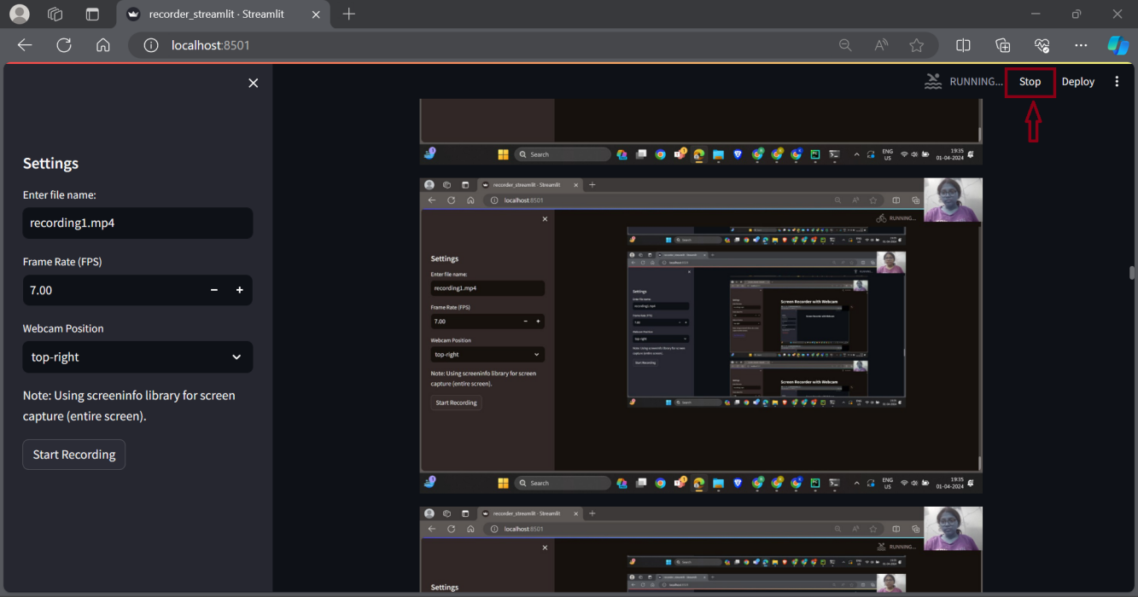

Step 9 : Access the Recorded video

Once you stop the recording, you can find the recorded video file in the directory where you ran the Streamlit app (where your python file is saved). The file will be saved with the name specified during configuration. (Step 6)

Step 10 : Exit Streamlit

After you have finished using the Streamlit app, you can close the command prompt or the terminal window to stop the Streamlit server and exit the application.