AUTOMATED TASK REMINDER APPLICATION

Introduction
Task Reminder Application is a software system designed to help users manage their daily tasks effectively. It allows users to create, save, and track tasks in an organized manner while also providing reminders to complete important activities on time
The application allows users to store task details such as title, description, due date, and completion status. All the task information is stored in a database so it can be accessed, updated, or viewed whenever needed.
A scheduler automatically sends reminders based on the task time .This helps users remember important tasks and avoid missing deadlines.
The backend can be developed using Spring Boot, REST APIs, Maven, and databases like MySQL or H2.This application helps students and employees manage their tasks efficiently
Project Initialization and Dependencies
The project was created using Spring Initializer, which helps developers quickly generate the basic structure required for a Spring Boot application. While setting up the project, several important dependencies were selected to support the different features of the system.
- Spring Web was added to build REST APIs and handle web requests and responses.
- Spring Data JPA was included to make database operations easier and to map Java classes with database tables.
- MySQL Driver was used to connect the application with the MySQL database.
- Lombok was included to minimize repetitive code like getters, setters, and constructors.
- Validation was added to check and validate user input before processing the data.
- Spring Boot Dev Tools was used to make development easier by automatically restarting the application whenever code changes are made.

System Architecture
The project is developed using a layered architecture, which is commonly followed in Spring Boot applications. This architecture separates the application into different layers so that each layer handles a specific responsibility, making the system easier to manage and maintain.
Model Layer
- The Model layer represents the data structure of the application and sdefines how task information is stored in the system. In this project, the model layer is implemented using the Task model class located in the model package.
- The Task model class contains important attributes such as id, title, description, due Date, and status. It uses JPA annotations to map the class with a database table, allowing the application to store and retrieve task data through Object Relational Mapping (ORM).
- The class also includes constructors, getter methods, and setter methods, which help other layers of the application access and modify the task information. This separation improves the organization and maintainability of the project.
Service Layer
- The Service Layer is responsible for handling the main business logic of the application. It works as a link between the model layer and other parts of the system, ensuring that task operations are processed correctly.
- In this project, the service layer is implemented using the Task Manager class, which is located in the service package. This class manages different task-related activities such as creating a new task, retrieving the list of tasks, updating task details, and deleting tasks when required.
- The tasks are stored temporarily in an Array list, which helps the application manage multiple task objects dynamically during execution.
- By keeping the task processing logic in the service layer, the application maintains better organization and improves code reusability. Whenever a task operation is requested, the service layer handles the request, updates the task data if necessary, and sends the result back to the component that initiated the request.

Scheduler Layer
- The Scheduler Layer is used to provide the reminder feature in the task management system. It is responsible for running background tasks that remind users to check their pending tasks.
- In this project, the scheduler functionality is implemented through the Task Scheduler class located in the schedular package. This class uses Java concurrency utilities to execute tasks in the background at fixed time intervals.
- The scheduler uses Scheduled Executor Service from the java. util. concurrent package to repeatedly run a reminder process after a specified period of time.
- While the application is running, the scheduler works continuously in the background and displays a message such as “Reminder: Check your Task!” at regular intervals. This acts like a simple notification system that reminds users to review their tasks.
- By including a scheduler layer, the project shows how background processes can run periodically in a backend application without affecting the main program execution.
Application Layer
- The Application Layer serves as the starting point of the Spring Boot application and is responsible for launching the system.
- In this project, this layer is implemented using the Task remainder Application class. The class is annotated with @SpringBootApplication, which enables features like automatic configuration and component scanning in the application.
- When the program is executed, the main method calls Spring Application . run(), which starts the Spring Boot framework and runs the embedded server.
- The application layer connects all the other layers of the project, such as the model, service, and scheduler, so that they work together as a complete system.
- This layer ensures that the application is properly initialized and ready to perform task management operations.
Database Configuration Layer
- The Database Configuration Layer explains how the application will connect to the database and store data permanently.
- In this project, the application's database configuration is defined in the application. Properties file, which is in the resources directory. In this application, MySQL is used as the database to store data regarding tasks.
- The file includes essential configurations, including the database URL, username, and password, as well as Hibernate configuration. This configuration will allow the application to generate or update database tables according to the entity classes in the model layer.
- The show-sql property can be added to show the SQL statements in the console. This will allow the application to debug database operations.
- With this configuration, the application can store data in the database efficiently.
TASKMODEL.JAVA:
package com.example.taskreminder.model;
import jakarta.persistence.Entity;
import jakarta.persistence.Id;
import java.time.LocalDateTime;
@Entity
public class Taskmodel {
@Id
private Long id;
private String title;
private String description;
private LocalDateTime dueDate;
private String status;
public Taskmodel() {}
public Taskmodel(Long id, String title, String description,
LocalDateTime dueDate, String status) {
this.id = id;
this.title = title;
this.description = description;
this.dueDate = dueDate;
this.status = status;
}
public Long getId() {
return id;
}public void setId(Long id) {
this.id = id;
}
public String getTitle() {
return title;
}
public void setTitle(String title) {
this.title = title;
} public String getDescription() {
return description;
}

public void setDescription(String description) {
this.description = description;
} public LocalDateTime getDueDate() {
return dueDate;
}
public void setDueDate(LocalDateTime dueDate) {
this.dueDate = dueDate;
}
public String getStatus() {
return status;
}
public void setStatus(String status) {
this.status = status;
}
}
TaskScedular.java
package com.example.taskreminder.scedular;

import com.example.taskreminder.model.Taskmodel;
import com.example.taskreminder.service.TaskManager;
import com.example.taskreminder.service.EmailService;
import org.springframework.scheduling.annotation.Scheduled;
import org.springframework.stereotype.Component;

import java.time.LocalDateTime;
import java.util.List;

@Component
public class TaskScedular {

private final TaskManager service;
private final EmailService emailService;

public TaskScedular(TaskManager service, EmailService emailService) {
this.service = service;
this.emailService = emailService;
}

@Scheduled(fixedRate = 60000)
public void checkTasks() {

System.out.println("Scheduler running...");

List<Taskmodel> tasks = service.getAllTasks();

for (Taskmodel task : tasks) {

if (task.getStatus().equalsIgnoreCase("PENDING") &&
task.getDueDate().isBefore(LocalDateTime.now())) {

System.out.println("⚠️ Task overdue: " + task.getTitle());

// SEND EMAIL
emailService.sendEmail(
"your-email@gmail.com",
"Task Reminder",
"Task overdue: " + task.getTitle()
);
}
}
}
}
TaskReminderApplication:
package com.example.taskreminder;

import org.springframework.boot.SpringApplication;
import org.springframework.boot.autoconfigure.SpringBootApplication;
import org.springframework.scheduling.annotation.EnableScheduling;
@SpringBootApplication
@EnableScheduling
public class TaskreminderApplication {
public static void main(String[] args) {
SpringApplication.run(TaskreminderApplication.class, args);
}
}
Application.properties:
spring.application.name=taskreminder
# Database connection
spring.datasource.url=jdbc:mysql://localhost:3306/taskreminderdb
spring.datasource.username=root
spring.datasource.password=vignesh
# JPA settings
spring.jpa.hibernate.ddl-auto=update
spring.jpa.open-in-view=false
spring.jpa.properties.hibernate.dialect=org.hibernate.dialect.MySQLDialect
# Server port
server.port=8080
spring.mail.host=smtp.gmail.com
spring.mail.port=587
spring.mail.username=valevignesh2@gmail.com
spring.mail.password=twzq dwtj qzwm nfde
spring.mail.properties.mail.smtp.auth=true
spring.mail.properties.mail.smtp.starttls.enable=true
TaskManager.java
package com.example.taskreminder.service;
import com.example.taskreminder.model.Taskmodel;
import com.example.taskreminder.Repository.TaskRepository;
import org.springframework.stereotype.Service;
import java.util.List;
@Service
public class TaskManager {
private final TaskRepository repository;
public TaskManager(TaskRepository repository) {
this.repository = repository;
}
public void addTask(Taskmodel task){
repository.addTask(task);
}
public List<Taskmodel> getAllTasks(){
return repository.getTasks();
}
public void deleteTask(Long id){
repository.deleteTask(id);
}
public void updateTask(Long id, Taskmodel task){
repository.updateTask(id, task);
}
}
TaskController:
package com.example.taskreminder.controller;
import com.example.taskreminder.model.Taskmodel;
import com.example.taskreminder.service.TaskManager;
import org.springframework.web.bind.annotation.*;
import java.util.List;
@RestController
@RequestMapping("/tasks")
public class TaskController {
private final TaskManager service;
public TaskController(TaskManager service) {
this.service = service;
}
@GetMapping
public List<Taskmodel> getAllTasks() {
return service.getAllTasks();
}
@PostMapping
public String addTask(@RequestBody Taskmodel task) {
service.addTask(task);
return "Task added successfully";
}
@PutMapping("/{id}")
public String updateTask(@PathVariable Long id,
@RequestBody Taskmodel task) {
service.updateTask(id, task);
return "Task updated successfully";
}
@DeleteMapping("/{id}")
public String deleteTask(@PathVariable Long id) {
service.deleteTask(id);
return "Task deleted successfully";
}
}
TaskRepository:
package com.example.taskreminder.Repository;
import com.example.taskreminder.model.Taskmodel;
import org.springframework.jdbc.core.JdbcTemplate;
import org.springframework.stereotype.Repository;
import java.util.List;
@Repository
public class TaskRepository {
private final JdbcTemplate jdbcTemplate;
public TaskRepository(JdbcTemplate jdbcTemplate){
this.jdbcTemplate = jdbcTemplate;
}
// ADD TASK
public void addTask(Taskmodel task){
String sql = "INSERT INTO tasks (id,title,description,due_date,completed) VALUES (?,?,?,?,?)";
jdbcTemplate.update(sql,
task.getId(),
task.getTitle(),
task.getDescription(),
task.getDueDate(),
task.getStatus());
}
// GET ALL TASKS
public List<Taskmodel> getTasks(){
String sql = "SELECT * FROM tasks";
return jdbcTemplate.query(sql,(rs,rowNum)->{
Taskmodel task = new Taskmodel();
task.setId(rs.getLong("id"));
task.setTitle(rs.getString("title"));
task.setDescription(rs.getString("description"));
task.setDueDate(rs.getTimestamp("due_date").toLocalDateTime());
task.setStatus(rs.getString("completed"));
return task;
});
}
// DELETE TASK
Public void deleteTask(Long id){
String sql = "DELETE FROM tasks WHERE id = ?";
jdbcTemplate.update(sql,id);
}
// UPDATE TASK
public void updateTask(Long id, Taskmodel task){
String sql = "UPDATE tasks SET title=?, description=?, due_date=?, completed=? WHERE id=?";
jdbcTemplate.update(sql,
task.getTitle(),
task.getDescription(),
task.getDueDate(),
task.getStatus(),
id);
}
}
Pom.xml(taskreminder):
<?xml version="1.0" encoding="UTF-8"?>
<project xmlns="http://maven.apache.org/POM/4.0.0"
xmlns:xsi="http://www.w3.org/2001/XMLSchema-instance"
xsi:schemaLocation="http://maven.apache.org/POM/4.0.0
https://maven.apache.org/xsd/maven-4.0.0.xsd">
<modelVersion>4.0.0</modelVersion>
<parent>
<groupId>org.springframework.boot</groupId>
<artifactId>spring-boot-starter-parent</artifactId>
<version>3.3.5</version>
<relativePath/>
</parent>
<groupId>com.example</groupId>
<artifactId>taskreminder</artifactId>
<version>0.0.1-SNAPSHOT</version>
<name>taskreminder</name>
<description>Task Reminder Application</description>
<properties>
<java.version>17</java.version>
</propertie
<dependencies>
<dependency>
<groupId>org.springframework.boot</groupId>
<artifactId>spring-boot-starter-web</artifactId>
</dependency>
<dependency>
<groupId>org.springframework.boot</groupId>
<artifactId>spring-boot-starter-data-jpa</artifactId>
</dependency>
<dependency>
<groupId>org.springframework.boot</groupId>
<artifactId>spring-boot-starter-validation</artifactId>
</dependency>
<dependency>
<groupId>com.mysql</groupId>
<artifactId>mysql-connector-j</artifactId>
<scope>runtime</scope>
</dependency>
<dependency>
<groupId>org.projectlombok</groupId>
<artifactId>lombok</artifactId>
<optional>true</optional>
</dependency>
<dependency>
<groupId>org.springframework.boot</groupId>
<artifactId>spring-boot-starter-mail</artifactId>
</dependency>
<dependency>
<groupId>org.springframework.boot</groupId>
<artifactId>spring-boot-devtools</artifactId>
<scope>runtime</scope>
</dependency>
<dependency>
<groupId>org.springframework.boot</groupId>
<artifactId>spring-boot-starter-test</artifactId>
<scope>test</scope>
</dependency>
</dependencies>
<build>
<plugins>
<plugin>
<groupId>org.apache.maven.plugins</groupId>
<artifactId>maven-compiler-plugin</artifactId>
<configuration>
<annotationProcessorPaths>
<path>
<groupId>org.projectlombok</groupId>
<artifactId>lombok</artifactId>
</path>
</annotationProcessorPaths>
</configuration>
</plugin>
<plugin>
<groupId>org.springframework.boot</groupId>
<artifactId>spring-boot-maven-plugin</artifactId>
</plugin>
</plugins>
</build>
</project>
EmailService.java:
package com.example.taskreminder.service;
import org.springframework.beans.factory.annotation.Autowired;
import org.springframework.mail.SimpleMailMessage;
import org.springframework.mail.javamail.JavaMailSender;
import org.springframework.stereotype.Service;
@Service
public class EmailService {
@Autowired
private JavaMailSender mailSender;
public void sendEmail(String to, String subject, String text) {
SimpleMailMessage message = new SimpleMailMessage();
message.setFrom("your-email@gmail.com"); // ✅ ADD THIS
message.setTo(to);
message.setSubject(subject);
message.setText(text);
mailSender.send(message);
}
}
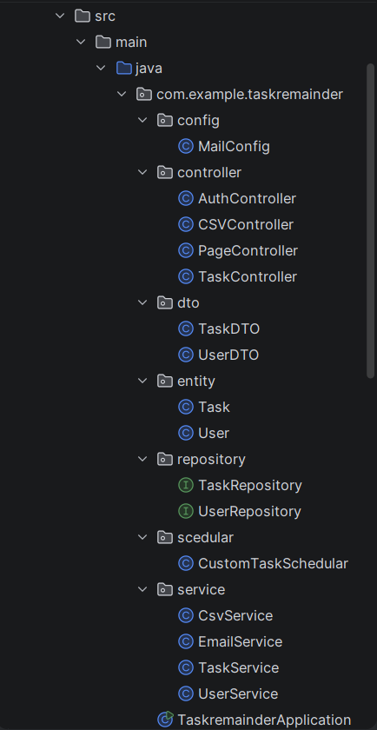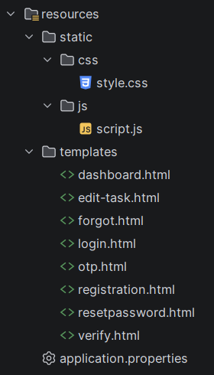

Modules :
The system is divided into multiple modules, each handling a specific functionality of the application.
1.User Module :
This module manages user-related operations such as registration, login, and authentication.
- Allows new users to register using name, email, and password
- Validates user credentials during login
- Maintains user session after successful login
- Provides logout functionality
- Includes OTP-based forgot password feature for secure password reset

2.Task Module:
This module handles all task-related operations.
- Users can add new tasks with title, description, date, and time
- Tasks are stored in the database with status
- Users can update task details
- Users can delete tasks
- Each task is linked to a specific user using email
3.Dashboard Module:
The dashboard provides an overview of all user tasks.
- Displays total number of tasks
- Shows count of completed tasks
- Shows count of pending tasks
- Shows count of overdue tasks
- Displays all tasks in a tabular format
- Provides filter options to view tasks by status
4.Email Module:
This module is responsible for sending email notifications.
- Sends confirmation email when a task is added
- Sends OTP for login and password reset
- Sends reminders when tasks become overdue or remain pending
- Uses JavaMailSender for email communication
5.Scheduler Module:
This module automates task status updates.
- Runs at a fixed interval (every 1 minute)
- Checks task deadlines
- Updates task status automatically:
  - If time passed → Overdue
  - If not completed → Pending
- Triggers email notifications for overdue tasks
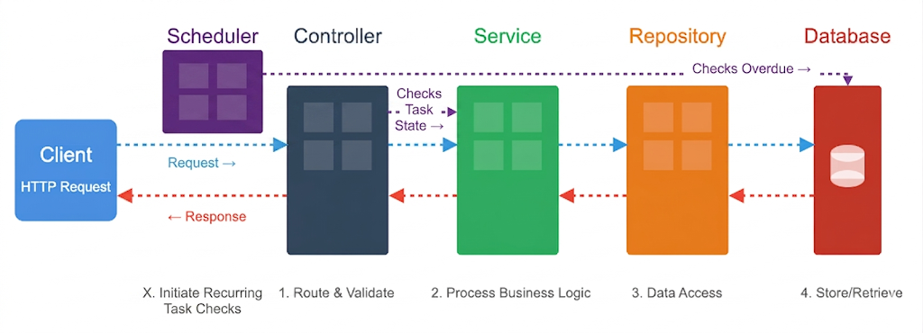
- Project Flow:
The working flow of the system is as follows:
- User registers in the system
- User logs in using credentials or OTP
- Dashboard is displayed
- User adds tasks
- Task is saved in the database
- Email confirmation is sent
- Scheduler checks task deadlines
- Status is updated automatically
- User can filter and manage tasks
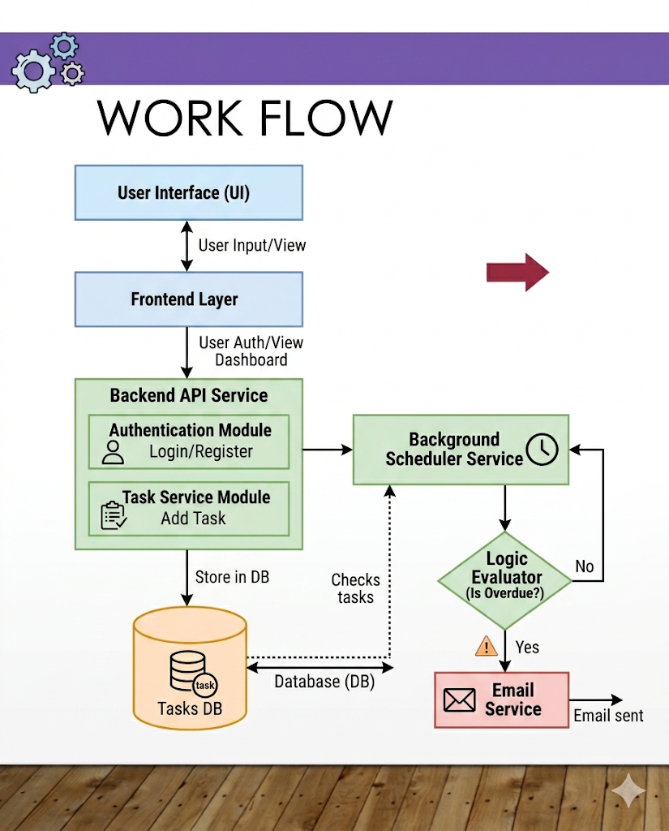
Database Design:
The system uses a relational database (MySQL).
User Table:
- id (Primary Key)
- name
- email
- password
Tasks Table:
- id (Primary Key)
- title
- description
- time
- status
- email (Foreign key reference to user)
Features:
- User authentication system
- Task creation and management
- Status tracking (Pending, Completed, Overdue)
- Email notifications
- OTP-based login and password reset
- Task filtering
- CSV export functionality
- Automatic status updates using scheduler
Advantages:
- Simple and user-friendly interface
- Helps in better time management
- Reduces manual tracking effort
- Provides real-time updates
- Improves productivity
Future Enhancements
- Mobile application integration
- Push notifications
- Task priority levels
- Calendar integration
- Dark mode UI
- AI-based task suggestions
Conclusion:
The Task Reminder system is an effective solution for managing daily tasks.
It combines automation, reminders, and user-friendly features to help users stay organized and productive.

