Software Requirements Specification
Project: Online Exam Portal
Version: 1.1
Authors: Tanusha Prakash, Guntupalli Manaswi, Vidimalla Guru Teja
Date: 19 October 2026
Status: Pending team review

Revision History
Ver | Date | Author | Change Summary | Approval
1.0 | 09 October 2026 | Tanusha, Manaswi, Vidimalla Guru Teja | Initial SRS baseline for Release 1 | Pending
1.1 | 19 October 2026 | Manaswi (Codex assisted) | Align scope and permissions with #17/#19; correct team names | Pending

Approvals
Role | Name | Signature / Email | Date
Course Coordinator
Team Reviewer

Table of Contents
1. Introduction
2. Overall Description
3. External Interface Requirements
4. System Features (Functional Requirements)
5. Non-Functional Requirements
5.1 Security
6. Quality Attributes & Acceptance Tests
7. System Models and UML Use-Case Diagrams
8. Requirements Traceability Matrix (RTM)

1. Introduction

1.1 Purpose
This Software Requirements Specification defines the functional and non-functional requirements for Release 1 of the Online Exam Portal. It provides a common baseline for development, architecture, testing, traceability and evaluation.

1.2 Scope
Release 1 is a MERN web application for single-answer MCQ examinations. It includes active-account login/logout, Student/Instructor/Admin permissions, minimal Admin account/role/status management, owned draft exam and question/option management, publication, owned-exam dashboards, eligible Student listings, timed resumable attempts, saved answers/navigation, manual and timeout submission, automatic +1/0 evaluation and authorized result viewing. It excludes negative marking, AI/proctoring, reusable question banks, course/enrollment management, advanced analytics, CSV export, offline synchronization, native mobile applications and multiple result-release modes. Public self-registration, retakes and answer-key disclosure are not required.
The review record is docs/RELEASE_1_AGREEMENT.md (#17/#19). It maps all 17 primary PDF SRS IDs to these 21 functional IDs and existing GitHub implementation issues. It contains the shared permission matrix and planned TC-RBAC-01 through TC-RBAC-26 checks. Team agreement is pending; scope approval does not assert implementation or executed tests. Current delivery dates are 19-23 and 26-30 October 2026 in the Project Plan.

1.3 Audience
Intended readers are the project team, course faculty/evaluators, testers and future maintainers.

1.4 Definitions
API - Application Programming Interface; FR - Functional Requirement; NFR - Non-Functional Requirement; RBAC - Role-Based Access Control; RTM - Requirements Traceability Matrix; MCQ - Multiple Choice Question; UI - User Interface; REST - Representational State Transfer; ODM - Object Data Mapping.

2. Overall Description

2.1 Product Perspective
The system is a browser-based MERN application. A React client communicates with a Node.js/Express REST API. MongoDB stores users, exams, questions, attempts, responses and scores through Mongoose schemas.

2.2 Major Product Functions
- Authenticate users and enforce Student, Instructor and Admin roles.
- Allow Instructors to create owned drafts, edit/delete only owned drafts, publish valid owned exams and list their owned draft/published exams (primary FR-08, GitHub #37).
- Allow instructors to create and manage MCQ questions and options.
- Allow students to view available exams, start timed attempts, save answers and submit.
- Automatically submit when time expires.
- Automatically evaluate submitted MCQs and store scores.
- Allow students to view their own results and instructors to view results for exams they own.

2.3 User Roles and Characteristics
- Student - basic web literacy; needs a clear timed exam interface and access only to own attempts/results.
- Instructor - creates and manages exams/questions and reviews results for owned exams.
- Admin - provisions accounts, assigns exactly one Student/Instructor/Admin role and changes active status. Admin does not inherit Instructor or Student workflows. Account changes preserve historical exam, attempt and result references.
Anonymous/inactive accounts cannot access protected operations. Express enforces the agreement matrix, current stored role/status and object ownership on every request, including direct URL/API access. Student payloads exclude correct-option IDs, correctness flags and answer keys. Non-Admins cannot provision accounts, change roles/status or escalate privileges. The same matrix applies to #23, #24 and #51.

2.4 Operating Environment
Modern desktop browser (Chrome/Edge), React frontend, Node.js/Express backend and MongoDB database. Development is performed using Git/GitHub and VS Code.

2.5 Constraints
- Release 1 is limited to MCQ examinations with one correct option per question.
- The system is web-based and requires network connectivity between client, server and database.
- Core security decisions are enforced on the backend; the client is not trusted for authorization or timing validity.
Availability start time is optional and gates new attempts. Each Student has one resumable attempt per exam with a fixed server deadline from attempt start. Published definitions/keys are immutable. Manual and browser-closed timeout paths use one atomic finalization and persisted answers; reject late saves. Evaluation awards 1 per correct and 0 per incorrect/unanswered answer. Submission remains durable if evaluation must be retried.
- The project must follow the submitted SRS, SAD and Test Plan; deviations are documented through Agile change history.

3. External Interface Requirements

3.1 User Interfaces
Responsive browser pages will include login, role-specific dashboards, exam creation/question management forms, available-exam listing, timed attempt screen, submission confirmation and result views. The interface will provide clear validation/error messages and visible remaining time during an active attempt.

3.2 Hardware Interfaces
No specialized hardware is required. Users access the system using a standard computer with keyboard, pointing device and network connection.

3.3 Software Interfaces
- React client to Express REST API using JSON over HTTP/HTTPS.
- Express backend to MongoDB through Mongoose.
- GitHub Issues and Projects hold current development tracking; historical OEP/Jira references retain traceability. These tools are not runtime dependencies.

3.4 Communications
Client-server communication uses REST-style HTTP requests with JSON payloads. Deployment should use HTTPS. Authentication information must not expose plaintext passwords.
Authentication uses one server-managed session mechanism. Cookies are HttpOnly, Secure over HTTPS and use a documented SameSite policy; protect state-changing authenticated requests against CSRF. Logout invalidates the server session and clears its cookie. Current stored role/active status controls existing sessions. Finalize store, local origins and configuration in the implementation PRs; never commit credentials.

4. System Features (Detailed Functional Requirements)
Each requirement is uniquely identified and written as a testable "shall" statement. Release 1 contains more than the required minimum of 15 functional requirements.
Req ID | Requirement | Type | Priority | Source | Acceptance Criteria | Test Ref
AUTH-FR-01 | The system shall authenticate valid credentials only for an active registered account. | Functional | High | All users | Valid active credentials create a server-managed session; invalid/inactive credentials are rejected safely. | TC-AUTH-01, TC-AUTH-02
AUTH-FR-02 | The system shall allow an authenticated user to log out and terminate the active authentication context. | Functional | High | All users | Logout invalidates the server session and clears its cookie; replaying the old session fails. | TC-AUTH-03
AUTH-FR-03 | The system shall enforce role-based authorization for Student, Instructor and Admin operations on the server. | Functional | High | Security | Apply the shared matrix, current stored role/status and ownership on every request; deny unauthorized direct API/URL access. | TC-SEC-01
EXAM-FR-01 | The system shall allow an Instructor to create an owned draft examination with a title, optional description/start time and positive duration. | Functional | High | Instructor | Valid exam data is persisted with Draft status. | TC-EXAM-01
EXAM-FR-02 | The system shall allow the owning Instructor to edit an unpublished draft examination. | Functional | High | Instructor | Changes to an owned draft persist; unauthorized edits are rejected. | TC-EXAM-02
EXAM-FR-03 | The system shall allow the owning Instructor to delete an unpublished draft examination. | Functional | Medium | Instructor | Owned draft is removed; published/non-owned exam deletion is rejected. | TC-EXAM-03
QUES-FR-01 | The system shall allow the owning Instructor to add MCQ questions and answer options to a draft examination. | Functional | High | Instructor | Question and options are persisted under the selected draft exam. | TC-QUES-01
QUES-FR-02 | The system shall allow the owning Instructor to edit or delete MCQ questions before publication. | Functional | High | Instructor | Owned draft question can be changed/deleted; unauthorized action is rejected. | TC-QUES-02
QUES-FR-03 | The system shall require each Release 1 MCQ to have at least two options and exactly one correct option. | Functional | High | Business rule | Invalid question configuration cannot be saved/published. | TC-QUES-03
EXAM-FR-04 | The system shall allow the owning Instructor to publish an examination only when required exam and question data are valid. | Functional | High | Instructor | Valid exam becomes Published; invalid exam remains Draft. | TC-EXAM-04
ATT-FR-01 | The system shall show a Student only examinations that are published and eligible for attempt according to the configured start time. | Functional | High | Student | Available list excludes drafts and ineligible exams. | TC-ATT-01
ATT-FR-02 | The system shall create an examination attempt when an eligible Student starts an exam and shall record the server-side start time. | Functional | High | Student | One attempt per Student/exam; start records server time/deadline and repeated start resumes without extending it. | TC-ATT-02
ATT-FR-03 | The system shall allow a Student to select, change and navigate answers before submission while preserving saved responses. | Functional | High | Student | Saved answers remain associated with the attempt across question navigation/refresh. | TC-ATT-03
ATT-FR-04 | The system shall calculate remaining time from server-side attempt timing information and shall not reset the allowed duration on page refresh. | Functional | High | Student/Security | Refresh does not extend the deadline. | TC-TIME-01
ATT-FR-05 | The system shall allow a Student to manually submit an active attempt. | Functional | High | Student | Submission records submittedAt/status and freezes further edits. | TC-SUB-01
ATT-FR-06 | The server shall automatically finalize expired attempts from persisted responses even when the browser closes, and reject late answer changes. | Functional | High | Student | A documented server expiry interval finalizes the attempt; manual/timeout races return one persisted outcome. | TC-SUB-02
EVAL-FR-01 | The system shall evaluate submitted MCQs against immutable correct options, awarding 1 for correct and 0 for incorrect/unanswered responses. | Functional | High | System | No negative or variable marking; maximum equals the number of published questions. | TC-EVAL-01
EVAL-FR-02 | The system shall calculate and persist the final score for a submitted attempt. | Functional | High | System | Stored score equals the sum of awarded marks and remains available later. | TC-EVAL-02
RES-FR-01 | The system shall allow a Student to view only results belonging to that Student. | Functional | High | Student/Security | Own result is displayed; another student result request is denied. | TC-RES-01, TC-SEC-02
RES-FR-02 | The system shall allow an Instructor to view results only for examinations owned by that Instructor. | Functional | High | Instructor/Security | Owned exam results display; non-owned exam results are denied. | TC-RES-02, TC-SEC-03
ADMIN-FR-01 | The system shall allow an Admin to manage user accounts and assigned roles. | Functional | Medium | Admin | Only Admin provisions unique accounts, assigns one role and changes active status; current privileges apply to existing sessions, history is retained and non-Admin escalation is denied. | TC-ADMIN-01

5. Non-Functional Requirements (Detailed)
Req ID | Requirement | Category | Priority | Acceptance Criteria / Measurement | Test Ref
OEP-NF-001 | For normal classroom load of up to 30 concurrent active users, 95% of non-file API requests shall complete within 2 seconds, excluding client network delay. | Performance | High | Performance test reports 95th percentile <= 2 s. | TC-NF-PERF-01
OEP-NF-002 | A response save acknowledged as successful shall remain persisted and visible after page refresh during the same active attempt. | Reliability | High | 100% of acknowledged saves in the persistence test survive refresh. | TC-NF-REL-01
OEP-NF-003 | The web application shall support the current major versions of Google Chrome and Microsoft Edge at 1366x768 or higher without loss of core functionality. | Compatibility | Medium | Core workflow passes on both target browsers/resolution. | TC-NF-COMP-01
OEP-NF-004 | Automated unit and integration tests shall achieve at least 70% line coverage for backend business-logic modules by the end of Sprint 2. | Maintainability/Testability | Medium | Coverage report >= 70% for scoped backend modules. | TC-NF-COV-01
OEP-NF-005 | All validation errors shown to end users shall identify the affected field or operation and shall not expose stack traces, database credentials or internal exception details. | Usability/Security | High | Negative-input tests show actionable messages and no sensitive internals. | TC-NF-ERR-01

5.1 Security

5.1.1 Security Objectives
- SEC-O-01 - Confidentiality and access control: only authenticated and authorized users shall access protected exams, attempts and results.
- SEC-O-02 - Integrity of examination state: timing, submission state, correct answers and scores shall be protected from unauthorized client-side modification.
Req ID | Requirement (shall...) | Priority | Acceptance Criteria | Test Ref
OEP-SR-001 | The system shall store user passwords only as one-way salted password hashes using bcrypt or an equivalent approved password-hashing function. | High | Database inspection shows no plaintext passwords; login still verifies valid credentials. | TC-SEC-04
OEP-SR-002 | The system shall require authentication for every protected backend API route. | High | Unauthenticated protected requests return an authorization error. | TC-SEC-05
OEP-SR-003 | The system shall enforce Student, Instructor and Admin role permissions on the server for all protected operations. | High | Cross-role requests are denied even if manually constructed. | TC-SEC-01
OEP-SR-004 | The system shall enforce ownership checks so students access only their own attempts/results and instructors manage/view only their own exams/results. | High | Cross-user and cross-instructor resource requests are denied. | TC-SEC-02, TC-SEC-03
OEP-SR-005 | The system shall not send the correct option for an examination question to a Student while the Student has an active, unsubmitted attempt. | High | Network/API response inspection during active attempt contains no correct-answer field. | TC-SEC-06
OEP-SR-006 | The backend shall validate required fields, allowed values and identifiers before persisting state-changing requests. | High | Malformed/invalid requests are rejected without database corruption. | TC-SEC-07

6. Quality Attributes & Acceptance Tests
- Functional correctness - acceptance requires all planned Release 1 requirements to be implemented and pass mapped checks; scheduling priority does not make an included feature optional.
- Security - no open critical authorization/data-exposure defect; mapped security tests pass.
- Performance - OEP-NF-001 target is met under the defined classroom-load test.
- Maintainability - required backend coverage target is met by the end of Sprint 2.
- Acceptance exit criterion - all planned critical test cases executed, no unresolved critical defect, and the RTM contains traceable requirement-to-test mappings.

7. System Models and UML Use-Case Diagrams

7.1 UML Use-Case Diagram - Overall System
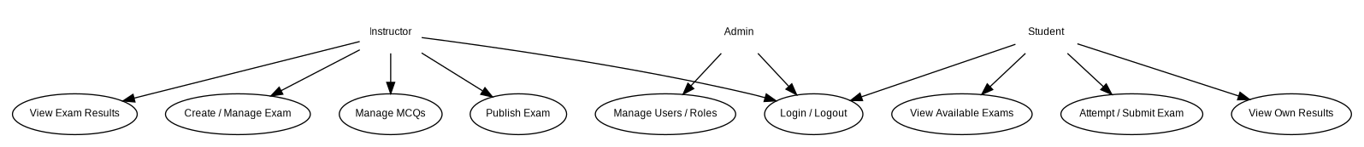
Figure 1. Overall use-case diagram for Student, Instructor and Admin.

7.2 UML Use-Case Diagram - Examination Lifecycle
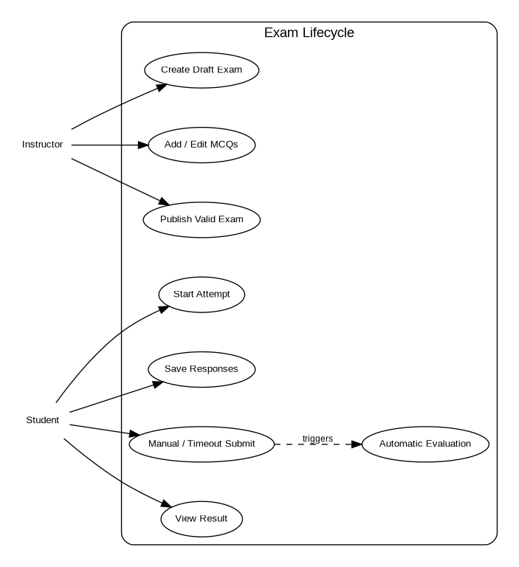
Figure 2. Examination lifecycle use-case view.

8. Requirements Traceability Matrix (RTM)
Status legend: N = Not yet implemented/verified, P = Partially implemented/verified, A = Accepted. The RTM will be updated during the two implementation sprints.
Req ID | Requirement Short | Design ref | Module | Test Case(s) | State | Notes
AUTH-FR-01 | The system shall authenticate a registered user us... | SAD §3-4 | Auth/RBAC | TC-AUTH-01, TC-AUTH-02 | N
AUTH-FR-02 | The system shall allow an authenticated user to lo... | SAD §3-4 | Auth/RBAC | TC-AUTH-03 | N
AUTH-FR-03 | The system shall enforce role-based authorization ... | SAD §3-4 | Auth/RBAC | TC-SEC-01 | N
EXAM-FR-01 | The system shall allow an Instructor to create a d... | SAD §3-4 | Exam/Question | TC-EXAM-01 | N
EXAM-FR-02 | The system shall allow the owning Instructor to ed... | SAD §3-4 | Exam/Question | TC-EXAM-02 | N
EXAM-FR-03 | The system shall allow the owning Instructor to de... | SAD §3-4 | Exam/Question | TC-EXAM-03 | N
QUES-FR-01 | The system shall allow the owning Instructor to ad... | SAD §3-4 | Exam/Question | TC-QUES-01 | N
QUES-FR-02 | The system shall allow the owning Instructor to ed... | SAD §3-4 | Exam/Question | TC-QUES-02 | N
QUES-FR-03 | The system shall require each Release 1 MCQ to hav... | SAD §3-4 | Exam/Question | TC-QUES-03 | N
EXAM-FR-04 | The system shall allow the owning Instructor to pu... | SAD §3-4 | Exam/Question | TC-EXAM-04 | N
ATT-FR-01 | The system shall show a Student only examinations ... | SAD §3-4 | Attempt | TC-ATT-01 | N
ATT-FR-02 | The system shall create an examination attempt whe... | SAD §3-4 | Attempt | TC-ATT-02 | N
ATT-FR-03 | The system shall allow a Student to select, change... | SAD §3-4 | Attempt | TC-ATT-03 | N
ATT-FR-04 | The system shall calculate remaining time from ser... | SAD §3-4 | Attempt | TC-TIME-01 | N
ATT-FR-05 | The system shall allow a Student to manually submi... | SAD §3-4 | Attempt | TC-SUB-01 | N
ATT-FR-06 | The system shall automatically submit or reject fu... | SAD §3-4 | Attempt | TC-SUB-02 | N
EVAL-FR-01 | The system shall automatically evaluate submitted ... | SAD §3-4 | Evaluation | TC-EVAL-01 | N
EVAL-FR-02 | The system shall calculate and persist the final s... | SAD §3-4 | Evaluation | TC-EVAL-02 | N
RES-FR-01 | The system shall allow a Student to view only resu... | SAD §3-4 | Results | TC-RES-01, TC-SEC-02 | N
RES-FR-02 | The system shall allow an Instructor to view resul... | SAD §3-4 | Results | TC-RES-02, TC-SEC-03 | N
ADMIN-FR-01 | The system shall allow an Admin to manage user acc... | SAD §3-4 | Admin | TC-ADMIN-01 | N
OEP-NF-001 | For normal classroom load of up to 30 concurrent a... | SAD §3.1/4.4 | Cross-cutting | TC-NF-PERF-01 | N
OEP-NF-002 | A response save acknowledged as successful shall r... | SAD §3.1/4.4 | Cross-cutting | TC-NF-REL-01 | N
OEP-NF-003 | The web application shall support the current majo... | SAD §3.1/4.4 | Cross-cutting | TC-NF-COMP-01 | N
OEP-NF-004 | Automated unit and integration tests shall achieve... | SAD §3.1/4.4 | Cross-cutting | TC-NF-COV-01 | N
OEP-NF-005 | All validation errors shown to end users shall ide... | SAD §3.1/4.4 | Cross-cutting | TC-NF-ERR-01 | N
OEP-SR-001 | The system shall store user passwords only as one-... | SAD §3.9 | Security | TC-SEC-04 | N
OEP-SR-002 | The system shall require authentication for every ... | SAD §3.9 | Security | TC-SEC-05 | N
OEP-SR-003 | The system shall enforce Student, Instructor and A... | SAD §3.9 | Security | TC-SEC-01 | N
OEP-SR-004 | The system shall enforce ownership checks so stude... | SAD §3.9 | Security | TC-SEC-02, TC-SEC-03 | N
OEP-SR-005 | The system shall not send the correct option for a... | SAD §3.9 | Security | TC-SEC-06 | N
OEP-SR-006 | The backend shall validate required fields, allowe... | SAD §3.9 | Security | TC-SEC-07 | N

