Software Architecture and Design Specification
Project: Online Exam Portal
Version: 1.0
Authors: Tanusha, Manaswi, Gururaj
Date: 09 October 2026
Status: Initial Baseline

Revision History
Version | Date | Author | Change Summary
1.0 | 09 October 2026 | Tanusha, Manasvi, Gururaj | Initial architecture and design baseline

Approvals
Role | Name | Signature / Date
Team Reviewer
Course Evaluator

1. Introduction

1.1 Purpose
This document specifies the architecture and initial software design for Release 1 of the Online Exam Portal and provides traceability from requirements to architectural components and design interfaces.

1.2 Scope
Covers the MERN-based web architecture, component responsibilities, security boundaries, data model, preliminary REST APIs, error handling and two representative interaction sequences for exam creation/publication and student attempt/submission.

1.3 Audience
Developers, testers, course evaluators and future maintainers.

1.4 Definitions
MERN - MongoDB, Express, React, Node.js; API - Application Programming Interface; REST - Representational State Transfer; RBAC - Role-Based Access Control; ODM - Object Data Mapping; SRS - Software Requirements Specification; STP - Software Test Plan; RTM - Requirements Traceability Matrix.

2. Document Overview

2.1 How to Use This Document
Section 3 presents the high-level architecture, component diagram, architectural pattern, technology stack, risks, traceability and security architecture. Section 4 presents the initial software design, two sequence diagrams, API design, error handling, logging, monitoring and UX guidance.

2.2 Related Documents
Online Exam Portal SRS, Software Test Plan, Project Plan and RTM.

3. Architecture

3.1 Goals & Constraints
- Goals: correctness, secure role separation, modularity, maintainability and testability.
- Constraint: Release 1 is an MCQ-only web application with no AI/proctoring, negative marking or offline mode.
- Constraint: security-sensitive decisions such as authorization, timing validity and result ownership are enforced on the backend.

3.2 Stakeholders & Concerns
Stakeholder | Primary Concerns
Student | Reliable timed attempt, saved responses, privacy of own result
Instructor | Simple exam/question management, ownership protection, correct results
Admin | Controlled user/role management
Developers/Testers | Modularity, traceability, testability and maintainability
Faculty Evaluator | Conformance to SRS/SAD/STP and demonstrable Agile increments

3.3 Component (UML) Diagram
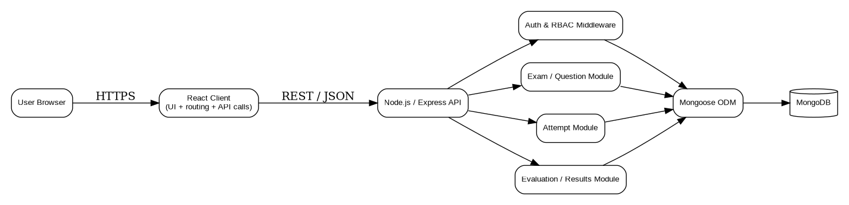
Figure 1. Initial MERN component architecture.

3.4 Component Descriptions
Component | Responsibilities
React Client | Role-specific UI, forms, navigation, timer display and REST API calls.
Express API | HTTP routing, validation, orchestration and standardized responses.
Auth & RBAC Middleware | Authentication checks, role checks and ownership enforcement.
Exam / Question Module | Draft exam CRUD, question/option management, publication validation.
Attempt Module | Attempt creation, response persistence, timing and submission state.
Evaluation / Results Module | Score calculation, result persistence and authorized result retrieval.
Mongoose ODM | Schema/model definitions and persistence abstraction.
MongoDB | Persistent storage for users, exams, questions, attempts and results.

3.5 Chosen Architecture Pattern and Rationale
A layered client-server architecture is selected: Presentation (React), API/application layer (Express), domain modules/services, data-access layer (Mongoose) and MongoDB. This separates concerns, supports independent frontend/backend testing and is appropriate for a three-member academic project. Microservices were rejected because they would add deployment, network and consistency complexity without sufficient Release 1 benefit.

3.6 Technology Stack & Data Stores
Area | Technology
Frontend | React.js, HTML/CSS, Bootstrap
Backend | Node.js, Express.js
Database | MongoDB
ODM | Mongoose
Password security | bcrypt
Testing | Jest, Supertest, React Testing Library
CI/CD / Quality | GitHub Actions or Jenkins, Docker, SonarQube
Documentation/Diagrams | Word/Markdown, draw.io/Graphviz

3.7 Risks & Mitigations
Risk | Mitigation
Client timer manipulation | Server stores start/deadline and validates submission timing.
Unauthorized cross-user access | Backend RBAC and ownership checks on every protected resource route.
Correct-answer leakage | Student-facing attempt responses exclude correct-answer fields.
Frontend/backend contract mismatch | Define and test REST endpoints incrementally; use Supertest for API integration.
Scope growth | Keep optional features outside Release 1 and document deviations.
Merge/integration conflicts | Small Jira/GitHub backlog items, short-lived branches and frequent integration.

3.8 Traceability to Requirements
Requirement Group | Architecture / Component Mapping
AUTH-FR-01..03, OEP-SR-001..03 | React Login + Express Auth/RBAC Middleware + User model
EXAM-FR-01..04, QUES-FR-01..03 | Exam/Question Module + MongoDB models
ATT-FR-01..06 | Attempt Module + React Exam Attempt UI
EVAL-FR-01..02 | Evaluation Service + Attempt/Question data
RES-FR-01..02 | Results routes/service + ownership checks
OEP-NF-001..005 | Cross-cutting API, error handling, testing and compatibility mechanisms

3.9 Security Architecture
Threat-oriented controls follow a lightweight STRIDE view: Spoofing is reduced through authentication and hashed passwords; Tampering is reduced by server-authoritative timing/submission and backend validation; Information Disclosure is reduced through ownership checks and exclusion of correct answers from active-attempt responses; Denial of Service is partially mitigated through input limits and deployment-level rate limiting where configured; Elevation of Privilege is reduced through server-side RBAC. Sensitive information must not be written to logs.

4. Design

4.1 Design Overview
The backend is organized into routes, middleware, controllers/services and Mongoose models. The React client is organized into pages/components and API service utilities. The design favors small modules aligned with functional ownership: Exam/Question Management, Student Attempt, and Evaluation/Results.

4.2 UML Sequence Diagrams

4.2.1 Instructor Creates and Publishes an Exam
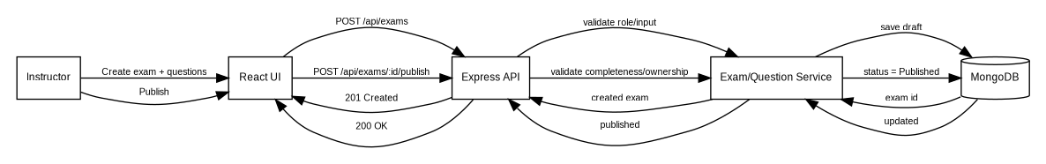
Figure 2. Sequence - instructor creates and publishes an examination.

4.2.2 Student Starts and Submits an Attempt
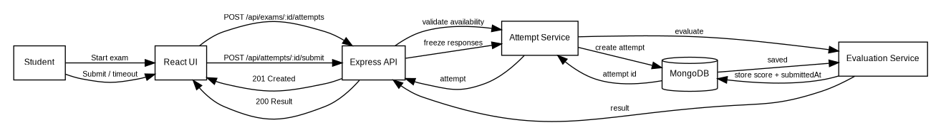
Figure 3. Sequence - student starts and submits an examination attempt.

4.3 API Design
Method | Endpoint | Request | Response / Errors | Requirements
POST | /api/auth/login | {email, password} | 200 {user}; 401 invalid credentials | AUTH-FR-01
POST | /api/auth/logout | none / auth context | 200 success | AUTH-FR-02
POST | /api/exams | {title, description, startTime, duration} | 201 {exam}; 400/403 on invalid/unauthorized | EXAM-FR-01
PUT | /api/exams/:id | editable draft fields | 200 {exam}; 403/409 if non-owner/non-draft | EXAM-FR-02
POST | /api/exams/:id/publish | none | 200 published exam; 400 if invalid | EXAM-FR-04
POST | /api/exams/:examId/questions | {questionText, options, correctOption, marks} | 201 {question}; 400/403 on failure | QUES-FR-01
POST | /api/exams/:examId/attempts | none | 201 {attempt, questionsWithoutAnswers} | ATT-FR-02
PUT | /api/attempts/:id/responses | {questionId, selectedOption} | 200 saved response | ATT-FR-03
POST | /api/attempts/:id/submit | none | 200 {score/result}; 409 if already expired/submitted | ATT-FR-05/06, EVAL-FR-01/02
GET | /api/results/me | none | 200 own result list | RES-FR-01
GET | /api/exams/:examId/results | none | 200 owned-exam results; 403 otherwise | RES-FR-02

4.4 Error Handling, Logging & Monitoring
- Use consistent JSON error responses with a human-readable message and optional field errors.
- Typical codes: 400 invalid input, 401 unauthenticated, 403 unauthorized, 404 missing resource, 409 invalid state/conflict, 500 unexpected server error.
- Do not expose stack traces, password hashes, database credentials or correct answers in end-user errors/logs.
- Log major server failures and security-relevant denied operations without sensitive payloads.
- Monitor API/test failures through CI output and SonarQube/static-analysis reports.

4.5 UX Design
- Role-specific dashboards minimize irrelevant actions.
- Exam attempt page visibly displays remaining time and submission state.
- Forms show field-level validation messages.
- Question navigation preserves saved selections.
- Submission asks for confirmation where appropriate and shows a clear final state.

4.6 Open Issues & Next Steps
- Finalize authentication transport/session mechanism during Sprint 1.
- Finalize embedded-versus-referenced question/response schema decisions after first implementation spike.
- Refine request/response schemas as APIs are implemented.
- Add deployment-specific HTTPS/rate-limit configuration before final release.

5. Appendices
5.1 Glossary: API, MERN, ODM, RBAC, REST, RTM, SRS, STP.
5.2 References: Online Exam Portal SRS; OWASP web security guidance; course mini-project deliverables.
5.3 Tools: GitHub, Jira, VS Code, draw.io/Graphviz, Jest, Supertest, React Testing Library, Docker, SonarQube.

