Intelligent Detection of Phishing Websites: A URL and Webpage Feature-Based Approach
S.No. | Roll No. | Student Name
1 | 2420030182 | G. Manaswi
2 | 2420030100 | M. Aruna Grace

ABSTRACT
The rapid growth of Internet-based services in banking, e-commerce, education, and healthcare has been accompanied by a sharp rise in phishing attacks, in which malicious websites imitate legitimate ones to steal usernames, passwords, banking credentials, and other sensitive data. Traditional blacklist- and rule-based defenses cannot keep pace with newly created phishing domains, motivating the use of Artificial Intelligence and Machine Learning for detection. Existing AI-based solutions, including the PhiUSIIL similarity-index and incremental-learning framework, achieve strong accuracy but still show limited feature integration, weak explainability, restricted cross-dataset generalization, and limited end-to-end deployment.
This project proposes an enhanced, explainable, and deployable phishing detection framework built on the D1 phishing webpage dataset. The framework analyzes URL character sequences, webpage text, hyperlink structure, and login-form characteristics, and augments them with engineered indicators such as URL entropy, suspicious-keyword signals, external-link ratio, and form-domain relationships. XGBoost, CatBoost, and LightGBM classifiers are trained and compared under a common preprocessing and evaluation pipeline, with feature selection and hyperparameter optimization applied to balance accuracy and complexity. SHAP/LIME explainability is integrated so that predictions are accompanied by an interpretable rationale, and the trained model is deployed through a web application that returns real-time phishing/legitimate predictions, stores prediction history, and visualizes performance. Models are evaluated using accuracy, precision, recall, F1-score, ROC-AUC, and confusion matrices, and compared against baseline and existing approaches. The goal is an accurate, interpretable, and practically deployable system that helps users browse the Internet safely.

1. INTRODUCTION

1.1 Background
The Internet underpins modern activities such as online shopping, digital banking, cloud computing, education, healthcare, and social networking, with billions of users performing sensitive transactions online every day. This dependence has also created opportunities for cybercriminals, and phishing remains one of the most widespread and financially damaging attack types. Phishing attacks impersonate trusted organizations through fake emails, messages, or websites that copy the appearance, logos, and layout of genuine sites, tricking users into revealing login credentials, One-Time Passwords, or banking details.
Modern phishing campaigns increasingly rely on techniques such as homograph attacks, punycode manipulation, zero-width characters, subdomain spoofing, bit-squatting, and combosquatting to construct URLs that are visually indistinguishable from legitimate ones. Traditional detection mechanisms based on blacklists and manually defined rules struggle against these constantly evolving, previously unseen (zero-day) phishing sites, since they only recognize threats that have already been catalogued. This has driven interest in AI and Machine Learning approaches capable of learning phishing indicators directly from URL, webpage, and domain data.

1.2 Problem Statement
Phishing websites are a major cybersecurity threat because attackers create deceptive webpages that imitate legitimate organizations in order to obtain usernames, passwords, banking credentials, and other sensitive information. Blacklist- and rule-based systems fail to detect newly created or previously unseen phishing websites. Existing AI/ML approaches also show limitations such as limited feature integration, dependence on fixed feature sets, lack of explainable predictions, limited cross-dataset generalization, and limited practical deployment. There is therefore a need for an accurate, explainable, and deployable AI-based framework that analyzes multiple website characteristics — URL, webpage content, hyperlinks, and login forms — and classifies a website as phishing or legitimate in real time.

1.3 Research Gap
Analysis of prior work reveals four major research gaps that this project aims to address:
- Limited Explainability – Existing phishing detection models often provide only a phishing or legitimate prediction without clearly explaining the features responsible for the decision.
- Limited Feature Integration – Many existing approaches mainly rely on URL features or a fixed feature set and do not comprehensively combine URL, webpage text, hyperlink, and login-form characteristics.
- Limited Model Comparison and Practical Deployment – Existing studies provide limited systematic comparison of modern boosting models under a common pipeline, and many approaches remain focused on offline experiments rather than a usable web-based application.
- Performance–Complexity Trade-off – Some high-performing approaches, particularly deep-learning methods, require greater computational resources and may be difficult to interpret, creating a need for an effective balance between detection performance and model complexity.

1.4 Research Objectives
- To develop an explainable phishing detection model using SHAP/LIME to identify and interpret the important features contributing to each prediction.
- To extract and integrate URL, webpage text, hyperlink, and login-form features from the D1 dataset, along with feasible enhanced features such as URL entropy, suspicious keywords, external-link ratio, and form-domain relationships.
- To train and compare XGBoost, CatBoost, and LightGBM using a common preprocessing and feature-selection pipeline, and to develop a web-based application for phishing prediction and result visualization.
- To evaluate the proposed framework using accuracy, precision, recall, F1-score, ROC-AUC, confusion matrix, and computational measures, and compare the results with baseline and existing approaches.

1.5 Research Questions
- RQ1: Which combination of URL, webpage-text, hyperlink, and login-form features yields the highest phishing-detection accuracy on the D1 dataset?
Answer: The project will compare different feature combinations to identify the feature set that provides the highest phishing-detection performance on the D1 dataset.
- RQ2: Do engineered indicators (URL entropy, suspicious-keyword ratio, external-link ratio, form-domain mismatch) measurably improve classification performance over baseline feature sets?
Answer: The performance of baseline features will be compared with enhanced feature sets to determine whether the engineered indicators provide measurable improvement in phishing classification.
- RQ3: Among XGBoost, CatBoost, and LightGBM, which model offers the best accuracy-to-complexity trade-off after feature selection and hyperparameter tuning?
Answer: XGBoost, CatBoost, and LightGBM will be trained and optimized under the same pipeline, and their performance and computational requirements will be compared to identify the most suitable model.
- RQ4: Can SHAP/LIME explanations reliably surface the features driving individual phishing predictions without materially reducing detection performance?
Answer: SHAP/LIME will be applied to the trained model to identify the features influencing individual predictions, while model performance will be compared before and after adding the explanation component.
- RQ5: How does the proposed framework perform relative to baseline machine-learning and existing published approaches on standard evaluation metrics?
Answer: The proposed framework will be compared with baseline and published approaches using accuracy, precision, recall, F1-score, ROC-AUC, and confusion matrix to determine its relative effectiveness.

1.6 Contributions
- A combined-feature detection pipeline integrating URL, webpage text, hyperlink, and login-form information rather than a single feature family.
- Engineered phishing indicators (URL entropy, keyword signals, external-link ratio, form-domain relationship) evaluated on top of the base feature set.
- A systematic, consistent comparison of three modern boosting algorithms — XGBoost, CatBoost, and LightGBM — with feature selection and hyperparameter optimization.
- Integration of SHAP/LIME explainability so that every prediction is accompanied by an interpretable rationale.
- An end-to-end web application that accepts a URL, returns a real-time prediction, stores prediction history, and visualizes model performance.

1.7 Organization of the Paper
The remainder of this report is organized as follows. Section 2 reviews related work, covering existing rule-based approaches, machine-learning approaches, deep-learning approaches, and explainability techniques, followed by a critical comparison and a consolidated statement of the research gap. Section 3 presents the proposed methodology, including the overall system architecture, the dataset, data preprocessing, feature engineering, and feature selection, together with the corresponding implementation. Subsequent sections (outside the current scope of this document) will cover model training, hyperparameter optimization, evaluation, explainability, comparative analysis, and web-application deployment.

2. RELATED WORK

2.1 Existing Approaches

1. Look Before You Leap: Detecting Phishing Web Pages by Exploiting Raw URL and HTML Characteristics

Author(s) proposed this approach to detect phishing webpages using raw URL and HTML characteristics. Deep-learning techniques were used to learn representations from both sources. The study showed that combining URL and HTML information can effectively detect phishing webpages. However, the approach has higher computational complexity and limited interpretability.

2. An Effective Detection Approach for Phishing Websites Using URL and HTML Features

Author(s) proposed a machine-learning approach using URL, webpage text, hyperlink, and login-form features. Different machine-learning models were evaluated, with XGBoost achieving strong performance on the D1 dataset. The study demonstrated that combining multiple feature groups improves detection. However, explainability and practical deployment were limited.

3. A Sophisticated Framework for the Accurate Detection of Phishing Websites

Author(s) developed a framework using feature processing and machine-learning techniques for phishing detection. Feature selection and ensemble/deep-learning strategies were explored. The framework achieved effective phishing and legitimate website classification. However, its performance depends heavily on feature engineering, with limited explainability and deployment.

4. PhiUSIIL: A Diverse Security Profile Empowered Phishing URL Detection Framework Based on Similarity Index and Incremental Learning

Author(s) introduced PhiUSIIL to detect diverse and evolving phishing URLs. The approach uses a URL Similarity Index and Incremental Learning. It demonstrated strong detection performance and adaptability to changing phishing patterns. However, it mainly focuses on URLs and provides limited webpage-feature integration and explainability.

5. A High-Accuracy Phishing Website Detection Method Based on Machine Learning

Author(s) proposed a machine-learning approach for phishing website classification. Models including Random Forest, SVM, Decision Tree, and XGBoost were evaluated. The study achieved high phishing-detection performance across the evaluated classifiers. However, it provides limited explainability and practical end-user deployment.

6. Phishing Website Detection Based on Deep Convolutional Neural Network and Random Forest Ensemble Learning

Author(s) proposed an ensemble method combining a Deep Convolutional Neural Network with Random Forest. The combination improved phishing website detection by using learned and ensemble-based features. The study demonstrated effective classification performance. However, the approach has higher computational complexity and limited interpretability.

7. Improved Phishing Attack Detection with Machine Learning: A Comprehensive Evaluation of Classifiers and Features

Author(s) evaluated different machine-learning classifiers and feature sets for phishing detection. KNN, SVM, Naive Bayes, Decision Tree, MLP, and SGD-based models were compared. The results showed that classifier and feature selection significantly affect detection performance. However, broader validation, modern boosting-model comparison, and explainability remain limited.

8. GramBeddings: A New Neural Network for URL-Based Identification of Phishing Web Pages Through N-gram Embeddings

Author(s) proposed GramBeddings for phishing webpage identification using URL representations. N-gram embeddings and neural-network techniques were used to learn URL patterns. The approach demonstrated effective URL-based phishing detection. However, it mainly focuses on URLs and does not integrate HTML, webpage content, hyperlinks, or login-form features.

9. Phishing URL Detection Generalisation Using Unsupervised Domain Adaptation

Author(s) investigated phishing URL detection across different data distributions. Unsupervised Domain Adaptation techniques were used to improve cross-domain detection. The study highlighted the importance of generalization when phishing data distributions change. However, it is primarily URL-based and has limited webpage-feature integration and practical deployment.

10. A Machine Learning-Based Phishing Detection Approach Using URL and Website Features

Author(s) proposed a machine-learning approach using URL and website characteristics for phishing detection. Models such as Random Forest, SVM, and Decision Tree were evaluated. The study demonstrated that website features can effectively distinguish phishing from legitimate websites. However, performance depends on feature quality, with limited explainability and adaptability to emerging attacks.

2.2 Machine Learning Approaches

Machine learning approaches formulate phishing detection as a classification problem using features extracted from webpages. In our proposed work, URL, webpage-text, hyperlink, and login-form features will be extracted from the D1 dataset and used for classification. XGBoost, CatBoost, and LightGBM will be trained and compared under a common preprocessing and feature-selection pipeline. Additional features such as URL entropy, suspicious-keyword indicators, external-link ratio, and form-domain relationships will be explored to improve detection performance. Hyperparameter optimization will then be applied to the selected models, followed by SHAP/LIME-based explainability to identify the features influencing phishing predictions. Finally, the best-performing model will be integrated into a web-based phishing detection application.

2.3 Deep Learning Approaches
Deep-learning approaches learn feature representations automatically from phishing webpages and URLs. WebPhish used raw URL and HTML content for end-to-end phishing detection, while Deep CNN with Random Forest combined automatic feature extraction with ensemble classification. GramBeddings used N-gram embeddings and attention mechanisms for URL-based phishing detection. These approaches can achieve strong detection performance but generally require higher computational resources and provide limited interpretability. Therefore, our proposed framework does not implement these deep-learning models; instead, their limitations motivate our use of lightweight boosting models with explainability.

2.4 Explainability / Existing Techniques

SHAP (SHapley Additive exPlanations) and LIME (Local Interpretable Model-Agnostic Explanations) are established techniques for explaining machine-learning predictions. In our proposed framework, SHAP/LIME will be applied to the trained XGBoost, CatBoost, or LightGBM model to identify the features influencing phishing predictions. This will help users understand why a webpage is classified as phishing or legitimate. Thus, explainability is directly incorporated into our proposed system to improve transparency, user trust, and security analysis.

2.5 Critical Comparison
Model / Approach | Dataset | Features Used | Accuracy (%) | ROC-AUC (%) | Outcome | Limitations
Model 1 – Baseline | D1
Model 2 | D1
XGBoost | D1
CatBoost | D1
LightGBM | D1
Optimized XGBoost | D1
Optimized CatBoost | D1
Optimized LightGBM | D1
Proposed Best Model | D1

2.6 Research Gap

• Research Gap 1 – Limited Explainability: Existing phishing detection models often provide only a phishing/legitimate prediction without clearly explaining the features responsible for the decision. Proposed solution: Integrate SHAP/LIME techniques to explain individual model predictions.

• Research Gap 2 – Limited Feature Integration: Many existing approaches mainly rely on URL features or a fixed feature set and do not comprehensively combine URL, webpage text, hyperlink, and login-form characteristics. Proposed solution: Integrate these feature groups and evaluate feasible enhanced features such as URL entropy, suspicious keywords, external-link ratio, and form-domain relationships.

• Research Gap 3 – Limited Model Comparison and Practical Deployment: Existing studies provide limited systematic comparison of modern boosting models under a common pipeline, and many remain focused on offline experiments rather than a usable application. Proposed solution: Compare XGBoost, CatBoost, and LightGBM using a consistent pipeline and develop a web-based phishing detection application.

• Research Gap 4 – Performance–Complexity Trade-off: Some high-performing approaches, particularly deep-learning methods, require greater computational resources and may be difficult to interpret. Proposed solution: Apply feature selection, hyperparameter optimization, and model comparison to achieve an effective balance between detection performance and computational complexity.

3. PROPOSED METHODOLOGY

3.1 Overall Framework (System Architecture)
The proposed system follows a sequential pipeline from raw data to a deployed prediction service, illustrated below.
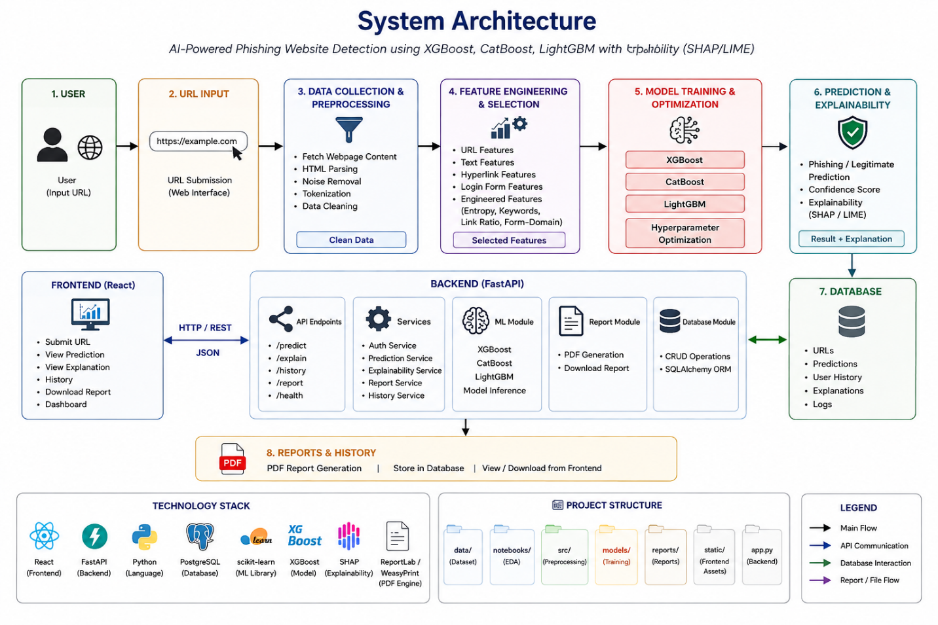

The architecture separates offline components (data preparation, feature engineering, model training, evaluation, explainability) from the online serving component (the web application), which loads the trained, optimized model artifact and exposes a single prediction endpoint that accepts a URL and returns a legitimate/phishing label with an associated confidence score and explanation.

3.2 Dataset
The primary dataset for model development is the D1 phishing webpage dataset, which provides URL, HTML, hyperlink, and login-form based feature groups aligned with the project's objectives. Two additional public datasets are referenced for context and cross-dataset comparison: the PhiUSIIL Phishing URL dataset (235,795 URLs — 134,850 legitimate and 100,945 phishing) and the UCI Phishing Websites dataset.
Dataset | Description / Link
D1 — Phishing Webpage Dataset (primary) | Base dataset used for feature extraction, model training and evaluation; https://www.nature.com/articles/s41598-022-10841-5
PhiUSIIL Phishing URL Dataset | 235,795 URLs (134,850 legitimate / 100,945 phishing); https://archive.ics.uci.edu/dataset/967/phiusil+phishing+url+dataset
UCI Phishing Websites Dataset | https://archive.ics.uci.edu/dataset/327/phishing+websites

Each record is labeled as legitimate or phishing, and the class distribution, duplicate entries, and missing values in D1 are profiled before any modeling is performed, as described in Section 3.3.

3.3 Data Preprocessing
- Data understanding: inspect schema, label balance, feature data types, and identify duplicate or near-duplicate records.
- Missing-value handling: impute or drop fields with excessive missing values; flag structurally missing indicators (e.g., no login form present) rather than treating them as errors.
- Deduplication and noise removal: remove duplicate URLs/records and malformed entries that would bias training.
- Encoding: convert categorical/text fields (e.g., protocol, TLD) using appropriate encodings; tokenize and vectorize webpage text (TF-IDF) separately from tabular features.
- Scaling: normalize/standardize numeric features (e.g., URL length, counts) where required by the downstream model.
- Class balance check: assess the legitimate/phishing ratio and apply stratified sampling in the train–validation–test split to preserve class proportions.
- Train/validation/test split: partition the cleaned dataset (e.g., 70/15/15) prior to feature engineering fit steps such as TF-IDF, to avoid data leakage.

3.4 Feature Engineering
Feature engineering is organized into the four base feature groups defined by the project objectives, augmented with additional engineered indicators evaluated where the data supports them.
- URL character-sequence features: URL length, number of dots/hyphens/digits/special characters, presence of an IP address, use of HTTPS, subdomain count, and n-gram/character-level representations of the URL string.
- Webpage text features: TF-IDF representation of visible page text and title, used to capture wording patterns typical of phishing pages (e.g., urgency language, brand-impersonation phrases).
- Hyperlink features: ratio of internal to external links, ratio of links pointing to a different domain than the page itself, and presence of broken or anchor-only links.
- Login-form features: presence/absence of a login or credential-entry form, and whether the form action submits to the same domain as the page (a strong phishing indicator when it does not).
- Enhanced/engineered indicators: URL entropy (Shannon entropy of the URL string, higher entropy often indicating randomly generated phishing domains); suspicious-keyword indicators (presence of terms such as 'verify', 'secure', 'update', 'account' in the URL or title); external-link ratio (proportion of outbound links relative to total links); and form-domain relationship (binary/categorical flag for form-action domain mismatch).
Each engineered feature is evaluated for coverage and predictive value on the D1 dataset before being retained, since some indicators (e.g., login-form fields) may not be populated for every record.

