ABSTRACT
The rapid expansion of Internet services has significantly improved communication, online banking, e-commerce, education, healthcare, and many other digital services. However, this digital transformation has also resulted in a substantial increase in cyber threats, among which phishing attacks are one of the most dangerous. Phishing websites are malicious websites designed to imitate legitimate websites with the objective of deceiving users into revealing confidential information such as usernames, passwords, credit card details, banking credentials, and other sensitive personal information. As cybercriminals continuously develop sophisticated phishing techniques, traditional detection mechanisms such as blacklist-based filtering and manually defined rules have become insufficient for identifying newly generated phishing websites.
Recent developments in Artificial Intelligence (AI) and Machine Learning (ML) have provided more effective approaches for detecting phishing websites by learning hidden patterns from large collections of legitimate and malicious URLs. Instead of depending solely on previously known phishing websites, machine learning models analyze various URL characteristics, webpage features, and domain information to accurately classify websites. This project proposes an AI-powered phishing website detection system that utilizes URL-based and webpage-based features for identifying phishing attacks. The system performs data preprocessing, feature extraction, model training, testing, and evaluation using machine learning algorithms.
The proposed system is inspired by the PhiUSIIL phishing detection framework, which introduces similarity index analysis and incremental learning for phishing URL detection. Building upon this concept, the project develops a practical phishing detection application using Python technologies. The trained machine learning model is integrated with a web-based application that enables users to enter a website URL and instantly receive a prediction indicating whether the website is legitimate or phishing. The application also stores prediction history in a database and provides performance visualization through graphical reports.
The proposed system aims to improve cybersecurity by providing accurate, scalable, and real-time phishing website detection. The project also compares multiple machine learning algorithms using standard performance metrics such as accuracy, precision, recall, F1-score, and ROC-AUC to identify the most effective classification model. The overall objective is to develop an intelligent phishing detection solution that assists users in safely browsing the Internet while minimizing the risk of phishing attacks.

INTRODUCTION
The Internet has become an essential component of modern society, enabling individuals and organizations to perform a wide range of activities including online shopping, digital banking, cloud computing, education, healthcare services, business transactions, and social networking. As digital technologies continue to evolve, billions of users rely on the Internet every day to access sensitive information and perform financial transactions. While this technological advancement has greatly improved convenience and accessibility, it has also created new opportunities for cybercriminals to exploit users through sophisticated cyberattacks.
Among various cyber threats, phishing attacks remain one of the most widespread and financially damaging forms of cybercrime. A phishing attack is a fraudulent attempt to trick users into disclosing confidential information by impersonating trusted organizations through fake emails, websites, or messages. Attackers often create websites that closely resemble genuine websites by copying their appearance, logos, layouts, and domain names. Unsuspecting users who visit these websites may unknowingly provide sensitive information such as login credentials, banking details, One-Time Passwords (OTPs), or credit card information.
Traditional phishing detection techniques mainly rely on blacklists, manually maintained databases, and predefined rules. Although these techniques are effective against previously identified phishing websites, they struggle to detect newly created phishing websites because attackers constantly generate new domain names and modify URL structures. Modern phishing attacks also employ advanced techniques such as homograph attacks, punycode manipulation, zero-width characters, subdomain spoofing, bit squatting, and combosquatting to create URLs that appear visually similar to legitimate websites. These evolving attack strategies make traditional detection approaches less effective.
Artificial Intelligence and Machine Learning have emerged as promising solutions for addressing these challenges. Machine learning algorithms can automatically learn patterns from large datasets of phishing and legitimate websites and identify suspicious characteristics that are difficult to detect using manually defined rules. By extracting lexical URL features, domain-based attributes, webpage characteristics, and similarity measures, machine learning models can accurately classify websites without relying solely on historical blacklists. Furthermore, modern feature engineering techniques significantly improve detection accuracy by introducing new indicators capable of identifying sophisticated phishing attempts.
This project is based on the concepts presented in the PhiUSIIL phishing detection framework, which combines URL Similarity Index (USI) and Incremental Learning to detect phishing websites more effectively. The framework constructs a comprehensive phishing URL dataset by extracting URL features, downloading webpage content, and generating HTML-based features. Inspired by this approach, the proposed project develops an AI-powered phishing website detection system using Python. The system performs comprehensive data preprocessing, feature extraction, machine learning model training, performance evaluation, and deployment as a web application.
The application allows users to submit website URLs for analysis and instantly receive predictions indicating whether the website is legitimate or phishing. The backend processes user requests, extracts relevant features, applies the trained machine learning model, and stores prediction results in a database for future analysis. Performance evaluation is carried out using multiple machine learning algorithms, enabling comparison between existing models and the proposed approach based on metrics such as accuracy, precision, recall, F1-score, and ROC-AUC. The project ultimately aims to provide an efficient, scalable, and intelligent solution capable of protecting users from increasingly sophisticated phishing attacks while contributing to modern cybersecurity research.

LITERATURE SURVEY
Phishing attacks have become one of the fastest-growing cybersecurity threats due to the increasing dependence on Internet-based applications and online services. Researchers have proposed numerous techniques to identify phishing websites using blacklist databases, heuristic rules, machine learning algorithms, deep learning models, and hybrid detection frameworks. The primary objective of these techniques is to accurately distinguish legitimate websites from malicious phishing websites while minimizing false positive and false negative rates.
Early phishing detection systems were primarily based on blacklist databases maintained by security organizations. These systems compared website URLs against known phishing websites and blocked access whenever a match was found. Although blacklist approaches provided fast detection for previously reported phishing websites, they were unable to identify newly created phishing websites, commonly referred to as zero-day phishing attacks. Additionally, blacklist databases required continuous updates and maintenance, making them less suitable for detecting rapidly evolving cyber threats.
To overcome these limitations, researchers introduced machine learning techniques capable of learning phishing characteristics directly from data. Machine learning algorithms such as Decision Trees, Logistic Regression, Support Vector Machines (SVM), Naïve Bayes, Random Forest, Gradient Boosting, and XGBoost have demonstrated significant improvements in phishing detection accuracy. These algorithms utilize various URL-based features including URL length, domain age, presence of HTTPS, number of dots, special characters, IP addresses, subdomains, lexical patterns, and HTML-based webpage features to classify websites. The use of feature engineering has greatly improved model performance by enabling algorithms to identify subtle differences between phishing and legitimate websites.
One of the most significant contributions in recent phishing detection research is the PhiUSIIL framework proposed by Arvind Prasad and Shalini Chandra. The framework introduces a URL Similarity Index (USI) that detects visually deceptive phishing attacks such as homograph attacks, zero-width character attacks, punycode attacks, homophone attacks, bit squatting, and combosquatting. In addition to similarity analysis, the framework incorporates Incremental Learning, allowing the model to continuously learn from newly available phishing data without requiring complete retraining. This approach improves scalability and enables the model to remain effective against emerging phishing techniques. The authors also developed the PhiUSIIL phishing URL dataset containing 235,795 URLs, including 134,850 legitimate URLs and 100,945 phishing URLs, making it one of the largest publicly available phishing URL datasets. Experimental evaluation demonstrated detection accuracies of 99.24% using incremental training and 99.79% using a pre-training strategy.
Although the PhiUSIIL framework achieves excellent performance, the authors acknowledge certain limitations. Continuous incremental learning may increase computational complexity and training time as new phishing data becomes available. There is also the possibility of model overfitting if the learning process is not properly managed. These challenges highlight opportunities for further research involving improved feature engineering, optimized machine learning models, explainable artificial intelligence techniques, and enhanced web application deployment.
Inspired by these findings, the proposed project develops an AI-powered phishing website detection system using Python that combines URL analysis, webpage feature extraction, machine learning, and web technologies. The project aims to build a practical phishing detection application capable of accurately identifying phishing websites while providing users with real-time predictions through an interactive web interface. Furthermore, the proposed system evaluates multiple machine learning algorithms and compares their performance using standard evaluation metrics to determine the most suitable model for phishing website detection.

Datasets
Dataset | URL Link
D1 Phishing Webpage Dataset | The dataset used as the base for your selected Scientific Reports paper. Research Paper & Dataset Reference
UCI Phishing Websites Dataset | UCI Phishing Websites Dataset
PhiUSIIL Phishing URL Dataset | UCI PhiUSIIL Phishing URL Dataset

Approach
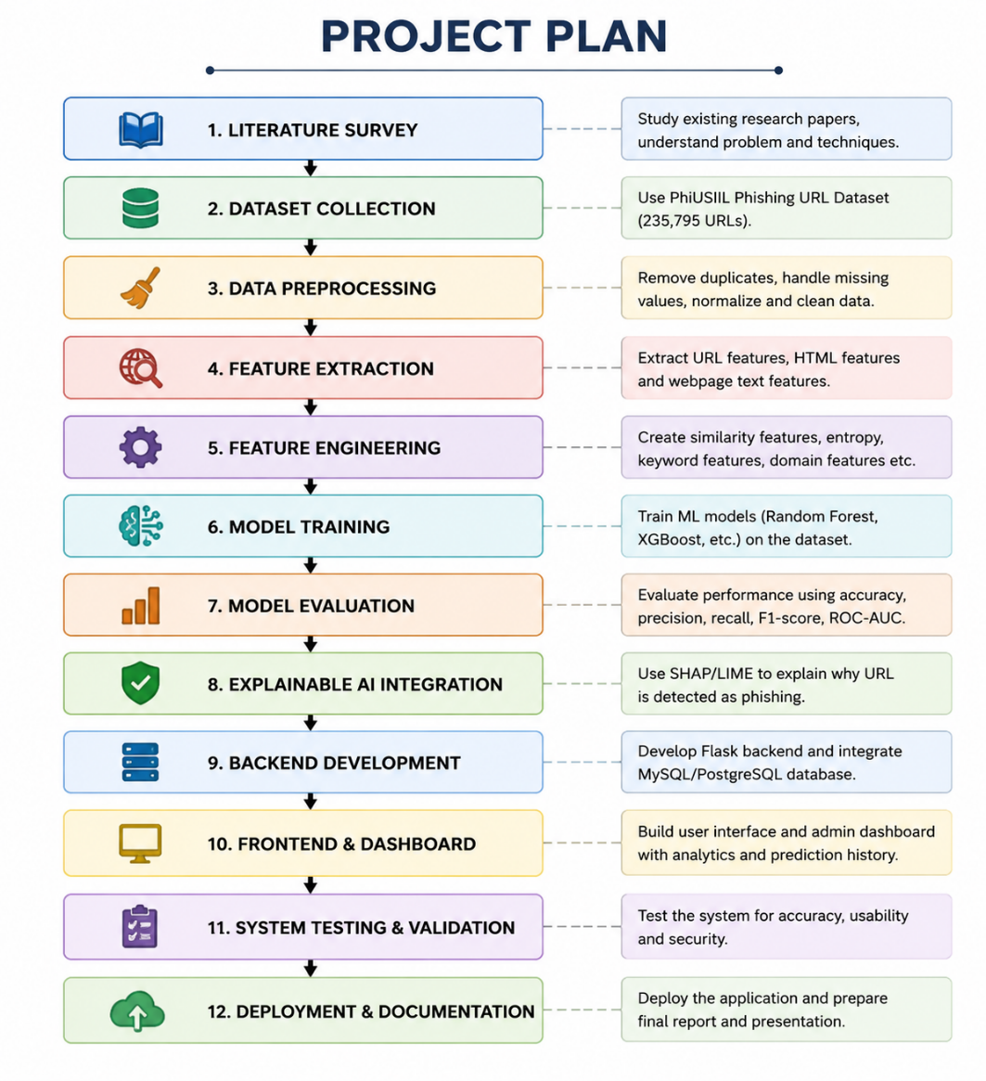
Project Group Members
S.No. | Roll No. | Student Name
1 | 2420030182 | G.Manaswi
2 | 2420030100 | M.Aruna Grace

