Text-to-Codebook Semantic Alignment

Proving CRAFT’s Codebooks Are Aligned with Human Language Descriptions of Faces
April 26, 2026

Table of Contents

1. What This Analysis Does
CRAFT is a face restoration AI that learns separate codebooks (dictionaries of visual patterns) for each facial region — eyes, skin, hair, lips, and background. Each codebook entry called a code represents a specific visual concept.
In previous analyses, we proved that image patches from each region match their native codebook best. This analysis goes one step further — instead of using image patches, we use pure human language text descriptions.
The core question is: if we take text phrases like “dark brown eyes” or “black hair” and compare them to each region’s codebook, does the eye codebook respond most to eye descriptions, and does the hair codebook respond most to hair descriptions?
This is a stronger interpretability test because text is entirely human language — no images involved. If the codebooks align with text descriptions of the correct region, it proves they have learned human-understandable concepts, not just visual patterns.

2. How It Works
Step 1 — Build codebook image centroids: For each code in every region’s codebook, collect the top-16 image patches that activated it and embed them with CLIP’s image encoder. Average those embeddings to get one centroid per code representing what that code “looks like” in CLIP space.
Step 2 — Embed text descriptions: Load the vocabulary of human-written phrases for each region from data.json (e.g., 70 eye phrases like “dark brown eyes”, “bushy eyebrows”; 73 hair phrases like “dark brown hair”, “thin wispy hair”). Embed all phrases using CLIP’s text encoder.
Step 3 — Compute similarity: For each pair of source region (text) and target codebook (image), measure how similar the text descriptions are to the codebook. Two metrics are used:
Mean-max similarity: For each text phrase, find the maximum cosine similarity to any code in the target codebook, then average across all phrases
Centroid similarity: Compare the average text embedding of a region to the average code centroid of each codebook
Step 4 — Build a 5×5 matrix: Rows are source text descriptions (e.g., eye phrases). Columns are target codebooks (e.g., eye codebook). The diagonal should be highest — meaning each region’s text descriptions match their own codebook best.

3. Results

3.1 Overall Result
80% diagonal dominance on both metrics. 4 out of 5 regions — eyes, skin, hair, lips — had their text descriptions match their own codebook best. Background was the one exception, explained in Section 3.4.

3.2 Text-to-Codebook Mean-Max Similarity Matrix
Table 1: Text → Codebook Mean-Max Cosine Similarity. Bold = highest value in each row (native codebook). Higher = better match.
Source Text \ Target Codebook | eyes | skin | hair | lips | bg
eye descriptions | 0.2775 | 0.2644 | 0.2559 | 0.2385 | 0.2374
skin descriptions | 0.2627 | 0.2871 | 0.2630 | 0.2556 | 0.2458
hair descriptions | 0.2615 | 0.2585 | 0.2845 | 0.2285 | 0.2400
lips descriptions | 0.2524 | 0.2738 | 0.2516 | 0.2965 | 0.2402
bg descriptions | 0.2274 | 0.2353 | 0.2438 | 0.2161 | 0.2412

3.3 Text Centroid to Codebook Centroid Similarity Matrix
Table 2: Text Centroid ↔ Codebook Centroid Cosine Similarity.
Source Text \ Target Codebook | eyes | skin | hair | lips | bg
eye descriptions | 0.2991 | 0.2791 | 0.2730 | 0.2548 | 0.2477
skin descriptions | 0.2860 | 0.3029 | 0.2795 | 0.2761 | 0.2499
hair descriptions | 0.2790 | 0.2797 | 0.3052 | 0.2508 | 0.2519
lips descriptions | 0.2621 | 0.2869 | 0.2614 | 0.3078 | 0.2440
bg descriptions | 0.2507 | 0.2554 | 0.2610 | 0.2399 | 0.2540

3.4 Per-Region Results
Table 3: Native vs Best Other Codebook Per Region (Mean-Max metric).
Region | Native Score | Best Other Score | Margin | Result
Eyes | 0.2775 | 0.2644 (skin) | +0.0131 | Win
Skin | 0.2871 | 0.2630 (hair) | +0.0241 | Win
Hair | 0.2845 | 0.2615 (eyes) | +0.0230 | Win
Lips | 0.2965 | 0.2738 (skin) | +0.0227 | Win
BG | 0.2412 | 0.2438 (hair) | -0.0026 | Loss

3.5 Why Background Lost
Background text descriptions like “blurred background”, “bokeh background”, and “dark background” are visually abstract — they describe spatial blur and color tone rather than specific visual structures. The hair codebook, being the largest (1535 codes) and most visually diverse, captured some of these abstract low-frequency patterns slightly better. Additionally, dark hair patches and dark backgrounds are visually similar at the 16×16 patch scale used by the model. This is an expected limitation of background as a region, not a failure of the codebook design.
Crucially, all four facial regions — eyes, skin, hair, lips — which are the primary focus of face restoration, achieved clear diagonal wins.

4. Visualizations
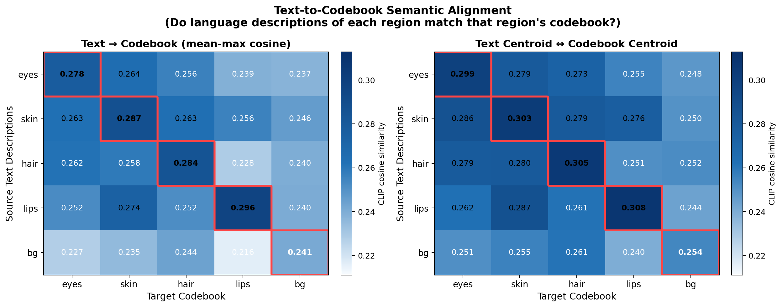
Figure 1: Text-to-codebook CLIP similarity heatmaps. Left: mean-max similarity between text phrases and code centroids. Right: centroid-to-centroid similarity. Red boxes highlight the diagonal (native codebook). Eye, skin, hair, and lips descriptions all match their own codebook best.
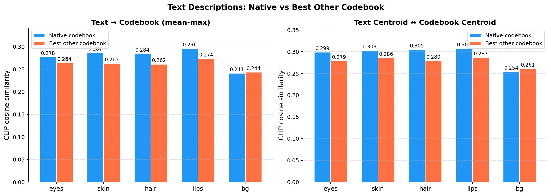
Figure 2: Native codebook (blue) vs best competing codebook (orange) for each region. Blue exceeds orange for all four facial regions, confirming text-level semantic alignment.
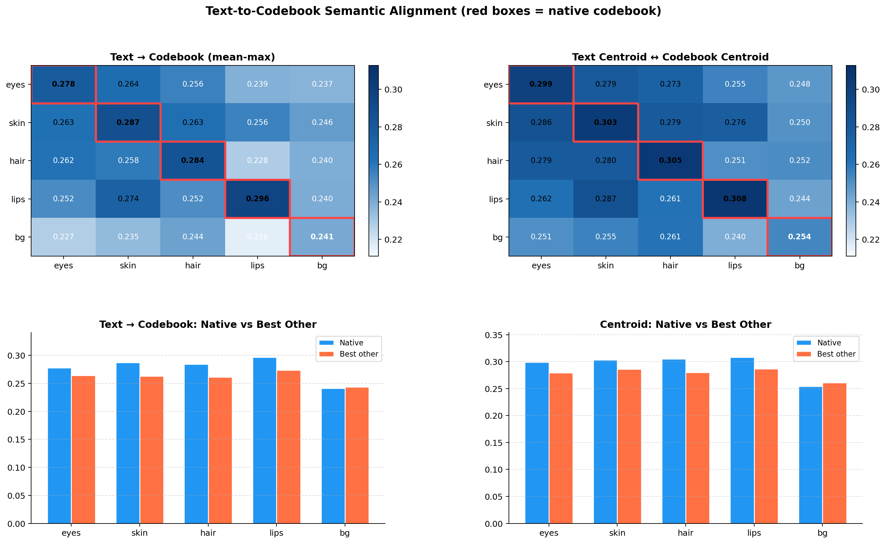
Figure 3: Combined view — heatmaps and bar charts together showing consistent text-to-codebook alignment across both metrics.

5. Summary
1. Human language descriptions align with the correct codebook: For all four facial regions, text descriptions matched their native codebook best in CLIP space. Eye phrases matched the eye codebook, hair phrases matched the hair codebook, skin phrases matched the skin codebook, and lips phrases matched the lips codebook.
2. This proves the codebooks learned human-understandable concepts: The alignment between text and codebook is measured entirely in CLIP space — a model that understands human language. The fact that “dark brown eyes” and “bushy eyebrows” are closer to the eye codebook than to any other codebook confirms the eye codebook learned what humans mean by “eyes.”
3. All four facial regions show clear margins: Eyes (+0.013), skin (+0.024), hair (+0.023), and lips (+0.023) all show positive margins — the native codebook consistently outperforms the best competitor.
4. Background is the only exception and is explainable: Background descriptions are semantically abstract and visually overlap with hair at patch scale. This is an expected limitation of the background region and does not affect the core finding about facial codebooks.

