Lab 2: Agile Backlog Creation & Sprint Simulation in Jira
Name: H K Manaswin SRN: PES1UG24AM108
Scenario: Telemedicine Slot Booking & Prescription Portal (from Lab 1)
My part: Set 1, Doctor Discovery & Slot Booking (UC-01 and UC-02)
1. Introduction
In Lab 1 our team of four wrote the requirements for a telemedicine portal and split the work into four sets. For this lab I used only my own set, Set 1, so my Epics are different from my teammates’. I took the requirements for searching for a doctor (FR-002) and booking a consultation slot (FR-003), plus the UC-02 flow including the payment-declined case, and turned them into Epics and User Stories in Jira. Then I estimated them, prioritised them and ran two sprints.
Jira project: Telemedicine-Booking (key MP), Scrum template.
2. Epics
Epic | Description
MP-1 Epic 1: Doctor Discovery | Lets patients find a suitable physician by medical specialty and only see doctors who actually have open slots, so they can start a booking. (UC-01, FR-002)
MP-2 Epic 2: Slot Booking & Reservation | Lets patients book a video consultation slot, holds it while they pay, reserves it only for them once payment is confirmed, and handles payment failure properly. (UC-02, FR-003)
3. User Stories, Priority and Story Points
Every story is written as “As a patient, I want ..., so that ...” in the description in Jira. Story points use the Fibonacci scale. Epic 1 adds up to 13 points and Epic 2 to 40 points, so 53 points in total.
Key | Story | Priority | Points
MP-3 | Story 1.1: Search Doctors by Specialty | High | 3
MP-4 | Story 1.2: Filter by Real-Time Availability | High | 5
MP-5 | Story 1.3: View Doctor Profile and Open Slots | Medium | 3
MP-6 | Story 1.4: No-Results Guidance | Low | 2
MP-7 | Story 2.1: Select a Slot from the Booking Calendar | High | 5
MP-9 | Story 2.2: Review Booking Summary and Confirm | High | 3
MP-11 | Story 2.3: Temporary Slot Hold During Payment | High | 8
MP-13 | Story 2.4: Prevent Double Booking | High | 8
MP-15 | Story 2.5: Payment Hand-off and Permanent Reservation | High | 5
MP-17 | Story 2.6: Booking Confirmation with Reference ID | Medium | 3
MP-19 | Story 2.7: Retry After Declined Payment | High | 5
MP-21 | Story 2.8: Release Hold and Notify on Failure | Medium | 3

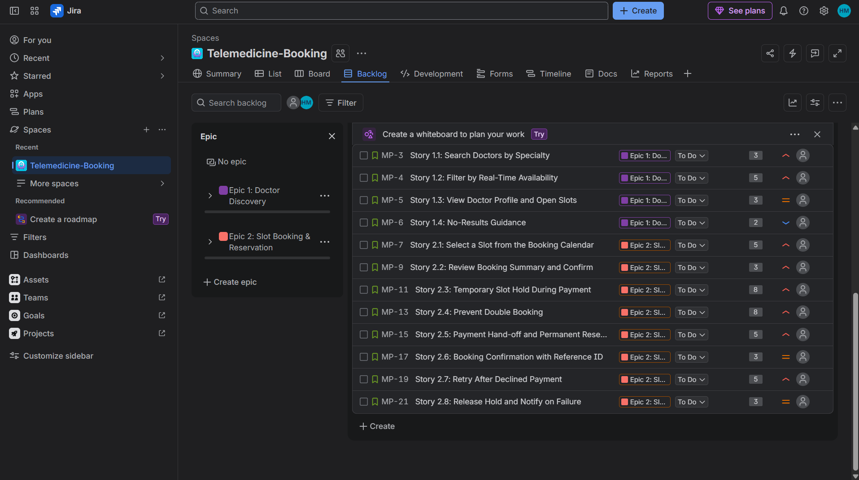
Figure 1: Jira backlog showing both Epics’ stories, with priority icons and story points
4. Sprints
I put the stories into two sprints. Sprint 1 had the whole of Epic 1 plus the first three booking stories (29 points). The second sprint had the rest of the booking and payment-failure stories (24 points). Each sprint was started and then the stories were moved from To Do to In Progress to Done one by one as a simulation (a few minutes in total), as the lab asks.
Sprint | Stories | Points | Goal
MP Sprint 1 | MP-3, 4, 5, 6, 7, 9, 11 | 29 | Patients can find a doctor and start a booking
MP Sprint 3 (my second sprint) | MP-13, 15, 17, 19, 21 | 24 | Booking is secure, confirmed and failure-safe

Note about the sprint names: my first try at the second sprint (MP Sprint 2) was set to only 10 minutes, so that the quick simulation would look realistic. When I opened its burndown chart Jira did not draw the remaining-work line at all, even though the data was there. So I moved the five stories into a new sprint, MP Sprint 3, with a normal one-day length, and that chart worked. MP Sprint 3 is therefore my real second sprint. MP Sprint 2 is still in Jira but is closed. The board and backlog screenshots for the second sprint (Figures 4 and 5) were taken during that first run, with the same five stories.
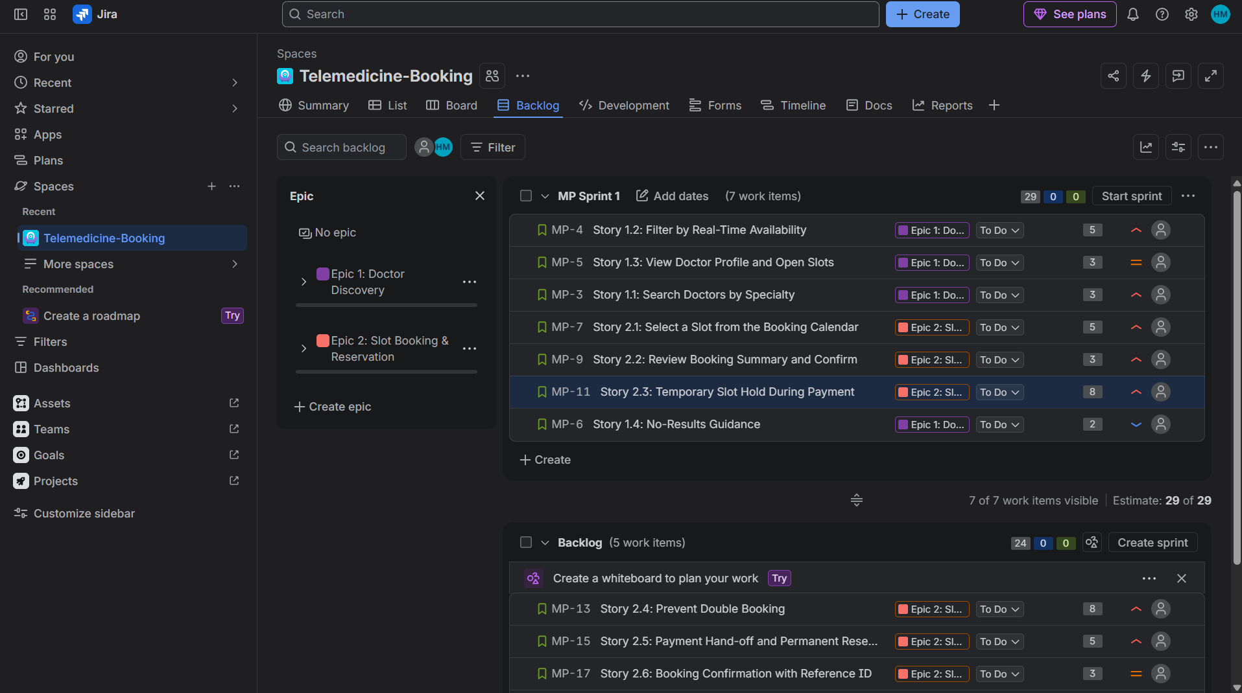
Figure 2: Sprint 1 planned with 7 stories and an estimate of 29 points, before starting
Sprint board (Active sprint view)
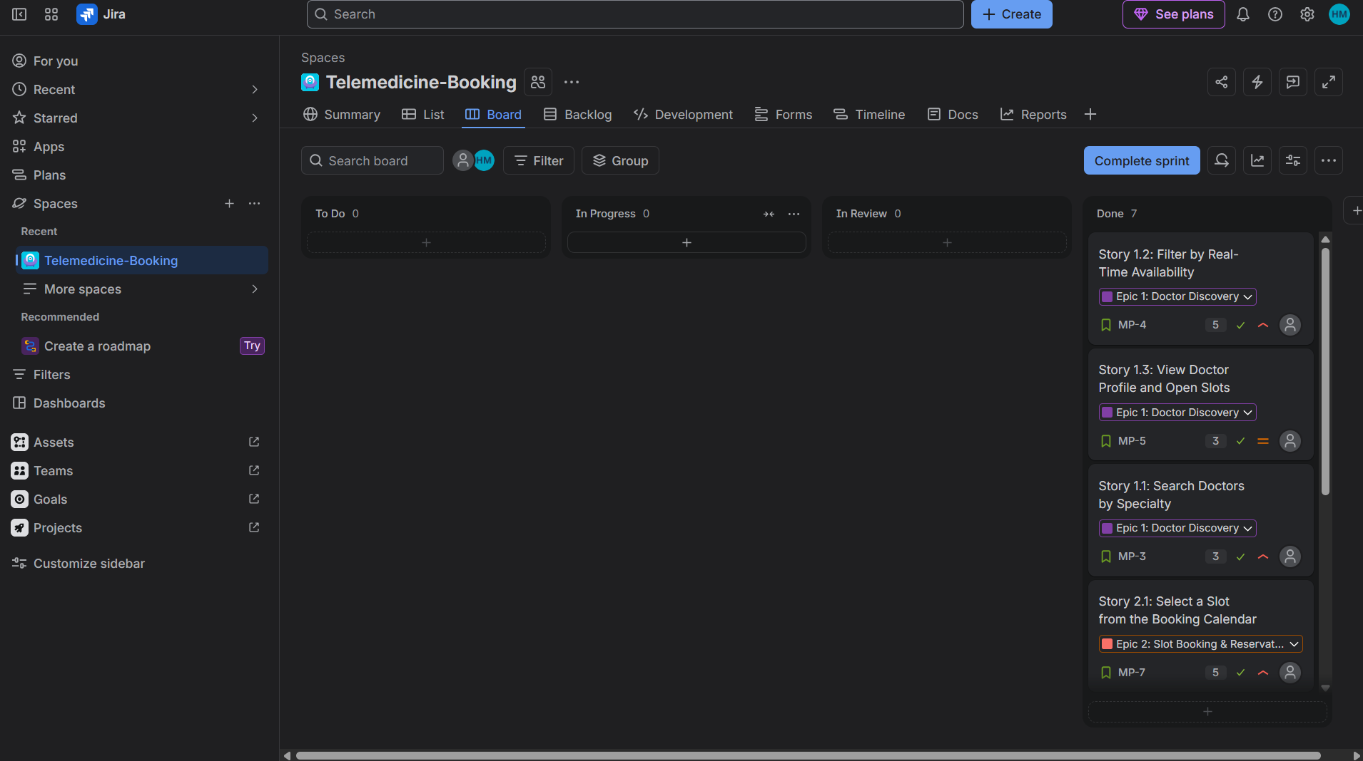
Figure 3: Active sprint board for Sprint 1, all 7 stories moved to Done
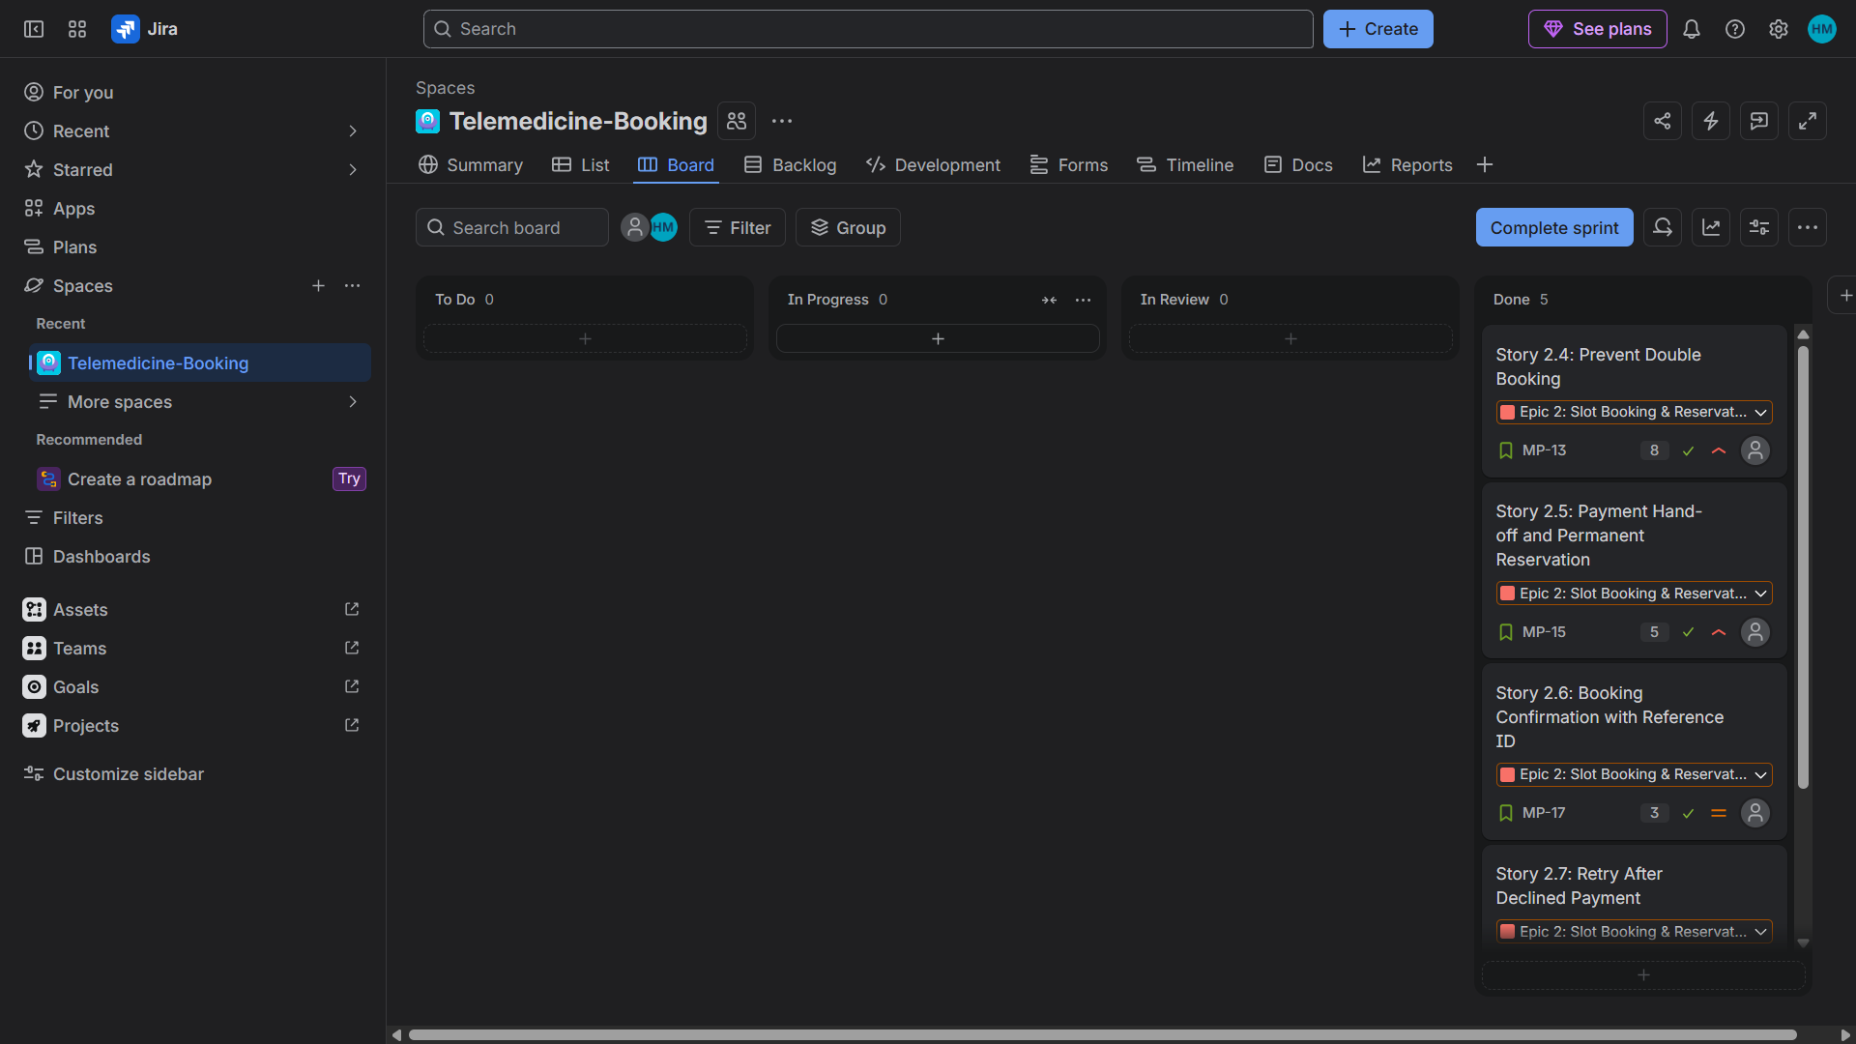
Figure 4: Active sprint board for the second sprint (this is from its first run, MP Sprint 2), all 5 stories in Done
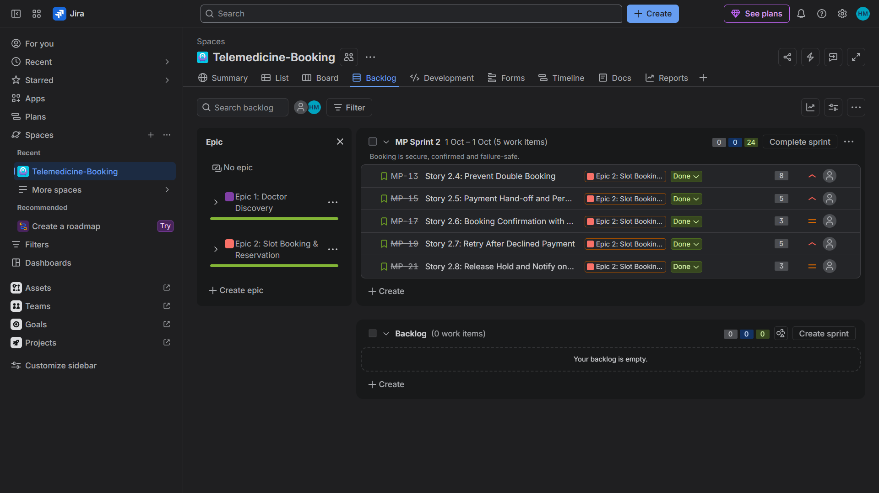
Figure 5: Backlog after the second sprint, both Epics show full green progress bars
5. Burndown Charts
Both charts use story points. The grey line is the ideal burn rate and the red line is the work left.
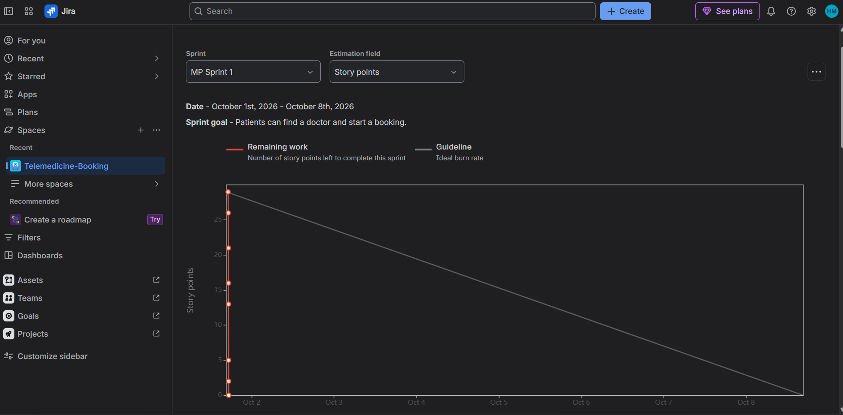
Figure 6: Burndown chart, MP Sprint 1 (1 to 8 Oct)
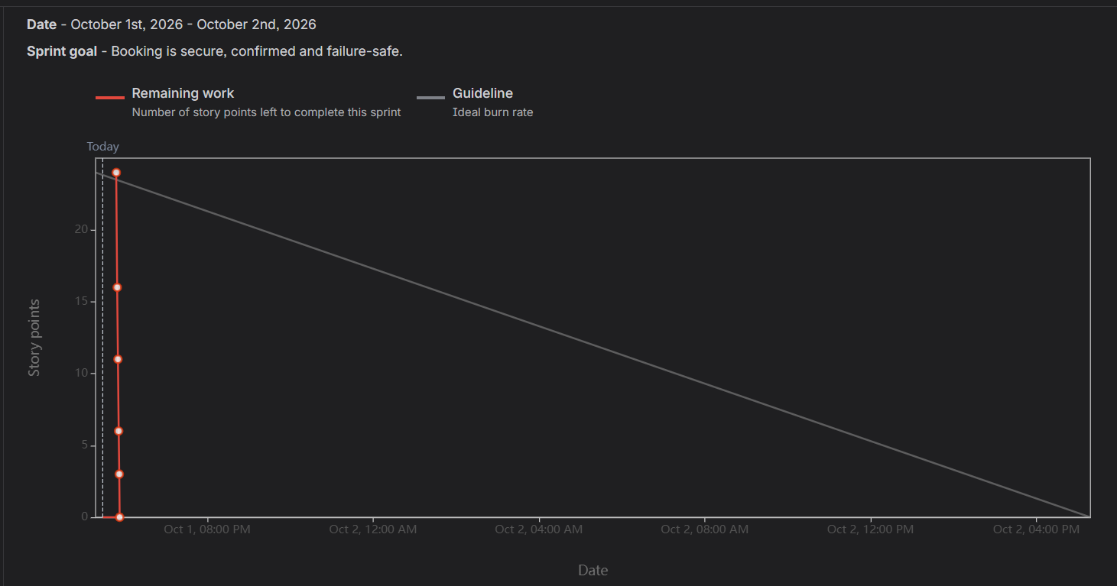
Figure 7: Burndown chart, MP Sprint 3 (1 to 2 Oct), 24 points down to 0 as each story was completed
6. Reflection
1. Did your estimations reflect the actual effort?
I can’t fully say, because we did not actually build the portal. The work was only simulated by moving the cards across the board, so every story took about the same short time no matter what it was worth. What I can say is that the sizes felt sensible while I was estimating. I gave the simple stories like search and the no-results message 2 or 3 points and the slot hold and double-booking stories 8 points, because they have to handle two people trying to book the same slot and a hold that expires. In a real sprint I think those two would have been the riskiest, and I might even have under-estimated them. I would split them into smaller stories next time.
2. Was your backlog well-prioritized?
Mostly. I ordered the stories the way a patient uses the portal: search first, then pick a slot, then confirm, hold the slot and pay. That order also made sense for dependencies, since you can’t book before you can search. Only one story was Low (the no-results message) and three were Medium. But eight of the twelve stories ended up as High, which is a lot. If almost everything is High then the label doesn’t help much. Next time I would be stricter and keep High for the things the portal truly can’t work without.
3. How did your simulated sprint align with your plan?
It matched the plan perfectly: Sprint 1 planned 29 points and finished 29, and the second sprint planned 24 and finished 24. Nothing was carried over and I did not add any stories during a sprint. I know this is too perfect to be realistic, because the cards were moved through the board within a few minutes in a simulation and nothing could go wrong. The only thing that really did not go to plan was the 10-minute sprint, whose chart would not draw, so I had to redo it as MP Sprint 3.
4. What insights did the burndown chart give about your team’s capacity?
In Sprint 1 the red line falls from 29 to 0 almost straight down on the first day and sits far below the grey guideline. In a real team that would mean the sprint was under-committed, or the estimates were too high, or the work was not broken down properly. Here it is mostly because a one-week sprint was finished in a few minutes, so the chart does not show real capacity. Still, I noticed two useful things. The line only drops when a story is moved to Done, so the big 8-point stories cause big steps and smaller stories would give a smoother chart. And my two sprints gave 29 and 24 points, which is about 26 on average, but that number isn’t a real velocity. I also learned that a very short sprint can break the burndown chart, so real sprints should span days.

