Game Design Document

Fill up the following document

1. Write the title of your project.

Wizard of oz.

1. What is the goal of the game?

The goal of the story is to get the man out of the maze.

1. Write a brief story of your game.

The game shows the journey of a man through the garden maze

collecting coins while being chased by the wizard, who resides in the

said garden of the haunted mansion of oz.

1. Which are the playing characters of this game?

* Playing characters are the ones who respond to the user based on the input from the user.
* Cars, monkeys, dinos, wizards, etc., are the playing characters in the game.

|  |  |  |
| --- | --- | --- |
| Number | Character Name | What can this character do? |
| 1 | John(player) | No special powers |
| 2 | Wizard of oz | Telekinesis,telepathy,psychic powers, etc. |
| 3 |  |  |
| 4 |  |  |
| 5 |  |  |
| 6 |  |  |
| 7 |  |  |
| 8 |  |  |

1. Which are the Non-Playing Characters of this game?

* Non-Playing characters are the ones that don't have an action or behavior when the user interacts with the game.
* Hurdles, stones, bananas, coins, etc., are non-playing characters in the game.

|  |  |  |
| --- | --- | --- |
| Number | Character Name | What can this character do? |
| 1 | Walls of the maze | Stand as a barrier |
| 2 | Coin | Add points on John’s score |
| 3 |  |  |
| 4 |  |  |
| 5 |  |  |
| 6 |  |  |
| 7 |  |  |
| 8 |  |  |

Draw your imagination of this game. What does this game look like?

* Draw the game either on your computer or on paper.
* Add images of the game scenes to show each of the playing and non-playing characters at least once.

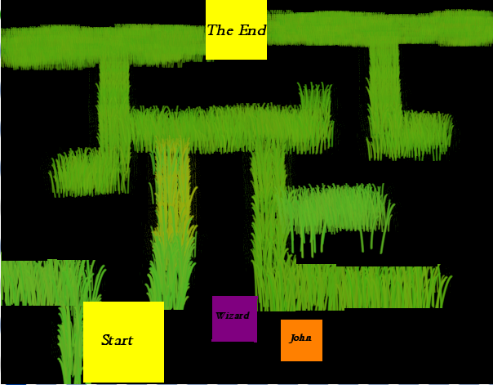

How do you plan to make your game engaging?

The will be engaging since the needs to constantly look out for the hurdles.