PBL ASSIGNMENT REPORT
Assignment 4
SDLC Foundations: High-Level Design and Low-Level Design
Movie Ticket Booking System

Name: Manaswini Kusampudi
Roll Number: 24WU0101061
Semester: 5th Semester
Class: CSE-Rhinos
Department of Computer Science and Engineering
Academic Year 2026

TABLE OF CONTENTS
1. Abstract
2. Assignment Definition
3. Problem Statement and Scope
4. Objectives
5. Requirements Analysis
6. Assumptions and Constraints
7. High-Level Design
8. Architecture and Module Design
9. Data Flow Design
10. Low-Level Design
11. UML Class Design
12. Booking Sequence Design
13. Database Design
14. API and Interface Contracts
15. Security, Reliability, and Scalability
16. Traceability and Review Checklist
17. Conclusion
18. References

1. Abstract
This document presents the High-Level Design (HLD) and Low-Level Design (LLD) for a Movie Ticket Booking System. The design translates business requirements into a buildable software structure before implementation begins. The HLD defines the system boundary, major services, modules, data flow, external integrations, storage choices, and deployment concerns. The LLD refines those decisions into domain classes, booking interactions, database entities, API contracts, business rules, validation rules, and error handling. The system supports movie discovery, theatre and showtime browsing, seat availability, temporary seat locking, payment, booking confirmation, ticket delivery, cancellation, and administration. The diagrams are provided as rendered UML/architecture images and editable Mermaid source files.

2. Assignment Definition
Item | Description
Assignment number | 4
Part | SDLC Foundations
Topic | High-level and low-level design (HLD/LLD)
Task | Turn requirements into a buildable design
System | Movie Ticket Booking System
HLD deliverables | Architecture, modules, data flow, external integrations
LLD deliverables | Class diagram, sequence diagram, database schema, API contracts
Tools | Draw.io / PlantUML equivalent; editable Mermaid sources included
Industry lesson | Design documents are reviewed and signed off before coding starts

3. Problem Statement and Scope
Customers need a reliable way to discover movies, choose a theatre and show, select seats, pay securely, and receive a ticket. The central consistency challenge is preventing two customers from booking the same seat during concurrent checkout. Theatre administrators need to maintain movie metadata, screens, seats, show schedules, pricing, and operational reports. The design must therefore separate browsing from inventory mutation, use temporary seat locks, make payment and booking states explicit, and preserve an auditable record of every confirmed transaction.

3.1 In scope
• Customer registration and authentication
• Movie, theatre, screen, seat, and showtime discovery
• Availability lookup
• Temporary seat locks with expiry
• Checkout and payment gateway integration
• Booking confirmation and e-ticket notification
• Booking history and cancellation/refund request
• Administrative management of movies, theatres, screens, shows, and pricing
• Operational logging, metrics, and audit events

3.2 Out of scope
• Cinema staff point-of-sale hardware
• Physical ticket scanning implementation
• Recommendation engine
• Multi-currency settlement and tax engine
• Full payment-card storage; card data remains with the payment gateway

4. Objectives
• Convert functional and quality requirements into an implementation-ready architecture.
• Define clear module ownership and service boundaries.
• Model the complete booking flow from search through notification.
• Design a concurrency-safe seat inventory strategy.
• Provide a normalized relational schema for durable booking data.
• Define interfaces that can be implemented and tested independently.
• Document security, reliability, scalability, and sign-off criteria before coding.

5. Requirements Analysis

5.1 Functional requirements
ID | Requirement | Priority
FR-01 | Users shall search movies by title, language, genre, and date. | High
FR-02 | Users shall browse theatres, screens, shows, prices, and available seats. | High
FR-03 | Users shall select one or more seats and obtain a temporary lock. | Critical
FR-04 | A lock shall expire automatically after a configured TTL. | Critical
FR-05 | Users shall pay through an external payment gateway. | Critical
FR-06 | A successful payment shall create one confirmed booking and reserve seats. | Critical
FR-07 | The system shall issue a unique booking code and e-ticket. | High
FR-08 | Users shall view booking history and request cancellation subject to policy. | Medium
FR-09 | Administrators shall manage catalog, theatres, screens, shows, and prices. | High
FR-10 | The platform shall record audit events and operational errors. | High

5.2 Non-functional requirements
ID | Quality attribute | Design target
NFR-01 | Availability | 99.9% monthly availability for booking APIs
NFR-02 | Consistency | No double booking for the same show and seat
NFR-03 | Performance | Availability response p95 < 300 ms under normal load
NFR-04 | Security | TLS, hashed credentials, least privilege, token expiry
NFR-05 | Scalability | Stateless API instances; horizontal scaling for read traffic
NFR-06 | Auditability | Trace booking, payment, lock, cancellation, and admin changes
NFR-07 | Recoverability | Durable booking/payment records and database backups
NFR-08 | Maintainability | Service boundaries, validation, tests, and documented APIs

6. Assumptions and Constraints
• A user has a unique email address and may have one active checkout per show.
• The payment gateway returns an idempotency-safe transaction reference.
• Redis is available for short-lived seat locks; PostgreSQL is the source of truth for durable bookings.
• The initial release supports one regional timezone per theatre.
• Seat locks expire after 10 minutes unless converted into a booking.
• A booking is confirmed only after verified payment success.
• The system uses REST/JSON interfaces between clients and services in the first release.
• The diagrams are logical designs; exact cloud products can be selected during implementation planning.

7. High-Level Design
The HLD uses a layered service-oriented architecture. Customer and administrator clients enter through an API Gateway. Stateless domain services handle identity, catalog, shows, inventory, booking, payment coordination, and notification. PostgreSQL stores durable transactional records; Redis manages short-lived seat locks; a message queue decouples notification delivery from the booking request. Observability is cross-cutting and receives structured logs, metrics, traces, and audit events.
Figure 1. HLD system architecture
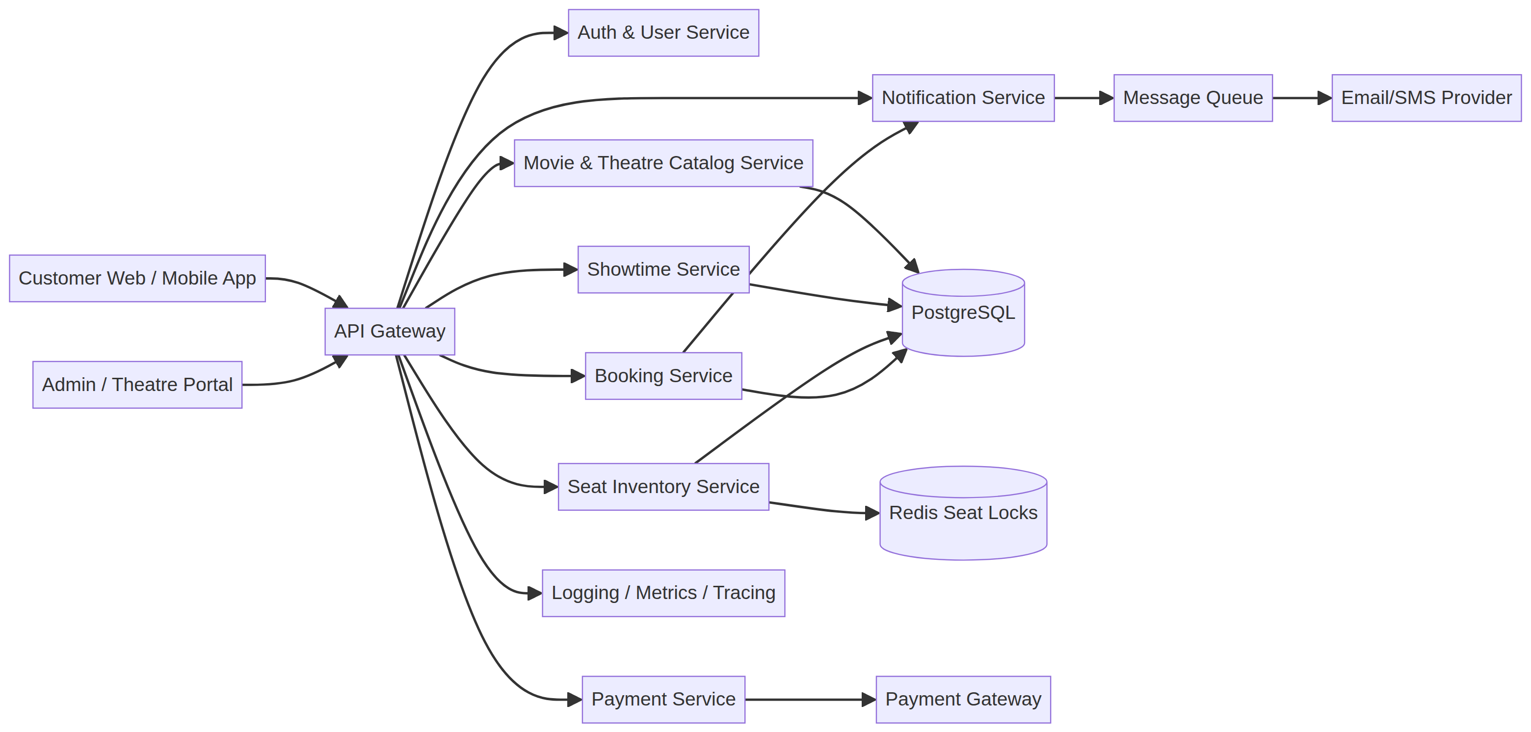
The architecture intentionally separates inventory mutation from catalog reads. This reduces the chance that a slow search or catalogue query can interfere with seat locking. Payment remains an external boundary, and the Booking Service reconciles payment results before committing the final reservation.

8. Architecture and Module Design
Figure 2. Module decomposition
Module | Responsibilities | Owns
Customer Module | Search, show browsing, seat selection, checkout, ticket history | Customer-facing workflows
Administration Module | Movie, theatre, screen, show, pricing, and reports | Operational configuration
Availability Module | Seat map, availability, lock validation, expiry | Read model and lock coordination
Booking Core | Booking state machine, confirmation, cancellation, refunds | Booking lifecycle
Payment Integration | Payment intent, callback verification, idempotency | Gateway adapter
Notification Module | E-ticket, email/SMS templates, retries | Delivery workflow
Identity and Access | Registration, login, roles, tokens, authorization | Users and permissions
Observability | Logs, metrics, tracing, audit records | Operational evidence

9. Data Flow Design
Figure 3. End-to-end booking data flow
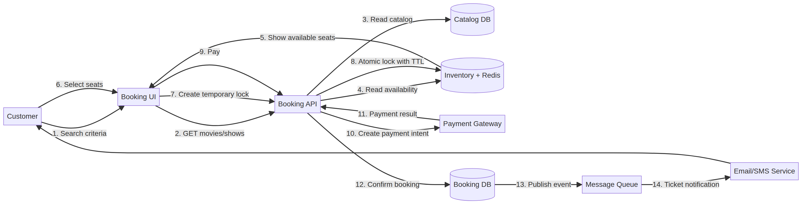
The main flow reads catalog and availability before modifying inventory. A customer selection is converted into a temporary lock with a TTL. Payment is requested only after a successful lock. The Booking Service then verifies the gateway response, writes the durable booking and booking-seat rows, converts the locks into booked state, and publishes a ticket event. Notification delivery is asynchronous so a slow email provider does not keep the customer’s booking transaction open.

10. Low-Level Design
The LLD defines the domain objects, state transitions, data ownership, and interfaces required to implement the HLD. The most important design decision is that seat availability is show-specific: a physical seat can be available for one show and booked for another. Therefore, the booking and lock records always carry both show identity and seat identity.

10.1 Booking state model
State | Meaning | Allowed transitions
PENDING_PAYMENT | Seats locked; payment not yet confirmed | CONFIRMED, PAYMENT_FAILED, EXPIRED
CONFIRMED | Payment verified and seats permanently reserved | CANCELLED
PAYMENT_FAILED | Gateway or verification failure | PENDING_PAYMENT retry or EXPIRED
EXPIRED | Lock TTL ended before confirmation | None
CANCELLED | Booking cancelled and refund policy applied | None

10.2 Seat-lock rules
• Lock operation must be atomic for all requested seats.
• If any requested seat is unavailable, no partial lock is retained.
• Each lock contains show_id, seat_id, user_id, expiry, and status.
• A background expiry worker marks expired locks and releases Redis keys.
• Confirmation checks that the lock belongs to the requesting user and has not expired.
• Database uniqueness and transactional checks protect against duplicate durable reservations.

11. UML Class Design
Figure 4. UML domain class diagram
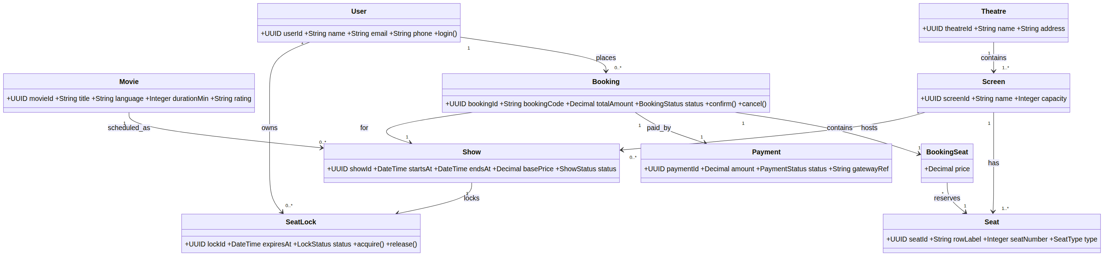
The class model separates catalogue entities (Movie, Theatre, Screen, Seat, Show) from transaction entities (SeatLock, Booking, BookingSeat, Payment). BookingSeat is an associative entity because a booking contains many seats and a seat participates in many bookings across different shows. Payment is one-to-one with a booking in the first-release design, while gateway callbacks are made idempotent by gateway_ref.

12. Booking Sequence Design
Figure 5. UML sequence diagram for seat booking
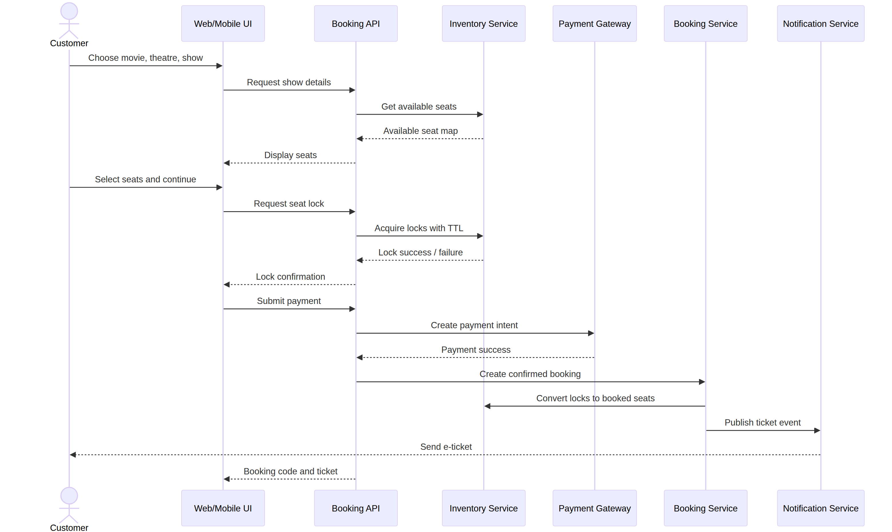
The sequence shows the success path. Error paths include unavailable seats, expired locks, payment failure, duplicate callback, and notification retry. The API must never report a confirmed booking before the durable booking transaction succeeds.

12.1 Error paths
Scenario | System response
Seat lock conflict | Return HTTP 409 with unavailable seat identifiers; do not create partial lock
Lock expiry | Return HTTP 410 or domain error; ask customer to select seats again
Payment failure | Mark payment failed, release locks, return retry-safe response
Payment timeout | Keep booking pending only within policy window; reconcile asynchronously
Duplicate callback | Use gateway reference and idempotency key; return prior outcome
Notification failure | Keep booking confirmed; retry notification through queue

13. Database Design
Figure 6. Relational database schema
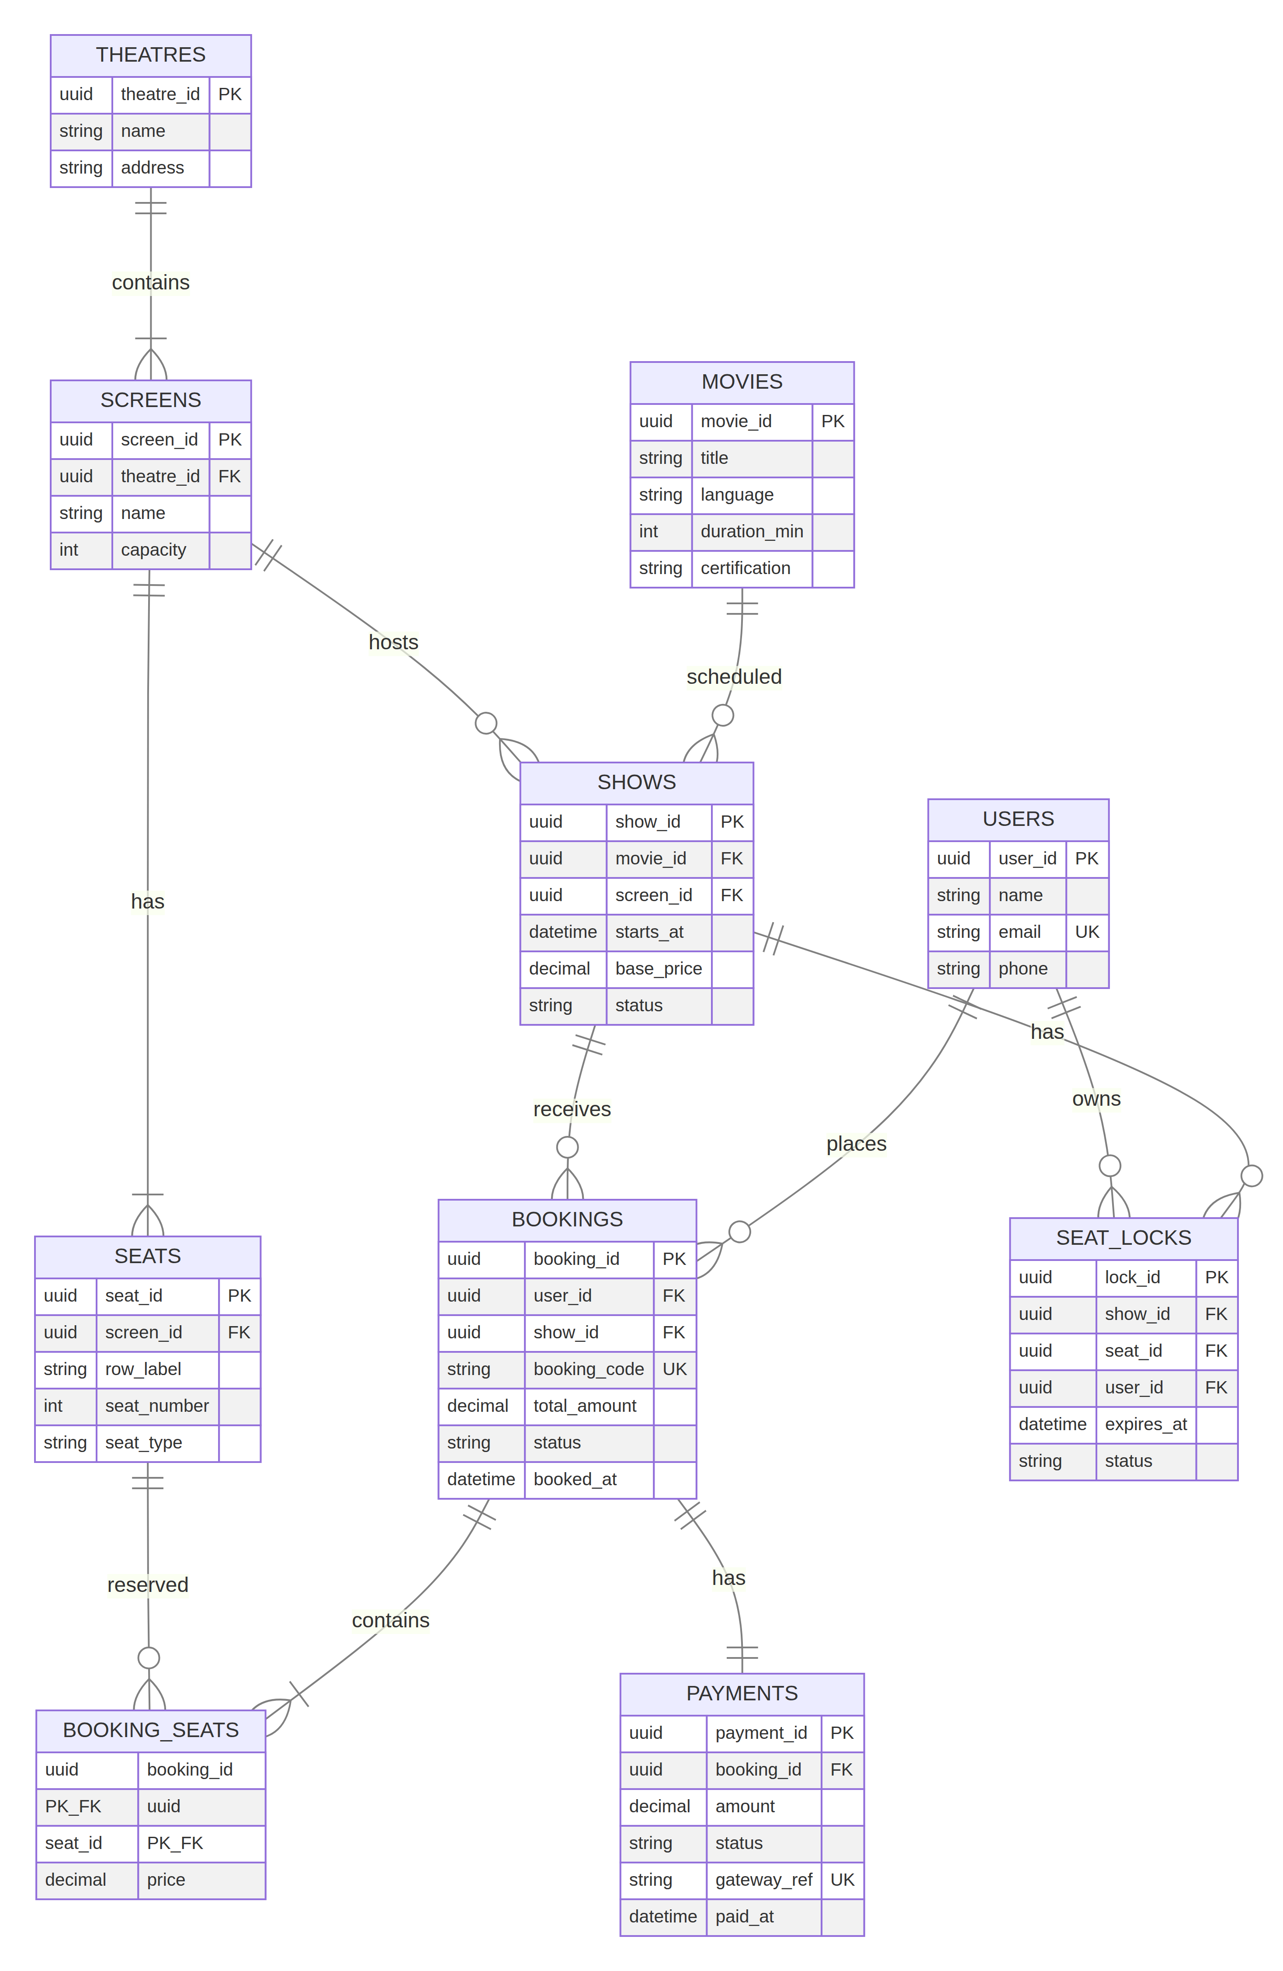
PostgreSQL is the durable store for users, catalogue, shows, bookings, payments, and audit-relevant records. Redis is deliberately not shown as the source of truth in the ER model because its keys are temporary coordination state. The schema is normalized around theatre, screen, seat, show, booking, and booking-seat relationships.
Table | Primary key | Important fields / constraints
users | user_id | email UNIQUE; role; password_hash; created_at
movies | movie_id | title; language; duration_min; certification
theatres | theatre_id | name; address
screens | screen_id | theatre_id FK; capacity
seats | seat_id | screen_id FK; row_label; seat_number; seat_type
shows | show_id | movie_id FK; screen_id FK; starts_at; base_price; status
seat_locks | lock_id | show_id + seat_id; user_id; expires_at; status
bookings | booking_id | user_id FK; show_id FK; booking_code UNIQUE; status; total_amount
booking_seats | booking_id + seat_id | Composite key; price snapshot
payments | payment_id | booking_id FK; gateway_ref UNIQUE; status; amount

13.1 Representative SQL DDL
CREATE TABLE bookings (
booking_id UUID PRIMARY KEY,
user_id UUID NOT NULL REFERENCES users(user_id),
show_id UUID NOT NULL REFERENCES shows(show_id),
booking_code VARCHAR(24) NOT NULL UNIQUE,
total_amount NUMERIC(10,2) NOT NULL CHECK (total_amount >= 0),
status VARCHAR(24) NOT NULL,
booked_at TIMESTAMPTZ NOT NULL DEFAULT now()
);

CREATE TABLE booking_seats (
booking_id UUID REFERENCES bookings(booking_id),
seat_id UUID REFERENCES seats(seat_id),
price NUMERIC(10,2) NOT NULL CHECK (price >= 0),
PRIMARY KEY (booking_id, seat_id)
);

14. API and Interface Contracts
Method | Endpoint | Purpose | Success response
POST | /api/v1/auth/login | Authenticate user | 200 token payload
GET | /api/v1/movies?date=&city= | Search movies | 200 movie list
GET | /api/v1/shows/{showId}/seats | Read seat availability | 200 seat map
POST | /api/v1/shows/{showId}/locks | Lock selected seats | 201 lock id and expiry
POST | /api/v1/bookings/checkout | Create payment intent | 201 checkout id
POST | /api/v1/payments/webhook | Receive verified gateway event | 200 acknowledged
GET | /api/v1/bookings/{bookingId} | View booking | 200 booking and ticket
POST | /api/v1/bookings/{bookingId}/cancel | Cancel under policy | 200 cancellation/refund status
POST | /api/v1/admin/shows | Create or update show | 201 show

14.1 Example lock request
POST /api/v1/shows/SHOW-123/locks
Idempotency-Key: 3d8d...
Authorization: Bearer <token>

{
"seatIds": ["SEAT-A-10", "SEAT-A-11"],
"clientRequestId": "checkout-789"
}

14.2 Example response
HTTP/1.1 201 Created
{
"lockId": "LOCK-456",
"expiresAt": "2026-10-06T02:10:00Z",
"status": "ACTIVE"
}

15. Security, Reliability, and Scalability

15.1 Security
• TLS for all client and service traffic.
• Passwords stored using a slow adaptive hash; never store raw passwords.
• Short-lived access tokens and refresh-token rotation.
• Role-based authorization for customer, theatre-admin, and platform-admin actions.
• Payment-card data delegated to the gateway; store only tokenized references.
• Validate all request fields and enforce ownership checks on bookings and locks.
• Rate-limit login, lock, payment, and webhook endpoints.
• Record security-relevant actions in an append-only audit stream.

15.2 Reliability and scalability
• Use database transactions for booking confirmation.
• Use idempotency keys for checkout and gateway callbacks.
• Use Redis TTLs and an expiry worker for abandoned locks.
• Keep APIs stateless so instances can scale horizontally.
• Cache movie and theatre catalogue reads with explicit invalidation.
• Use queue retries and dead-letter handling for notification failures.
• Monitor lock conflicts, payment failures, booking latency, queue depth, and database health.
• Back up PostgreSQL and test restore procedures.

16. Traceability and Review Checklist
Requirement / decision | HLD/LLD location | Verification method
FR-03 / FR-04 seat locking | Sections 7, 10.2, 12 | Concurrency and expiry tests
FR-05 / FR-06 payment and confirmation | Sections 7, 12, 14 | Gateway sandbox and idempotency tests
FR-07 e-ticket | Sections 7, 8, 12 | Notification event and retry test
NFR-02 no double booking | Sections 10.2, 13 | Parallel booking test
NFR-04 security | Section 15.1 | Threat model and security review
NFR-05 scalability | Section 15.2 | Load test and horizontal scale test
Database integrity | Section 13 | Migration and constraint tests
API readiness | Section 14 | Contract tests and OpenAPI review

Design review exit criteria: all high-priority requirements have a mapped component and test approach; every diagram has an owner; unresolved assumptions are documented; security and concurrency risks have mitigation owners; and the sign-off table below is completed before coding begins.

17. Conclusion
The Movie Ticket Booking System has been translated from a business problem into a buildable design. The HLD establishes a clear architecture with customer and admin clients, an API Gateway, domain services, durable storage, temporary inventory locks, payment integration, asynchronous notifications, and observability. The LLD turns that architecture into classes, a booking sequence, normalized tables, state transitions, API contracts, validation rules, and error handling.
The design’s most important correctness guarantee is the seat-lock and confirmation flow. A seat is temporarily reserved before payment, the lock expires safely when checkout is abandoned, and only verified payment can convert the lock into a durable booking. The documents should be reviewed and signed off before implementation so that the team can code against an agreed structure rather than discovering architectural decisions late in development.

18. References
• Object Management Group. UML specification and diagram concepts. https://www.omg.org/spec/UML/
• PlantUML documentation. https://plantuml.com/
• Mermaid documentation. https://mermaid.js.org/
• OWASP Application Security Verification Standard. https://owasp.org/www-project-application-security-verification-standard/
• PostgreSQL documentation. https://www.postgresql.org/docs/
• Redis documentation. https://redis.io/docs/

