**BIPOLAR JUNCTION TRANSISTOR**

In the [**Diode**](http://www.electronics-tutorials.ws/diode/diode_1.html)  we saw that simple diodes are made up from two pieces of semiconductor material, either silicon or germanium to form a simple PN-junction and we also learnt about their properties and characteristics. If we now join together two individual signal diodes back-to-back, this will give us two PN-junctions connected together in series that share a common P or N terminal. The fusion of these two diodes produces a three layer, two junction, three terminal device forming the basis of a **Bipolar Transistor**, or **BJT** for short.

Transistors are three terminal active devices made from different semiconductor materials that can act as either an insulator or a conductor by the application of a small signal voltage. The transistor's ability to change between these two states enables it to have two basic functions: "switching" (digital electronics) or "amplification" (analogue electronics). Then bipolar transistors have the ability to operate within three different regions:

* 1. Active Region - the transistor operates as an amplifier and Ic = β.Ib

•

* 2. Saturation - the transistor is "fully-ON" operating as a switch and Ic = I(saturation)

•

* 3. Cut-off - the transistor is "fully-OFF" operating as a switch and Ic = 0

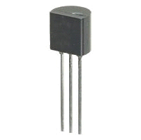 **Bipolar Transistor**

The word Transistor is an acronym, and is a combination of the words Transfer Varistor used to describe their mode of operation way back in their early days of development. There are two basic types of bipolar transistor construction, NPN and PNP, which basically describes the physical arrangement of the P-type and N-type semiconductor materials from which they are made.

The **Bipolar Transistor** basic construction consists of two PN-junctions producing three connecting terminals with each terminal being given a name to identify it from the other two. These three terminals are known and labelled as the Emitter ( E ), the Base ( B ) and the Collector ( C ) respectively.

Bipolar Transistors are current regulating devices that control the amount of current flowing through them in proportion to the amount of biasing voltage applied to their base terminal acting like a current-controlled switch. The principle of operation of the two transistor types NPN and PNP, is exactly the same the only difference being in their biasing and the polarity of the power supply for each type.

**Bipolar Transistor Construction**

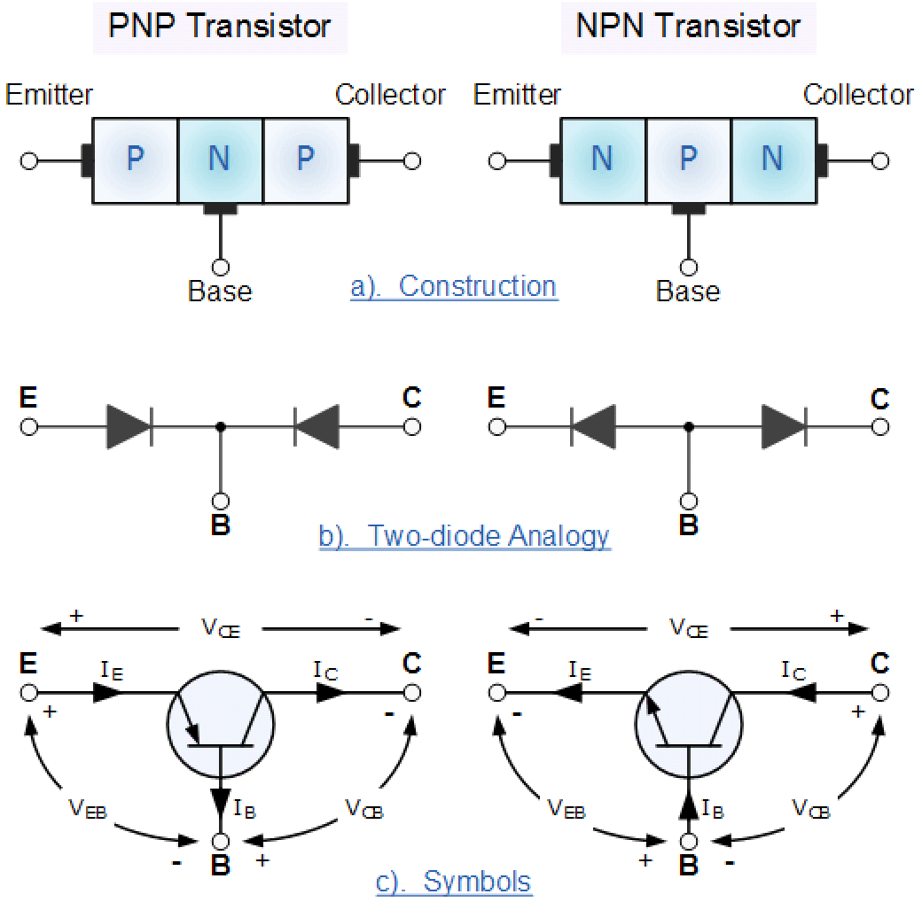

The construction and circuit symbols for both the NPN and PNP bipolar transistor are given above with the arrow in the circuit symbol always showing the direction of "conventional current flow" between the base terminal and its emitter terminal. The direction of the arrow always points from the positive P-type region to the negative N-type region for both transistor types, exactly the same as for the standard diode symbol.

**Bipolar Junction Transistor Configurations**

As the **Bipolar Transistor** is a three terminal device, there are basically three possible ways to connect it within an electronic circuit with one terminal being common to both the input and output. Each method of connection responding differently to its input signal within a circuit as the static characteristics of the transistor vary with each circuit arrangement.

* 1. Common Base Configuration - has Voltage Gain but no Current Gain.

•

* 2. Common Emitter Configuration - has both Current and Voltage Gain.

•

* 3. Common Collector Configuration - has Current Gain but no Voltage Gain.

**The Common Base (CB) Configuration**

As its name suggests, in the **Common Base** or grounded base configuration, the BASE connection is common to both the input signal AND the output signal with the input signal being applied between the base and the emitter terminals. The corresponding output signal is taken from between the base and the collector terminals as shown with the base terminal grounded or connected to a fixed reference voltage point. The input current flowing into the emitter is quite large as its the sum of both the base current and collector current respectively therefore, the collector current output is less than the emitter current input resulting in a current gain for this type of circuit of "1" (unity) or less, in other words the common base configuration "attenuates" the input signal.

**The Common Base Transistor Circuit**

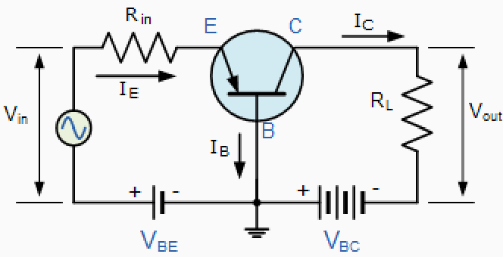

This type of amplifier configuration is a non-inverting voltage amplifier circuit, in that the signal voltages Vin and Vout are in-phase. This type of transistor arrangement is not very common due to its unusually high voltage gain characteristics. Its output characteristics represent that of a forward biased diode while the input characteristics represent that of an illuminated photo-diode. Also this type of bipolar transistor configuration has a high ratio of output to input resistance or more importantly "load" resistance (RL) to "input" resistance (Rin) giving it a value of

"Resistance Gain". Then the voltage gain (Av for a common base configuration is therefore given as:

**Common Base Voltage Gain**

The common base circuit is generally only used in single stage amplifier circuits such as microphone pre-amplifier or radio frequency (Rf) amplifiers due to its very good high frequency response.

**The Common Emitter (CE) Configuration**

In the **Common Emitter** or grounded emitter configuration, the input signal is applied between the base, while the output is taken from between the collector and the emitter as shown. This type of configuration is the most commonly used circuit for transistor based amplifiers and which represents the "normal" method of bipolar transistor connection. The common emitter amplifier configuration produces the highest current and power gain of all the three bipolar transistor configurations. This is mainly because the input impedance is LOW as it is connected to a forward-biased PN-junction, while the output impedance is HIGH as it is taken from a reverse-biased PN-junction.

**The Common Emitter Amplifier Circuit**

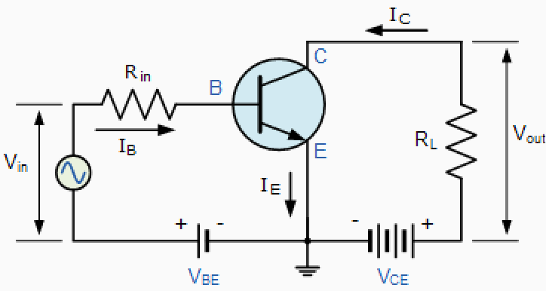

In this type of configuration, the current flowing out of the transistor must be equal to the currents flowing into the transistor as the emitter current is given as Ie = Ic + Ib. Also, as the load resistance (RL) is connected in series with the collector, the current gain of the common emitter transistor configuration is quite large as it is the ratio of Ic/Ib and is given the Greek symbol of Beta, (β). As the emitter current for a common emitter configuration is defined as

Ie = Ic + Ib, the ratio of Ic/Ie is called Alpha, given the Greek symbol of α. Note: that the value of Alpha will always

be less than unity.

Since the electrical relationship between these three currents, Ib, Ic and Ie is determined by the physical construction of the transistor itself, any small change in the base current (Ib), will result in a much larger change in the collector

current (Ic). Then, small changes in current flowing in the base will thus control the current in the emitter-collector circuit. Typically, Beta has a value between 20 and 200 for most general purpose transistors.

By combining the expressions for both Alpha, α and Beta, β the mathematical relationship between these parameters and therefore the current gain of the transistor can be given as:

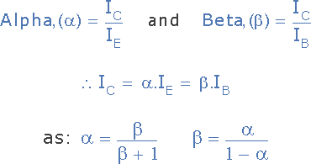

Where: "Ic" is the current flowing into the collector terminal, "Ib" is the current flowing into the base terminal and "Ie" is the current flowing out of the emitter terminal.

Then to summarise, this type of bipolar transistor configuration has a greater input impedance, current and power gain than that of the common base configuration but its voltage gain is much lower. The common emitter configuration is an inverting amplifier circuit resulting in the output signal being 180o out-of-phase with the input voltage signal.

**The Common Collector (CC) Configuration**

In the **Common Collector** or grounded collector configuration, the collector is now common through the supply. The input signal is connected directly to the base, while the output is taken from the emitter load as shown. This type of configuration is commonly known as a **Voltage Follower** or **Emitter Follower** circuit. The emitter follower configuration is very useful for impedance matching applications because of the very high input impedance, in the region of hundreds of thousands of Ohms while having a relatively low output impedance.

**The Common Collector Transistor Circuit**

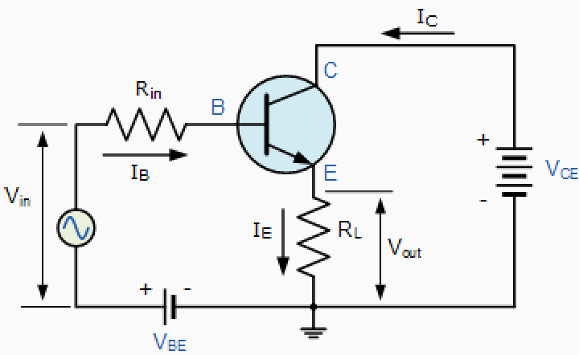

The common emitter configuration has a current gain approximately equal to the β value of the transistor itself. In the common collector configuration the load resistance is situated in series with the emitter so its current is equal to that of the emitter current. As the emitter current is the combination of the collector AND the base current combined, the load resistance in this type of transistor configuration also has both the collector current and the input current of the base flowing through it. Then the current gain of the circuit is given as:

**The Common Collector Current Gain**

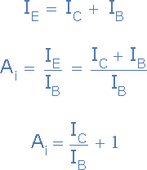

This type of bipolar transistor configuration is a non-inverting circuit in that the signal voltages of Vin and Vout are in- phase. It has a voltage gain that is always less than "1" (unity). The load resistance of the common collector transistor receives both the base and collector currents giving a large current gain (as with the common emitter configuration) therefore, providing good current amplification with very little voltage gain.

**Bipolar Junction Transistor Summary**

Then to summarise, the behaviour of the bipolar transistor in each one of the above circuit configurations is very different and produces different circuit characteristics with regards to input impedance, output impedance and gain whether this is voltage gain, current gain or power gain and this is summarised in the table below.

**Bipolar Transistor Characteristics**

The static characteristics for a **Bipolar Transistor** can be divided into the following three main groups.

|  |  |  |
| --- | --- | --- |
| Input Characteristics:- | Common Base - | ΔVEB / ΔIE |
|  | Common Emitter - | ΔVBE / ΔIB |
| Output Characteristics:- | Common Base - | ΔVC / ΔIC |
|  | Common Emitter - | ΔVC / ΔIC |
| Transfer Characteristics:- | Common Base - | ΔIC / ΔIE |
|  | Common Emitter - | ΔIC / ΔIB |

with the characteristics of the different transistor configurations given in the following table:

|  |  |  |  |
| --- | --- | --- | --- |
| Characteristic | Common  Base | Common  Emitter | Common  Collector |
| Input Impedance | Low | Medium | High |
| Output Impedance | Very High | High | Low |
| Phase Angle | 0o | 180o | 0o |
| Voltage Gain | High | Medium | Low |
| Current Gain | Low | Medium | High |
| Power Gain | Low | Very High | Medium |

Manaswin tripathi

Sec-b(g1)

22BTCSE0093