HEALTHCARE SYSTEM

Requirement:

A Health Care insurance company is facing challenges in enhancing its revenue and understanding the customers so it wants to take help of Azure Ecosystem to analyze the Competitors company data received from varieties of sources, namely through scrapping and third-party sources. This analysis will help them to track the behavior, condition of customers so that to customize offers for them to buy insurance policies and also calculate royalties to those customers who buy policies in past, this in turn will enhance their revenues.

Objective:

The goal of the project The goal of the project is to create data pipelines for the Health Care insurance company which will make the company make appropriate business strategies to enhance their revenue by analyzing customers behaviors and send offers and royalties to customers respectively.

Architecture

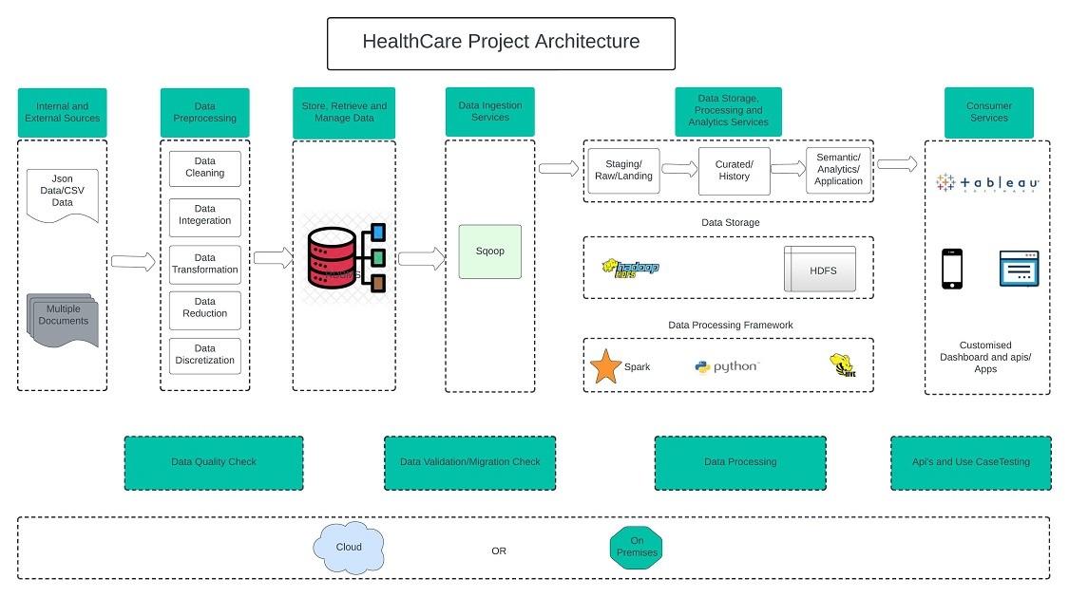

Dataset Explanation & Schema

Data coming from third-party sources reside in blob storage and has csv and json format.

Fields present in the data files and tables

Data files contain the below fields.

Column Name/Field Name Column Description/Field Description

Json File Fields

● CLAIM_ID

● PATIENT_ID

● DISEASE_NAME

● SUB_ID

● CLAIM_DATE

● CLAIM_TYPE

● CLAIM_AMOUNT

● CLAIMED_OR_REJECTED

CSV File 1 Fields (Patient.csv)

● PATIENT_ID

● PATIENT_NAME

● PATIENT _GENDER

● PATIENT _BIRTHDATE

● PATIENT _PHONE

● HOSPITAL_ID

● DISEASE _ NAME

● CITY

CSV File 2 Fields (Subscriber.csv)

● SUB_ID

● FIRST_NAME

● LAST_NAME

● STREET

● BIRTH_DATE

● GENDER

● PHONE_NO

● COUNTRY

● CITY

● ZIP_CODE

● SUBGRP_ID

● ELIG_IND

● E_DATE

● T_DATE

CSV File 3 Fields (Group.csv)

● GRP_ID

● GRP_NAME

● PREMIUM_WRITTEN

● GRP_TYPE

● PIN_CODE

● CITY

● COUNTRY

● ESTABLISHMENT_YEAR

CSV File 4 Fields (disease.csv)

● SUBGRP_ID

● DISEASE_NAME

● DISEASE_ID

CSV File 5 Fields (subgroup.csv)

● SUBGRP_ID

● SUBGRP_NAME

● GRP_ID CSV

File 6 Fields (hospital.csv)

● HOSPITAL_ID

● HOSPITAL _ NAME

● CITY

● STATE

● COUNTRY

CSV File 7 Fields (grpsubgrp.csv)

● SUBGRP_ID

● GRP_ID