Healthcare Project

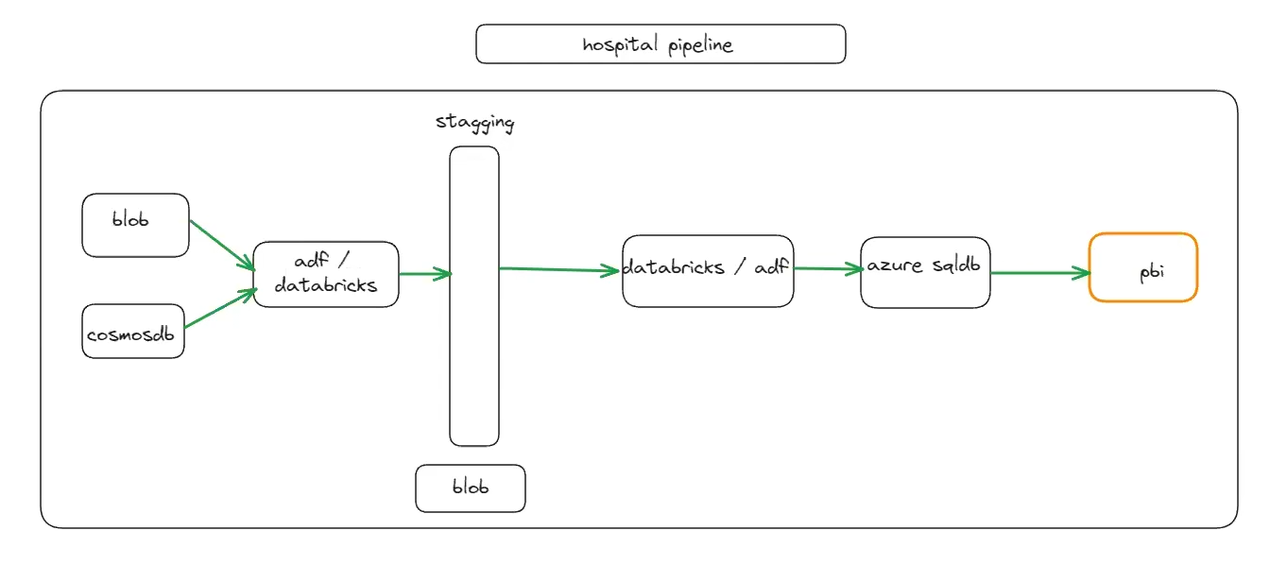

**Step 1: Create Storage Account, Cosmos DB account, ADF Account, Azure SQL Account, Azure Key Vault Account, and ADB Account**

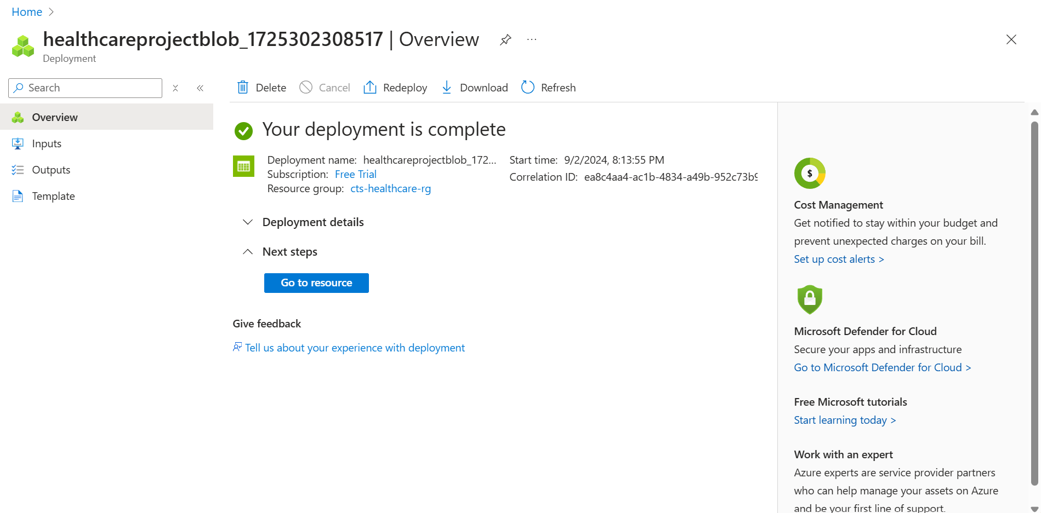

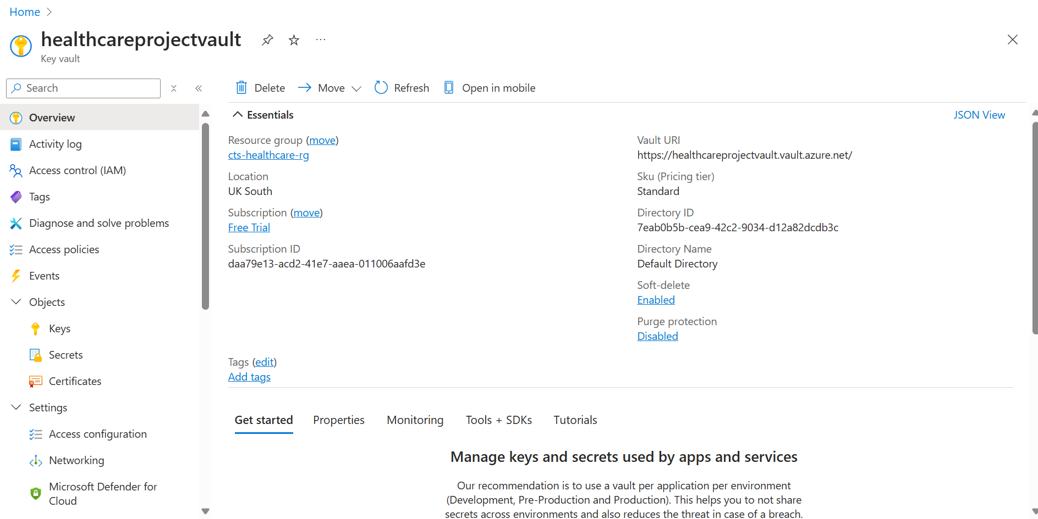

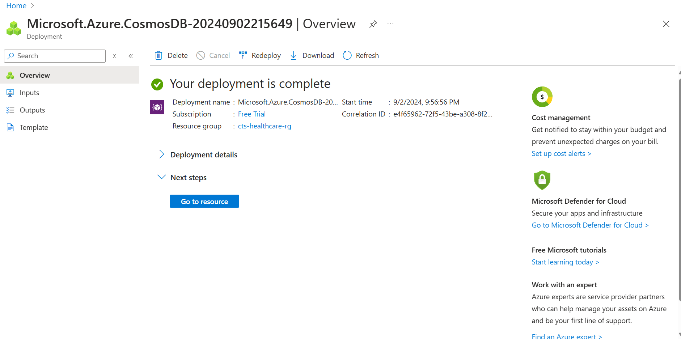

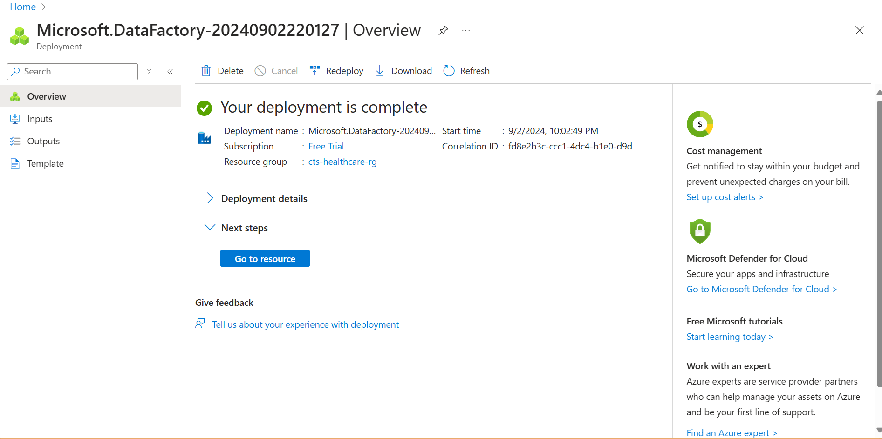

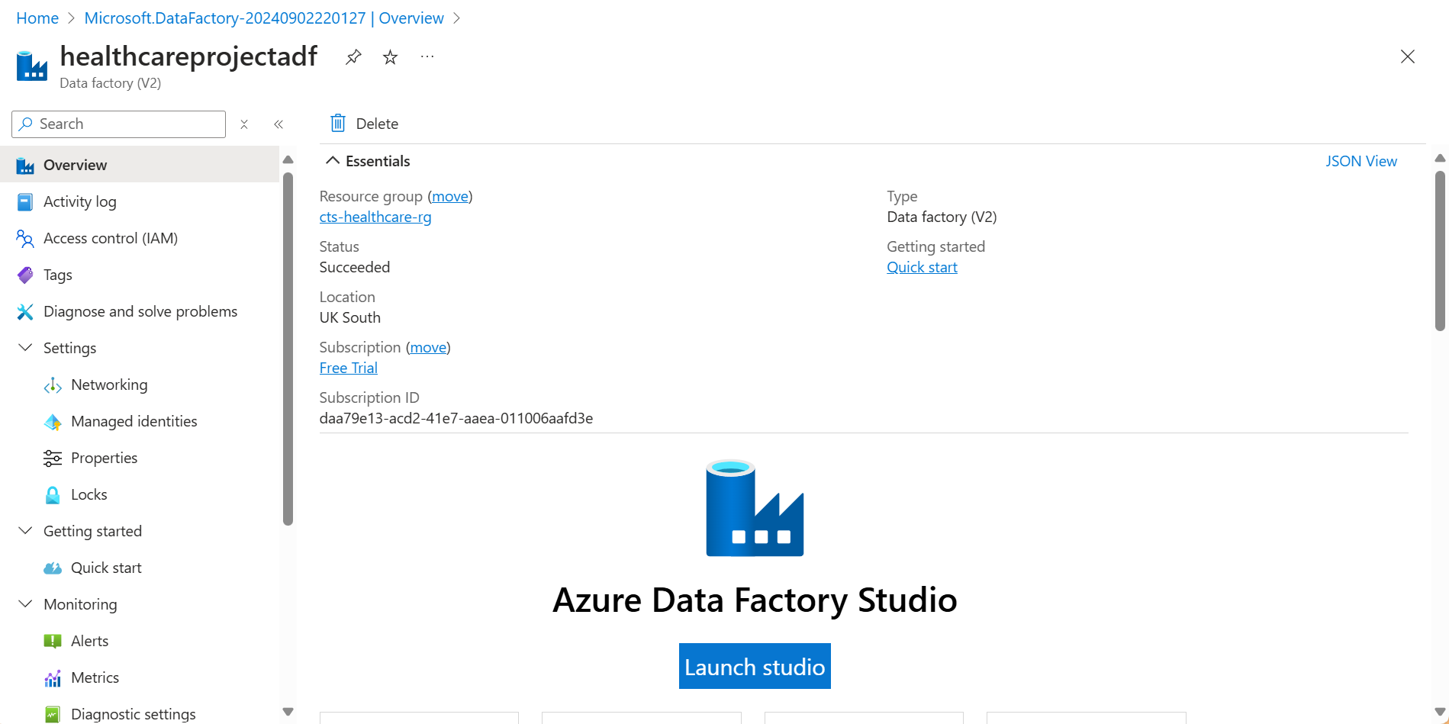

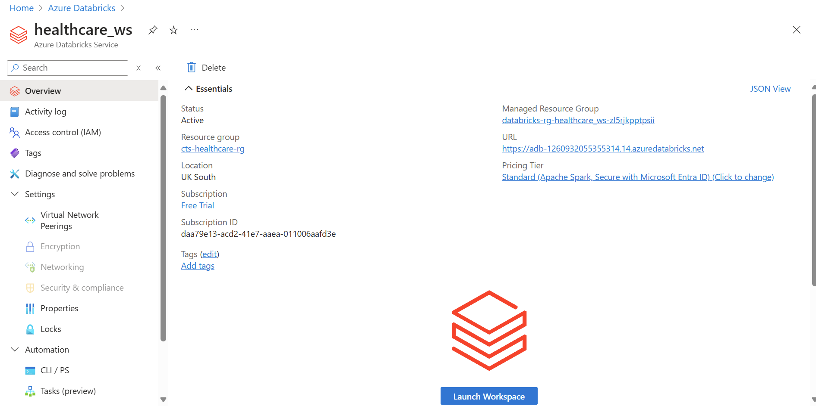

**Step 2:** Create scope in Databricks to connect to key-vault and access it.

<https://adb-1260932055355314.14.azuredatabricks.net#secrets/createScope>

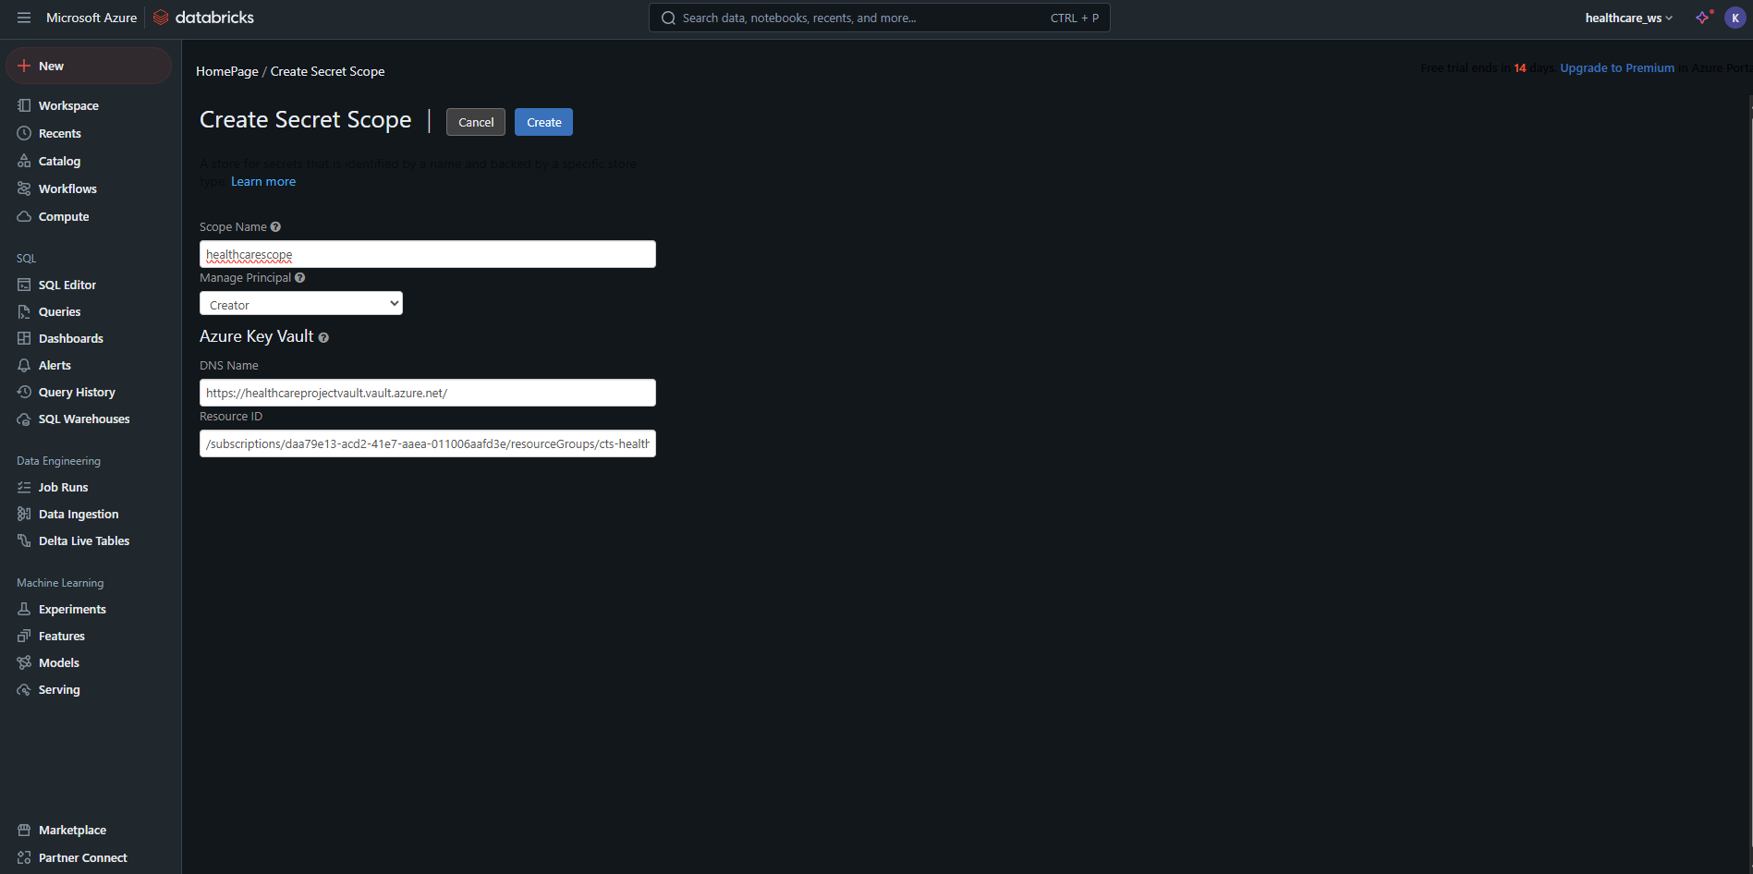

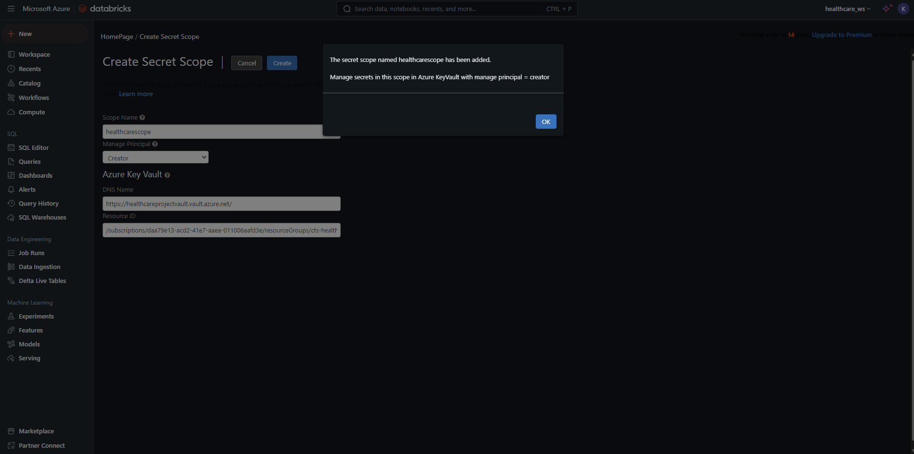

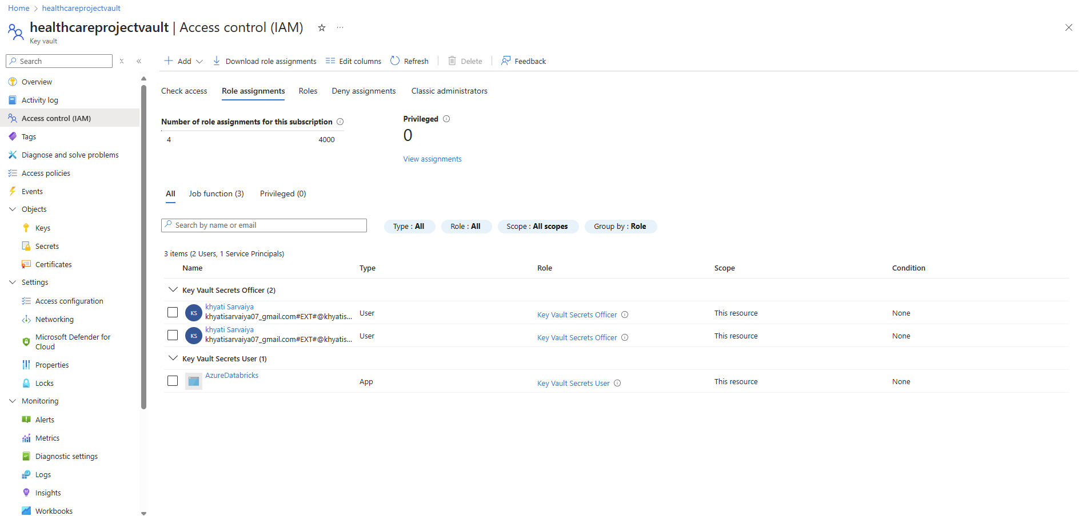

**Step 3:** Get the raw data from cosmosDB to raw container.

**Step 4:** Write all transformations in the Databricks to store the transformed data to stagging container.

Databricks notebooks are present in the folder.

**Step 5:** Run the pipeline in ADF.

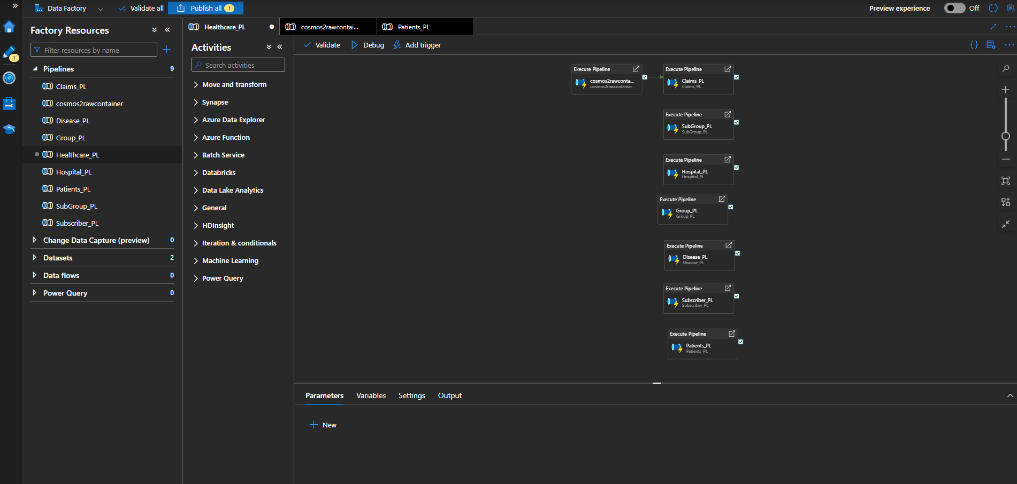

**Step 6:** Create Data Flow:

Based on the requirement, we need to de-normalize the data. It means bringing everything into one table.

Below is the final data flow for the transformations required in the healthcare project.

**Step-7:** Below is the final pipeline for the Healthcare Project

**Step-8:** Run the final pipeline.

We have the final transformed data in Azure SQL.

Step 9: Analyse the data by connecting Azure SQL to Power BI.