Computer Network (01CE0410) Lab Manual (2025-26)

Name: Manvendra Kumar
ER No.: 92400120027
Class: 4Ev-3
Lab Batch: A

92400120027
Practical 4: Implementation of Different LAN Topologies Using Network Simulator

Aim
To implement and analyze different Local Area Network (LAN) topologies such as Bus, Star, Ring, and Mesh using a Network Simulator and to study their structure and working.

Software Requirements
- Cisco Packet Tracer
- Operating System: Windows / Linux
- Basic knowledge of computer networks
Theory :
A Local Area Network (LAN) is a network that connects computers and devices within a limited geographical area such as a home, office, or campus.
The physical or logical arrangement of network devices is called network topology. Different LAN topologies are used based on cost, scalability, performance, and reliability.
1. Bus Topology

Description
In Bus Topology, all devices are connected to a single communication medium called the bus or backbone cable. Data transmitted by one node is received by all other nodes, but only the intended recipient processes it.

Advantages
- Easy to implement
- Low cost
- Requires less cable

Disadvantages
- Backbone failure causes entire network failure
- Difficult to troubleshoot
- Performance degrades with more nodes

Implementation Using Network Simulator
- Create multiple nodes
- Connect all nodes using a single shared link
- Assign IP addresses and simulate data transfer
Diagram

Figure 1: Bus Topology Implementation
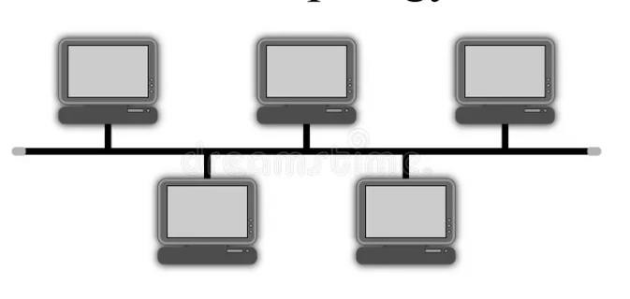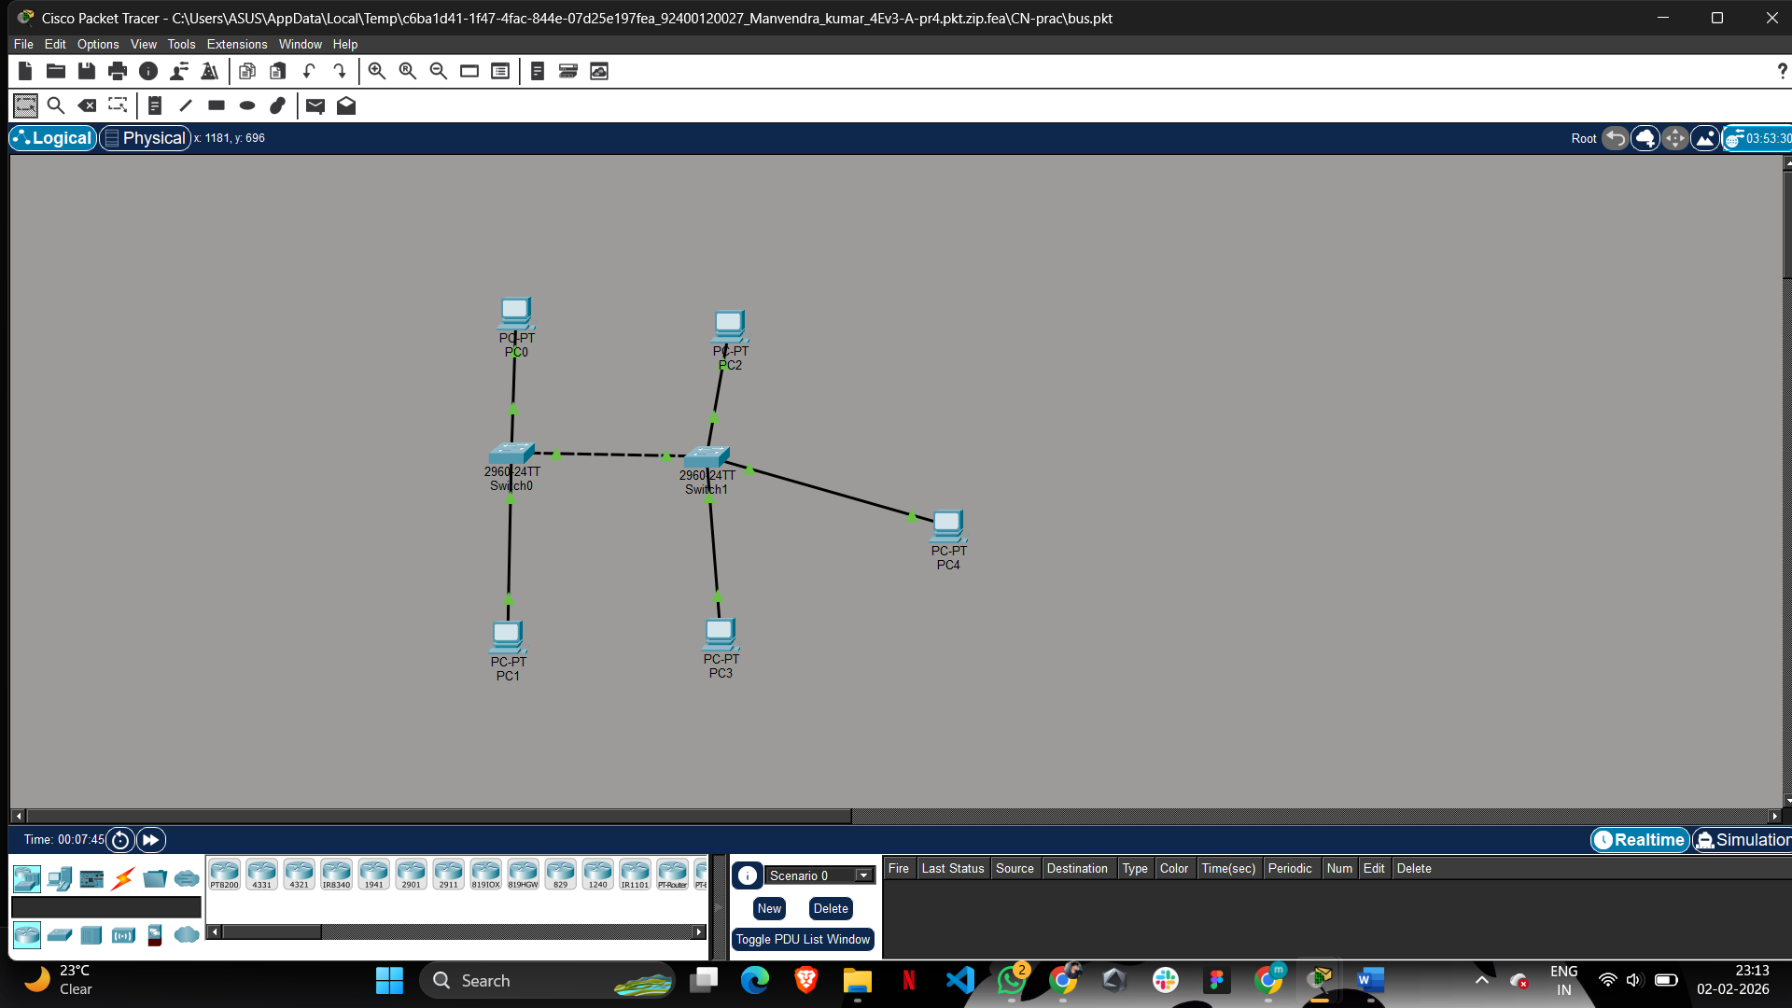

2. Star Topology

Description
In Star Topology, all nodes are connected to a central device such as a switch or hub. All communication passes through this central node.

Advantages
- Easy to manage and troubleshoot
- Failure of one node does not affect others
- Better performance

Disadvantages
- Central device failure brings down the network
- Requires more cabling

Implementation Using Network Simulator
- Place a switch/hub at the center
- Connect each node individually to the central device
- Configure IP addresses and test communication

Figure 2: Star Topology Implementation
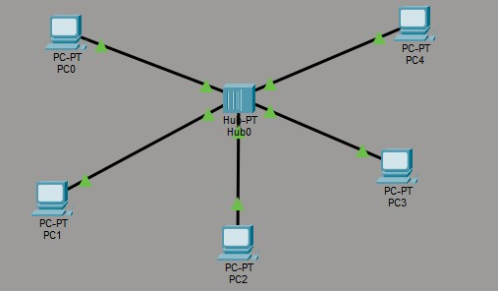

3. Ring Topology

Description
In Ring Topology, each node is connected to exactly two other nodes, forming a closed loop. Data travels in one direction (or both in dual ring).

Advantages
- Equal access to network
- No data collision
- Predictable performance

Disadvantages
- Failure of one node can break the network
- Difficult to add or remove nodes

Implementation Using Network Simulator
- Arrange nodes in a circular manner
- Connect each node to its adjacent nodes
- Simulate token passing or data transmission Figure 3: Ring Topology Implementation
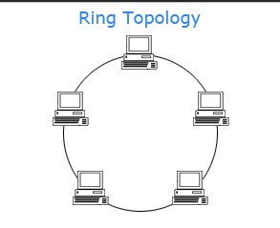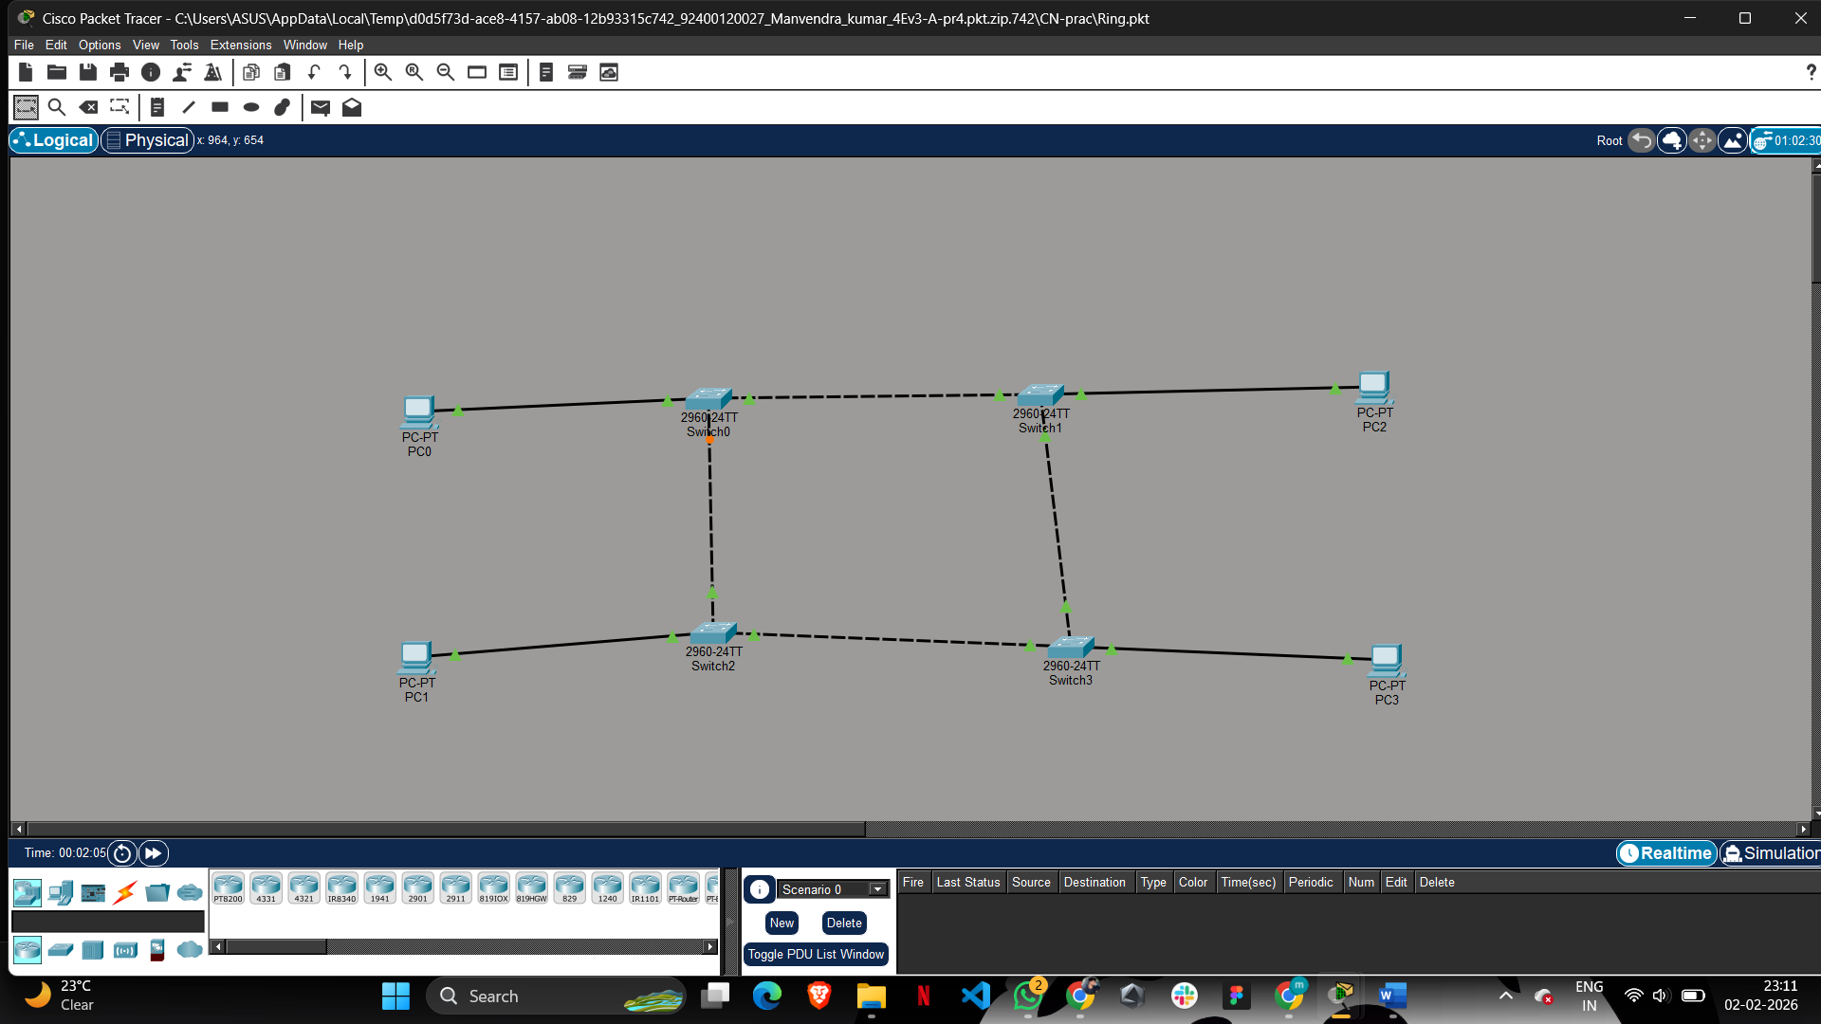
4. Full Mesh Topology

Description
In Full Mesh Topology, every node in the network is directly connected to all other nodes. This provides the highest level of redundancy and reliability, as multiple paths exist between any two nodes.

Advantages
- Very high reliability
- No single point of failure
- Supports high data traffic
- Easy fault detection

Disadvantages
- Very expensive
- Complex installation
- Requires large number of links and ports

Implementation Using Network Simulator
- Create multiple nodes
- Establish a direct link between every pair of nodes
- Assign IP addresses to each interface
- Simulate data transfer and observe multiple paths

Figure 4: Full Mesh Topology Implementation
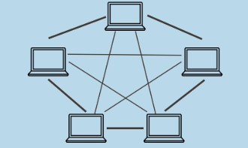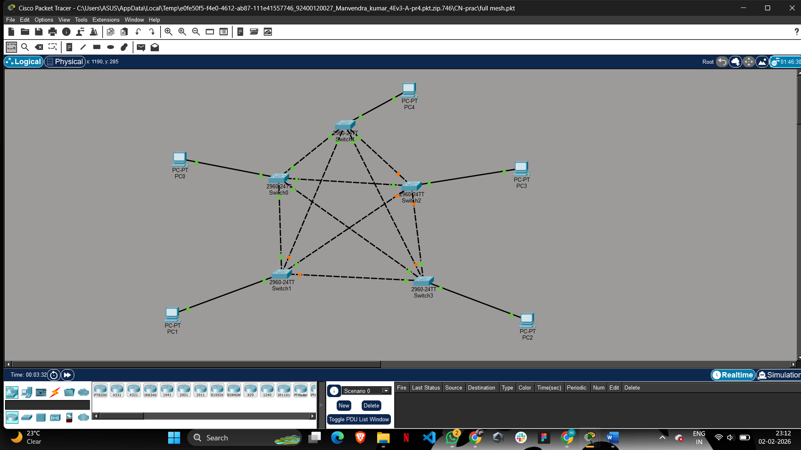

4.2 Half (Partial) Mesh Topology

Description
In Half Mesh (Partial Mesh) Topology, not all nodes are directly connected to every other node. Only selected nodes have multiple connections, while others are connected to one or two nodes. This reduces cost while still providing redundancy.

Advantages
- Less costly than full mesh
- More scalable
- Provides backup paths for critical nodes

Disadvantages
- Lower reliability compared to full mesh
- Network design can be complex

Implementation Using Network Simulator
- Create multiple nodes
- Connect only important nodes with multiple links
- Assign IP addresses
- Simulate communication and observe alternate paths
Diagram

Figure 5: Half (Partial) Mesh Topology Implementation

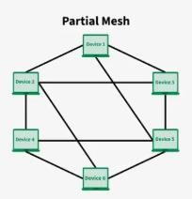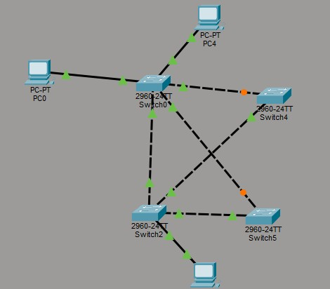

5. Hybrid Topology

Description
A Hybrid Topology is a combination of two or more different network topologies such as Star–Bus, Star– Ring, or Star–Mesh. It is designed to meet specific network requirements by combining the advantages of different topologies into a single network.
Hybrid topology is commonly used in large organizations, campuses, and enterprise networks, where different departments use different network structures but are interconnected.

Advantages
- Highly flexible and scalable
- Reliable compared to single topology networks
- Easy to expand by adding new segments
- Fault isolation is possible

Disadvantages
- Complex network design
- Higher cost
- Requires skilled administration

Implementation Using Network Simulator
- Design two or more different topologies (e.g., Star and Bus)
- Connect them using a switch or router
- Assign IP addresses to all nodes
- Simulate data transfer between nodes belonging to different topologies

Figure 6: Hybrid Topology Implementation (Star–Bus Combination)

