DEXIGNER

Team Name: Code_Og

Domain: Personal Portfolio

Member 1 Name: Manav Darji

Email id: manavdarji1@gmail.com

Phone No: 7069574054

Member 2 Name: -

Email id: -

Phone No: -

Tools and Technologies used:

Html, css and javascript is used in the project and a library called tilt.js is used for the cards.

Description(max 100 words):

This web will guide the techies to understand the flow of the web. And how the personal portfolio can be represented.

Screenshots(max 5):



(Main Screen)

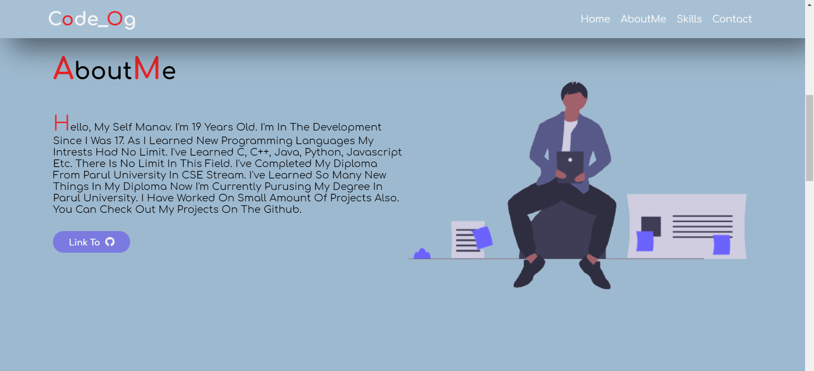

(About Screen)

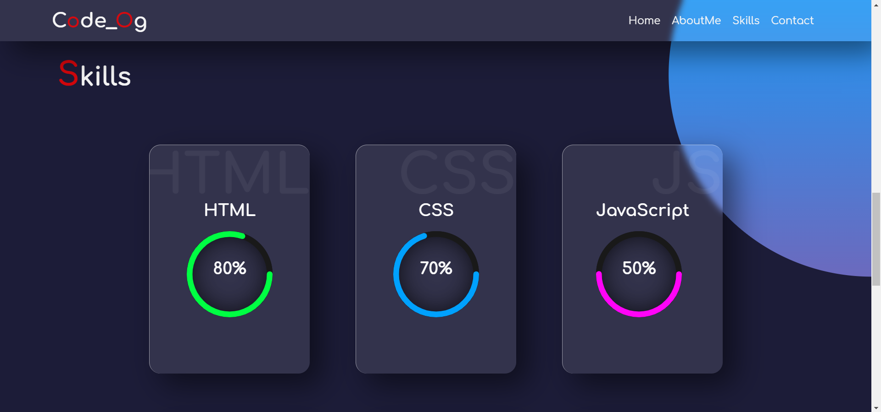

(skills Screen)



(contact Screen)