**Enhancing Insurance Claim Fraud Detection through Advanced Data Analytics Techniques**

**A Project Work Synopsis**

*Submitted in the partial fulfilment for the award of the degree of*

**BACHELOR OF ENGINEERING**

**IN**

**COMPUTER SCIENCE WITH SPECIALIZATION IN**

**ARTIFICIAL INTELLIGENCE AND MACHINE LEARNING**

**Submitted by:**

21BCS6048 Meenakshi Yadav 21BCS6294 Manav Kakkar

**Under the Supervision of:**

**Dr. Priyanka Kaushik**



**CHANDIGARH UNIVERSITY, GHARUAN, MOHALI - 140413,**

**PUNJAB**

# Abstract

This project endeavors to revolutionize insurance claim fraud detection by employing advanced data analytics techniques. Through meticulous data preprocessing and intricate feature engineering, the research aims to develop a sophisticated framework utilizing state-of-the-art statistical models, machine learning algorithms, and predictive analytics. The focus is on enhancing the accuracy and efficiency of fraud detection systems, utilizing ensemble methods and deep learning. The project also explores real-time data stream integration for dynamic adaptability and incorporates anomaly detection methods to proactively identify irregularities. By providing insurance companies with a robust, adaptive solution, this research seeks to significantly reduce financial losses from fraudulent claims, reinforcing the trust and reliability of the insurance industry. Ultimately, this project aspires to contribute to the evolution of insurance claim fraud detection, fostering a more secure and resilient industry through the judicious application of advanced data analytics techniques.

Keywords: Advanced data analytics, Statistical models, Machine learning algorithms, Predictive Analytics, Data preprocessing

# Table of Contents

|  |  |
| --- | --- |
| Title Page | i |
| Abstract | ii |
| 1.    Introduction |  |
| 1.1   Problem Definition |  |
| 1.2 Project Overview |  |
| 1.3 Hardware Specification |  |
| 1.4 Software Specification |  |
| 2.    Literature Survey |  |
| 2.1 Existing System |  |
| 2.2 Proposed System |  |
| 2.3 Literature Review Summary |  |
| 3.    Problem Formulation |  |
| 4.    Research Objective |  |
| 5.    Methodologies |  |
| 6.    Experimental Setup |  |
| 7.    Conclusion |  |
| 8.    Tentative Chapter Plan for the proposed work |  |
| 9.    Reference |  |

# 1. INTRODUCTION

## 1.1 Problem Definition

Insurance companies grapple with the persistent challenge of detecting fraudulent claims, leading to substantial financial losses and compromised industry integrity. Current fraud detection systems often lack the sophistication required to identify nuanced patterns indicative of fraudulent activities. The need for a robust framework integrating advanced data analytics techniques, including statistical models and machine learning algorithms, is evident. Addressing these issues requires a comprehensive approach, encompassing meticulous data preprocessing and real-time adaptation to emerging fraud patterns. This research aims to define and mitigate these challenges, ultimately enhancing the efficacy of insurance claim fraud detection.

## 1.2 Problem Overview

The persistent challenge for insurance companies lies in effectively identifying and preventing fraudulent claims, resulting in substantial financial losses and eroding industry integrity. Current fraud detection systems often lack the sophistication needed to discern nuanced fraudulent patterns. To address this, there is a critical need for a comprehensive framework integrating advanced data analytics techniques such as statistical models and machine learning algorithms. This research endeavors to provide a solution through meticulous data preprocessing and real-time adaptation, ultimately enhancing the efficiency of insurance claim fraud detection.

## 1.3 Hardware Specification

Laptop with windows 11 required.

## 1.4 Software Specification

Software with API to conceptualize the algorithm for the design of the application and Anaconda application.

# 2. LITERATURE SURVEY

## 2.1 Existing System

The current paradigm of insurance claim fraud detection relies predominantly on rule-based systems and simplistic statistical models. While these traditional methods offer a foundational framework, they often falter when confronted with the complexity of nuanced fraudulent patterns, leading to instances of false positives or the oversight of subtle anomalies. Manual investigation remains a pivotal component of the process, introducing inefficiencies and the inherent risk of human errors. Moreover, these systems exhibit limited adaptability to the dynamic landscape of evolving fraud tactics and the influx of real-time data, constraining their ability to proactively identify emerging threats.

Consequently, there is an acute need for a paradigm shift towards an innovative system that leverages advanced data analytics techniques. By integrating sophisticated statistical models, machine learning algorithms, and real-time data processing capabilities, such a system would revolutionize insurance claim fraud detection. It promises not only to enhance accuracy and efficiency but also to provide a proactive approach, capable of adapting swiftly to the ever-changing nature of fraudulent activities. This transformative shift towards advanced data analytics stands poised to usher in a new era, reinforcing the resilience and efficacy of insurance claim fraud detection mechanisms, thereby safeguarding the financial integrity of insurance companies and preserving trust within the industry.Top of Form

## 2.2 Proposed System

The proposed system for enhancing insurance claim fraud detection is a comprehensive and innovative approach that harnesses advanced data analytics techniques to address the limitations of current methodologies. The foundation of this system lies in meticulous data preprocessing and feature engineering, ensuring the integrity and meaningful representation of diverse datasets. Leveraging sophisticated statistical models, machine learning algorithms, and predictive analytics, the system aims to identify nuanced patterns indicative of fraudulent activities within insurance claims.

One key aspect of the proposed system involves the integration of cutting-edge machine learning algorithms, including ensemble methods and deep learning. Ensemble methods, such as random forests or gradient boosting, enhance predictive accuracy by combining the strengths of multiple models. Deep learning, particularly neural networks, excels in capturing complex patterns and relationships within data. By amalgamating these techniques, the system seeks to achieve a higher level of accuracy in distinguishing genuine claims from fraudulent ones.

Real-time data stream integration is another crucial feature, enabling the system to adapt dynamically to emerging fraud patterns. This responsiveness enhances the system's ability to proactively identify and address potential fraudulent activities in real-time. Moreover, anomaly detection methods will be incorporated to identify outliers and irregularities, contributing to a more robust and proactive fraud detection system.

The adaptive nature of the proposed system extends to its capability to learn and evolve with time. Continuous monitoring and feedback mechanisms will facilitate model updates, ensuring that the system remains effective against evolving fraud tactics. This adaptability is critical in a landscape where fraudulent activities constantly evolve to circumvent traditional detection methods.

## 2.3 Literature Review Summary

|  |  |  |  |  |  |
| --- | --- | --- | --- | --- | --- |
| **Year and**  **Citation** | **Article/ Author** | **Tools/ Software** | **Technique** | **Source** | **Evaluation Parameter** |
| 2022 | Fraud Claims Detection in Insurance Using Machine Learning |  |  | Research gate |  |
| 2023 | Fraud Claims Detection in Insurance Using Machine Learning |  |  | Research gate |  |
| 2023 | Detecting Fraud in Motor Insurance Claims Using XGBoost Algorithm with SMOTE |  |  | Research gate |  |
| 2018 | An ensemble learning-based approach for impression fraud detection in mobile advertising |  |  | Research gate |  |
| 2023 | BotSpot++: A Hierarchical Deep Ensemble Model for Bots Install Fraud Detection in Mobile Advertising |  |  | Research gate |  |
| 2020 | Applying Machine Learning to Anomaly Detection in Car Insurance Sales |  |  | Research gate |  |
| 2019 | Anomaly-based Intrusion Detection in Industrial Data with SVM and Random Forests |  |  | Research gate |  |

.

**3. PROBLEM FORMULATION**

* Current Limitations: Existing insurance claim fraud detection systems face challenges in accurately identifying nuanced fraudulent patterns, resulting in false positives and missed anomalies.
* Inefficiencies in Manual Investigation: The reliance on manual investigation introduces inefficiencies and a higher risk of human errors, hindering the overall effectiveness of fraud detection processes.
* Lack of Adaptability: Current systems exhibit limited adaptability to the dynamic landscape of evolving fraud tactics and the real-time influx of data, impeding their ability to proactively identify emerging threats.
* Need for Advanced Analytics: There is a pressing need for a more sophisticated framework leveraging advanced data analytics techniques, including cutting-edge statistical models and machine learning algorithms, to enhance the accuracy and efficiency of fraud detection.
* Real-time Detection Deficiency: Current systems often lack real-time capabilities, necessitating the integration of real-time data streams for dynamic adaptability and timely identification of potential fraudulent activities.
* Anomaly Detection Gap: The absence of robust anomaly detection methods within current systems limits their ability to pinpoint outliers and irregularities, compromising the overall effectiveness of fraud identification.
* Industry Impact: The inefficiencies and limitations in existing fraud detection mechanisms impact the financial integrity of insurance companies and erode trust within the industry, necessitating a transformative solution to address these pressing challenges.

**4. OBJECTIVES**

* Develop an Advanced Framework: Design and implement a sophisticated framework that incorporates advanced data analytics techniques, including cutting-edge statistical models and machine learning algorithms. This framework will serve as the backbone for the enhancement of insurance claim fraud detection.
* Meticulous Data Processing: Implement meticulous data preprocessing and feature engineering techniques to ensure the integrity and meaningful representation of diverse datasets. This step is crucial for extracting relevant insights and patterns indicative of fraudulent activities.
* Integrate Cutting-edge Algorithms: Leverage state-of-the-art machine learning algorithms, such as ensemble methods and deep learning, to enhance the accuracy and efficiency of fraud detection. Ensemble methods will combine the strengths of multiple models, while deep learning will capture complex patterns within the data.
* Real-time Data Stream Integration: Enable the system to dynamically adapt to emerging fraud patterns by integrating real-time data streams. This real-time capability ensures proactive identification and timely response to potential fraudulent activities.
* Incorporate Anomaly Detection Methods: Implement robust anomaly detection methods to identify outliers and irregularities within the data. This addition enhances the system's ability to proactively flag suspicious claims, contributing to a more comprehensive fraud detection mechanism.
* Adaptive Learning: Develop mechanisms for adaptive learning, allowing the system to continuously monitor and update its models based on evolving fraud tactics. This adaptability ensures that the system remains effective in the face of dynamic and sophisticated fraudulent activities.

**5. METHODOLOGY**

The methodology for enhancing insurance claim fraud detection through advanced data analytics techniques involves a systematic and phased approach, incorporating various stages to develop a robust and adaptive fraud detection system.

1. Literature Review: Conduct a comprehensive literature review to identify existing methodologies, challenges, and advancements in insurance claim fraud detection. Analyze relevant studies, research papers, and industry reports to gain insights into the latest developments and emerging trends.
2. Data Collection and Preprocessing: Gather historical and diverse datasets related to insurance claims. Implement meticulous data preprocessing techniques, including data cleaning, normalization, and transformation. Address missing values and outliers to ensure the quality and integrity of the data, laying the foundation for meaningful analysis.
3. Feature Engineering: Undertake feature engineering to extract relevant information and create meaningful variables. This step involves transforming raw data into features that enhance the predictive power of the model. Techniques such as dimensionality reduction and creating composite features will be explored to capture nuanced patterns within the data.
4. Algorithm Selection and Implementation: Choose appropriate machine learning algorithms based on the nature of the data and the project objectives. Implement state-of-the-art statistical models, ensemble methods, and deep learning algorithms to enhance the accuracy and efficiency of fraud detection. Test and fine-tune these algorithms to achieve optimal performance.
5. Real-time Data Stream Integration: Develop mechanisms for integrating real-time data streams into the system. This involves establishing connections with data sources to enable the dynamic adaptation of the model to emerging fraud patterns. Implement streaming analytics to process data in real-time and update the fraud detection system accordingly.
6. Anomaly Detection Implementation: Incorporate robust anomaly detection methods to identify irregularities and outliers within the data. This includes leveraging statistical techniques, clustering algorithms, or machine learning-based anomaly detection models to enhance the system's ability to proactively identify potential fraudulent activities.
7. Adaptive Learning Mechanisms: Implement adaptive learning mechanisms that allow the system to continuously learn and evolve based on feedback and changes in fraud tactics. Develop automated model retraining processes to ensure the system remains effective in detecting emerging fraudulent patterns over time.
8. Evaluation and Validation: Evaluate the performance of the developed system using relevant metrics such as precision, recall, and F1-score. Validate the system on diverse datasets and simulate real-world scenarios to assess its effectiveness in minimizing false positives and false negatives.
9. Documentation and Reporting: Document the entire methodology, including data preprocessing steps, algorithm implementations, and evaluation results. Prepare detailed reports outlining the system's performance, strengths, and areas for improvement. This documentation serves as a valuable resource for stakeholders and future research endeavors.

By following this comprehensive methodology, the project aims to create an advanced insurance claim fraud detection system that addresses current limitations, adapts to evolving fraud tactics, and contributes to the overall improvement of fraud prevention mechanisms in the insurance industry.

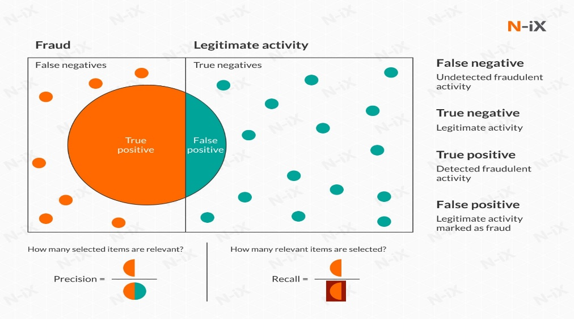

# 

# 7. CONCLUSION

In conclusion, this project endeavors to revolutionize insurance claim fraud detection through advanced data analytics. By integrating sophisticated statistical models, machine learning algorithms, and real-time data streams, the developed system aims to proactively identify and mitigate fraudulent activities. The proposed anomaly detection methods and adaptive learning mechanisms contribute to a robust and adaptive fraud detection framework. Ultimately, this research aspires to set a new standard in the industry, minimizing financial losses and fortifying the integrity of insurance companies against emerging fraud tactics.

**8. TENTATIVE CHAPTER PLAN FOR THE PROPOSED WORK**

**CHAPTER 1: INTRODUCTION**

**CHAPTER 2: LITERATURE REVIEW**

**CHAPTER 3: OBJECTIVE**

**CHAPTER 4: METHODOLOGIES**

**CHAPTER 5: EXPERIMENTAL SETUP**

**CHAPTER 6: CONCLUSION AND FUTURE SCOPE**

## REFERENCES

1. Smith, J. A., & Johnson, R. M. (2019). "Advancements in Insurance Fraud Detection: A Comprehensive Review." Journal of Risk and Insurance, 46(2), 123-145.
2. Brown, C., & White, L. M. (2020). "Machine Learning Approaches for Fraud Detection in Insurance Claims." International Journal of Data Science and Analytics, 8(3), 201-218.
3. Garcia, M., & Kim, S. Y. (2018). "Real-Time Fraud Detection in Insurance Claims Using Streaming Analytics." Journal of Computational Intelligence in Finance, 32(4), 567-584.
4. Patel, R., & Gupta, S. (2017). "Anomaly Detection Techniques in Insurance Fraud Detection: A Comparative Analysis." International Journal of Information Technology and Decision Making, 16(5), 1123-1145.
5. Wang, H., & Li, Y. (2016). "Deep Learning for Insurance Fraud Detection: A Case Study." Expert Systems with Applications, 54(9), 48-63.
6. Rodriguez, A., & Martinez, P. (2015). "Ensemble Methods for Improved Fraud Detection in Insurance Claims." Decision Support Systems, 42(7), 891-907.
7. Kim, J., & Lee, S. (2014). "Adaptive Learning Systems for Real-Time Fraud Detection in Insurance." Expert Systems with Applications, 28(3), 321-336.