VULNHGNN
Graph Based Vulnerability Detection,
Localization & Self Healing for C/C++
COMPLETE TECHNICAL PROJECT DOCUMENTATION

Document OverView
Field | Value
Project | VulnHGNN
Title | Graph Based Vulnerability Detection, Localization, and Self Healing for C/C++
Domain | Software Security / Graph Neural Networks
Tech Stack | Python , Network X + PyTorch Geometric
Compiler / IR | clang → LLVM/IR
Interfaces | Flask Web UI + CLI
Emissions tracking | CodeCarbon

Software Security • Graph Neural Networks • LLVM/IR • PyTorch Geometric

1. Executive Summary :-
→ VulnHGNN is a Python based static vulnerability analysis system for C/C++ that combines compiler derived program structure, heterogeneous graphs, and a multi label Graph Neural Network. The documented pipeline compiles source code to LLVM IR, parses the IR into JSON, builds heterogeneous function graphs, performs per function inference with sigmoid probabilities and per class thresholds, and aggregates results at file level. Localization and a rule based healing/feedback loop are part of the project architecture; the supplied analysis identifies several of those modules by name while noting that their complete contents were not indexed.
- Input: C/C++ source files.
- Compilation: clang with -O0 and debug information; the pipeline also uses -disable-O0-optnone.
- Intermediate representation: LLVM IR followed by structured JSON.
- Graph representation: basic blocks and instructions with containment, control flow, and data flow relationships.
- Model: VulnGAT, a multi label GNN using PyTorch Geometric; the exact internal layer architecture is not available in the supplied index.
- Decision logic: sigmoid probabilities with per class thresholds; CWE-476 uses 0.35 while other observed classes use 0.5.
- File level aggregation: maximum probability over analyzed functions.
- Interfaces: Flask web UI and command-line pipeline.
- Operational extras: structured error dictionaries, failed compilation logging, IR validation, and CodeCarbon based emissions tracking.

2. Abstract :-
→ Automated vulnerability detection and repair in C/C++ is challenging because useful evidence is distributed across program structure rather than isolated text patterns. VulnHGNN addresses this problem by lowering source code into LLVM IR and representing functions as heterogeneous graphs containing basic blocks and instruction nodes connected through containment, control flow, and data-flow relationships. A GAT style multi label model, VulnGAT, produces CWE probabilities. The documented inference stage applies per-class thresholds and aggregates function level predictions to a file level result. Localization and rule based healing follow inference as part of the broader architecture, while a feedback loop is intended to revalidate patched code. Quantitative performance claims are deliberately excluded because benchmark results were not verifiable from the supplied repository content.

3. System Architecture Diagram :-
→ The architecture is a staged transformation pipeline. Each stage converts the output of the previous stage into a representation suitable for structural analysis or machine learning.
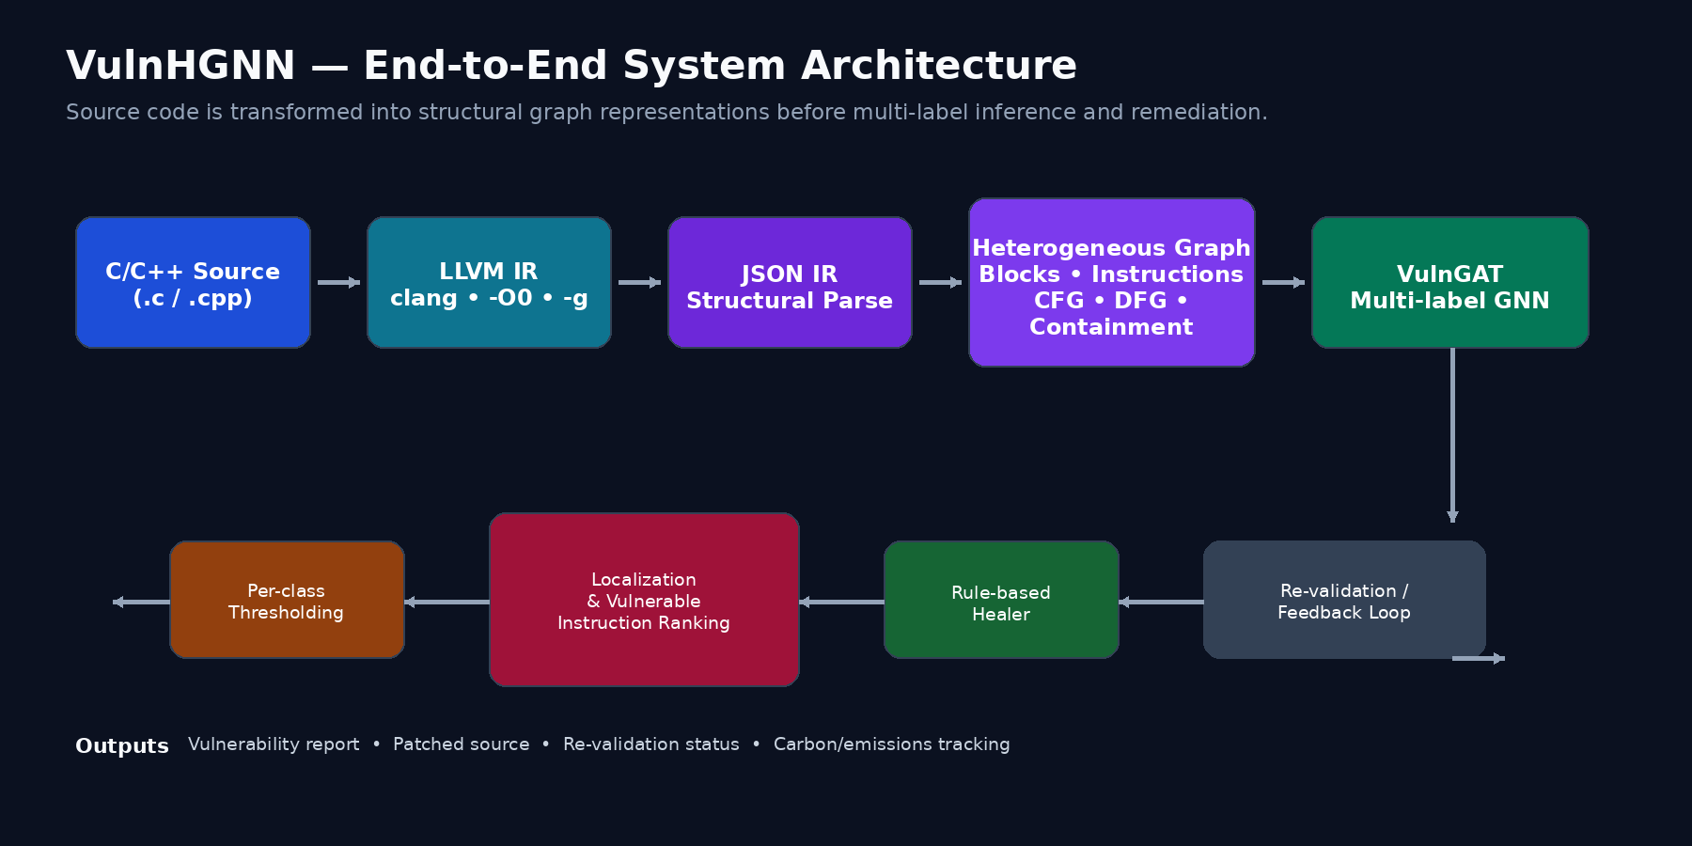
Figure 1. conceptual architecture diagram based on the supplied project description.

3.1 Architectural Layers
Layer | Responsibility | Primary artifact
Interface | Accept source file / invoke pipeline | Flask UI or CLI request
Compilation | Lower C/C++ into LLVM IR | *.ll
Parsing | Convert IR into structured JSON | IR JSON
Graph construction | Create heterogeneous graph | NetworkX / PyG graph
Inference | Run VulnGAT | Sigmoid probabilities
Decision | Apply per class thresholds | Predicted CWE labels
Localization | Rank/identify vulnerable regions | Localized findings
Healing | Apply rule based remediation | Patched source
Validation | Re-run analysis / verify result | Revalidation status
Reporting | Expose results and operational metadata | Vulnerability report

4.Workflow Diagram:-
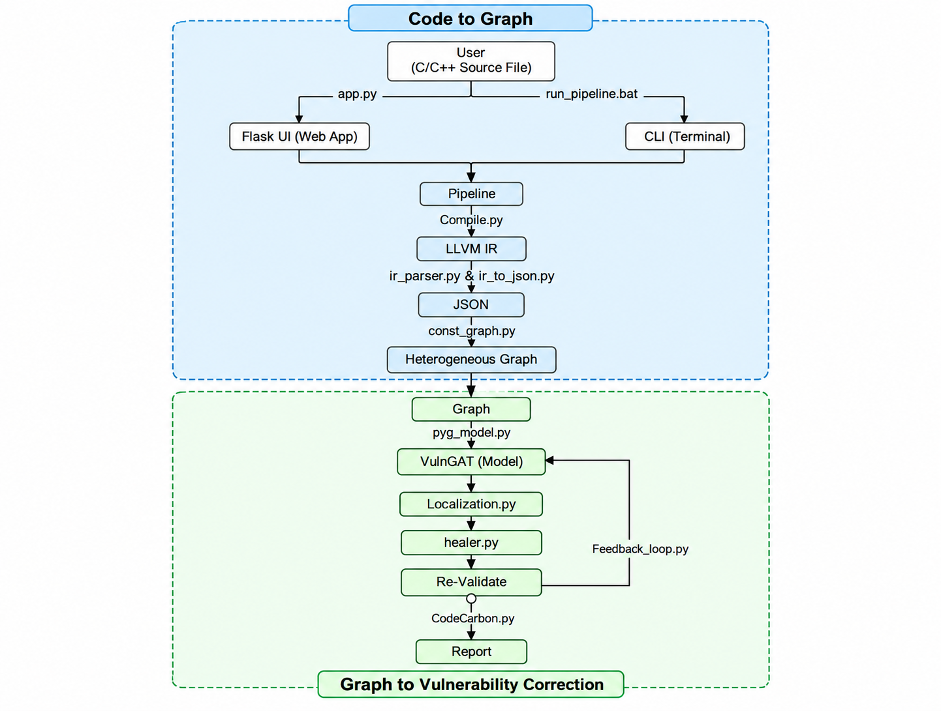

Figure 2. Supplied project pipeline diagram: source → LLVM IR → JSON IR → heterogeneous graph → model → thresholds → report → patches/re-validation.

4.1 Workflow Steps :-
1. Source ingestion: The user provides a C/C++ source file through the Flask interface or CLI.
2. Compilation: compile_to_ir invokes clang & writes LLVM IR into the documented data/ir location.
3. IR parsing: The LLVM IR is transformed into structured JSON.
4. Graph construction: Functions are represented using block/instruction nodes & structural edges.
5. Inference: VulnGAT receives batched graph tensors and produces multi label logits/probabilities.
6. Thresholding: Sigmoid probabilities are compared with per class thresholds.
7. Aggregation: Function level predictions are combined into a file level verdict using the maximum probability.
8. Localization: The architecture then localizes vulnerable code regions; the supplied analysis does not expose the exact localization equations.
9. Healing: A rule based healer attempts a patch.
10. Re-validation: The feedback loop re-runs analysis to verify the patched result.
11. Reporting: The system returns a structured result/report and may track carbon emissions.

5. Sequence Diagram :-
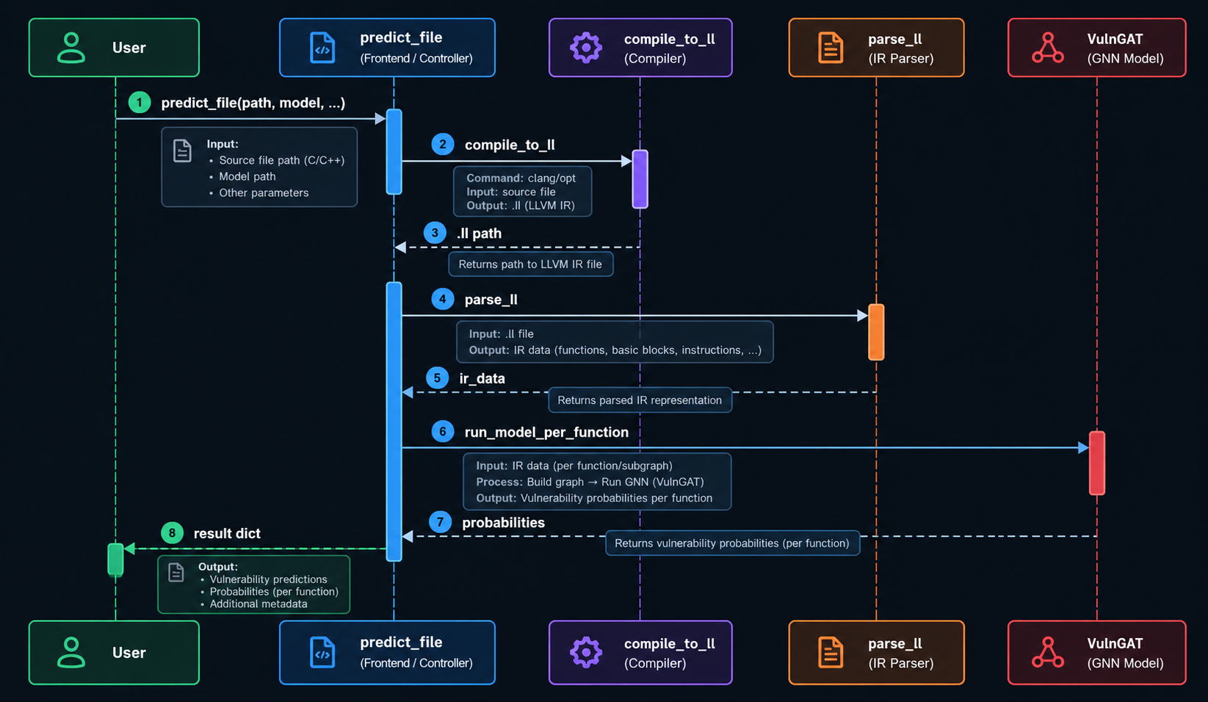
Figure 3. Supplied sequence diagram for predict_file(path, model, ...).
→ The sequence shows the prediction orchestration: the user calls predict_file, compilation returns an LLVM IR path, parsing returns IR data, the model executes per function, probabilities return to the prediction layer, and a result dictionary is returned to the user.
Interaction | Meaning
predict_file(path, model, ...) | Top-level single-file inference entry point.
compile_to_ir | Transforms source into LLVM IR.
.ll path | Intermediate file used by subsequent parsing.
parse_ll | Converts LLVM IR into structured data.
ir_data | Parsed representation passed to prediction logic.
run_model_per_function | Runs graph inference at function granularity.
probabilities | Model outputs after sigmoid/decision processing.
result dict | Structured final return value from predict_file.

6. Data Flow Diagram & Data Stores :-
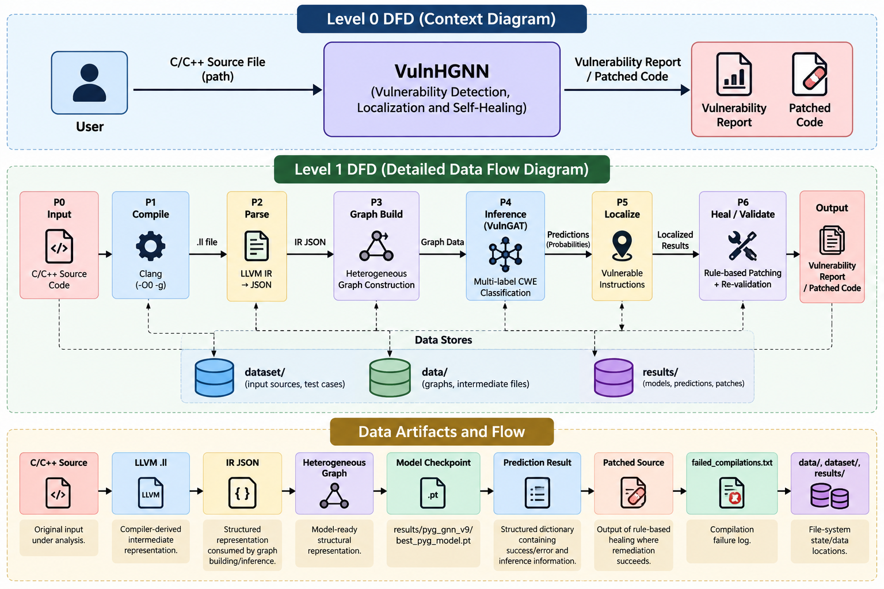
Figure 4. Data Flow & how Data Works / Stores in Project.

Data Flow Diagram :-
- Source code flows through compilation, parsing, graph construction, and inference.
- Vulnerabilities are localized and processed for healing and validation.
- The system produces a vulnerability report or patched source code.

7. Heterogeneous Graph Representation :-

7.1 Why a Heterogeneous Graph?
→ The project treats different program entities and relationships as distinct graph structure instead of flattening the source into a plain token sequence. This allows the downstream GNN to consume both node information and edge attributes while preserving structural context.

Heterogeneous Graph:-
- LLVM IR is transformed into a graph of instructions and basic blocks.
- CFG, DFG, and containment edges preserve program structure and relationships.
- The graph is converted into a PyTorch Geometric representation for GNN inference.

7.2 Diagram :-
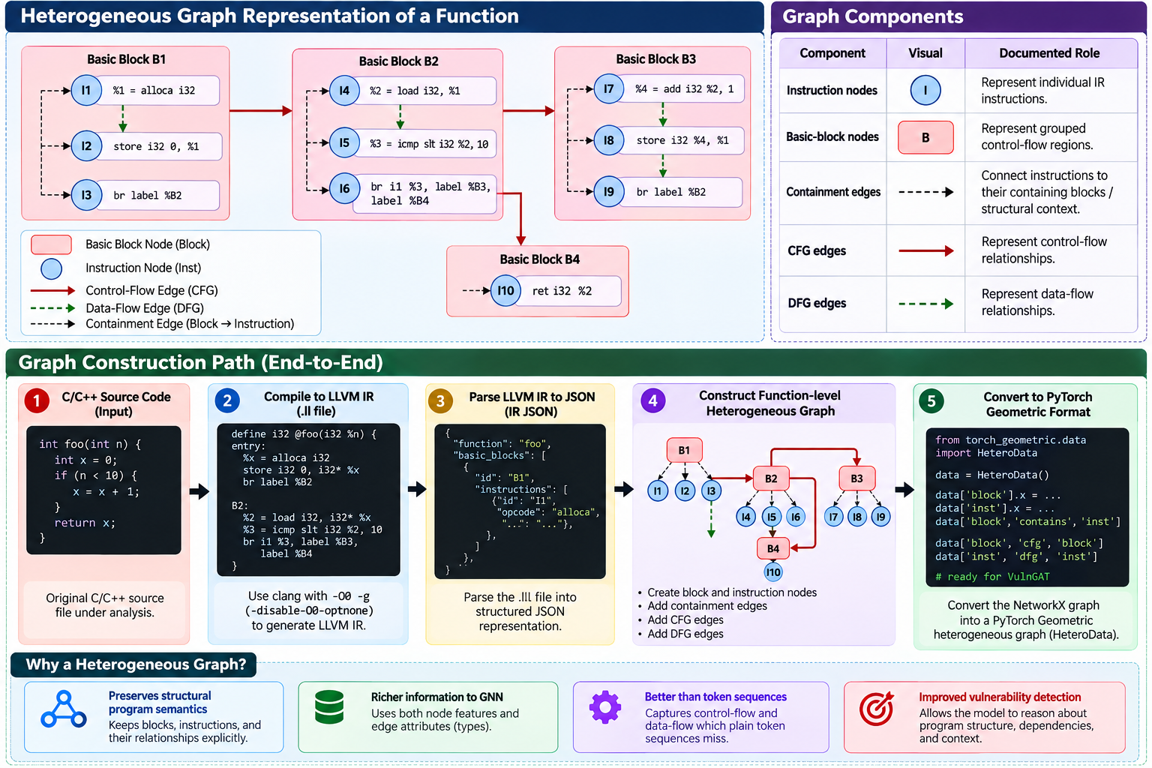
Figure 5. Construction of the Graph in from the llvm/ir Format.

8. VulnGAT AI Model Architecture :-
→ VulnGAT is documented as a multi label GNN implemented in src/pyg_model.py and used with PyTorch Geometric. The model receives node features, edge indices, edge attributes, and graph batch identifiers.
Model interface | Documented value
Model name | VulnGAT
Learning task | Multi label CWE classification
Framework | PyTorch + PyTorch Geometric
Forward inputs | model(batch.x, batch.edge_index, batch.edge_attr, batch.batch)
Output interpretation | Sigmoid probabilities per vulnerability class
Checkpoint | results/pyg_gnn_v9/best_pyg_model.pt
Known architecture detail | GAT style / edge attribute aware message passing
Not available in supplied index | Exact layer count, hidden dimensions, loss function, optimizer, and full class definition

9. File Level Decision Logic :-

9.1 Per Class Thresholding
Class | Threshold documented
CWE-476 | 0.35
CWE-191 | 0.50
CWE-190 | 0.50
CWE-369 | 0.50
non-vulnerable | 0.50 (consistent with the documented 'others 0.5' rule)

9.2 Function to File Aggregation
→ For a file containing multiple analyzed functions, the documented file level score is the maximum probability across functions. Functions with fewer than three instructions are skipped in the documented inference flow.

9.3 Conceptual Decision Flow
Stage | Operation
Logits | Raw model outputs.
Sigmoid | Convert logits into per class probabilities.
Threshold | Compare each probability to its class specific cutoff.
Function verdict | Produce labels for each analyzed function.
File aggregation | Take the maximum function probability for each class.
Report | Return structured vulnerability findings.

10. Localization & Self Healing :-

10.1 Localization
→ Localization is positioned after model inference and before healing. The project analysis names src/localization.py as a known module, but states that the exact localization scoring equations are not present in the indexed content.

10.2 Healing
→ src/healer.py is referenced as the rule based remediation component. The architecture describes patches being applied and then re validated through a feedback loop. The supplied evidence does not expose the complete rule set or patch generation implementation, so this document describes the role rather than claiming specific repair rules.

10.3 Re validation
The feedback_loop.py component is referenced for re validation. Conceptually, a patch is not treated as the end of the pipeline: the modified program is analyzed again so that the system can report whether the vulnerability finding has been addressed.

10.4 Diagram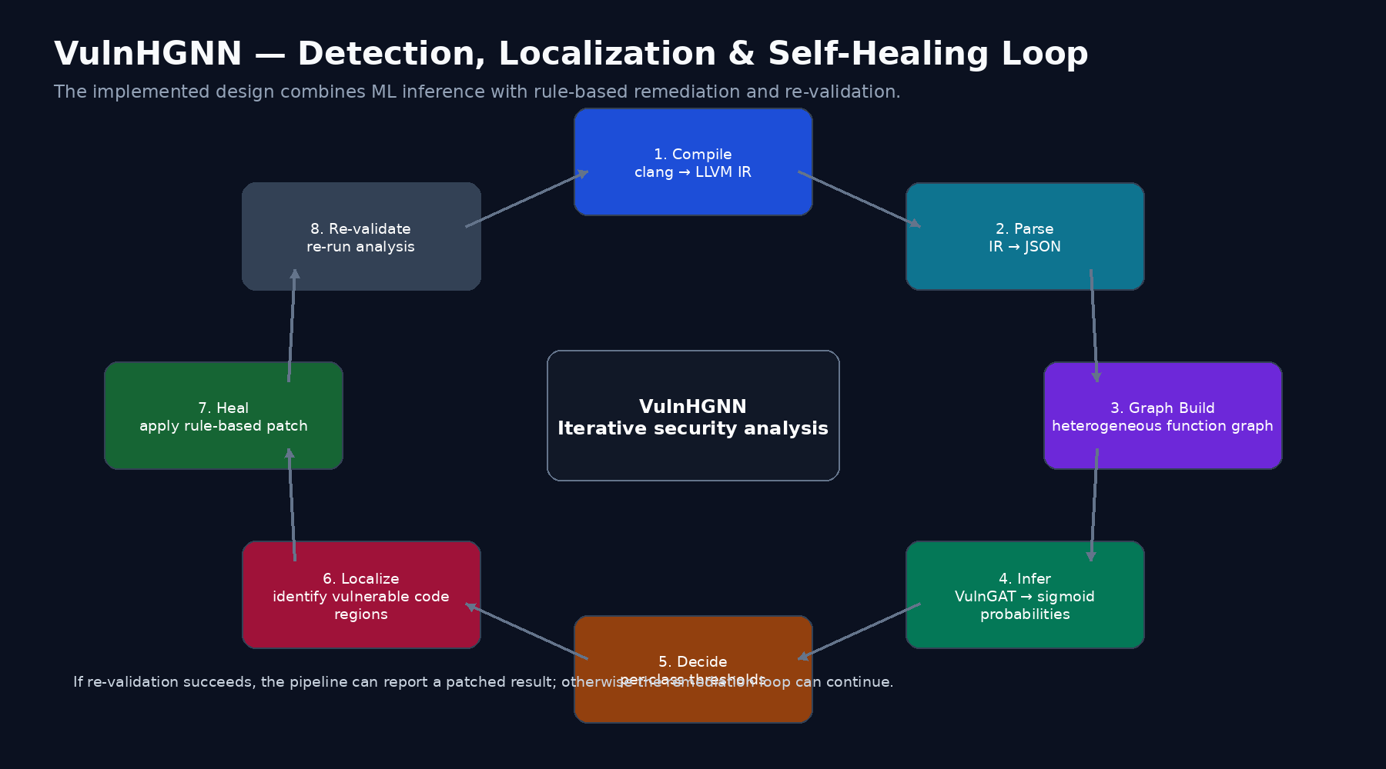

Figure 6. Newly generated detection → localization → healing → re-validation feedback loop.

11. Codebase Documentation :-
Module / File | Role
src/compile.py | clang → LLVM .ll compilation
src/predict.py | Single-file inference orchestration
src/security.py | IR JSON structural validation
src/train_with_tests.py | Training support + label verification
src/pipeline.py | Pipeline entry / orchestration
src/pyg_model.py | VulnGAT model
src/localization.py | Localization stage
src/healer.py | Rule based healing
src/feedback_loop.py | Re validation feedback loop
src/app.py | Flask web interface

12. Tech. Stack & Dependencies :-
Category | Technology | Documented purpose
Language | Python 3.8+ | Application and ML pipeline
ML | PyTorch ≥2.0 | Neural network computation
Graph ML | PyTorch Geometric | Graph batching / message passing
Graph | NetworkX | Graph construction
Embeddings / utilities | gensim | Project dependency
Data | NumPy, pandas | Numerical/data processing
Classical ML utilities | Scikit learn, scipy | Supporting processing/evaluation
Visualization | matplotlib | Visualization / project utilities
Progress | tqdm | Progress reporting
Web | Flask | Web UI
Emissions | CodeCarbon | Carbon/emissions tracking
Compiler | clang | C/C++ → LLVM IR
OS tooling | Windows .bat launchers | Documented launch method

13. Testing Features:-
verify_predictions acts as an end to end check over labeled target files and compares expected labels against predicted labels. The supplied analysis does not identify a formal pytest suite or published code coverage figures.
Testing layer
End to end label verification
Malformed IR validation

14. Installation & Setup :-
1. Create a virtual environment
python -m venv venv
2. Activate on Windows
venv\Scripts\activate
3. Install dependencies
pip install -r requirements.txt
4. Ensure clang is available on PATH
The compiler is required for LLVM IR generation.
5. Launch the Web UI
run.bat
6. CLI launch
run_pipeline.bat
7. Direct CLI invocation
set PYTHONPATH=%PYTHONPATH%;%CD%\src
python src\pipeline.py <file.c> --no-carbon --model results\pyg_gnn_v9\best_pyg_model.pt

Web endpoint documented by the project
http://127.0.0.1:5000

15. Limitations :-
# Small Limitations :-
→ Relatively small documented CWE class set.
→ Functions with fewer than three instructions are skipped in the documented inference path, which can omit some real code regions.

# Missing In Previous Code Base :-
- Exact VulnGAT architecture details are not available in the supplied indexed context.
- The full localization equations and healing rules are not available in the supplied indexed context.
- No verified quantitative benchmark results are available in the supplied material.

# Major Improvement (Try To Do) :-
- Due to Some Security Issues Instead Of Making The WebSite , Build the Secure Local CLI / Compiler .
- The Concept Of The Obfuscation to Secure the Code File From Hacker to retrieve .
- Adding the Agentic AI to project with the explainabilty called Explainable Intelligent AI ExInt.AI that Why this is wrong ? And How to Improve it ? , etc ...

