VulnHGNN 2.0
SECURE C/C++ ANALYSIS & COMPILATION TOOLCHAIN
Project Technical Documentation & Target-State Specification

DOCUMENT PURPOSE : -
This document defines the finished state architecture, engineering boundaries, security model, interfaces, and acceptance criteria for VulnHGNN 2.0. It describes the evolution beyond the original VulnHGNN research prototype; it intentionally does not redocument capabilities that belong to Version 1 unless they are being replaced, hardened, or integrated into the new system.

Version 2.0 • Architecture baseline
Prepared as the engineering reference for implementation, validation, and deployment.

1. Executive Summary :-
→ VulnHGNN 2.0 is the next generation evolution of the existing VulnHGNN repository. The project does not replace the original research work. Instead, it keeps the useful research assets like program graph construction, learned representations, vulnerability detection, localization and repair concepts and restructures them into a dependable security pipeline that can operate as a developer tool.
→ The defining change is architectural: the system is no longer treated as a collection of ML experiments. It becomes a security toolchain with explicit contracts between source analysis, LLVM/IR analysis, graph construction, Agentic AI inference, localization, repair, verification, compilation, binary hardening and optional protection.

What makes 2.0 different :-
- Detection is separated from localization, explanation, repair and verification.
- Clang/LLVM becomes the compilation foundation instead of attempting to build a new C/C++ compiler frontend Website.
- Binary hardening and optional obfuscation become measurable compiler/toolchain stages.
- The entire system is exposed through a stable local CLI and machine-readable output.
- Agentic AI is an orchestration layer over deterministic tools and evidence, not the security authority by itself.
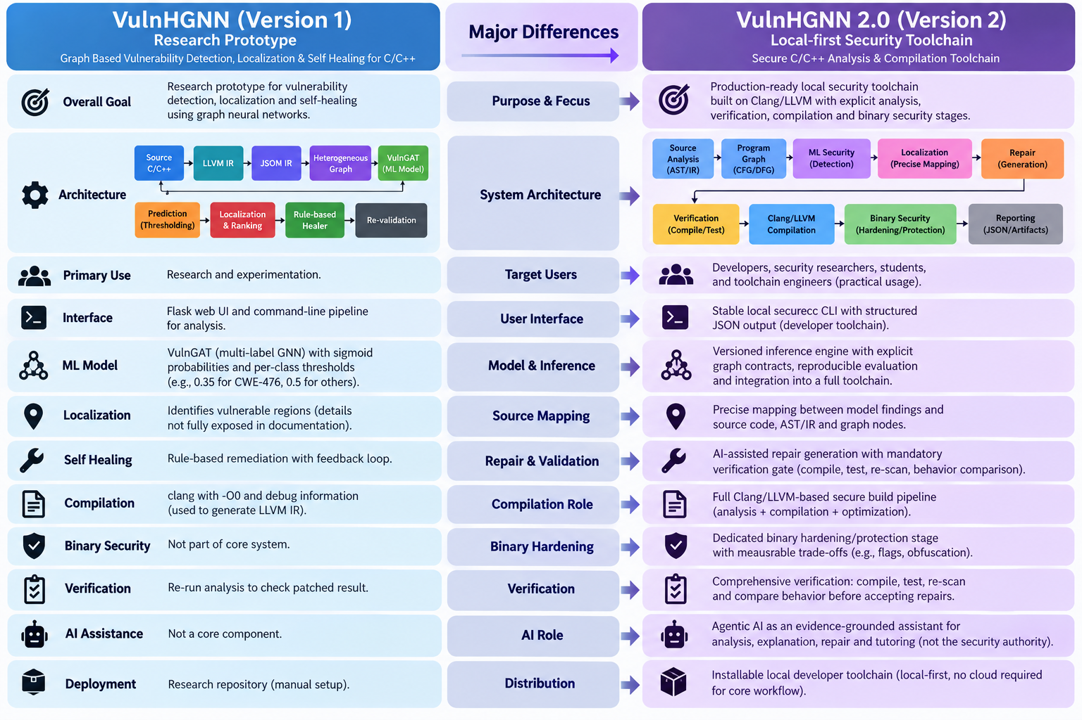

2. Version 2.0 Scope & Upgrade Boundary :-
→ The original VulnHGNN work established the research foundation. Version 2.0 focuses on everything required to turn that foundation into a reliable security product. Existing functionality is preserved when it is correct and useful; components that mix concerns, lack validation, duplicate experiments, or cannot support the new toolchain contracts are redesigned or replaced.
Area | Version 1 role | Version 2.0 transformation
IR / graph pipeline | Research data preparation | Canonical analysis pipeline with stable schemas and source/IR mapping
ML / GNN | Experimental vulnerability classifier | Versioned inference engine with explicit graph contracts and reproducible evaluation
Localization | Research output | Source ↔ AST ↔ LLVM IR ↔ graph node mapping
Healing | Prototype repair logic | Patch generation separated from verification and acceptance
Validation | Supporting experiments | Mandatory verification gate for accepted repairs
Compilation | Research preprocessing | Clang/LLVM based secure build pipeline
Binary security | Not the core system | Hardening/protection stage with measurable trade offs
Interface | Scripts / prototype app | Stable local secureCC CLI + JSON output
AI assistance | Feedback/experimental layer | Evidence grounded analyzer, explainer, repair and tutor orchestration
Deployment | Research repository | Installable local developer toolchain

3. Product Definition :-

3.1 Product statement
VulnHGNN 2.0 is a local first C/C++ security compiler/toolchain that combines program analysis, heterogeneous program graphs, machine learning, repair verification and LLVM based compilation into a single developer workflow.

3.2 Primary users
- C/C++ developers who want security feedback during the build workflow.
- Security researchers studying graph based vulnerability detection.
- Students learning secure C/C++ programming through concrete findings.
- Toolchain engineers extending the LLVM and binary security stages.

4. Final System Architecture :-
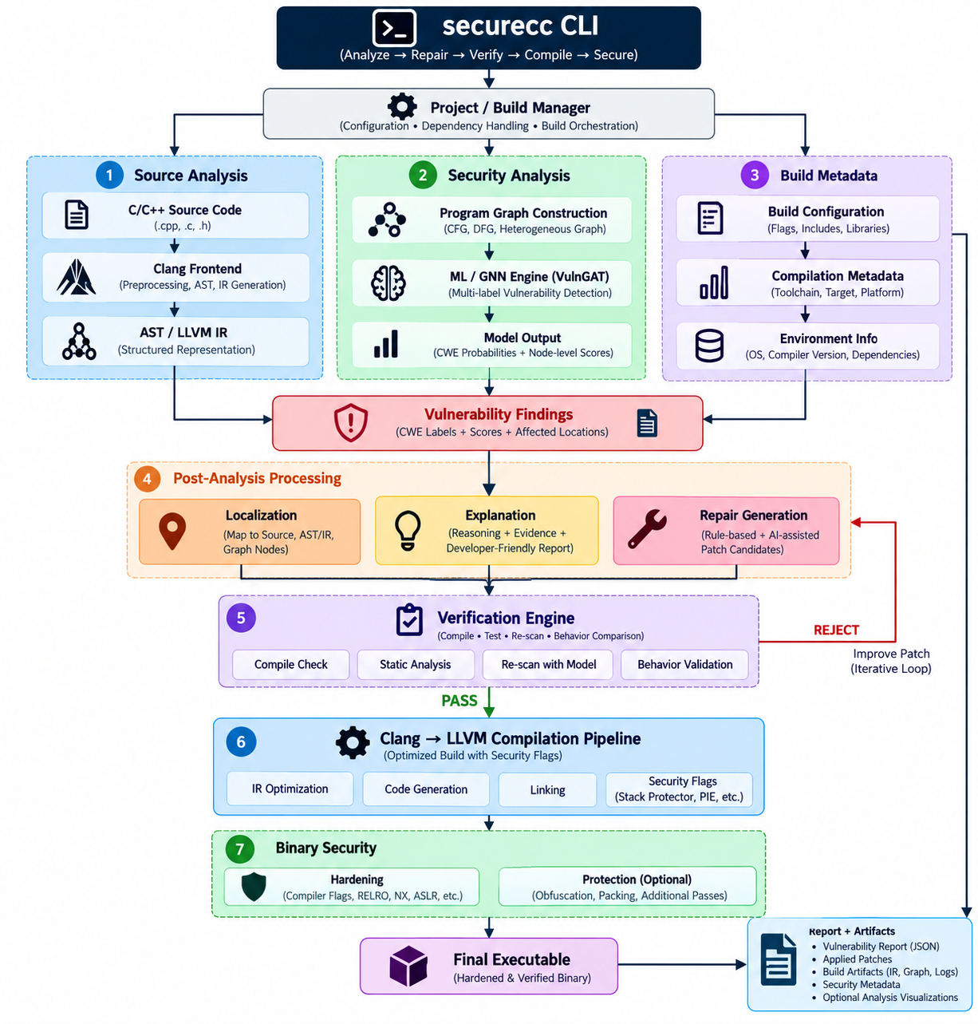

4.1 Architectural layers
Layer | Responsibility | Primary output
Interface | CLI commands,configuration,machine readable output | Command result / JSON
Orchestration | Build and analysis lifecycle | Execution plan
Source analysis | Parsing, AST/source locations, compiler diagnostics | Source facts
Program graph | CFG, DFG, call and heterogeneous relations | Versioned graph
ML security | Detection, classification and node-level inference | Findings
Localization | Map findings to source and IR | Precise locations
Repair | Generate candidate patches | Patch candidates
Verification | Compile, test, re-scan and compare behavior | Verification decision
Compiler | Clang/LLVM compilation and optimization | Object/executable
Binary security | Hardening and optional protection | Protected binary
Reporting | Human and machine-readable evidence | Report/artifacts

5. VulnHGNN 2.0 Security Intelligence Engine :-

5.1 Improved Graph representation
→ The 2.0 engine treats program structure as a heterogeneous graph rather than a flat feature vector. Graph construction is an explicit subsystem and is validated independently of the model.
Entity / relation | Role in 2.0
Instruction / operation | Fine grained computational and memory behavior
Basic block | Control flow and local execution context
Function | Interprocedural context and call relationships
Variable / value | Data flow and def use relationships
CFG edge | Execution ordering / branching
DFG / def use edge | Value propagation
Call edge | Interprocedural context
Containment edge | Program hierarchy

5.2 AI/ML Model responsibilities
- Vulnerability detection at the appropriate graph/program granularity.
- CWE aware classification where supported by validated training data.
- Node or region localization where labels and mappings are available.
- Confidence estimation that is calibrated and not presented as proof of safety.

5.3 Research discipline
- Dataset splits are performed to prevent source family leakage.
- Training, validation and test data are versioned.
- Model checkpoints are tied to graph/feature/dataset versions.
- Per CWE metrics are reported rather than hiding weak classes behind one aggregate score.
- A simple baseline remains available to distinguish genuine graph learning gains from feature engineering gains.

6. Localization, Explanation & Repair :-

Source to graph traceability & Repair life cycle
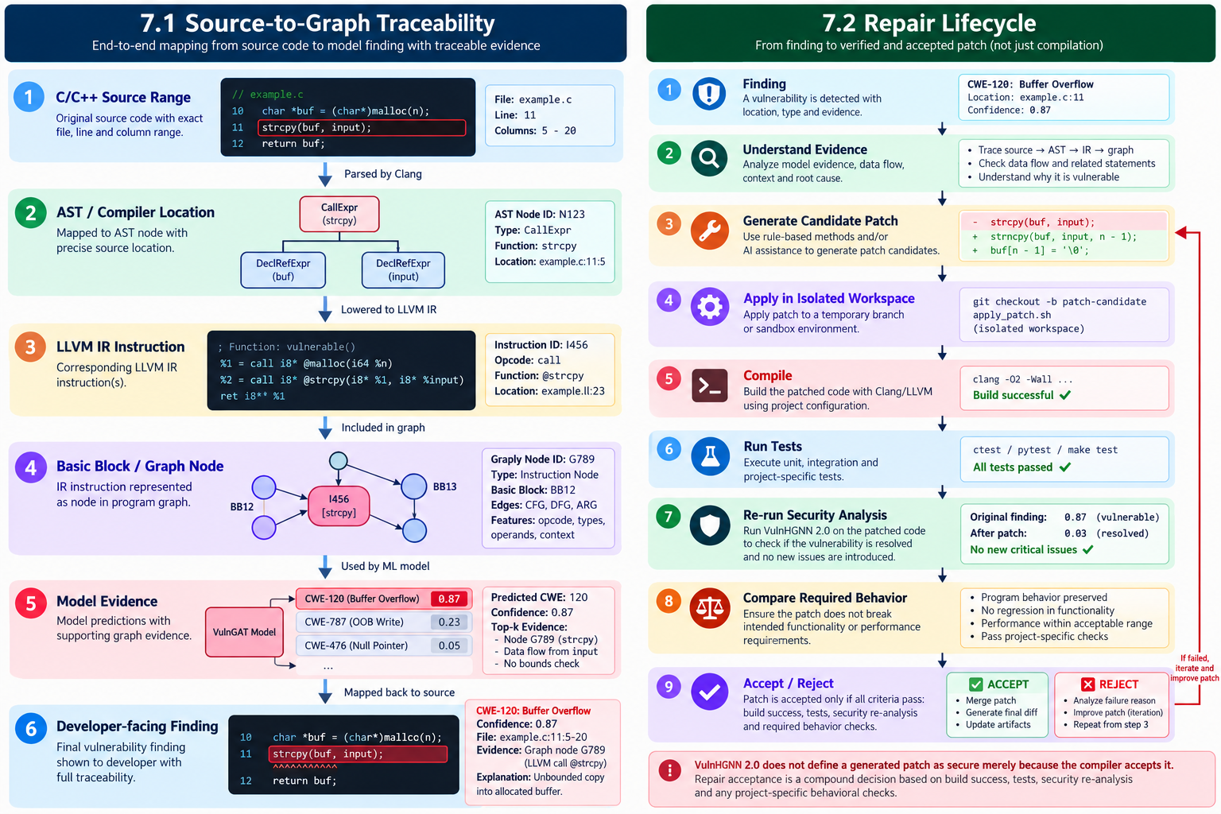

7. Binary Hardening & Protection :-
The binary security subsystem is designed to increase resistance to exploitation and reverse engineering while preserving correctness. It does not claim that a native binary can be made impossible to reverse engineer.

7.3 Required measurements
- Compiler/linker security: Apply platform/profile specific security properties and protections.
- Metadata & memory safety: Minimize unnecessary metadata and enable supported control-flow/memory protections.
- Binary validation: Validate the final binary against the active security policy.

7.3 Required measurements
- Policy controlled: Apply optional protection/obfuscation transformations as configured.
- Measured impact: Benchmark every transformation against an unprotected baseline for security, performance, and compatibility.
- No absolute guarantees: Prioritize correctness and express security gains as measured resistance/cost increases.

7.3 Required measurements
Metric | Purpose
Runtime overhead | Measure performance cost
Binary size | Measure deployment/storage impact
Startup time | Measure initialization cost
Memory use | Measure runtime resource impact
Compatibility | Detect platform/toolchain regressions
Security properties | Confirm requested hardening/protection is actually present
Transformation stability | Detect correctness failures

8. Agentic Security & Learning Layer :-
→ The agentic layer is deliberately downstream of deterministic evidence producing tools. Agents may reason over findings, explain concepts, propose repairs and guide learners, but security acceptance remains grounded in compiler, test and analysis results.
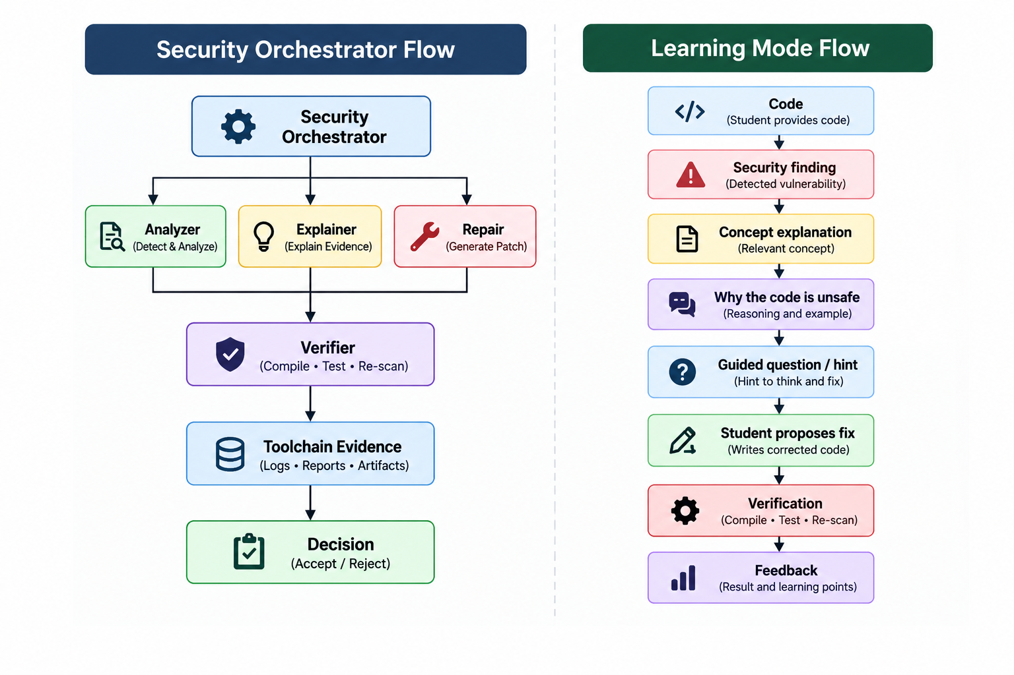

9. SecureCC Local CLI :-
→ The CLI is the primary product interface of VulnHGNN 2.0. The internal implementation can evolve without forcing developers to understand the research pipeline.

9.1 Machine readable interface
securecc scan project/ --format json
securecc build app.cpp --secure --report build/report.json
securecc verify build/app

9.2 Local first behavior
Command | Purpose
secureCC scan <file/project> | Run local security analysis
secureCC build <target> | Compile using the configured toolchain
secureCC build <target> --secure | Analyze, verify policy, compile and apply configured hardening
secureCC explain <finding> | Explain evidence and security implications
secureCC fix <target> | Generate and validate repair candidates
SecureCC verify <target> | Run verification checks
SecureCC harden <binary> | Apply/validate binary hardening
SecureCC protect <binary> | Apply configured protection transformations
secureCC learn <file> | Launch evidence based secure programming guidance

10. Security Model & Trust Boundaries :-
→ VulnHGNN 2.0 treats its own components as different trust domains. A model prediction is evidence, not authority; a generated patch is a proposal, not a trusted change; and a binary transformation is accepted only after verification.
Component | Trust role | Required control
Parser / compiler | Structured program facts | Compiler/toolchain validation
Graph builder | Program representation | Graph consistency tests
ML model | Probabilistic evidence | Calibration, thresholds, evaluation
Repair generator | Untrusted proposal | Isolation + compile + test + re-scan
AI agent | Reasoning assistant | Tool grounded evidence + bounded actions
Binary transformer | Security transformation | Correctness + benchmark + policy checks
CLI | User facing orchestrator | Input validation + safe process execution

11. Verification, Testing & Release Engineering :-

11.1 Release gate
- All critical tests pass.
- No known security regression is introduced.
- Model/data versions are recorded.
- Compiler/toolchain versions are recorded.
- Security profile is reproducible.
- Binary security checks pass where enabled.
- CLI output schemas remain compatible or are versioned.

11.2 Test layers
Layer | Examples
Unit | Graph utilities, parsers, feature encoders, policy logic
Integration | Source → IR → graph → inference → finding
Compiler | C/C++ build matrix, flags, LLVM pass behavior
Security regression | Known vulnerable and patched samples
Repair | Compile/test/rescan acceptance cases
Binary | Hardening/protection correctness
Performance | Runtime, memory, binary size, analysis latency
CLI | Commands, exit codes, JSON schema, error handling

# VulnHGNN 2.0 Definition of Done :-
→ VulnHGNN 2.0 is considered complete when the following statements are demonstrably true through tests, benchmarks and reproducible demonstrations.
Area | Completion condition
Security engine | The validated ML/graph pipeline produces reproducible findings on the supported evaluation set.
Localization | A finding can be mapped to a developer meaningful source location with supporting evidence.
Repair | Supported repairs are generated as candidates and are never accepted without verification.
Verification | Compilation, tests and security reanalysis are integrated into the repair/build decision.
Compiler | C/C++ projects can be compiled through Clang/LLVM using the SecureCC workflow.
Hardening | Configured binary hardening is applied and its presence is validated.
Protection | Optional protection transformations are measurable, policy controlled and correctness tested.
CLI | A developer can use secureCC without interacting directly with internal Python research modules.
Offline core | Core analysis and compilation do not require cloud services.
Observability | Reports contain versions, policies, findings, verification results and artifact references.
Testing | Unit, integration, regression and performance tests protect the critical path.
Documentation | Installation, CLI usage, architecture, security boundaries and limitations are documented.

