Review II — Results Section
Hybrid Adaptive Color Correction, CLAHE, and Dehazing Framework for Underwater Image Restoration and Quality Enhancement — VIT, BCSE403L Digital Image Processing, Fall 2026-2027
Evaluated on the UIEB raw-890 / reference-890 dataset: 268 images for calibration, 622 held-out images for every reported table. Section numbers (0–9) are relative to this results section; renumber them to fit the existing Review I document structure.

0. Evaluation Protocol
Held-out test split. UIEB-890 was split once, stratified by water type, into a calibration split (268 images, 30%) and a test split (622 images, 70%; seed 42). Every parameter of the method was chosen on the calibration split in three stages: (1) per-stage profile multipliers, (2) red-channel compensation strength, and (3) the Module 7 fusion-weight predictor. Every table in this section is computed on the test images, which played no part in any of those choices.
Fair ablation. Each novel module is compared against an equally tuned alternative, not an untuned one. Routing OFF uses a single global profile tuned with the same grid, objective and data as the per-type profiles. Module 7 OFF uses a fixed α=0.5, which was within 0.01 dB of the best single fixed α in calibration.
Light supervision. Calibration selects 5 scalars per water type and fits one ridge regression (26 coefficients), using the UIEB reference images of the calibration split. No model is trained in the deep-learning sense and nothing is learned per pixel, but the method is no longer strictly reference-free.
UCIQE. Computed in true CIELAB, with L*, a* and b* scaled by 1/100 and a bounded saturation term C/√(C²+L²). Values therefore lie on the usual ≈0–1 scale. Absolute values are not directly comparable with papers that feed OpenCV's 8-bit Lab encoding into UCIQE unchanged (Section 9, item 1).
Statistics. Paired two-sided Wilcoxon signed-rank tests, with p-values Holm-adjusted across every test in the table. With several hundred pairs almost any difference is 'significant', so each comparison also reports the mean paired difference with a bootstrap 95% CI (2,000 resamples) and the matched-pairs rank-biserial correlation r (|r| < 0.1 negligible, < 0.3 small, < 0.5 medium, otherwise large). Conclusions are drawn from effect sizes, not from p-values alone.
All parameter selection (Module 5 profiles, red-compensation strength, Module 7 predictor) used PSNR/SSIM against references on the calibration split only; every number here is on the held-out test split. ‡ The original Module 7 maximizes UCIQE+UIQM per image, so its UCIQE/UIQM values are raised by construction.

1. Overall Comparison — All Methods, All Metrics
Mean ± standard deviation over the 622 held-out test images.
Method | Entropy | UCIQE | UIQM | PSNR (dB) | SSIM
UDCP (baseline) | 6.814 ± 0.527 | 0.430 ± 0.065 | 2.271 ± 0.518 | 12.99 ± 2.65 | 0.656 ± 0.118
Conventional HE (baseline) | 7.842 ± 0.172 | 0.445 ± 0.041 | 2.536 ± 0.492 | 16.36 ± 3.29 | 0.781 ± 0.119
CLAHE-only (baseline) | 7.304 ± 0.428 | 0.359 ± 0.059 | 2.175 ± 0.555 | 18.32 ± 3.11 | 0.840 ± 0.080
Hybrid — neither module | 7.239 ± 0.386 | 0.309 ± 0.068 | 2.209 ± 0.525 | 17.68 ± 3.07 | 0.844 ± 0.085
Hybrid — Module 7 only | 7.237 ± 0.375 | 0.312 ± 0.068 | 2.193 ± 0.524 | 17.82 ± 3.07 | 0.850 ± 0.080
Hybrid — Module 5 only | 7.229 ± 0.380 | 0.304 ± 0.067 | 2.145 ± 0.507 | 17.77 ± 3.05 | 0.850 ± 0.083
Hybrid — full (proposed) | 7.220 ± 0.373 | 0.308 ± 0.068 | 2.134 ± 0.507 | 17.87 ± 3.06 | 0.854 ± 0.079
Hybrid — original Module 7 (UCIQE+UIQM search)‡ | 7.162 ± 0.512 | 0.329 ± 0.073 | 2.159 ± 0.547 | 16.30 ± 2.90 | 0.804 ± 0.112
All parameter selection (Module 5 profiles, red-compensation strength, Module 7 predictor) used PSNR/SSIM against references on the calibration split only; every number here is on the held-out test split. ‡ The original Module 7 maximizes UCIQE+UIQM per image, so its UCIQE/UIQM values are raised by construction.

2. Paired Statistical Comparison — Proposed vs. Each Method
Δ = hybrid (full) − comparator, so a positive Δ means the proposed method scores higher. Markers give the Holm-adjusted significance (*** p<0.001, ** p<0.01, * p<0.05, ns not significant).
Comparator | Metric | Mean Δ [95% CI] | Rank-biserial r | Holm p
UDCP (baseline) | Entropy | +0.406 [+0.375, +0.438] | +0.90 (large) | 1.9e-83 ***
UDCP (baseline) | UCIQE | -0.122 [-0.125, -0.118] | -1.00 (large) | 5.4e-102 ***
UDCP (baseline) | UIQM | -0.138 [-0.153, -0.123] | -0.68 (large) | 7.6e-48 ***
UDCP (baseline) | PSNR (dB) | +4.88 [+4.59, +5.16] | +0.93 (large) | 1.8e-87 ***
UDCP (baseline) | SSIM | +0.198 [+0.188, +0.208] | +0.96 (large) | 1.5e-94 ***
Conventional HE (baseline) | Entropy | -0.622 [-0.647, -0.597] | -1.00 (large) | 5.6e-102 ***
Conventional HE (baseline) | UCIQE | -0.137 [-0.143, -0.132] | -1.00 (large) | 7.0e-102 ***
Conventional HE (baseline) | UIQM | -0.402 [-0.435, -0.369] | -0.83 (large) | 1.4e-70 ***
Conventional HE (baseline) | PSNR (dB) | +1.50 [+1.17, +1.81] | +0.40 (medium) | 5.1e-17 ***
Conventional HE (baseline) | SSIM | +0.073 [+0.063, +0.082] | +0.63 (large) | 2.4e-41 ***
CLAHE-only (baseline) | Entropy | -0.084 [-0.101, -0.067] | -0.52 (large) | 1.5e-28 ***
CLAHE-only (baseline) | UCIQE | -0.051 [-0.054, -0.048] | -0.96 (large) | 6.6e-95 ***
CLAHE-only (baseline) | UIQM | -0.041 [-0.055, -0.027] | -0.22 (small) | 1.2e-05 ***
CLAHE-only (baseline) | PSNR (dB) | -0.45 [-0.72, -0.19] | -0.16 (small) | 2.4e-03 **
CLAHE-only (baseline) | SSIM | +0.014 [+0.008, +0.020] | +0.21 (small) | 4.1e-05 ***
Hybrid — neither module | Entropy | -0.019 [-0.028, -0.009] | -0.52 (large) | 1.5e-28 ***
Hybrid — neither module | UCIQE | -0.001 [-0.002, +0.000] | -0.05 (negligible) | 2.5e-01 ns
Hybrid — neither module | UIQM | -0.075 [-0.080, -0.070] | -0.98 (large) | 3.5e-98 ***
Hybrid — neither module | PSNR (dB) | +0.18 [+0.11, +0.25] | +0.25 (small) | 4.2e-07 ***
Hybrid — neither module | SSIM | +0.009 [+0.007, +0.012] | +0.41 (medium) | 5.4e-18 ***
Hybrid — Module 7 only | Entropy | -0.016 [-0.023, -0.009] | -0.57 (large) | 1.9e-27 ***
Hybrid — Module 7 only | UCIQE | -0.004 [-0.005, -0.003] | -0.65 (large) | 1.8e-35 ***
Hybrid — Module 7 only | UIQM | -0.059 [-0.064, -0.054] | -0.99 (large) | 5.8e-83 ***
Hybrid — Module 7 only | PSNR (dB) | +0.04 [-0.01, +0.09] | +0.12 (small) | 5.6e-02 ns
Hybrid — Module 7 only | SSIM | +0.004 [+0.002, +0.005] | +0.31 (medium) | 1.0e-08 ***
Hybrid — Module 5 only | Entropy | -0.008 [-0.012, -0.005] | -0.37 (medium) | 2.1e-14 ***
Hybrid — Module 5 only | UCIQE | +0.004 [+0.003, +0.004] | +0.69 (large) | 1.9e-48 ***
Hybrid — Module 5 only | UIQM | -0.011 [-0.013, -0.009] | -0.50 (medium) | 1.4e-25 ***
Hybrid — Module 5 only | PSNR (dB) | +0.10 [+0.06, +0.14] | +0.20 (small) | 8.9e-05 ***
Hybrid — Module 5 only | SSIM | +0.004 [+0.003, +0.005] | +0.34 (medium) | 2.1e-12 ***
Hybrid — original Module 7 (UCIQE+UIQM search)‡ | Entropy | +0.058 [+0.035, +0.083] | +0.11 (small) | 5.6e-02 ns
Hybrid — original Module 7 (UCIQE+UIQM search)‡ | UCIQE | -0.021 [-0.022, -0.019] | -0.88 (large) | 2.3e-79 ***
Hybrid — original Module 7 (UCIQE+UIQM search)‡ | UIQM | -0.025 [-0.037, -0.014] | -0.10 (negligible) | 7.5e-02 ns
Hybrid — original Module 7 (UCIQE+UIQM search)‡ | PSNR (dB) | +1.56 [+1.39, +1.73] | +0.73 (large) | 8.2e-55 ***
Hybrid — original Module 7 (UCIQE+UIQM search)‡ | SSIM | +0.050 [+0.043, +0.058] | +0.64 (large) | 2.0e-42 ***

3. Where the Proposed Method Wins and Loses, and Why
Against each baseline, the lists below give only the differences that are significant after Holm correction and non-negligible in effect size:
- UDCP (baseline) — higher: entropy Δ=+0.406 (r=+0.90, large); PSNR Δ=+4.877 (r=+0.93, large); SSIM Δ=+0.198 (r=+0.96, large). Lower: UCIQE Δ=-0.122 (r=-1.00, large); UIQM Δ=-0.138 (r=-0.68, large).
- Conventional HE (baseline) — higher: PSNR Δ=+1.504 (r=+0.40, medium); SSIM Δ=+0.073 (r=+0.63, large). Lower: entropy Δ=-0.622 (r=-1.00, large); UCIQE Δ=-0.137 (r=-1.00, large); UIQM Δ=-0.402 (r=-0.83, large).
- CLAHE-only (baseline) — higher: SSIM Δ=+0.014 (r=+0.21, small). Lower: entropy Δ=-0.084 (r=-0.52, large); UCIQE Δ=-0.051 (r=-0.96, large); UIQM Δ=-0.041 (r=-0.22, small); PSNR Δ=-0.453 (r=-0.16, small).
PSNR/SSIM against the UIEB references. On the test split, hybrid PSNR = 17.87 dB and SSIM = 0.854, against CLAHE-only 18.32 dB / 0.840, conventional HE 16.36 dB / 0.781, and UDCP 12.99 dB / 0.656. The UIEB references are not ground-truth clear-water images. Li et al. (2019) produced each one by having volunteers choose the preferred output among 12 existing enhancement methods. PSNR/SSIM therefore measure closeness to the output volunteers preferred, which is usually a moderate correction. Against CLAHE-only, the strongest baseline, the hybrid preserves structure better (SSIM +0.014) but is 0.45 dB lower in PSNR. Its DCP stream dehazes and darkens more strongly than a moderate reference, which shifts global intensity. PSNR penalizes that shift directly, while SSIM, which normalizes local luminance and contrast, penalizes it much less.
UCIQE/entropy vs. conventional HE. Conventional HE scores UCIQE = 0.445 and entropy = 7.84, against the hybrid's 0.308 and 7.22. Per-channel global equalization stretches every channel to the full range, which directly inflates luminance contrast, chroma spread and histogram entropy. Those are the quantities UCIQE and entropy reward, and they rise whether or not the colours are faithful. Section 7 shows that these no-reference scores do not track reference fidelity.

4. Module 5 — Water-Type Routing with Red-Channel Compensation
Water absorbs red light first, and how much is lost depends on depth and turbidity. Module 5 classifies each image's water type from cheap colour and haze statistics, then routes the per-stage parameters. Those parameters now include the strength of an attenuation-aware red-channel compensation applied before white balance (Ancuti et al., 2018): I_r' = I_r + s·(mean I_g − mean I_r)·(1 − I_r)·I_g, which rebuilds red from green where green is strong and leaves already-red pixels alone.
Stage 1 — profile multipliers. On the calibration split, 182 settings of (WB gain cap, gamma multiplier, CLAHE clip multiplier, DCP ω) were scored at fixed α=0.5 by J = PSNR/sd + SSIM/sd. One global profile (the routing-OFF arm) and one profile per water type were selected. A per-type choice is kept only if it beats the global one on that type's calibration images (one-sided paired Wilcoxon, p<0.05); otherwise the type falls back to the global choice.
Selected global profile: cap=2, γ×1.4, clip×1, ω=0.7. On calibration images it scores 16.74 dB / 0.815, against 15.19 dB / 0.773 for the un-routed defaults.
Water type | n (cal.) | Original hand-set profile | Hand-set PSNR/SSIM | Best per-type profile | Per-type PSNR/SSIM | p vs. global | Decision
clear_blue | 192 | cap=2.5, γ×0.8, clip×0.9, ω=0.8 | 14.47 / 0.755 | cap=2, γ×1.4, clip×0.8, ω=0.7 | 16.85 / 0.832 | 0.00609 | per-type
green_turbid | 32 | cap=4, γ×1.1, clip×1.1, ω=0.9 | 16.89 / 0.843 | cap=3, γ×1.2, clip×1, ω=0.7 | 18.24 / 0.861 | 0.19 | fallback-to-global
deep_lowlight | 29 | cap=3, γ×1.4, clip×1.3, ω=0.7 | 14.09 / 0.687 | cap=2, γ×1.4, clip×1.3, ω=0.7 | 14.15 / 0.688 | 0.00605 | per-type
hazy_bright | 15 | cap=2, γ×0.7, clip×0.8, ω=0.92 | 14.73 / 0.821 | cap=2, γ×1.2, clip×1.3, ω=0.7 | 17.71 / 0.856 | 0.262 | fallback-to-global

Stage 2 — red-compensation strength s ∈ {0, 0.25, 0.5, 0.75, 1, 1.25, 1.5, 2, 2.5, 3, 4, 5}, searched with the stage-1 profiles fixed and the same gate. The global strength is s=0.75, which scores 17.20 dB / 0.830 on calibration images, against 16.73 dB / 0.815 with no compensation.
Water type | n (cal.) | Best s | PSNR: s=0 → best s | p vs. global s | Selected s | Decision
clear_blue | 192 | 1 | 16.85 → 17.49 | 0.259 | 0.75 | fallback-to-global
green_turbid | 32 | 0.75 | 18.19 → 18.38 | 1 | 0.75 | fallback-to-global
deep_lowlight | 29 | 4 | 14.15 → 15.19 | 0.00323 | 4 | per-type
hazy_bright | 15 | 0 | 17.68 → 17.68 | 0.0912 | 0.75 | fallback-to-global
The per-type best strength follows the physics of red attenuation: strongest for deep, low-light water, near zero for well-lit hazy water.

Held-out effect of red-channel compensation. Both arms of the ablation table (Section 5) include compensation, so its own effect is measured here. The comparison is the 'neither' configuration (global profile, fixed α=0.5) with and without compensation, paired per test image:
Metric | Without | With | Mean Δ [95% CI] | Rank-biserial r | Holm p
Entropy | 7.200 | 7.239 | +0.040 [+0.032, +0.047] | +0.45 (medium) | 1.1e-21
UCIQE | 0.326 | 0.309 | -0.017 [-0.019, -0.015] | -0.87 (large) | 1.8e-76
UIQM | 2.291 | 2.209 | -0.082 [-0.091, -0.074] | -0.87 (large) | 1.8e-76
PSNR (dB) | 17.01 | 17.68 | +0.68 [+0.54, +0.81] | +0.51 (large) | 4.0e-27
SSIM | 0.823 | 0.844 | +0.021 [+0.017, +0.025] | +0.46 (medium) | 1.6e-22

Held-out effect of routing. Below, the full pipeline WITH routing is compared against the identical pipeline with the global profile (Module 7 on in both arms), per test image, grouped by assigned water type. Gain = ON − OFF; types that fell back to the global profile show exactly zero.
Water type | n (test) | PSNR gain | SSIM gain | UCIQE gain | UIQM gain
clear_blue | 447 | +0.03 ± 0.38 | +0.006 ± 0.015 | -0.002 ± 0.004 | -0.061 ± 0.031
deep_lowlight | 67 | +0.22 ± 1.73 | -0.005 ± 0.053 | -0.021 ± 0.023 | -0.144 ± 0.128
green_turbid | 73 | +0.00 ± 0.00 | +0.000 ± 0.000 | +0.000 ± 0.000 | +0.000 ± 0.000
hazy_bright | 35 | +0.00 ± 0.00 | +0.000 ± 0.000 | +0.000 ± 0.000 | +0.000 ± 0.000
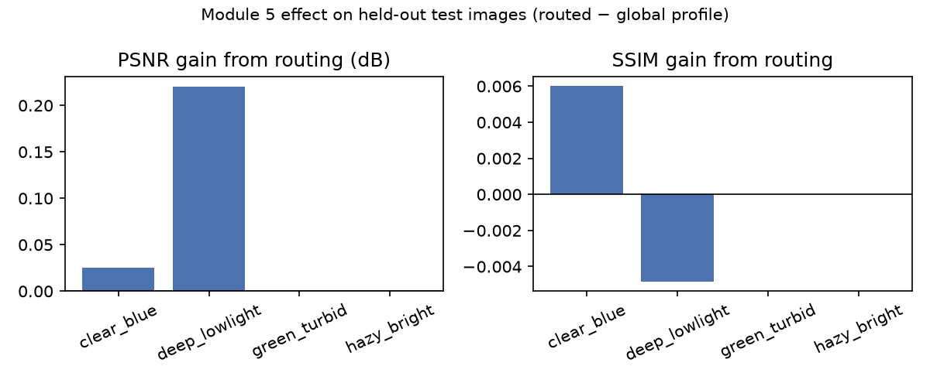

5. Ablation Table — Isolating Module 5 and Module 7
Mean ± std per metric over the 622 test images. Row 3 (neither module: global profile, fixed α=0.5) is the control, and rows 4–6 isolate each module's individual and combined contribution. Both arms include the global red-compensation strength, so the routing rows measure per-type routing only, and the compensation's own effect is reported in Section 4. Row 7 is the original Module 7 (Section 7).
Configuration | Entropy | UCIQE | UIQM | PSNR (dB) | SSIM
0. UDCP baseline (Drews et al. 2013) | 6.814 ± 0.527 | 0.430 ± 0.065 | 2.271 ± 0.518 | 12.99 ± 2.65 | 0.656 ± 0.118
1. Conventional HE baseline | 7.842 ± 0.172 | 0.445 ± 0.041 | 2.536 ± 0.492 | 16.36 ± 3.29 | 0.781 ± 0.119
2. CLAHE-only baseline | 7.304 ± 0.428 | 0.359 ± 0.059 | 2.175 ± 0.555 | 18.32 ± 3.11 | 0.840 ± 0.080
3. Hybrid - global profile, fixed alpha=0.5 (neither novel module) | 7.239 ± 0.386 | 0.309 ± 0.068 | 2.209 ± 0.525 | 17.68 ± 3.07 | 0.844 ± 0.085
4. Hybrid - global profile, predicted alpha (Module 7 only) | 7.237 ± 0.375 | 0.312 ± 0.068 | 2.193 ± 0.524 | 17.82 ± 3.07 | 0.850 ± 0.080
5. Hybrid - routed profile, fixed alpha=0.5 (Module 5 only) | 7.229 ± 0.380 | 0.304 ± 0.067 | 2.145 ± 0.507 | 17.77 ± 3.05 | 0.850 ± 0.083
6. Hybrid - full (Module 5 + Module 7) | 7.220 ± 0.373 | 0.308 ± 0.068 | 2.134 ± 0.507 | 17.87 ± 3.06 | 0.854 ± 0.079
7. Hybrid - routed profile, alpha by UCIQE+UIQM search (original Module 7) | 7.162 ± 0.512 | 0.329 ± 0.073 | 2.159 ± 0.547 | 16.30 ± 2.90 | 0.804 ± 0.112

Module contribution (subtraction analysis):
Metric | Combined (6−3) | Module 7 alone (4−3) | Module 5 alone (5−3) | Interaction (6−4−5+3)
Entropy | -0.019 | -0.003 | -0.011 | -0.005
UCIQE | -0.001 | +0.003 | -0.005 | +0.001
UIQM | -0.075 | -0.016 | -0.064 | +0.005
PSNR (dB) | +0.183 | +0.141 | +0.083 | -0.041
SSIM | +0.009 | +0.006 | +0.005 | -0.001
All parameter selection (Module 5 profiles, red-compensation strength, Module 7 predictor) used PSNR/SSIM against references on the calibration split only; every number here is on the held-out test split. ‡ The original Module 7 maximizes UCIQE+UIQM per image, so its UCIQE/UIQM values are raised by construction.

6. Module 7 — Calibrated Per-Image Fusion Weight
The fusion stage blends the CLAHE stream (detail and contrast) with the DCP stream (haze removal) under a global bias α. Module 7 predicts α per image with a ridge regression from 26 no-reference statistics of the raw image and of both streams: luminance, contrast, chroma, colour cast, clipping, haze density and colour dominance. It was fitted on the calibration split to the per-image α that best matches the reference. At inference it needs no reference and a single feature pass, and the search loop is gone.
5-fold cross-validation on the calibration split, grouped by image:
α selection | PSNR | SSIM
Fixed α = 0.5 | 17.27 | 0.834
Best single fixed α (chosen inside CV) | 17.26 | 0.835
Predicted α (ridge, λ=30) | 17.44 | 0.840
Oracle per-image α (uses reference; upper bound) | 18.03 | 0.855
The predictor recovers about 22% of the PSNR gap between a fixed α and the per-image oracle (correlation between predicted and oracle α: 0.49). The gain is real but modest, and most of the oracle headroom remains.
Held-out test split. Predicted α has mean 0.42 and std 0.16, with 1% of images at a boundary. Its isolated effect (row 4 − row 3) is PSNR +0.14 dB, SSIM +0.006, entropy -0.003, UCIQE +0.003, UIQM -0.016.
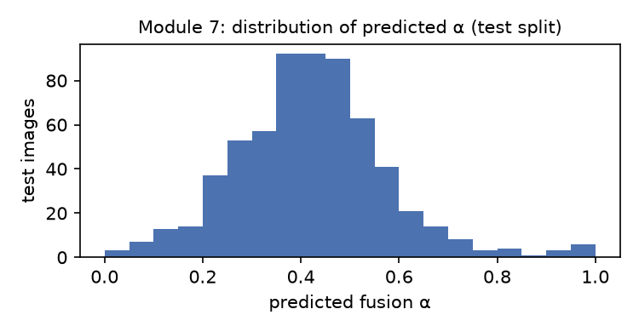

7. Finding — No-Reference Metrics Are Misaligned with Fidelity for Fusion-Weight Selection
The original Module 7 chose α per image by maximizing UCIQE+UIQM, a common pattern in underwater enhancement: optimize the image's own no-reference quality score, with no reference or training needed. On UIEB this does not work, and the reason is measurable.
Within-image alignment (calibration split). For each image, the fused output was computed at α = 0, 0.1, …, 1 in both pipeline arms. The table gives the median Spearman correlation between each no-reference score and PSNR/SSIM across those α values, and the share of images where it is negative, meaning the score ranks α in the opposite order to the reference:
No-reference score | vs. | Median within-image Spearman | Images with negative correlation
uciqe | PSNR | +0.03 | 49%
uciqe | SSIM | +0.29 | 42%
uiqm | PSNR | -0.25 | 56%
uiqm | SSIM | -0.19 | 54%
UCIQE+UIQM (Module 7 objective) | PSNR | -0.17 | 56%
UCIQE+UIQM (Module 7 objective) | SSIM | +0.18 | 46%
entropy | PSNR | +0.08 | 48%
entropy | SSIM | -0.34 | 57%

Choosing α by maximizing each score (calibration split):
α selector | PSNR | SSIM | α at 0 or 1
fixed alpha=0.5 | 17.27 | 0.834 | 0%
argmax nr_combined | 16.02 | 0.791 | 91%
argmax uciqe | 15.91 | 0.784 | 98%
argmax uiqm | 16.32 | 0.802 | 68%
argmax entropy | 16.63 | 0.814 | 91%
oracle (argmax reference J) | 18.03 | 0.855 | 24%

Held-out confirmation (test split, same routed profile). With α chosen by the UCIQE+UIQM search (row 7), PSNR = 16.30 dB and SSIM = 0.804. That compares with 17.77 dB / 0.850 at a fixed α=0.5 (row 5) and 17.87 dB / 0.854 with the predicted α (row 6). The proposed method's advantage over the search is Δ PSNR = +1.56 dB (r=+0.73) and Δ SSIM = +0.050 (r=+0.64), while the search raises the score it maximizes (UCIQE 0.329 vs. 0.308).
Interpretation. Across α, UCIQE and UIQM mostly reward the extremes: the DCP-heavy end (saturated, high chroma spread) or the CLAHE-heavy end (strong local contrast). The reference-preferred blend is usually in between. Maximizing these scores therefore selects a boundary α for most images and reduces fidelity. This is consistent with the observation that HE scores highest on UCIQE while losing on PSNR/SSIM (Section 3), and with red-channel compensation, which raises held-out PSNR by +0.68 dB while lowering UCIQE by -0.017 and UIQM by -0.082 (Section 4). The practical conclusion is that no-reference scores of this family should not be used as optimization objectives for restoration parameters without first checking their alignment against references.
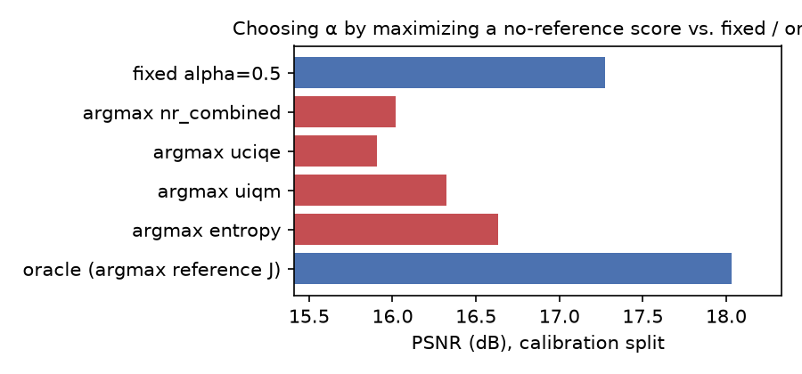

8. Downstream Task Validation
ORB keypoint yield and Canny edge density on the restored vs. raw image, computed with the corrected detector (nfeatures raised from 1000 to 200,000; see Section 9). Higher counts show that more structure is detectable. They can also rise from amplified noise or texture, so they are a proxy for usability, not proof of it.
Metric | Value (test split)
Keypoint gain, mean % | 343.1%
Keypoint gain, median % | 147.7%
Images with exactly 0% keypoint gain | 0/618 (0.0%)
Edge density gain, mean % | 264.3%
Edge density gain, median % | 71.4%
Cross-matches (raw vs. restored), mean | 7519.9

9. Known Issues & Limitations
Issues found while building the batch evaluation and the ablation study. Each is recorded here rather than silently patched, because each would otherwise distort the tables above.
UCIQE computed on OpenCV's 8-bit Lab encoding (Found & Fixed). compute_uciqe passed cv2.cvtColor(uint8, BGR2LAB) output straight into the UCIQE terms. That encoding stores L*·255/100 and a*+128, b*+128, so every neutral grey pixel had 'chroma' ≈181, and the unscaled 0–255 luminance range let the contrast term dominate. On a sample frame, contrast alone contributed 60.4 of a UCIQE of 68.5, and a flat grey image scored 0.34 instead of 0. The fix converts float [0,1] BGR to true CIELAB, scales L*/a*/b* by 1/100, centres chroma on the neutral axis, and uses the bounded saturation C/√(C²+L²). That also removes the near-black C/L blow-up found earlier, which had previously been patched by dropping pixels with L<1. All UCIQE values are now on the usual ≈0–1 scale. The earlier '0–100 range' statement was wrong.
Original Module 7 objective was mis-scaled, then shown to be misaligned (Found & Redesigned). With the mis-scaled UCIQE, the UCIQE+UIQM objective came out to ≈49 from UCIQE against ≈0.2 from UIQM, so it was mostly maximizing a luminance-contrast term. That accident pushed α toward the CLAHE stream, which made the module look helpful (+0.49 dB in the pre-fix ablation). With the metric fixed, the search lowers held-out PSNR by 1.46 dB against a fixed α on the same profile (Section 5, row 7 vs. row 5). Section 7 shows that the cause is the objective itself rather than a bug, so Module 7 was redesigned as a calibrated predictor (Section 6). The original search is kept as row 7 of the ablation for comparison.
Module 5's white-balance gain cap was never applied (Found & Fixed). TYPE_PROFILES defined a per-type wb_gain_cap, but restore_image called adaptive_white_balance without it, so every image used the default cap of 4.0. adaptive_white_balance now takes max_gain, and both the routed and the global profile pass it.
Routing profiles were hand-set and evaluated on the same images (Found & Fixed). The original hand-set profiles made routing hurt clear_blue images, 72% of UIEB (−1.12 dB PSNR in the pre-fix all-890 run). Profiles, compensation strength and the α predictor are now all chosen on a stratified 30% calibration split, against equally tuned alternatives, with a significance gate that falls back to the global choice. Every reported table uses the untouched 70% test split.
Per-type routing captures little of the available per-image headroom (Limitation). On the calibration split, giving each image its own best profile (an oracle that uses the reference) would add +0.78 dB over the single global profile, but per-type routing recovers only a small part of it. An exploratory ridge regression from global image statistics, not part of the released scripts, did no better. Held-out routing gain by water type: clear_blue +0.03 dB / +0.006 SSIM; deep_lowlight +0.22 dB / -0.005 SSIM; green_turbid +0.00 dB / +0.000 SSIM; hazy_bright +0.00 dB / +0.000 SSIM. Types that fell back to the global profile: green_turbid, hazy_bright.
Adaptive gamma formula uses the opposite convention from how it is applied (Found, Not Fixed). compute_adaptive_gamma derives γ = log(0.5)/log(mean) for the convention output = input^γ, where γ < 1 brightens. adaptive_gamma_correction applies output = input^(1/γ) instead, so the adaptive part is inverted: on its own it darkens dark images. Calibration selected the largest gamma multiplier in its grid (×1.4), which largely compensates, and on a sample of 80 test images the stage still brightened 96%. But the adaptivity remains backwards, with darker water types brightened less than brighter ones, and the boundary-valued multiplier is a symptom of it. Correcting the convention changes the pipeline, so it would require re-running all three calibration stages and the evaluation. It is left unfixed in the reported results.
Coordinate-wise, grid-limited calibration (Limitation). The calibration stages were run in sequence (profile, then red strength, then α predictor) rather than jointly, and some selected global stage-1 values lie at the grid boundary (WB cap 2, gamma ×1.4, DCP ω 0.7). A joint search over a wider grid could improve both arms. Stages 1–2 were scored at fixed α=0.5 and so are not tuned jointly with Module 7.
Significance testing without multiple-comparison correction or effect sizes (Found & Fixed). The earlier table reported 25 raw Wilcoxon p-values. With n=890, differences as small as +0.039 UIQM came out at p≈1e-18. The table now carries Holm-adjusted p-values over the whole family, rank-biserial effect sizes and bootstrap CIs.
ORB keypoint cap artificially tying raw vs. restored counts (Found & Fixed). cv2.ORB_create(nfeatures=1000) was low enough that raw and restored images routinely hit the same ceiling, so keypoint_gain_pct read 0% for a large fraction of the dataset. The cap was raised to nfeatures=200000, since restored images reach up to ~144k keypoints. _pct_change also returned inf when a raw image had zero keypoints. It now returns None, which is excluded from aggregates.
Original Module 7 search validity (Superseded). Before the UCIQE fix, some UCIQE+UIQM(α) curves had two local maxima, so the search gained a coarse 11-point grid before golden-section refinement. With the corrected metric, a re-scan across all 4 water types (outputs/investigate_fusion_alpha_postfix.log) found every sampled curve monotonic, so the search was valid but had no interior optimum to find. Section 7 explains this behaviour. The full-calibration-split α sweep in Section 7 confirms the result at scale: maximizing UCIQE+UIQM puts α at 0 or 1 for 91% of images.
Water-type classifier green_dominance threshold scale bug (Found & Fixed). The green_turbid rule was gated on green_dominance > 8/255.0, but green_dominance is a difference of raw 0–255 channel means, so the gate amounted to 'greener than zero'. It was fixed to > 8, after which 65 of 170 green_turbid images were reclassified.
No learned or recent baselines (Limitation). The comparison covers classical methods only: UDCP, global HE and CLAHE. Learning-based UIEB methods such as Water-Net (Li et al., 2019) report substantially higher PSNR/SSIM on UIEB. This work does not claim to compete with them. Its scope is classical restoration with light calibration.

