Assignment 3: Effect of Network Load on Delay and Packet Drops

Experiment Objectives
Students will generate simultaneous traffic in a LAN to observe increased delays and packet drops under higher load. The focus is on interpreting simulation behavior rather than complex measurements.

Components required :
Hardware Components (in Cisco Packet Tracer):
- 1 Switch (2960)
- 6 PC
- Copper Straight Through cables

In a network, when multiple devices send data at the same time, the network experiences load (traffic). As the load increases, devices like switches must handle more packets, which can cause:
- Delay (latency) → packets take longer to reach destination
- Queueing → packets wait in buffer
- Packet drops → packets are discarded when buffer is full
This situation is called network congestion.

ICMP Traffic
ICMP (used by ping) helps test connectivity and measure delay.
- Low traffic → fast replies
- High traffic → delayed or lost replies

Congestion in LAN
Even in a simple LAN:
- Multiple simultaneous transmissions → shared bandwidth
- Switch queues get filled
- Results in delay or packet loss

Simulation Mode
Using simulation mode:
- You can observe packet timing
- See how packets are delayed or dropped
- Analyze network behavior step-by-step

Basic Setup
Task 1: Baseline Test (Low Traffic)
- Open Cisco Packet Tracer
- Add devices:
  - 1 Switch (2960)
  - 6 PCs (PC0, PC1, PC2, PC3,PC4,PC5)
- Connect using Copper Straight Through Cable:
  - PC → Switch
- Assign IP Addresses to all PCs
- Switch to Simulation Mode
- Ping from:PC0 → PC5
Observe:
- Smooth packet flow
- No delay
- No packet drops
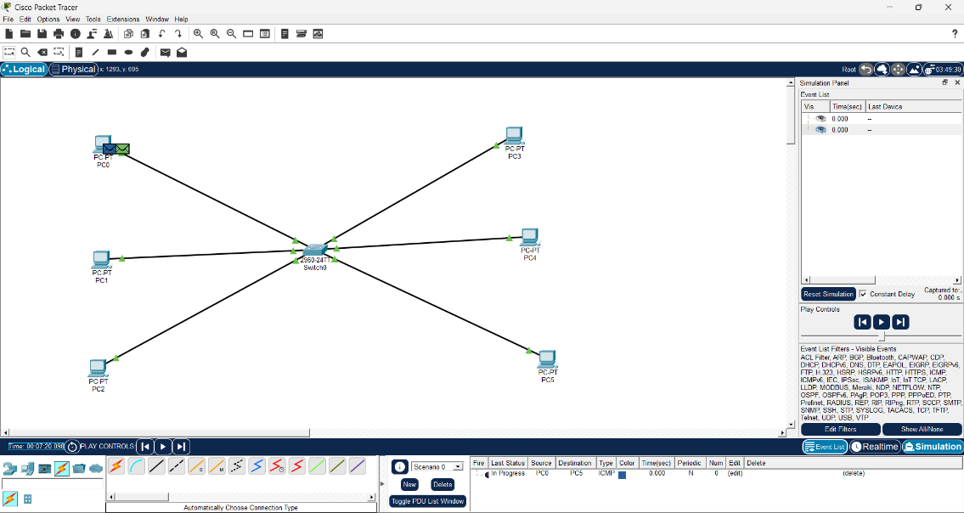

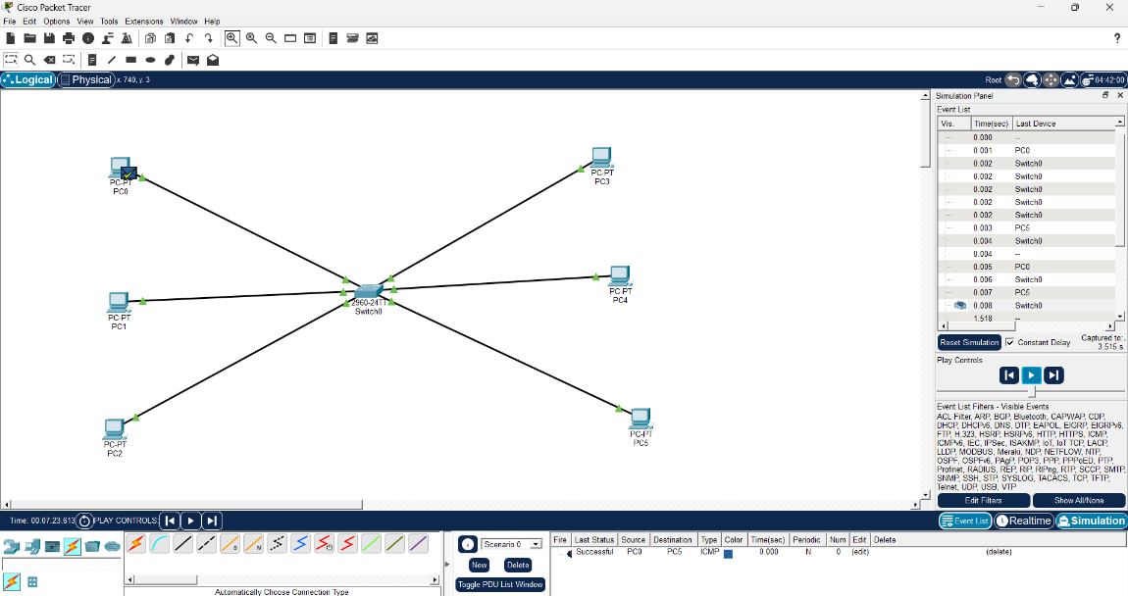

Task 2: High Traffic Test
Start multiple pings at the same time:
- PC0 → PC5
- PC1 → PC4
- PC2 → PC3

Observe in Simulation:
- Packets overlap
- Delay increases
- Some packets may be dropped
- Event list becomes crowded
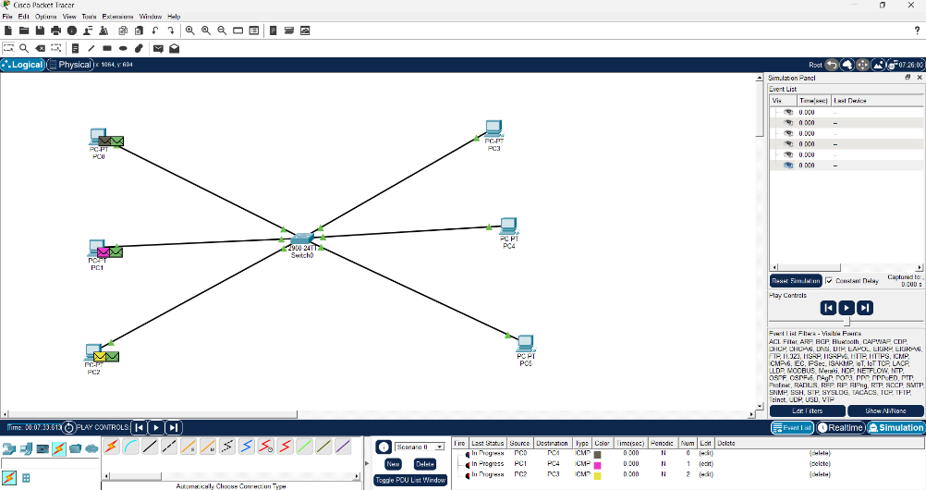

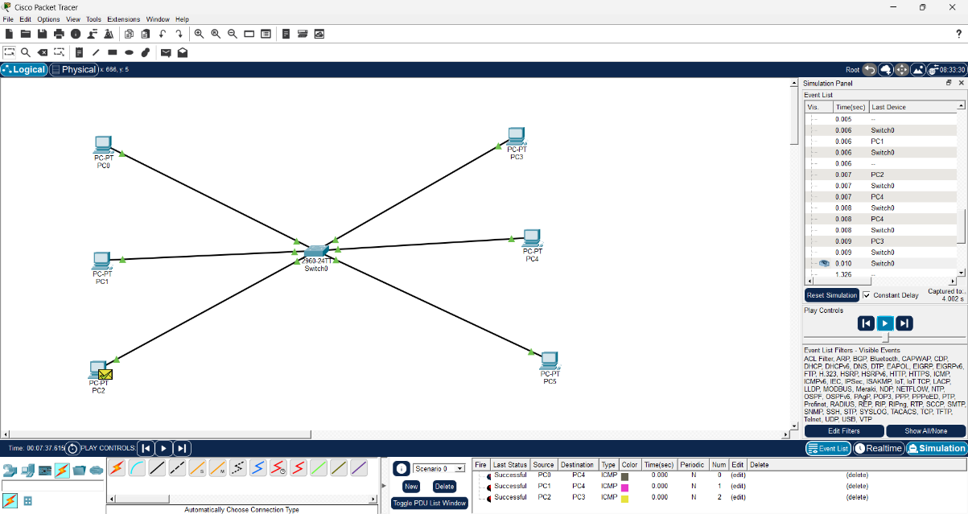

Task 3: Observation Summary
Low Traffic:
- Smooth communication
- No packet loss
- Fast response time
High Traffic:
- Increased delay
- Packet queueing observed
- Some packet drops possible
- Slower response time

