Assignment 4: Transmission Failure Demonstration (Link Errors & Retransmission Idea)

Experiment Objectives
This experiment demonstrates practical “errors” in communication by forcing link failures during transmission and observing which packets fail and how communication resumes after recovery.

Components required :
Hardware Components (in Cisco Packet Tracer):
- 1 Switch (2960)
- 2 PC
- Copper Straight Through cables

In a computer network, communication depends on physical links (cables) and network devices. If a link fails (e.g., cable unplugged), data transmission is interrupted.
This leads to:
- Packet loss (data not delivered)
- Timeouts (no response received)
- Communication failure
- When the link is restored, communication resumes, showing how networks recover after failure.

ICMP Behavior During Failure
- ICMP (ping) is used to test connectivity
- During normal conditions → Reply received
- During failure → Request timed out

Simulation Mode Role
Simulation Mode helps to:
- Visualize packet drops
- Observe failed transmissions
- Understand recovery

Basic Setup
Task 1: Setup
- Open Cisco Packet Tracer
- Add devices:
  - 1 Switch (2960)
  - 2 PCs (PC0, PC1)
- Connect using Copper Straight Through Cable:
  - PC → Switch
- Assign IP Addresses to both PCs
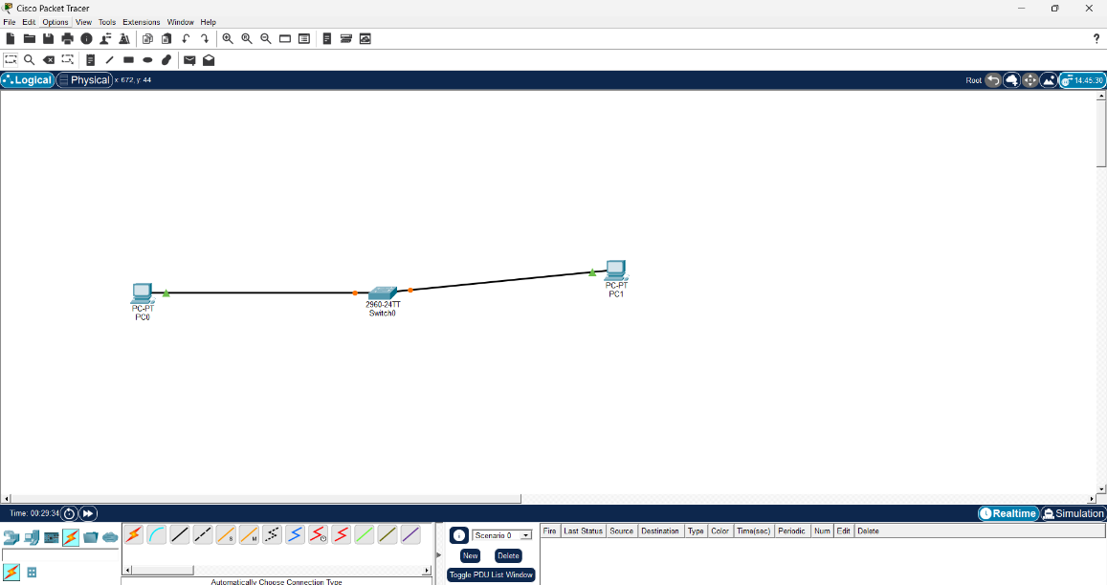

Task 2: Normal Communication
Ping PC0-PC1
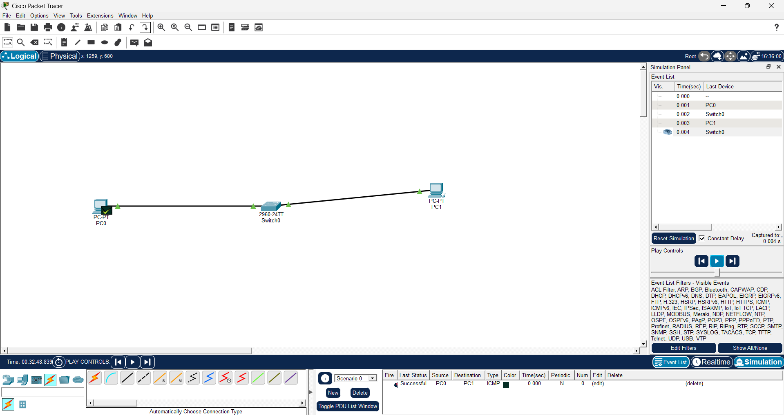

Observe in Simulation:
- Replies received
- Communication successful

Task 3: Force Error
- Start continuous ping: PC0-PC1
- While ping is running:
  - Disconnect cable between PC1 and Switch

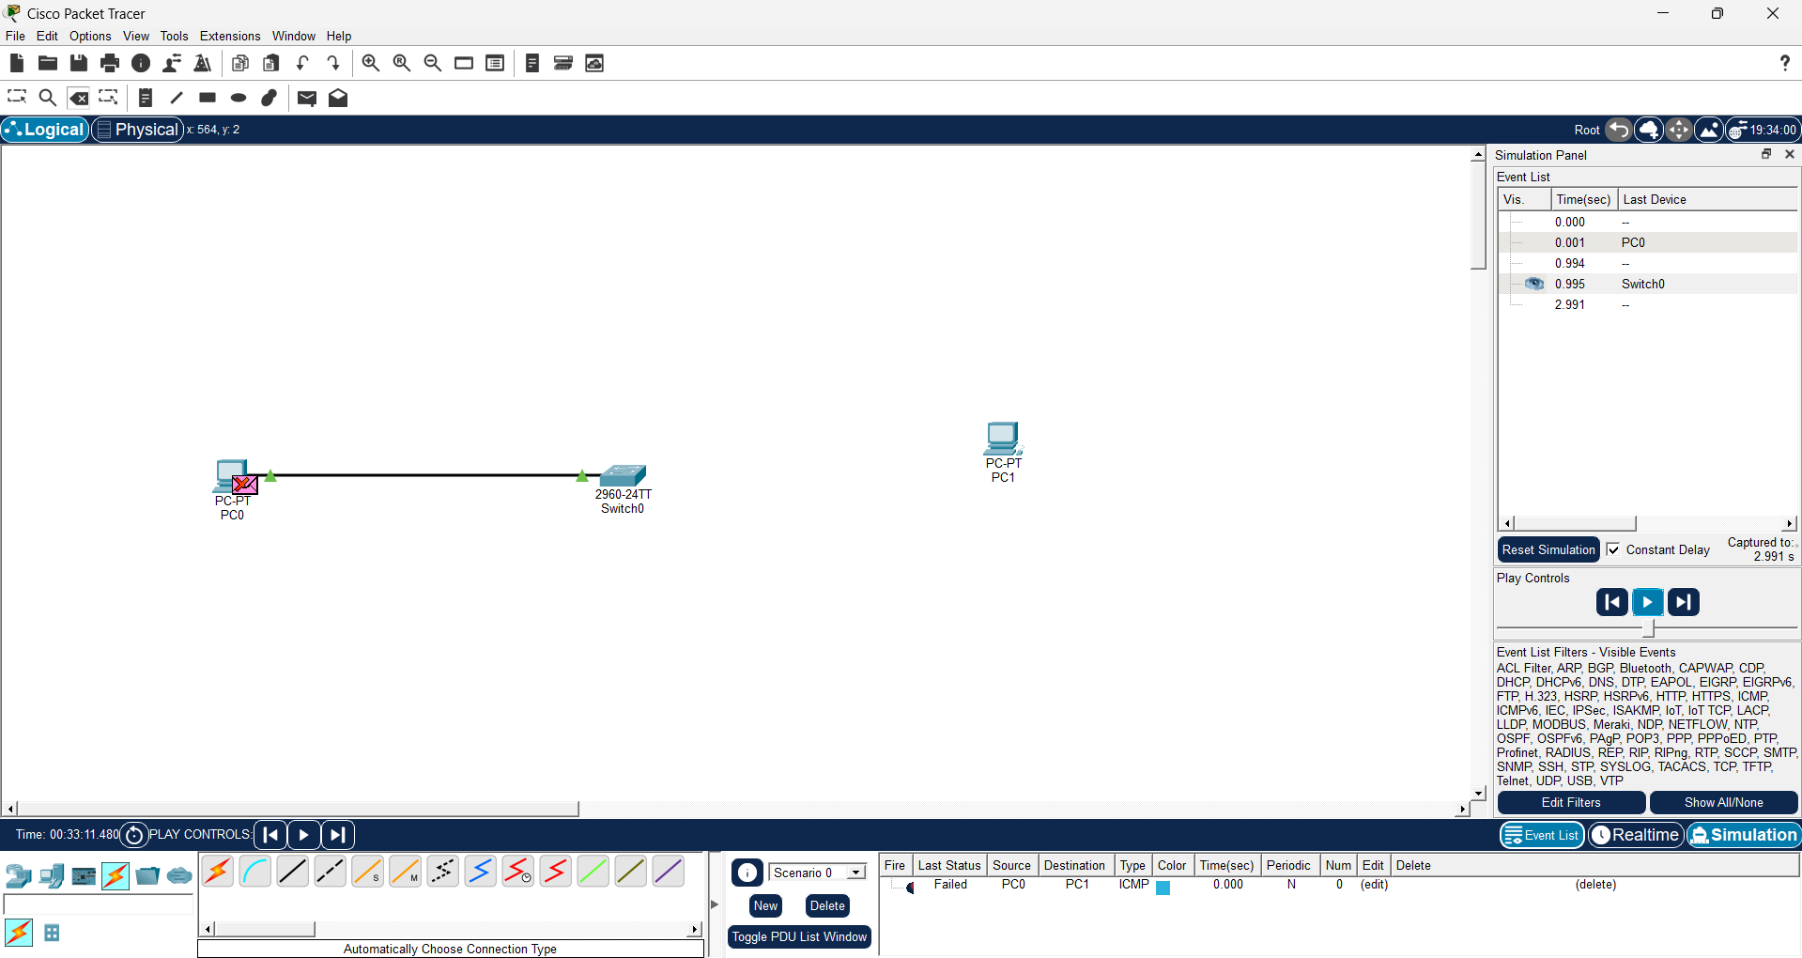

Observation:
- “Request timed out”
- Packets fail in Simulation Mode
- Red indicators (packet drops)

Task 4: Recovery
- Reconnect the cable
- Observe ping output

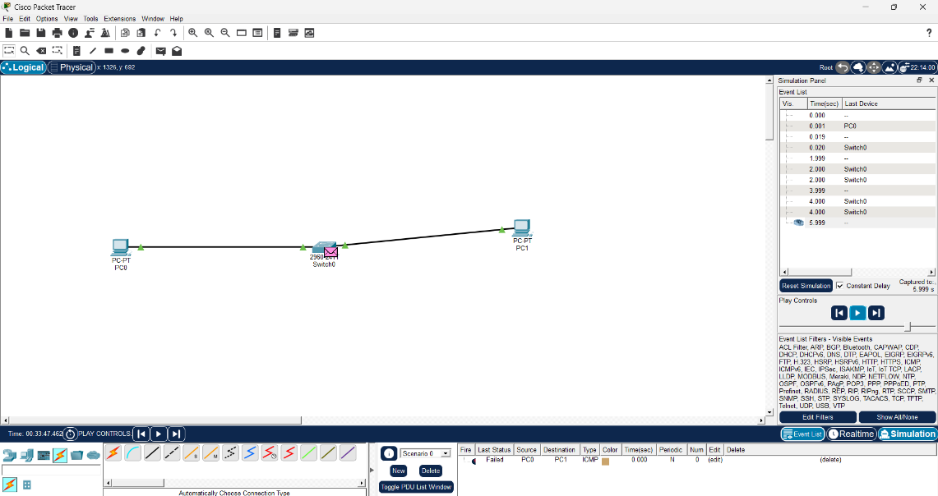

Observation:
- Replies start coming again
- Communication restored

