PathFinder Goal: To help students with finding jobs and internships related to their interests.

**PathFinder Features List**

* Job/internship search and filter feature
* Job/internship applying feature
* In-depth job description feature
* LinkedIn account linking feature
* Resume & interview tips/advice list feature
* Resume prep and workshop feature
* Personal profile feature
* Location input
* Database for job requirements
* Secondary database for general requirements for job groups
* Students can attach resume to profile
* Experience/level filter
* Job/Internship bookmark system
* Q & A feature

Solution Sketch #1: Bookmark System

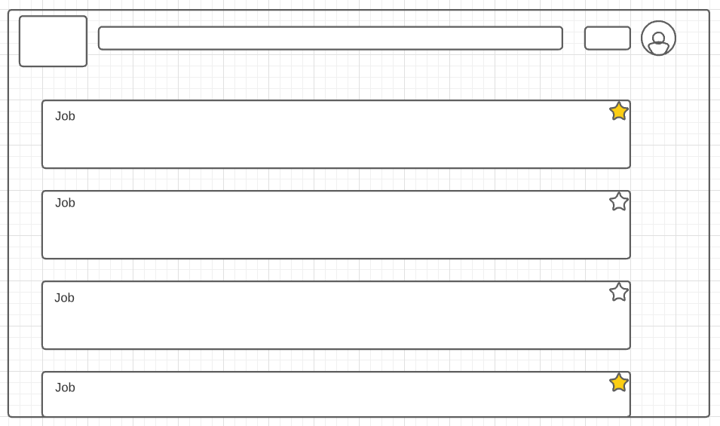

Solution Sketch #2: Attach resume to profile

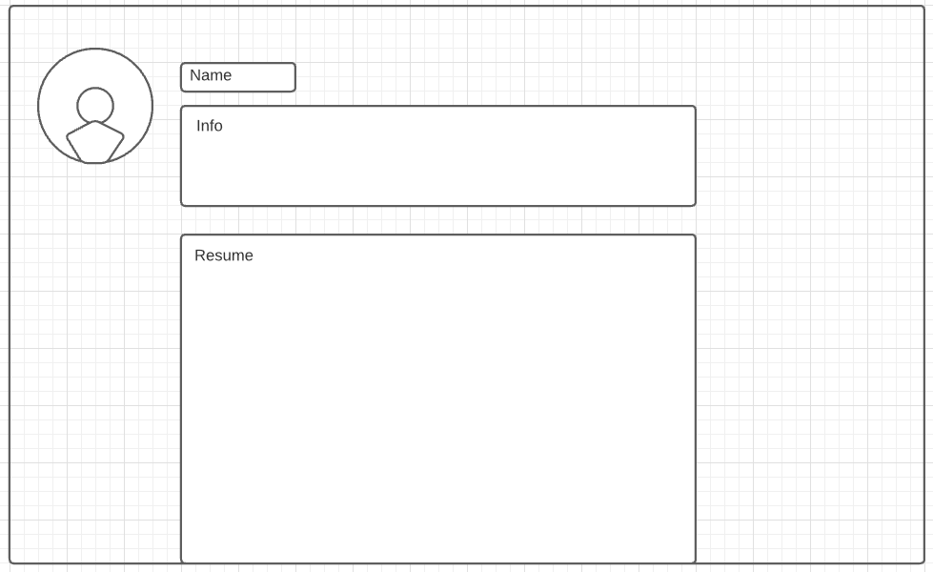

Solution Sketch #3: Job applying feature

