**PRACTICAL: 1**

**AIM:**

Installation of Kali Linux or Parrot Security Operating System in Virtual Box.

**THEORY:**

Kali Linux is an open-source, Debian-based Linux distribution aimed at advanced Penetration Testing and Security Auditing. Kali Linux contains several hundred tools targeted towards various information security tasks, such as Penetration Testing, Security Research, Computer Forensics and Reverse Engineering. Kali Linux is a multi platform solution, accessible and freely available to information security professionals and hobbyists.

Kali linux Features:-

* **More than 600 penetration testing tools included**
* **Open source Git tree**
* **Wide-ranging wireless device support**
* **Custom kernel, patched for injection**
* **Multi-language support**
* **Completely customizable**
* Kali Linux is made with pentesters and pentesting in mind so, expecting it to fit with your necessity might not be as simple even though it’s completely possible.
* If you are new to Linux or have less experience with command line you might find Kali Linux to be not so user-friendly, even though our developers try to make it as user-friendly as possible some things might be intimidating to you if you are new.
* The developers always try to make Kali Linux as much hardware compatible as possible but, still some hardware/s might not work as expected or not work at all. So, its better to research hardware compatibility beforehand rather than breaking your computer later.
* If you are installing Kali Linux for the first time, it is recommended to install first in Virtual Machine then, after getting familiar with it, you can install it in your own hardware.

**OUTPUT:**

Here We want to install kali linux.

* So first we have to download .ova file of kali linux.
* Then double click on .ova file so get that kind of box which shows appliance setting and than click on import.

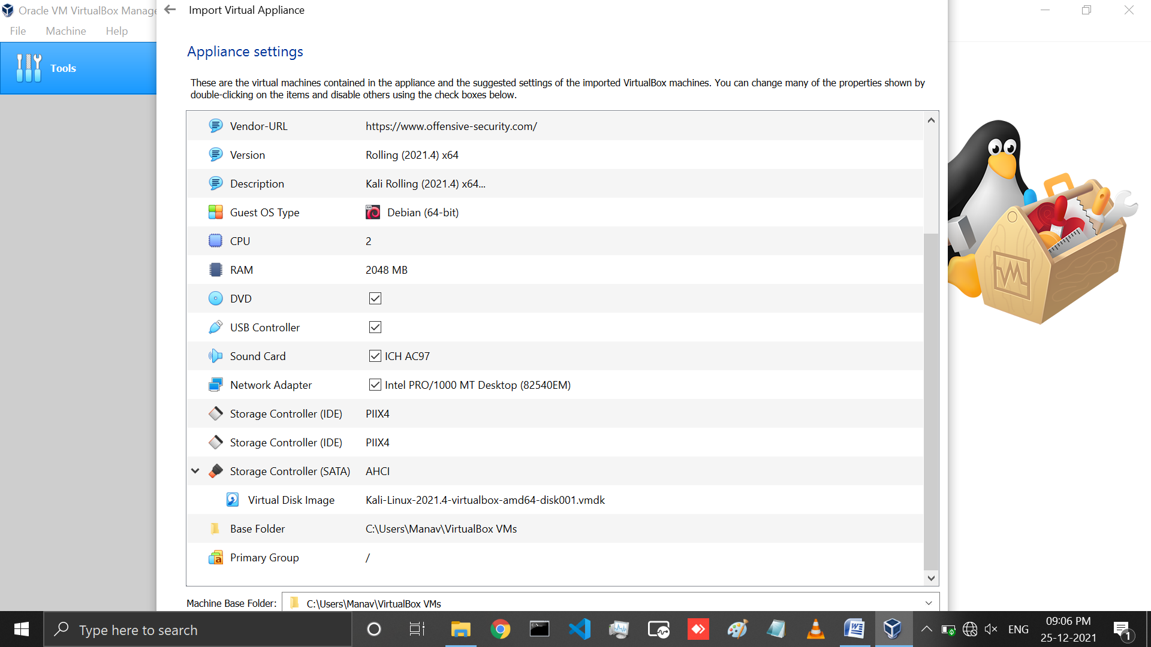

* Than we have to click agree for software License Agreement.

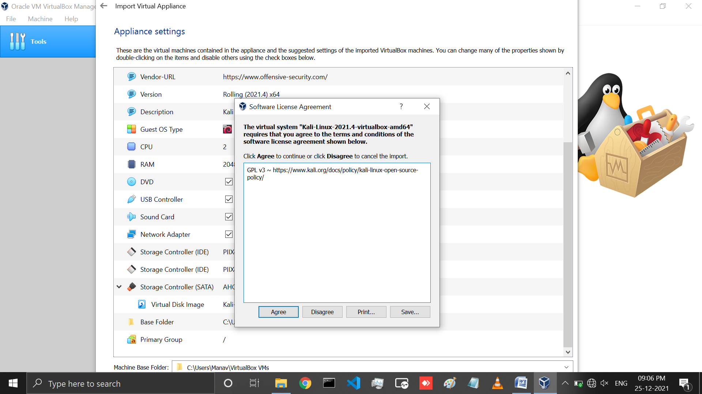

* When we agree for license it automatically start importing in virtualbox.

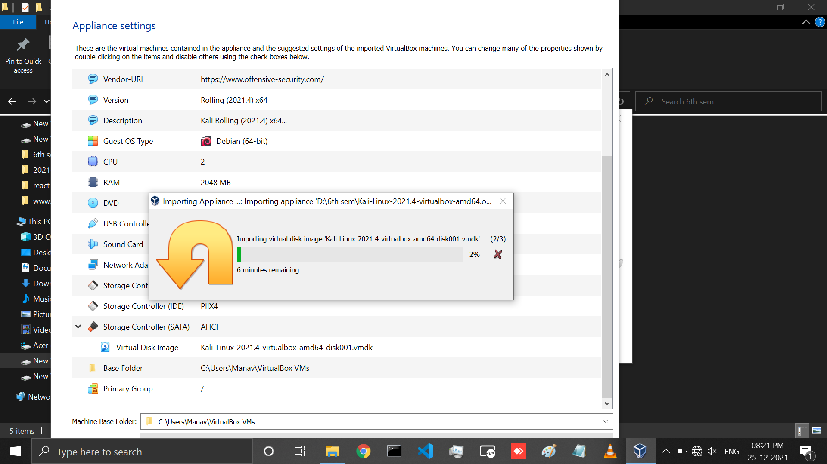

* After finish Importing we can see a instance of kali linux in virtual box.

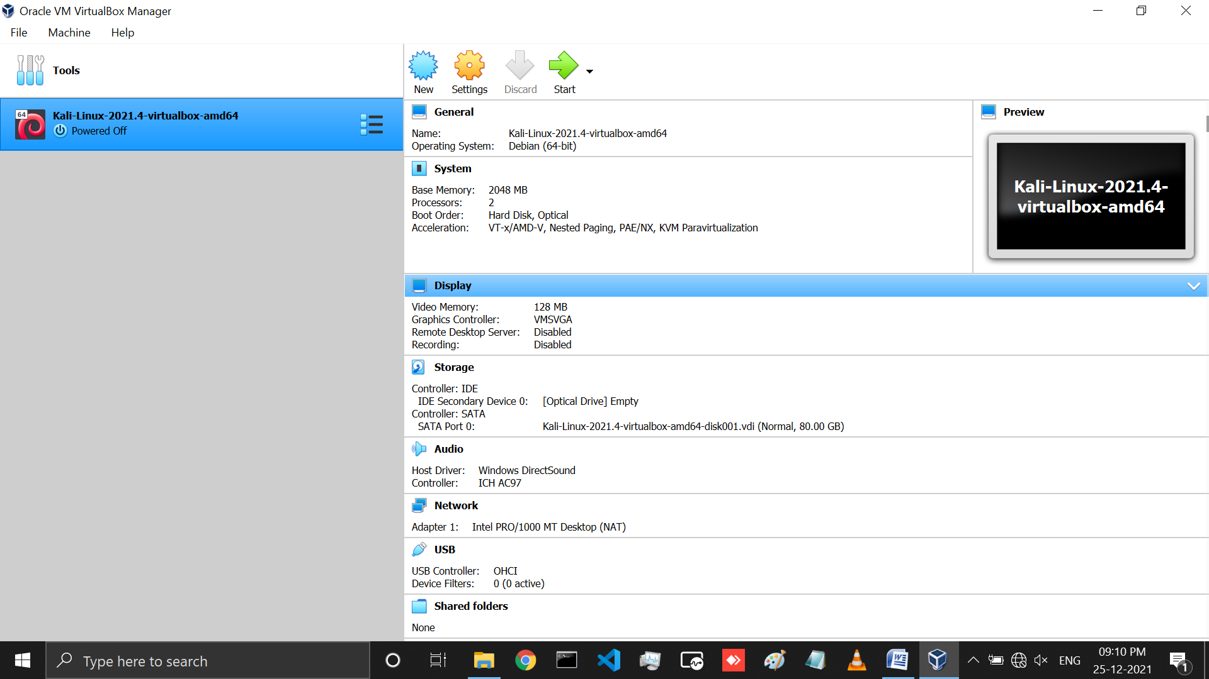

* For starting kali linux click on start arrow button.
* Than we can see that kind of screen for kali linux.
* Than wait for 5sec and click Enter.

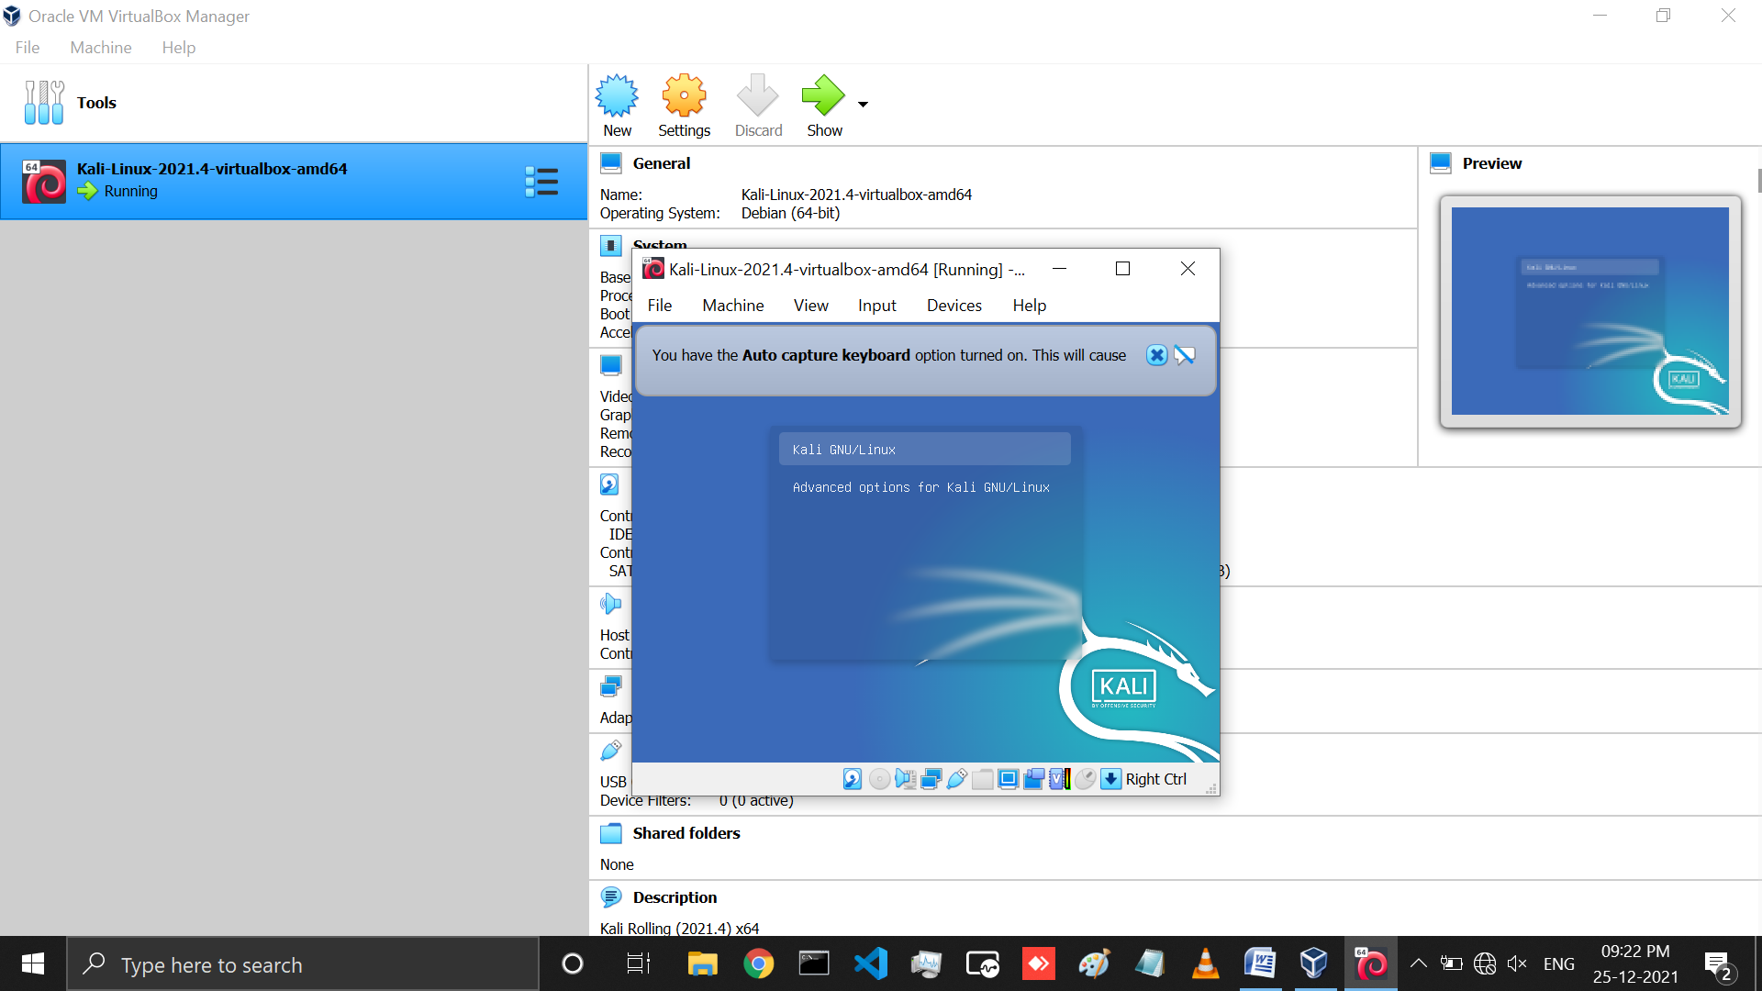

* After starting it ask for username and password.
* So we have to set username as kali and password as kali.

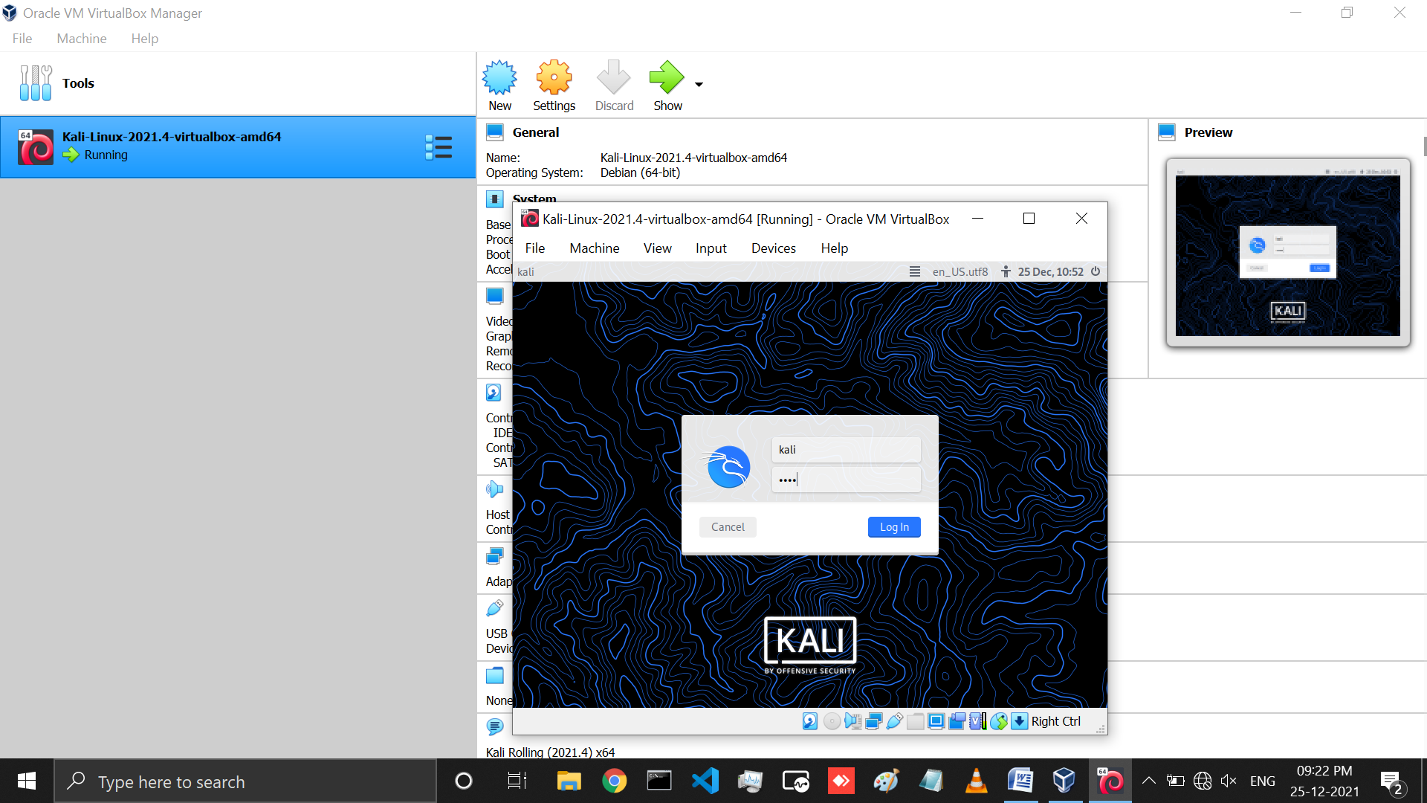

* Now, we have successfully installed kali linux in virtual box.

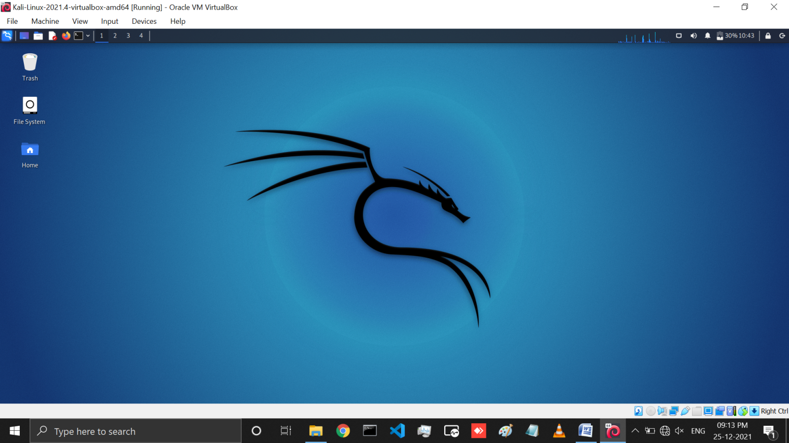

**LATEST APPLICATIONS:**

Kali Linux is mainly used for advanced Penetration Testing and Security Auditing. Kali contains several hundred tools which are geared towards various information security tasks, such as Penetration Testing, Security research, Computer Forensics and Reverse Engineering.

Latest kali Linux version is 2021.4 Release.

* Improved Apple M1 support
* Wide compatibility for Samba
* Switching package manager mirrors
* Kaboxertheming
* Updates to Xfce, GNOME and KDE
* Raspberry pi Zero 2 W + USBArmoryMkII ARM images

**LEARNING OUTCOME:**

Here, In this practical we learned how to install kali linux in Virtual box through .ova file.

**REFERENCES:**

1. Kali OS:<https://www.youtube.com/watch?v=jk2KGdJU2OI>
2. Parrot Security OS: <https://www.youtube.com/watch?v=4qvFp99rfXw>
3. Download Kali Linux OS: <https://www.kali.org/docs/introduction/download-official-kali-linux-images/>
4. Download Parrot Security OS: <https://parrotlinux.org/download/>