* **PC Configuration:**

# NGN Geforce (GPU)

* + Processor: Intel® Core™ i7-8700K CPU @ 3.70 GHz it’s 64 bit operating system
  + RAM: 32 GB
  + HDD : 2 TB HDD
  + Graphics Card: 1x NVIDIA GP 100 Accelerator card
  + Monitor: LG 22mp48hq LED
  + K/B & MOUSE: Logitech USB
* **Additional Feature**

NVIDIA GPU TITAN X Graphics Card of 12 GB TITAN X is crafted to offer superior heat dissipation using vapor chamber cooling technology in a die cast aluminum body. It's a powerful combination of brilliant efficiency, stunning design, and industry-leading performance.

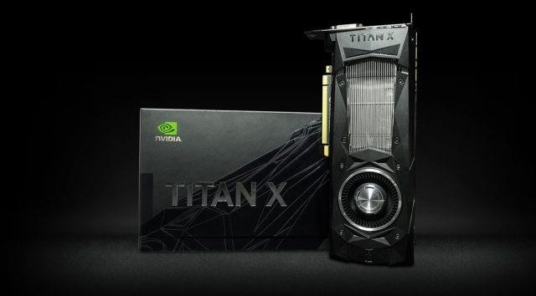

# Super micro computer

* Scientific Virtualization
* High Performance Computing
* Rendering
* AI/Deep Learning Training
  + Barebone GPU Full-Tower SuperServer Dual Intel Xeon Scalable, Intel C621A chipset, Up to 4TB in 16 DIMM Slots, SATA3, NVMe, 8x 3.5in drive bays, 2x 10GbE BaseT LAN Ports, 2000W Redundant Power Supply (CSE-747BTS-R2K20BP + X12DPG-QT)
    - Cost of computer : $ 3,509.00
    - Feature of super micro computer’ Dual Socket P+ (LGA-4189) 3rd Gen Intel®
    - Xeon® Scalable Processors
    - Intel® C621A Chipset
    - 16 DIMM Slots; Up to 4TB DRAM; Up to 4TB Intel® Optane™ Persistent Memory (up to 6TB with DRAM) ;
  + Processor
    - CPU 3rd Gen Intel® Xeon® Scalable processors
    - Support CPU TDP 270W
    - Dual Socket P+ (LGA-4189)
    - Cores Up to 40C/80T; Up to 60MB Cache
    - Motherboard Super X12DPG-QT6
  + System memory
    - Memory Capacity: 16 DIMM slots
    - Memory Type: 3200/2933/2666MHz ECC DDR4 RDIMM/LRDIMM
    - Intel® Optane™ persistent memory 200 series
    - Up to 4TB: 16x 256 GB DRAM
    - Up to 6TB: 8x 512 GB PMem
    - Memory Voltage 1.2 V
    - Error Detection ECC
  + Support gpu
    - NVIDIA A100,A40, and RTX A6000
    - CPU-GPU Interconnect PCI-E 4.0 x16 CPU-to-GPU Interconnect
    - GPU-GPU Interconnect PCI-E
  + Management
    - Watch Dog
    - NMI
    - KVM with dedicated LAN
    - Redfish API
    - SuperDoctor® 5
    - Intel® Node Manager
    - IPMI 2.0
    - SUM, SSM, SPM,
    - OOB Management Package (SFT-OOB-LIC )

Power Configurations Power-on mode for AC power recovery ACPI Power Management

**CONFIGURATION**

**Architecture:**

# SUPER COMPUTER - PARAM SHAVAK

The system consists of 2 multicore CPUs each with minimum 12 cores along with two number ofaccelerator cards. The entire configuration is available in a single server in a table top model. Regardless of the traditional HPC systems/supercomputers, this system does not require specificsupport infrastructure like precision air-conditioned environment, controlled humidity etc. Also,the accepted sound level is very less when compared to the traditional servers. This brings downthe infrastructure cost of the system

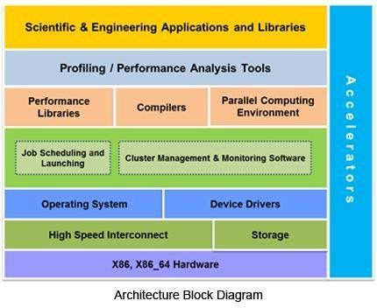

**Software Details:**

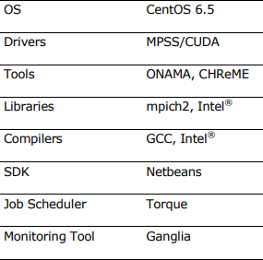

**Salient Features:**

* Supercomputer in a Box system in a table top model
* Powered with 2 multicore CPUs each with minimum 12 cores
* 2 numbers of accelerator cards
* 3 Tera-Flops peak computing power with 8 TB of storage
* Easy to deploy solution with no additional data center infrastructure
* Pre-loaded with parallel programming development tools and libraries
* Pre-Installed tools for scheduling and resource management
* Video Tutorials, learning materials and user manuals etc.
* Indigenous HPC portal- CHReME
* Indigenous applications interface – Onama

**APPLICATIONS**

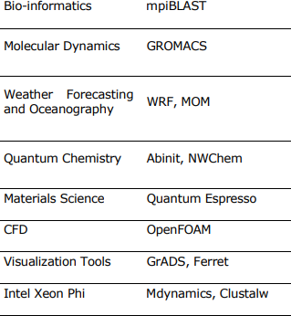

**ACCESSIBILITY**

|  |  |
| --- | --- |
| 1 | Install PUTTY : |
|  | [https://www.chiark.greenend.org.uk/~sgtatham/putty/late](https://www.chiark.greenend.org.uk/~sgtatham/putty/latest.html) [st.html](https://www.chiark.greenend.org.uk/~sgtatham/putty/latest.html) |
|  |  |
| 2 | Perform SSH Tunneling: |

|  |  |  |  |
| --- | --- | --- | --- |
|  | 1. Open command prompt 2. Type the following command without quotation andreplace username with your username:   “plink -N -L 13389:127.0.0.1:3389  [username@117.239.83.200](mailto:username@117.239.83.200) -P 8523 “  8523 – Supermicro  8522- Paramshavak   1. Enter your password and press Enter 2. Again press Enter to begin the session. 3. **Do not close the command prompt.** | | |
|  | |  |  |
|  | Enter your username Here Do not forget to press enter tobegin session!!  Do not close the command prompt !!! | | |

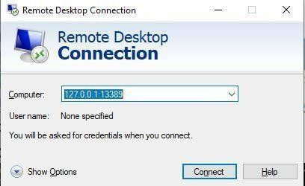

|  |  |
| --- | --- |
| 3 | Open Remote Desktop Connection and Enter: “http://127.0.0.1:13389” |
|  | You will be presented with following screen. Select xvnc insession and Enter your login credentials. |

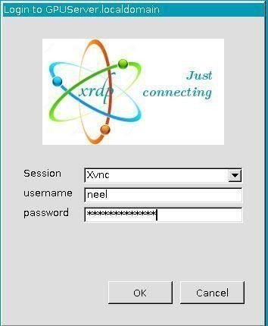

Select Xvnc

# NVIDIA DGX Server

## What is NVIDIA DGX Server?

* + DGX is a line of servers and workstations built by NVIDIA.
  + Provides a massive amount of computing power between 1-5 Petaflops.
  + DGX systems come out of the box with an optimized operating system and a complete pre-integrated environment for running deep learning projects.
  + Software architecture that lets data scientists easily deploy the deep learning frameworks and management tools they need with minimal setup or configuration.

## NVIDIA DGX-1 First Generation DGX Server

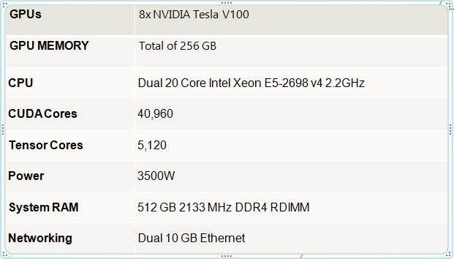

* **NVIDIA DGX-2 First Generation DGX Server**

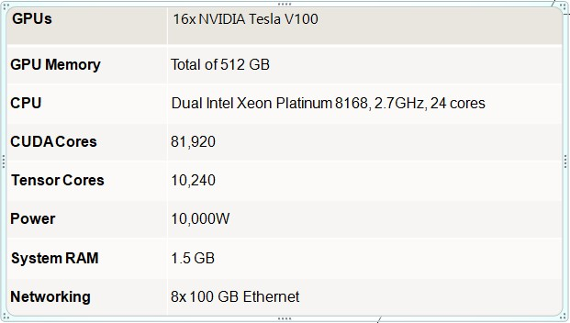

## NVIDIA DGX A100 Third Generation DGX Server

* + First and only workstation with 4 way NVIDIA A100 NVLink and MIG(Multi Instance GPU).
  + Four A100 Tensor core GPUs, 320GB total HBM2E(High bandwidth Memory).
  + 200GB/s bi-directional bandwidth between any GPU pair, almost 3x compare to PCIe Gen4.
  + New Maintenance free refrigerant Cooling system.

## CPU and Memory :

* + - 64-core AMD EPYC CPU, PCIe Gen4
    - Up to 512GB System Memory.

## Internal Storage :

* + - 1.92TB NVME M.2 SSD for OS, up to 7.68 TB NVME U.2.

## Connectivity :

* + - 2x 10GbE(RJ45)
    - 4x Mini Display Port for Display out
    - Remote management 1GbE LAN port(RJ45)

## How to Access It?

* + SSH is used to access DGX server and uploading it on docker.

## Location:

* + - Building A5 – Depstar
    - Room No – 118

