**Task**

**Aim: Write shell-script that takes input from user of .txt file , If the file available then print file exist and display file content and file not exist then print error message.**

**Code:**

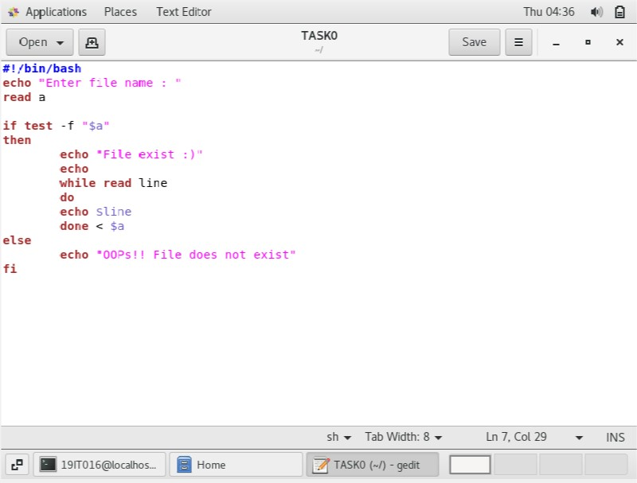

**Output:**

