**PRACTICAL-2**

1)• Change your password

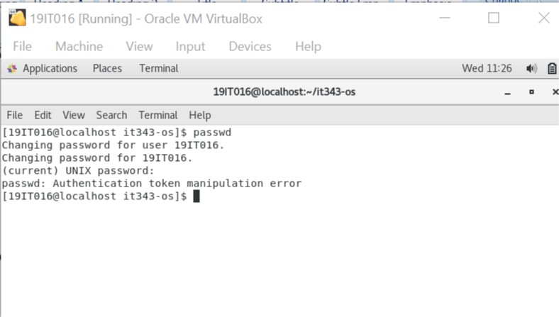

2)• Create 10 files under your home directory (File names = jerry, kramer, george, lex, clark, lois, homer, bart, lisa, and marge)

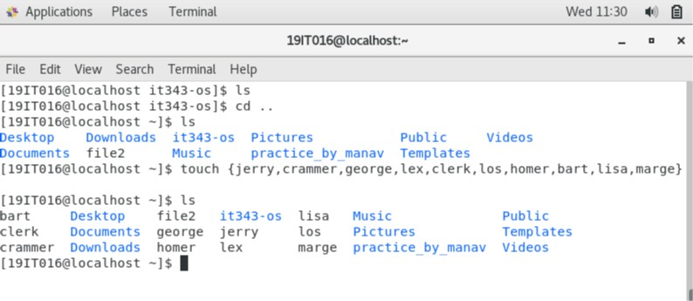

3)• Create 3 directories under your home directory (Dir name = seinfeld, superman and simpsons)

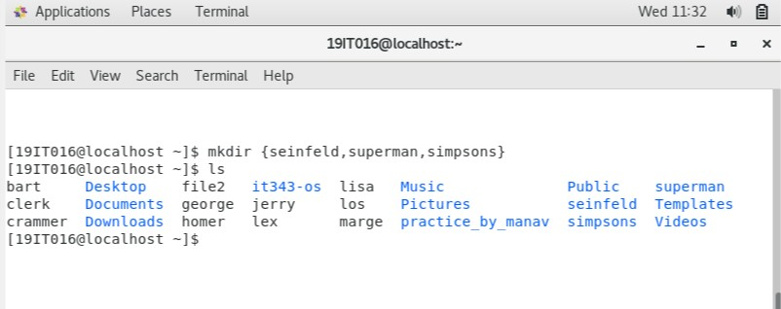

4)• Create a new file jupiter and write to it as "Jupiter is a planet". Then create a soft link in /tmp directory

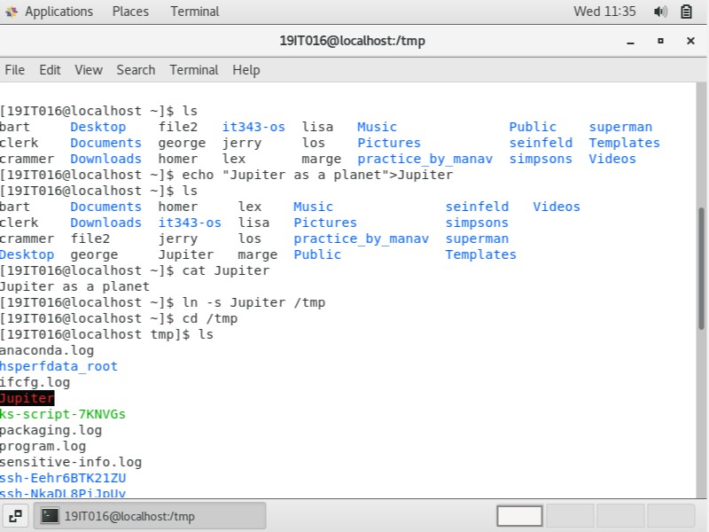

5)• Also create a hard link of jupiter in /tmp directory

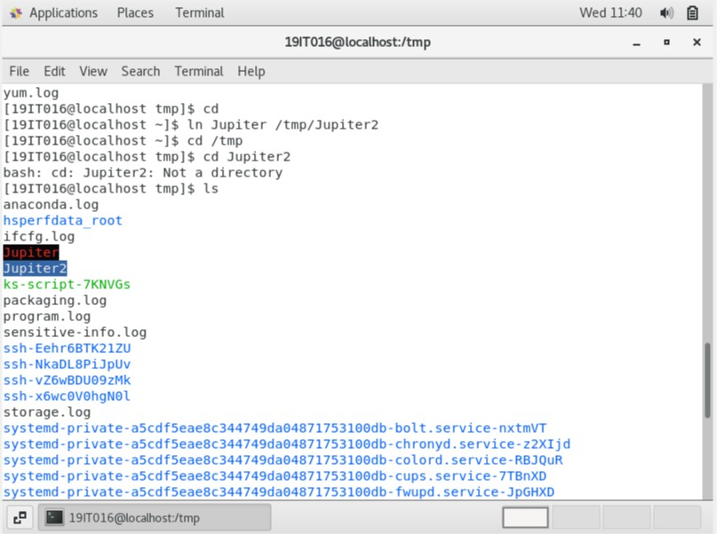

6)• Check the inodes of both links

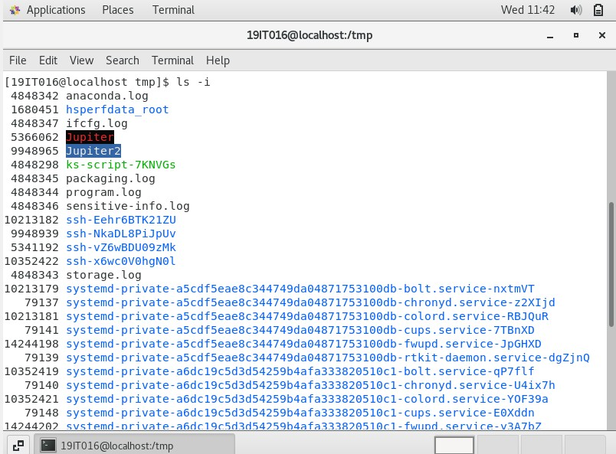

7)• Commands to determine the file system type in Linux OS

